Factors Report 20080102-20161230

**1. genticT77_3_10**

**截面指标累计曲线:**

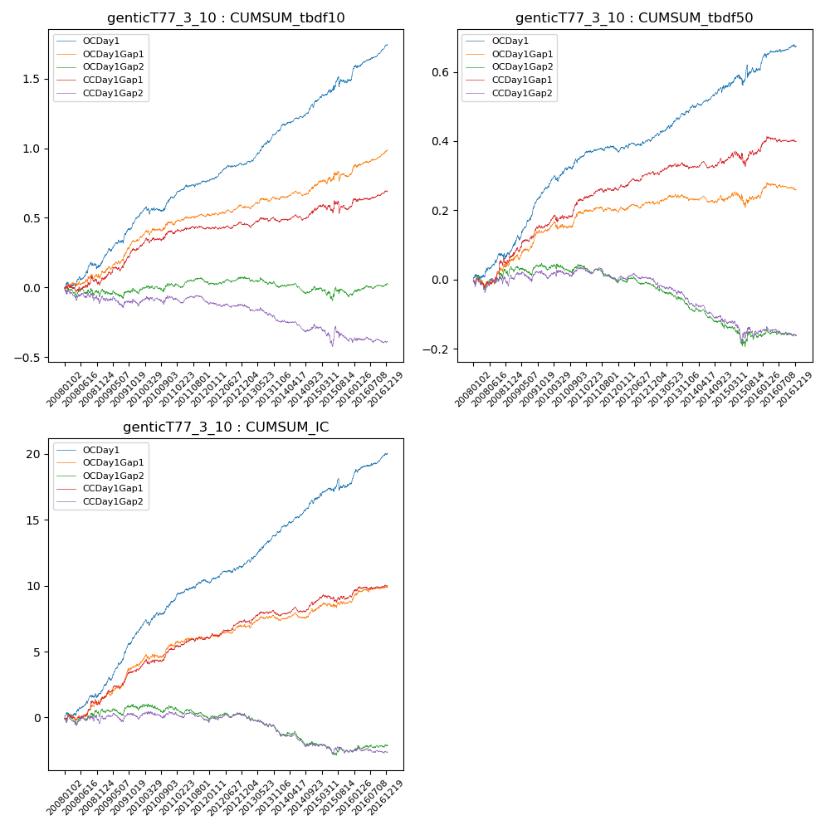

**因子换手率:** 57.46%

**截面指标_OCDay1:**

|  |  |  |  |  |  |  |  |  |
| --- | --- | --- | --- | --- | --- | --- | --- | --- |
| year | annret_tbdf10 | sharpe_tbdf10 | maxdd_tbdf10 | annret_tbdf50 | sharpe_tbdf50 | maxdd_tbdf50 | mean_IC | tstat_IC |
| 2008 | 0.16 | 1.99 | -0.05 | 0.07 | 2.02 | -0.02 | 0.01 | 2.56 |
| 2009 | 0.34 | 5.38 | -0.02 | 0.19 | 6.74 | -0.01 | 0.02 | 7.28 |
| 2010 | 0.15 | 2.3 | -0.05 | 0.09 | 3.11 | -0.02 | 0.01 | 3.51 |
| 2011 | 0.12 | 2.91 | -0.02 | 0.02 | 1.15 | -0.01 | 0.01 | 2.77 |
| 2012 | 0.12 | 3.27 | -0.02 | 0.04 | 1.83 | -0.01 | 0.01 | 2.82 |
| 2013 | 0.25 | 5.38 | -0.01 | 0.08 | 3.49 | -0.01 | 0.01 | 4.82 |
| 2014 | 0.21 | 4.4 | -0.03 | 0.06 | 2.88 | -0.01 | 0.01 | 4.51 |
| 2015 | 0.16 | 1.42 | -0.07 | 0.06 | 1.01 | -0.04 | 0.01 | 1.1 |
| 2016 | 0.25 | 4.92 | -0.02 | 0.07 | 2.79 | -0.01 | 0.01 | 4.24 |

**截面指标_CCDay1Gap1:**

|  |  |  |  |  |  |  |  |  |
| --- | --- | --- | --- | --- | --- | --- | --- | --- |
| year | annret_tbdf10 | sharpe_tbdf10 | maxdd_tbdf10 | annret_tbdf50 | sharpe_tbdf50 | maxdd_tbdf50 | mean_IC | tstat_IC |
| 2008 | 0.04 | 0.5 | -0.06 | 0.06 | 1.45 | -0.03 | 0.01 | 1.67 |
| 2009 | 0.23 | 3.46 | -0.03 | 0.09 | 3.13 | -0.01 | 0.01 | 3.8 |
| 2010 | 0.12 | 1.9 | -0.03 | 0.07 | 2.44 | -0.02 | 0.01 | 2.51 |
| 2011 | 0.03 | 0.74 | -0.02 | 0.03 | 1.56 | -0.01 | 0.0 | 1.8 |
| 2012 | 0.04 | 0.89 | -0.02 | 0.05 | 2.89 | -0.01 | 0.01 | 3.1 |
| 2013 | 0.02 | 0.32 | -0.04 | 0.01 | 0.67 | -0.01 | 0.0 | 0.76 |
| 2014 | 0.08 | 1.76 | -0.04 | 0.01 | 0.65 | -0.02 | 0.0 | 2.22 |
| 2015 | 0.02 | 0.19 | -0.09 | 0.03 | 0.69 | -0.04 | 0.0 | 0.63 |
| 2016 | 0.11 | 2.23 | -0.02 | 0.03 | 1.28 | -0.02 | 0.0 | 1.81 |

**风格暴露:**

|  |  |  |  |  |
| --- | --- | --- | --- | --- |
|  | long | short | corr_OCDay1 | corr_CCDay1Gap1 |
| liquidity10 | 0.03 | -0.03 | -0.06 | -0.06 |
| liquidity20 | 0.01 | -0.01 | -0.04 | -0.04 |
| liquidity5 | 0.05 | -0.05 | -0.09 | -0.05 |
| logmktcap | -0.0 | 0.01 | 0.03 | 0.03 |
| momentum15 | 0.13 | -0.12 | -0.2 | -0.11 |
| momentum30 | 0.08 | -0.08 | -0.17 | -0.1 |
| momentum5 | 0.16 | -0.15 | -0.23 | -0.15 |
| retvolatility30 | 0.0 | -0.01 | -0.04 | -0.01 |