Factors Report 20080102-20161230

**1. genticT77_3_15**

**截面指标累计曲线:**

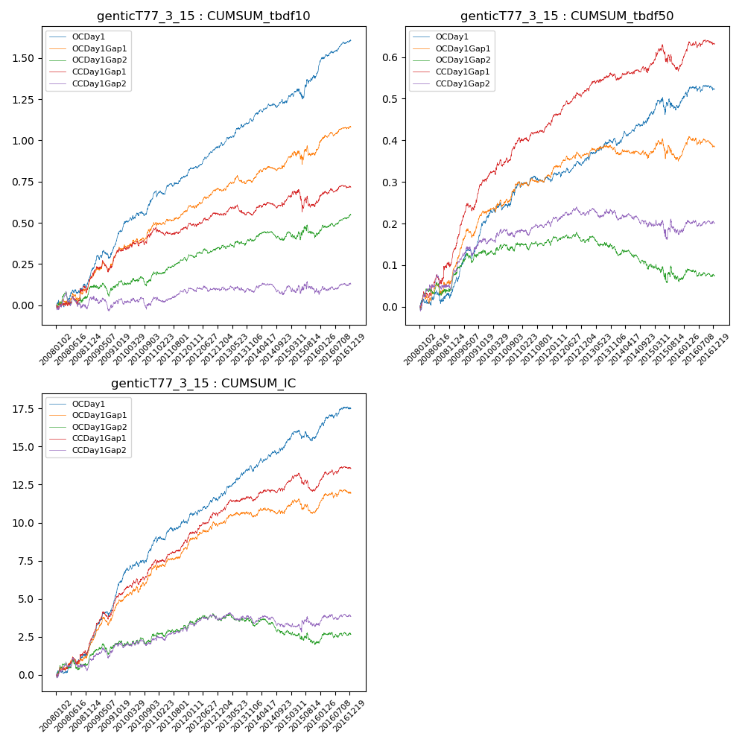

**因子换手率:** 53.66%

**截面指标_OCDay1:**

|  |  |  |  |  |  |  |  |  |
| --- | --- | --- | --- | --- | --- | --- | --- | --- |
| year | annret_tbdf10 | sharpe_tbdf10 | maxdd_tbdf10 | annret_tbdf50 | sharpe_tbdf50 | maxdd_tbdf50 | mean_IC | tstat_IC |
| 2008 | 0.16 | 2.16 | -0.04 | 0.04 | 1.07 | -0.03 | 0.01 | 2.49 |
| 2009 | 0.29 | 4.38 | -0.05 | 0.17 | 5.44 | -0.02 | 0.02 | 6.72 |
| 2010 | 0.24 | 3.69 | -0.03 | 0.09 | 2.89 | -0.02 | 0.01 | 3.77 |
| 2011 | 0.11 | 2.2 | -0.04 | 0.01 | 0.31 | -0.01 | 0.0 | 1.86 |
| 2012 | 0.18 | 4.35 | -0.01 | 0.05 | 2.23 | -0.01 | 0.01 | 3.05 |
| 2013 | 0.16 | 3.31 | -0.02 | 0.05 | 2.18 | -0.01 | 0.01 | 3.31 |
| 2014 | 0.11 | 2.48 | -0.03 | 0.05 | 2.26 | -0.01 | 0.01 | 2.7 |
| 2015 | 0.19 | 2.23 | -0.06 | 0.04 | 0.93 | -0.04 | 0.0 | 1.25 |
| 2016 | 0.19 | 3.98 | -0.01 | 0.03 | 1.17 | -0.01 | 0.01 | 2.77 |

**截面指标_CCDay1Gap1:**

|  |  |  |  |  |  |  |  |  |
| --- | --- | --- | --- | --- | --- | --- | --- | --- |
| year | annret_tbdf10 | sharpe_tbdf10 | maxdd_tbdf10 | annret_tbdf50 | sharpe_tbdf50 | maxdd_tbdf50 | mean_IC | tstat_IC |
| 2008 | 0.14 | 1.55 | -0.05 | 0.13 | 2.67 | -0.02 | 0.01 | 2.51 |
| 2009 | 0.2 | 2.9 | -0.07 | 0.18 | 5.58 | -0.02 | 0.01 | 5.02 |
| 2010 | 0.12 | 2.0 | -0.03 | 0.1 | 3.16 | -0.02 | 0.01 | 3.41 |
| 2011 | 0.01 | 0.22 | -0.05 | 0.04 | 1.84 | -0.01 | 0.01 | 2.52 |
| 2012 | 0.08 | 1.76 | -0.02 | 0.07 | 3.51 | -0.01 | 0.01 | 3.33 |
| 2013 | 0.0 | 0.06 | -0.06 | 0.04 | 1.71 | -0.01 | 0.0 | 1.76 |
| 2014 | 0.08 | 1.58 | -0.04 | 0.02 | 0.93 | -0.02 | 0.0 | 1.67 |
| 2015 | -0.0 | -0.01 | -0.13 | 0.01 | 0.22 | -0.06 | -0.0 | -0.04 |
| 2016 | 0.09 | 1.93 | -0.02 | 0.05 | 2.12 | -0.01 | 0.01 | 2.53 |

**风格暴露:**

|  |  |  |  |  |
| --- | --- | --- | --- | --- |
|  | long | short | corr_OCDay1 | corr_CCDay1Gap1 |
| liquidity10 | 0.06 | -0.06 | -0.08 | -0.14 |
| liquidity20 | 0.02 | -0.03 | -0.03 | -0.1 |
| liquidity5 | 0.09 | -0.09 | -0.12 | -0.15 |
| logmktcap | -0.0 | 0.01 | -0.07 | 0.06 |
| momentum15 | 0.21 | -0.2 | -0.3 | -0.25 |
| momentum30 | 0.12 | -0.12 | -0.24 | -0.16 |
| momentum5 | 0.22 | -0.22 | -0.3 | -0.2 |
| retvolatility30 | 0.02 | -0.02 | -0.0 | -0.07 |