Factors Report 20080102-20161230

**1. genticT77_3_20**

**截面指标累计曲线:**

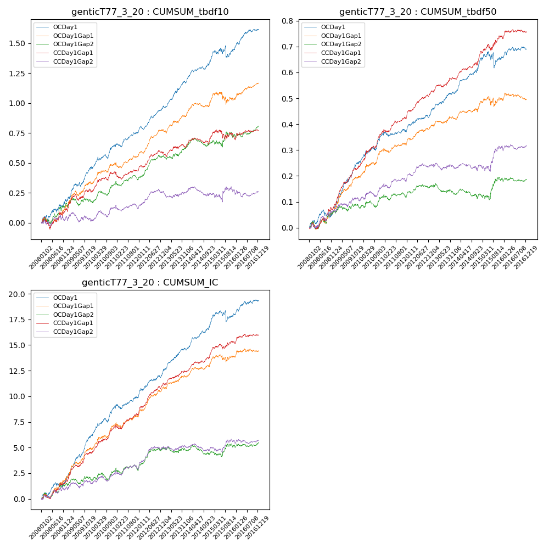

**因子换手率:** 51.22%

**截面指标_OCDay1:**

|  |  |  |  |  |  |  |  |  |
| --- | --- | --- | --- | --- | --- | --- | --- | --- |
| year | annret_tbdf10 | sharpe_tbdf10 | maxdd_tbdf10 | annret_tbdf50 | sharpe_tbdf50 | maxdd_tbdf50 | mean_IC | tstat_IC |
| 2008 | 0.19 | 2.5 | -0.04 | 0.06 | 1.71 | -0.03 | 0.01 | 2.45 |
| 2009 | 0.26 | 3.97 | -0.04 | 0.19 | 5.95 | -0.02 | 0.02 | 6.26 |
| 2010 | 0.2 | 3.16 | -0.04 | 0.11 | 3.61 | -0.01 | 0.01 | 4.12 |
| 2011 | 0.12 | 2.43 | -0.03 | 0.01 | 0.59 | -0.02 | 0.0 | 1.66 |
| 2012 | 0.2 | 4.73 | -0.03 | 0.06 | 2.95 | -0.01 | 0.01 | 3.98 |
| 2013 | 0.22 | 4.25 | -0.02 | 0.09 | 3.61 | -0.01 | 0.01 | 4.49 |
| 2014 | 0.18 | 4.02 | -0.02 | 0.09 | 4.0 | -0.01 | 0.01 | 4.44 |
| 2015 | 0.1 | 1.01 | -0.1 | 0.04 | 0.78 | -0.06 | 0.0 | 1.02 |
| 2016 | 0.17 | 3.65 | -0.02 | 0.03 | 1.45 | -0.01 | 0.01 | 2.47 |

**截面指标_CCDay1Gap1:**

|  |  |  |  |  |  |  |  |  |
| --- | --- | --- | --- | --- | --- | --- | --- | --- |
| year | annret_tbdf10 | sharpe_tbdf10 | maxdd_tbdf10 | annret_tbdf50 | sharpe_tbdf50 | maxdd_tbdf50 | mean_IC | tstat_IC |
| 2008 | 0.12 | 1.18 | -0.1 | 0.08 | 1.85 | -0.02 | 0.01 | 2.12 |
| 2009 | 0.15 | 2.11 | -0.05 | 0.15 | 4.88 | -0.01 | 0.01 | 4.12 |
| 2010 | 0.15 | 2.64 | -0.03 | 0.14 | 4.52 | -0.01 | 0.01 | 4.29 |
| 2011 | 0.02 | 0.37 | -0.06 | 0.05 | 2.34 | -0.01 | 0.0 | 2.14 |
| 2012 | 0.15 | 3.38 | -0.02 | 0.1 | 4.59 | -0.01 | 0.01 | 5.18 |
| 2013 | 0.05 | 0.98 | -0.04 | 0.06 | 2.64 | -0.01 | 0.01 | 2.56 |
| 2014 | 0.07 | 1.37 | -0.05 | 0.07 | 2.74 | -0.01 | 0.01 | 3.43 |
| 2015 | 0.0 | 0.04 | -0.09 | 0.09 | 2.29 | -0.02 | 0.0 | 1.77 |
| 2016 | 0.06 | 1.29 | -0.02 | 0.02 | 0.93 | -0.01 | 0.0 | 1.53 |

**风格暴露:**

|  |  |  |  |  |
| --- | --- | --- | --- | --- |
|  | long | short | corr_OCDay1 | corr_CCDay1Gap1 |
| liquidity10 | 0.08 | -0.09 | -0.17 | -0.13 |
| liquidity20 | 0.05 | -0.05 | -0.14 | -0.09 |
| liquidity5 | 0.12 | -0.12 | -0.21 | -0.14 |
| logmktcap | -0.0 | 0.01 | 0.06 | 0.01 |
| momentum15 | 0.22 | -0.22 | -0.35 | -0.29 |
| momentum30 | 0.17 | -0.17 | -0.32 | -0.2 |
| momentum5 | 0.26 | -0.25 | -0.37 | -0.25 |
| retvolatility30 | 0.03 | -0.03 | -0.07 | -0.03 |