Factors Report 20080102-20161230

**1. genticT77_3_25**

**截面指标累计曲线:**

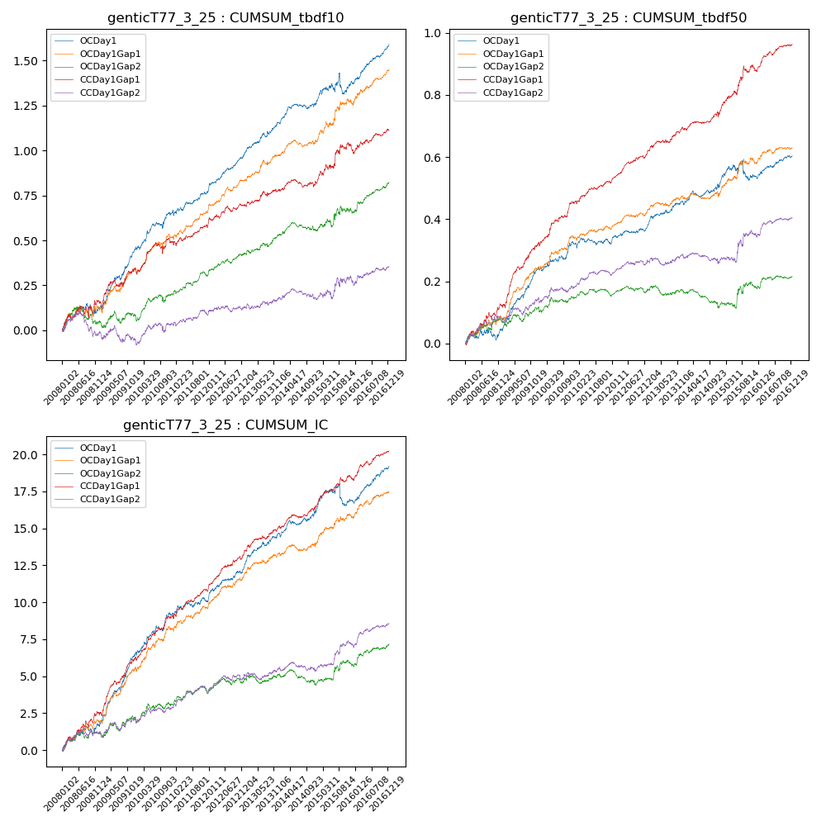

**因子换手率:** 49.8%

**截面指标_OCDay1:**

|  |  |  |  |  |  |  |  |  |
| --- | --- | --- | --- | --- | --- | --- | --- | --- |
| year | annret_tbdf10 | sharpe_tbdf10 | maxdd_tbdf10 | annret_tbdf50 | sharpe_tbdf50 | maxdd_tbdf50 | mean_IC | tstat_IC |
| 2008 | 0.12 | 1.6 | -0.07 | 0.04 | 1.09 | -0.04 | 0.01 | 2.22 |
| 2009 | 0.33 | 4.78 | -0.03 | 0.2 | 5.97 | -0.01 | 0.02 | 6.62 |
| 2010 | 0.2 | 3.13 | -0.03 | 0.08 | 2.4 | -0.01 | 0.01 | 3.47 |
| 2011 | 0.12 | 2.49 | -0.03 | 0.0 | 0.05 | -0.02 | 0.0 | 1.42 |
| 2012 | 0.2 | 4.86 | -0.01 | 0.05 | 2.42 | -0.01 | 0.01 | 3.88 |
| 2013 | 0.18 | 3.52 | -0.02 | 0.09 | 3.29 | -0.01 | 0.01 | 3.9 |
| 2014 | 0.11 | 2.38 | -0.03 | 0.04 | 1.57 | -0.02 | 0.01 | 2.35 |
| 2015 | 0.11 | 1.05 | -0.11 | 0.03 | 0.61 | -0.06 | 0.0 | 0.66 |
| 2016 | 0.22 | 4.92 | -0.01 | 0.07 | 3.04 | -0.01 | 0.01 | 4.37 |

**截面指标_CCDay1Gap1:**

|  |  |  |  |  |  |  |  |  |
| --- | --- | --- | --- | --- | --- | --- | --- | --- |
| year | annret_tbdf10 | sharpe_tbdf10 | maxdd_tbdf10 | annret_tbdf50 | sharpe_tbdf50 | maxdd_tbdf50 | mean_IC | tstat_IC |
| 2008 | 0.17 | 1.78 | -0.06 | 0.12 | 3.37 | -0.02 | 0.01 | 3.62 |
| 2009 | 0.18 | 2.37 | -0.04 | 0.2 | 5.57 | -0.01 | 0.02 | 5.09 |
| 2010 | 0.15 | 2.16 | -0.06 | 0.13 | 4.04 | -0.01 | 0.01 | 4.06 |
| 2011 | 0.09 | 1.93 | -0.03 | 0.06 | 2.8 | -0.01 | 0.01 | 3.22 |
| 2012 | 0.11 | 2.47 | -0.03 | 0.1 | 4.6 | -0.01 | 0.01 | 4.82 |
| 2013 | 0.09 | 1.68 | -0.03 | 0.08 | 3.13 | -0.01 | 0.01 | 3.18 |
| 2014 | 0.04 | 0.81 | -0.05 | 0.05 | 1.64 | -0.02 | 0.01 | 2.56 |
| 2015 | 0.19 | 2.09 | -0.05 | 0.14 | 3.06 | -0.02 | 0.01 | 2.99 |
| 2016 | 0.11 | 2.19 | -0.02 | 0.08 | 3.8 | -0.01 | 0.01 | 3.9 |

**风格暴露:**

|  |  |  |  |  |
| --- | --- | --- | --- | --- |
|  | long | short | corr_OCDay1 | corr_CCDay1Gap1 |
| liquidity10 | 0.1 | -0.1 | -0.18 | -0.17 |
| liquidity20 | 0.06 | -0.06 | -0.15 | -0.14 |
| liquidity5 | 0.13 | -0.13 | -0.21 | -0.19 |
| logmktcap | -0.01 | 0.01 | 0.06 | 0.03 |
| momentum15 | 0.24 | -0.23 | -0.28 | -0.29 |
| momentum30 | 0.22 | -0.22 | -0.27 | -0.24 |
| momentum5 | 0.28 | -0.27 | -0.3 | -0.24 |
| retvolatility30 | 0.03 | -0.03 | -0.11 | -0.1 |