Factors Report 20080102-20161230

**1. genticT77_3_30**

**截面指标累计曲线:**

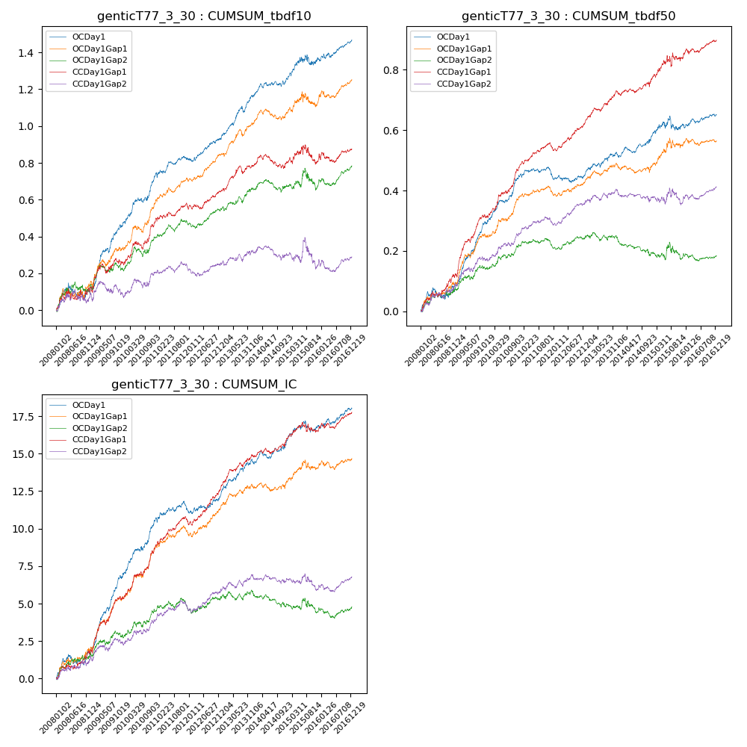

**因子换手率:** 48.62%

**截面指标_OCDay1:**

|  |  |  |  |  |  |  |  |  |
| --- | --- | --- | --- | --- | --- | --- | --- | --- |
| year | annret_tbdf10 | sharpe_tbdf10 | maxdd_tbdf10 | annret_tbdf50 | sharpe_tbdf50 | maxdd_tbdf50 | mean_IC | tstat_IC |
| 2008 | 0.1 | 1.34 | -0.08 | 0.07 | 1.69 | -0.04 | 0.01 | 2.09 |
| 2009 | 0.36 | 5.27 | -0.02 | 0.22 | 6.51 | -0.01 | 0.02 | 7.01 |
| 2010 | 0.27 | 4.12 | -0.03 | 0.16 | 4.71 | -0.01 | 0.02 | 4.78 |
| 2011 | 0.1 | 2.14 | -0.03 | -0.0 | -0.03 | -0.03 | 0.0 | 1.11 |
| 2012 | 0.11 | 2.54 | -0.02 | 0.01 | 0.41 | -0.03 | 0.0 | 1.68 |
| 2013 | 0.24 | 4.36 | -0.04 | 0.07 | 2.34 | -0.01 | 0.01 | 3.6 |
| 2014 | 0.08 | 1.96 | -0.03 | 0.04 | 1.62 | -0.02 | 0.0 | 1.85 |
| 2015 | 0.12 | 1.39 | -0.06 | 0.06 | 1.15 | -0.05 | 0.01 | 1.74 |
| 2016 | 0.1 | 2.34 | -0.03 | 0.03 | 1.46 | -0.01 | 0.0 | 2.16 |

**截面指标_CCDay1Gap1:**

|  |  |  |  |  |  |  |  |  |
| --- | --- | --- | --- | --- | --- | --- | --- | --- |
| year | annret_tbdf10 | sharpe_tbdf10 | maxdd_tbdf10 | annret_tbdf50 | sharpe_tbdf50 | maxdd_tbdf50 | mean_IC | tstat_IC |
| 2008 | 0.11 | 1.24 | -0.06 | 0.12 | 3.12 | -0.02 | 0.01 | 2.6 |
| 2009 | 0.14 | 1.87 | -0.05 | 0.19 | 5.25 | -0.01 | 0.01 | 4.73 |
| 2010 | 0.23 | 3.33 | -0.04 | 0.17 | 4.98 | -0.01 | 0.01 | 4.71 |
| 2011 | 0.08 | 1.63 | -0.03 | 0.06 | 2.71 | -0.02 | 0.01 | 3.07 |
| 2012 | 0.09 | 2.06 | -0.03 | 0.09 | 3.61 | -0.01 | 0.01 | 3.82 |
| 2013 | 0.14 | 2.74 | -0.04 | 0.11 | 3.84 | -0.01 | 0.01 | 3.79 |
| 2014 | 0.01 | 0.29 | -0.08 | 0.03 | 1.27 | -0.02 | 0.0 | 1.81 |
| 2015 | 0.04 | 0.39 | -0.1 | 0.09 | 1.55 | -0.04 | 0.0 | 1.05 |
| 2016 | 0.04 | 0.73 | -0.05 | 0.05 | 2.05 | -0.02 | 0.0 | 2.16 |

**风格暴露:**

|  |  |  |  |  |
| --- | --- | --- | --- | --- |
|  | long | short | corr_OCDay1 | corr_CCDay1Gap1 |
| liquidity10 | 0.11 | -0.11 | -0.22 | -0.24 |
| liquidity20 | 0.08 | -0.07 | -0.17 | -0.2 |
| liquidity5 | 0.14 | -0.14 | -0.25 | -0.23 |
| logmktcap | -0.0 | 0.01 | -0.02 | 0.11 |
| momentum15 | 0.24 | -0.24 | -0.36 | -0.31 |
| momentum30 | 0.27 | -0.27 | -0.31 | -0.24 |
| momentum5 | 0.3 | -0.29 | -0.35 | -0.23 |
| retvolatility30 | 0.07 | -0.07 | -0.12 | -0.16 |