Factors Report 20080102-20161230

**1. genticT77_3_5**

**截面指标累计曲线:**

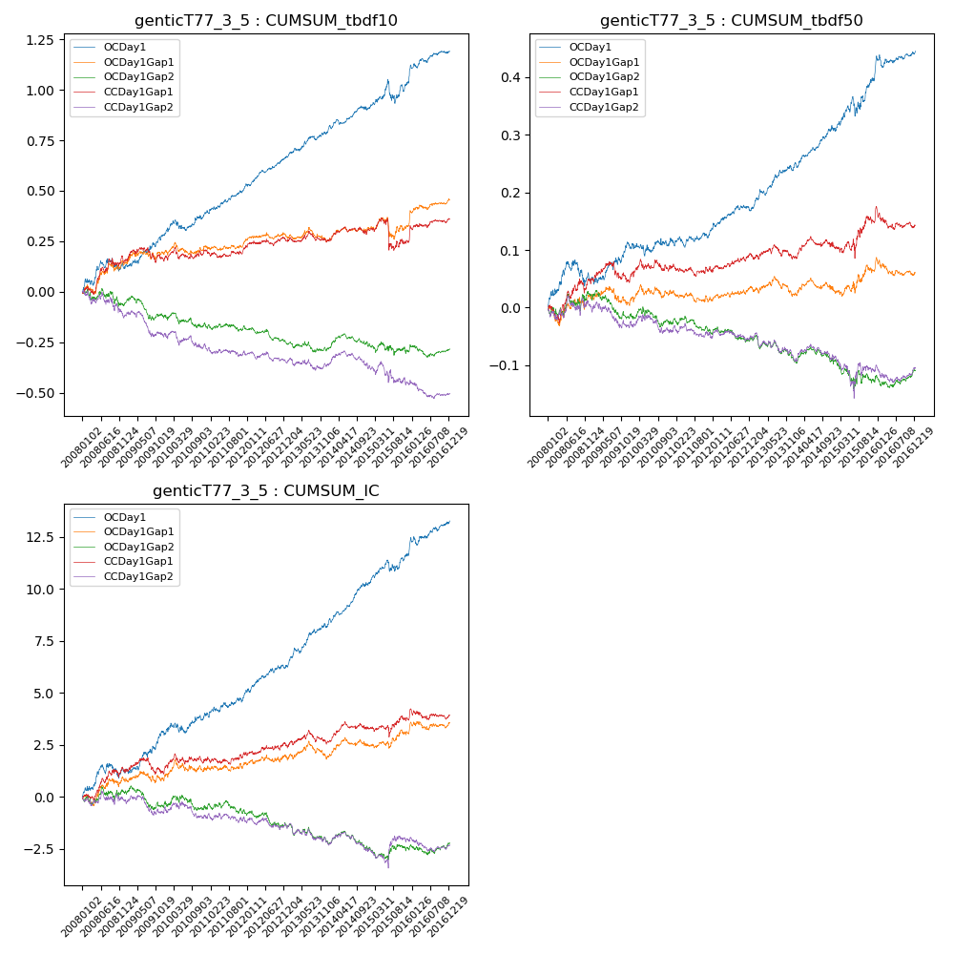

**因子换手率:** 70.75%

**截面指标_OCDay1:**

|  |  |  |  |  |  |  |  |  |
| --- | --- | --- | --- | --- | --- | --- | --- | --- |
| year | annret_tbdf10 | sharpe_tbdf10 | maxdd_tbdf10 | annret_tbdf50 | sharpe_tbdf50 | maxdd_tbdf50 | mean_IC | tstat_IC |
| 2008 | 0.12 | 1.46 | -0.06 | 0.05 | 1.2 | -0.04 | 0.0 | 1.54 |
| 2009 | 0.16 | 2.61 | -0.02 | 0.06 | 1.82 | -0.01 | 0.01 | 2.67 |
| 2010 | 0.11 | 1.78 | -0.05 | 0.01 | 0.42 | -0.02 | 0.0 | 1.31 |
| 2011 | 0.14 | 3.29 | -0.02 | 0.02 | 0.97 | -0.02 | 0.0 | 2.05 |
| 2012 | 0.14 | 3.72 | -0.01 | 0.04 | 1.98 | -0.01 | 0.0 | 2.3 |
| 2013 | 0.12 | 2.58 | -0.02 | 0.07 | 3.13 | -0.01 | 0.01 | 3.58 |
| 2014 | 0.12 | 2.79 | -0.02 | 0.07 | 3.83 | -0.01 | 0.01 | 4.52 |
| 2015 | 0.13 | 1.5 | -0.11 | 0.09 | 2.11 | -0.03 | 0.01 | 2.01 |
| 2016 | 0.16 | 2.66 | -0.02 | 0.05 | 2.04 | -0.02 | 0.01 | 2.85 |

**截面指标_CCDay1Gap1:**

|  |  |  |  |  |  |  |  |  |
| --- | --- | --- | --- | --- | --- | --- | --- | --- |
| year | annret_tbdf10 | sharpe_tbdf10 | maxdd_tbdf10 | annret_tbdf50 | sharpe_tbdf50 | maxdd_tbdf50 | mean_IC | tstat_IC |
| 2008 | 0.14 | 1.69 | -0.04 | 0.05 | 1.32 | -0.03 | 0.01 | 1.89 |
| 2009 | 0.02 | 0.35 | -0.07 | 0.0 | 0.13 | -0.04 | 0.0 | 0.09 |
| 2010 | 0.04 | 0.69 | -0.06 | 0.02 | 0.6 | -0.02 | 0.0 | 0.72 |
| 2011 | 0.02 | 0.49 | -0.04 | -0.0 | -0.12 | -0.02 | 0.0 | 0.73 |
| 2012 | 0.02 | 0.58 | -0.03 | 0.02 | 1.23 | -0.01 | 0.0 | 0.63 |
| 2013 | -0.0 | -0.03 | -0.05 | -0.0 | -0.08 | -0.02 | 0.0 | 0.28 |
| 2014 | 0.05 | 1.18 | -0.04 | 0.02 | 0.88 | -0.02 | 0.0 | 1.52 |
| 2015 | -0.06 | -0.49 | -0.15 | 0.04 | 0.93 | -0.03 | 0.0 | 0.56 |
| 2016 | 0.11 | 2.03 | -0.02 | -0.0 | -0.17 | -0.04 | 0.0 | 0.47 |

**风格暴露:**

|  |  |  |  |  |
| --- | --- | --- | --- | --- |
|  | long | short | corr_OCDay1 | corr_CCDay1Gap1 |
| liquidity10 | -0.0 | -0.01 | -0.03 | -0.06 |
| liquidity20 | -0.0 | -0.01 | -0.01 | -0.04 |
| liquidity5 | -0.0 | -0.01 | -0.03 | -0.04 |
| logmktcap | 0.0 | 0.0 | 0.03 | 0.08 |
| momentum15 | 0.01 | -0.01 | -0.06 | -0.03 |
| momentum30 | 0.01 | -0.01 | -0.05 | -0.05 |
| momentum5 | 0.04 | -0.03 | -0.05 | -0.03 |
| retvolatility30 | -0.0 | -0.01 | -0.04 | -0.05 |