Factors Report 20080102-20161230

**1. genticT77_4_10**

**截面指标累计曲线:**

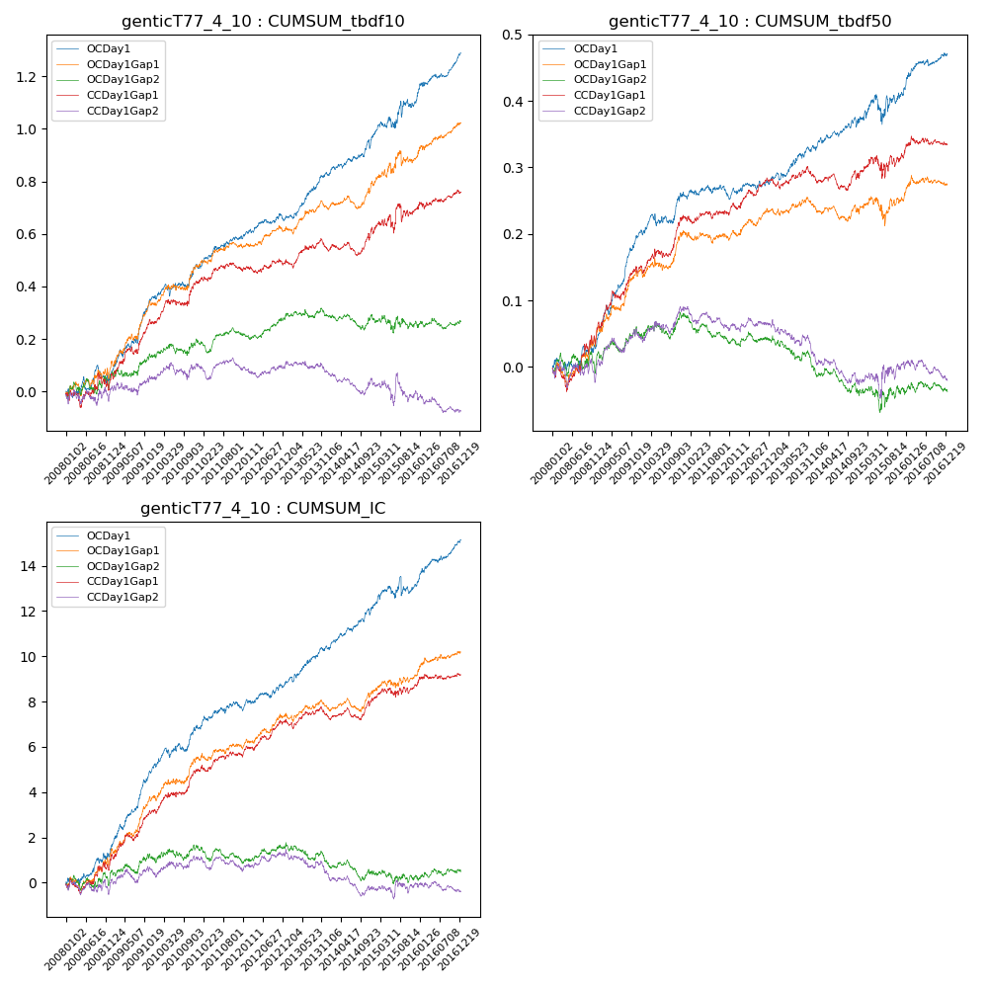

**因子换手率:** 51.59%

**截面指标_OCDay1:**

|  |  |  |  |  |  |  |  |  |
| --- | --- | --- | --- | --- | --- | --- | --- | --- |
| year | annret_tbdf10 | sharpe_tbdf10 | maxdd_tbdf10 | annret_tbdf50 | sharpe_tbdf50 | maxdd_tbdf50 | mean_IC | tstat_IC |
| 2008 | 0.06 | 0.7 | -0.07 | 0.04 | 1.01 | -0.02 | 0.01 | 1.93 |
| 2009 | 0.3 | 4.82 | -0.03 | 0.17 | 6.15 | -0.01 | 0.02 | 6.16 |
| 2010 | 0.11 | 1.74 | -0.04 | 0.05 | 1.85 | -0.02 | 0.01 | 2.38 |
| 2011 | 0.11 | 2.74 | -0.01 | -0.0 | -0.08 | -0.02 | 0.0 | 1.55 |
| 2012 | 0.08 | 1.91 | -0.03 | 0.03 | 1.52 | -0.01 | 0.0 | 2.25 |
| 2013 | 0.17 | 3.78 | -0.01 | 0.05 | 2.14 | -0.01 | 0.01 | 3.02 |
| 2014 | 0.14 | 2.98 | -0.03 | 0.04 | 1.63 | -0.01 | 0.01 | 3.28 |
| 2015 | 0.14 | 1.37 | -0.06 | 0.04 | 0.86 | -0.04 | 0.0 | 0.92 |
| 2016 | 0.18 | 3.87 | -0.02 | 0.06 | 2.93 | -0.01 | 0.01 | 4.03 |

**截面指标_CCDay1Gap1:**

|  |  |  |  |  |  |  |  |  |
| --- | --- | --- | --- | --- | --- | --- | --- | --- |
| year | annret_tbdf10 | sharpe_tbdf10 | maxdd_tbdf10 | annret_tbdf50 | sharpe_tbdf50 | maxdd_tbdf50 | mean_IC | tstat_IC |
| 2008 | 0.04 | 0.48 | -0.07 | 0.06 | 1.42 | -0.04 | 0.0 | 1.27 |
| 2009 | 0.22 | 3.33 | -0.03 | 0.1 | 3.37 | -0.01 | 0.01 | 3.72 |
| 2010 | 0.15 | 2.54 | -0.03 | 0.08 | 2.71 | -0.01 | 0.01 | 3.07 |
| 2011 | 0.04 | 1.06 | -0.03 | 0.0 | 0.26 | -0.01 | 0.0 | 1.32 |
| 2012 | 0.04 | 0.89 | -0.03 | 0.05 | 2.67 | -0.01 | 0.01 | 3.22 |
| 2013 | 0.04 | 0.82 | -0.05 | 0.0 | 0.1 | -0.02 | 0.0 | 0.28 |
| 2014 | 0.07 | 1.43 | -0.05 | 0.0 | 0.16 | -0.03 | 0.0 | 1.65 |
| 2015 | 0.09 | 0.84 | -0.07 | 0.03 | 0.54 | -0.03 | 0.0 | 0.88 |
| 2016 | 0.06 | 1.3 | -0.03 | 0.02 | 0.99 | -0.01 | 0.0 | 1.11 |

**风格暴露:**

|  |  |  |  |  |
| --- | --- | --- | --- | --- |
|  | long | short | corr_OCDay1 | corr_CCDay1Gap1 |
| liquidity10 | 0.02 | -0.02 | -0.04 | -0.04 |
| liquidity20 | 0.0 | -0.01 | -0.02 | -0.02 |
| liquidity5 | 0.03 | -0.04 | -0.06 | -0.02 |
| logmktcap | -0.0 | 0.01 | 0.0 | 0.03 |
| momentum15 | 0.09 | -0.09 | -0.1 | -0.05 |
| momentum30 | 0.05 | -0.05 | -0.11 | -0.05 |
| momentum5 | 0.11 | -0.1 | -0.17 | -0.08 |
| retvolatility30 | -0.0 | -0.01 | 0.0 | 0.01 |