Factors Report 20080102-20161230

**1. genticT77_4_15**

**截面指标累计曲线:**

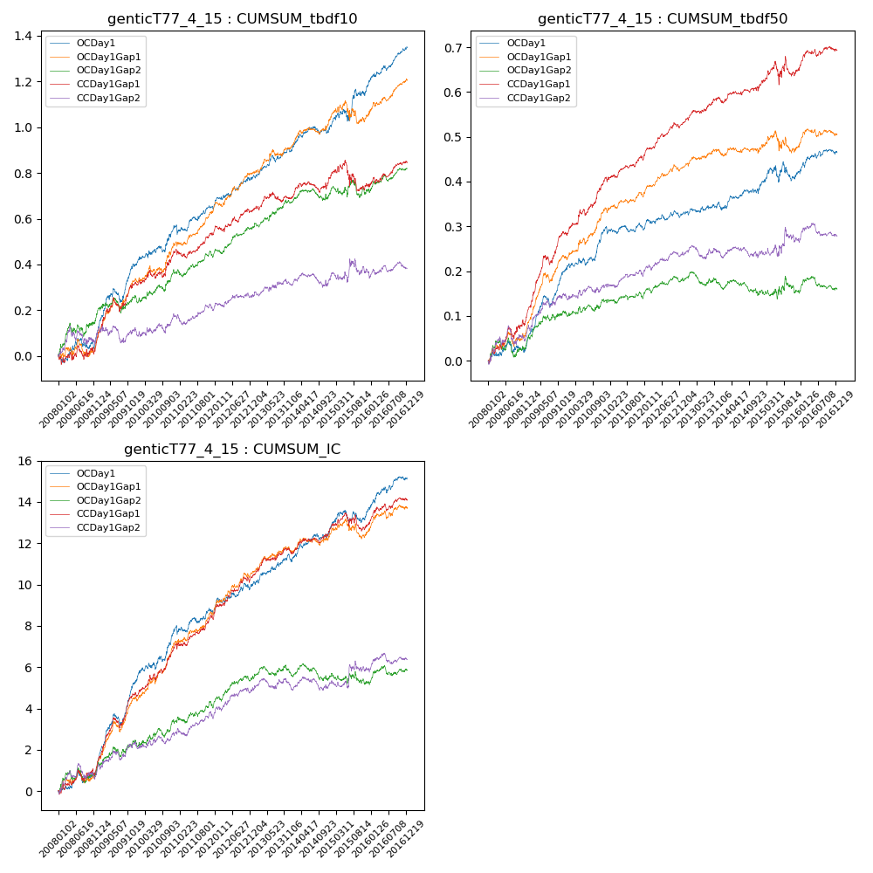

**因子换手率:** 47.85%

**截面指标_OCDay1:**

|  |  |  |  |  |  |  |  |  |
| --- | --- | --- | --- | --- | --- | --- | --- | --- |
| year | annret_tbdf10 | sharpe_tbdf10 | maxdd_tbdf10 | annret_tbdf50 | sharpe_tbdf50 | maxdd_tbdf50 | mean_IC | tstat_IC |
| 2008 | 0.1 | 1.32 | -0.05 | 0.04 | 1.21 | -0.03 | 0.0 | 1.78 |
| 2009 | 0.31 | 4.52 | -0.06 | 0.16 | 5.47 | -0.03 | 0.02 | 6.07 |
| 2010 | 0.17 | 2.52 | -0.03 | 0.09 | 2.84 | -0.02 | 0.01 | 3.47 |
| 2011 | 0.08 | 1.7 | -0.04 | -0.0 | -0.0 | -0.02 | 0.0 | 1.28 |
| 2012 | 0.13 | 2.88 | -0.01 | 0.03 | 1.6 | -0.02 | 0.01 | 2.24 |
| 2013 | 0.12 | 2.69 | -0.03 | 0.02 | 0.78 | -0.01 | 0.01 | 2.39 |
| 2014 | 0.09 | 1.98 | -0.03 | 0.04 | 1.55 | -0.01 | 0.01 | 2.29 |
| 2015 | 0.2 | 2.12 | -0.05 | 0.04 | 0.86 | -0.04 | 0.0 | 1.63 |
| 2016 | 0.16 | 3.62 | -0.02 | 0.04 | 1.86 | -0.01 | 0.01 | 2.66 |

**截面指标_CCDay1Gap1:**

|  |  |  |  |  |  |  |  |  |
| --- | --- | --- | --- | --- | --- | --- | --- | --- |
| year | annret_tbdf10 | sharpe_tbdf10 | maxdd_tbdf10 | annret_tbdf50 | sharpe_tbdf50 | maxdd_tbdf50 | mean_IC | tstat_IC |
| 2008 | 0.08 | 0.89 | -0.06 | 0.11 | 2.6 | -0.03 | 0.01 | 1.8 |
| 2009 | 0.24 | 3.45 | -0.06 | 0.18 | 5.45 | -0.02 | 0.01 | 4.76 |
| 2010 | 0.14 | 2.15 | -0.04 | 0.13 | 4.1 | -0.01 | 0.01 | 3.94 |
| 2011 | 0.09 | 1.85 | -0.04 | 0.05 | 2.18 | -0.01 | 0.01 | 2.55 |
| 2012 | 0.1 | 2.14 | -0.03 | 0.08 | 3.94 | -0.01 | 0.01 | 3.6 |
| 2013 | 0.06 | 1.15 | -0.04 | 0.06 | 2.7 | -0.01 | 0.01 | 2.55 |
| 2014 | 0.09 | 1.7 | -0.05 | 0.03 | 1.35 | -0.01 | 0.0 | 2.07 |
| 2015 | -0.03 | -0.3 | -0.13 | 0.03 | 0.71 | -0.05 | 0.0 | 0.4 |
| 2016 | 0.1 | 1.98 | -0.02 | 0.05 | 1.91 | -0.02 | 0.0 | 2.38 |

**风格暴露:**

|  |  |  |  |  |
| --- | --- | --- | --- | --- |
|  | long | short | corr_OCDay1 | corr_CCDay1Gap1 |
| liquidity10 | 0.05 | -0.06 | -0.06 | -0.13 |
| liquidity20 | 0.02 | -0.03 | -0.02 | -0.1 |
| liquidity5 | 0.07 | -0.08 | -0.09 | -0.16 |
| logmktcap | -0.0 | 0.01 | -0.08 | 0.02 |
| momentum15 | 0.17 | -0.16 | -0.26 | -0.26 |
| momentum30 | 0.11 | -0.11 | -0.2 | -0.15 |
| momentum5 | 0.18 | -0.17 | -0.23 | -0.17 |
| retvolatility30 | 0.02 | -0.02 | 0.02 | -0.07 |