Factors Report 20080102-20161230

**1. genticT77_4_20**

**截面指标累计曲线:**

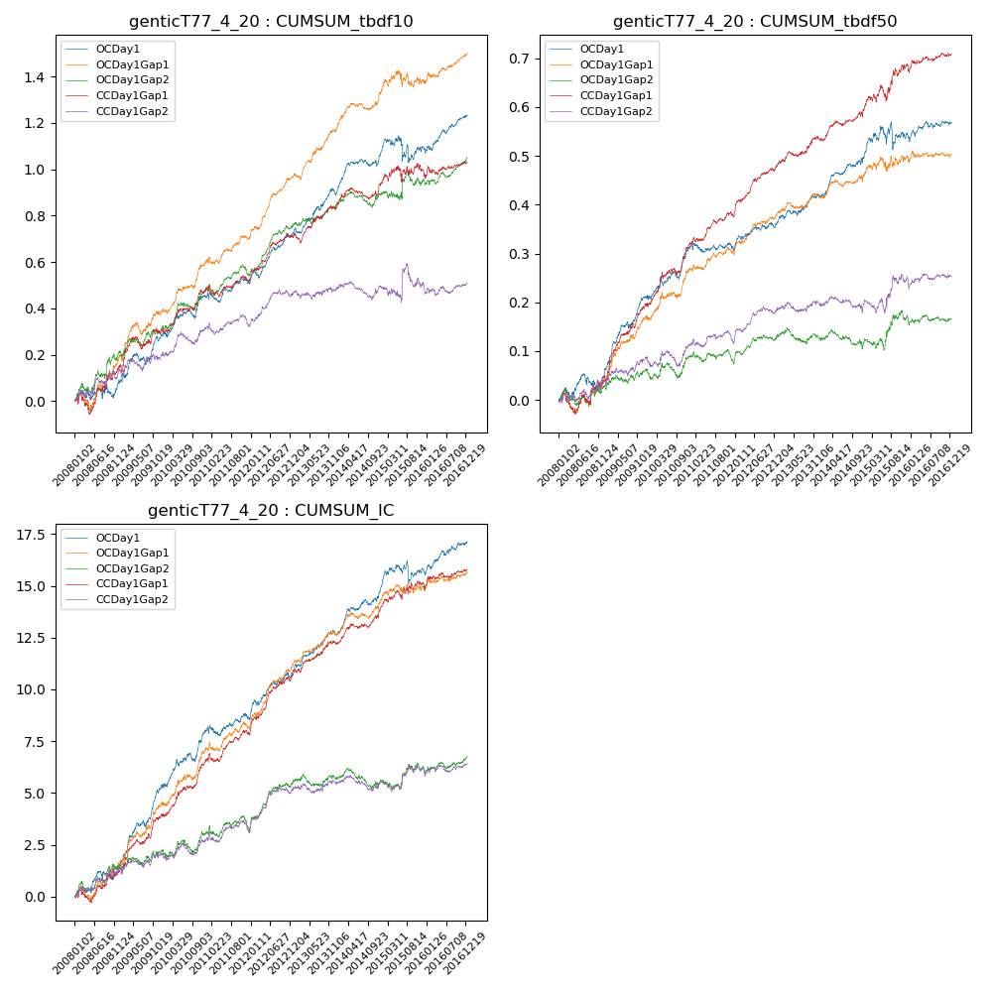

**因子换手率:** 45.67%

**截面指标_OCDay1:**

|  |  |  |  |  |  |  |  |  |
| --- | --- | --- | --- | --- | --- | --- | --- | --- |
| year | annret_tbdf10 | sharpe_tbdf10 | maxdd_tbdf10 | annret_tbdf50 | sharpe_tbdf50 | maxdd_tbdf50 | mean_IC | tstat_IC |
| 2008 | 0.09 | 1.07 | -0.05 | 0.05 | 1.31 | -0.03 | 0.01 | 2.01 |
| 2009 | 0.2 | 2.86 | -0.05 | 0.16 | 5.61 | -0.01 | 0.02 | 5.58 |
| 2010 | 0.17 | 2.79 | -0.04 | 0.11 | 3.34 | -0.02 | 0.01 | 3.87 |
| 2011 | 0.06 | 1.18 | -0.04 | -0.01 | -0.25 | -0.02 | 0.0 | 0.86 |
| 2012 | 0.22 | 4.79 | -0.03 | 0.06 | 2.47 | -0.01 | 0.01 | 3.82 |
| 2013 | 0.17 | 3.37 | -0.03 | 0.06 | 2.4 | -0.01 | 0.01 | 3.27 |
| 2014 | 0.17 | 3.54 | -0.03 | 0.08 | 3.17 | -0.01 | 0.01 | 3.67 |
| 2015 | 0.04 | 0.34 | -0.11 | 0.05 | 0.95 | -0.06 | 0.0 | 1.12 |
| 2016 | 0.14 | 3.01 | -0.03 | 0.02 | 1.12 | -0.01 | 0.01 | 2.52 |

**截面指标_CCDay1Gap1:**

|  |  |  |  |  |  |  |  |  |
| --- | --- | --- | --- | --- | --- | --- | --- | --- |
| year | annret_tbdf10 | sharpe_tbdf10 | maxdd_tbdf10 | annret_tbdf50 | sharpe_tbdf50 | maxdd_tbdf50 | mean_IC | tstat_IC |
| 2008 | 0.15 | 1.68 | -0.09 | 0.04 | 0.88 | -0.04 | 0.01 | 1.62 |
| 2009 | 0.15 | 2.1 | -0.05 | 0.15 | 4.82 | -0.01 | 0.01 | 3.89 |
| 2010 | 0.19 | 3.37 | -0.02 | 0.13 | 4.25 | -0.01 | 0.01 | 4.51 |
| 2011 | 0.03 | 0.67 | -0.05 | 0.05 | 2.42 | -0.01 | 0.01 | 2.13 |
| 2012 | 0.19 | 4.03 | -0.02 | 0.1 | 5.02 | -0.01 | 0.01 | 5.25 |
| 2013 | 0.13 | 2.54 | -0.04 | 0.06 | 2.34 | -0.01 | 0.01 | 2.83 |
| 2014 | 0.1 | 2.02 | -0.05 | 0.06 | 2.71 | -0.01 | 0.01 | 3.26 |
| 2015 | 0.06 | 0.59 | -0.07 | 0.09 | 2.09 | -0.03 | 0.01 | 1.9 |
| 2016 | 0.04 | 0.78 | -0.04 | 0.02 | 1.08 | -0.01 | 0.0 | 1.47 |

**风格暴露:**

|  |  |  |  |  |
| --- | --- | --- | --- | --- |
|  | long | short | corr_OCDay1 | corr_CCDay1Gap1 |
| liquidity10 | 0.08 | -0.09 | -0.15 | -0.12 |
| liquidity20 | 0.05 | -0.05 | -0.12 | -0.09 |
| liquidity5 | 0.11 | -0.11 | -0.19 | -0.15 |
| logmktcap | -0.01 | 0.01 | 0.03 | 0.01 |
| momentum15 | 0.2 | -0.2 | -0.31 | -0.25 |
| momentum30 | 0.16 | -0.15 | -0.27 | -0.17 |
| momentum5 | 0.22 | -0.21 | -0.32 | -0.21 |
| retvolatility30 | 0.03 | -0.03 | -0.06 | -0.05 |