Factors Report 20080102-20161230

**1. genticT77_4_25**

**截面指标累计曲线:**

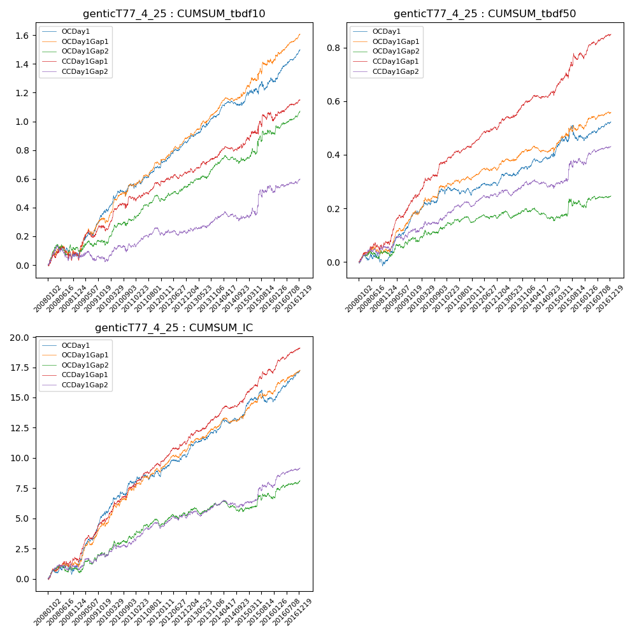

**因子换手率:** 44.4%

**截面指标_OCDay1:**

|  |  |  |  |  |  |  |  |  |
| --- | --- | --- | --- | --- | --- | --- | --- | --- |
| year | annret_tbdf10 | sharpe_tbdf10 | maxdd_tbdf10 | annret_tbdf50 | sharpe_tbdf50 | maxdd_tbdf50 | mean_IC | tstat_IC |
| 2008 | 0.07 | 0.92 | -0.08 | 0.0 | 0.1 | -0.05 | 0.0 | 1.33 |
| 2009 | 0.3 | 4.15 | -0.02 | 0.18 | 5.54 | -0.01 | 0.02 | 5.95 |
| 2010 | 0.19 | 2.72 | -0.04 | 0.08 | 2.41 | -0.01 | 0.01 | 3.32 |
| 2011 | 0.13 | 2.59 | -0.03 | -0.02 | -0.58 | -0.03 | 0.0 | 0.83 |
| 2012 | 0.18 | 4.24 | -0.01 | 0.05 | 2.23 | -0.01 | 0.01 | 3.23 |
| 2013 | 0.17 | 3.47 | -0.02 | 0.06 | 2.28 | -0.01 | 0.01 | 3.26 |
| 2014 | 0.09 | 2.04 | -0.03 | 0.04 | 1.44 | -0.02 | 0.0 | 2.11 |
| 2015 | 0.16 | 1.85 | -0.06 | 0.06 | 1.22 | -0.06 | 0.01 | 1.5 |
| 2016 | 0.21 | 4.48 | -0.02 | 0.06 | 2.69 | -0.01 | 0.01 | 4.28 |

**截面指标_CCDay1Gap1:**

|  |  |  |  |  |  |  |  |  |
| --- | --- | --- | --- | --- | --- | --- | --- | --- |
| year | annret_tbdf10 | sharpe_tbdf10 | maxdd_tbdf10 | annret_tbdf50 | sharpe_tbdf50 | maxdd_tbdf50 | mean_IC | tstat_IC |
| 2008 | 0.08 | 1.01 | -0.09 | 0.07 | 2.2 | -0.03 | 0.01 | 2.62 |
| 2009 | 0.18 | 2.44 | -0.05 | 0.17 | 4.94 | -0.01 | 0.01 | 4.4 |
| 2010 | 0.21 | 3.02 | -0.04 | 0.12 | 3.8 | -0.01 | 0.01 | 4.13 |
| 2011 | 0.08 | 1.69 | -0.03 | 0.06 | 2.64 | -0.01 | 0.01 | 3.14 |
| 2012 | 0.09 | 2.14 | -0.03 | 0.08 | 3.93 | -0.01 | 0.01 | 4.13 |
| 2013 | 0.11 | 2.16 | -0.03 | 0.09 | 3.41 | -0.01 | 0.01 | 3.34 |
| 2014 | 0.08 | 1.7 | -0.03 | 0.03 | 1.32 | -0.02 | 0.01 | 2.72 |
| 2015 | 0.2 | 1.67 | -0.06 | 0.13 | 2.81 | -0.02 | 0.01 | 3.53 |
| 2016 | 0.12 | 2.2 | -0.03 | 0.08 | 3.47 | -0.01 | 0.01 | 3.97 |

**风格暴露:**

|  |  |  |  |  |
| --- | --- | --- | --- | --- |
|  | long | short | corr_OCDay1 | corr_CCDay1Gap1 |
| liquidity10 | 0.1 | -0.1 | -0.17 | -0.18 |
| liquidity20 | 0.07 | -0.07 | -0.15 | -0.16 |
| liquidity5 | 0.13 | -0.13 | -0.2 | -0.19 |
| logmktcap | -0.0 | 0.01 | 0.03 | 0.06 |
| momentum15 | 0.22 | -0.21 | -0.24 | -0.26 |
| momentum30 | 0.22 | -0.21 | -0.23 | -0.2 |
| momentum5 | 0.24 | -0.23 | -0.25 | -0.18 |
| retvolatility30 | 0.04 | -0.04 | -0.11 | -0.11 |