Factors Report 20080102-20161230

**1. genticT77_4_30**

**截面指标累计曲线:**

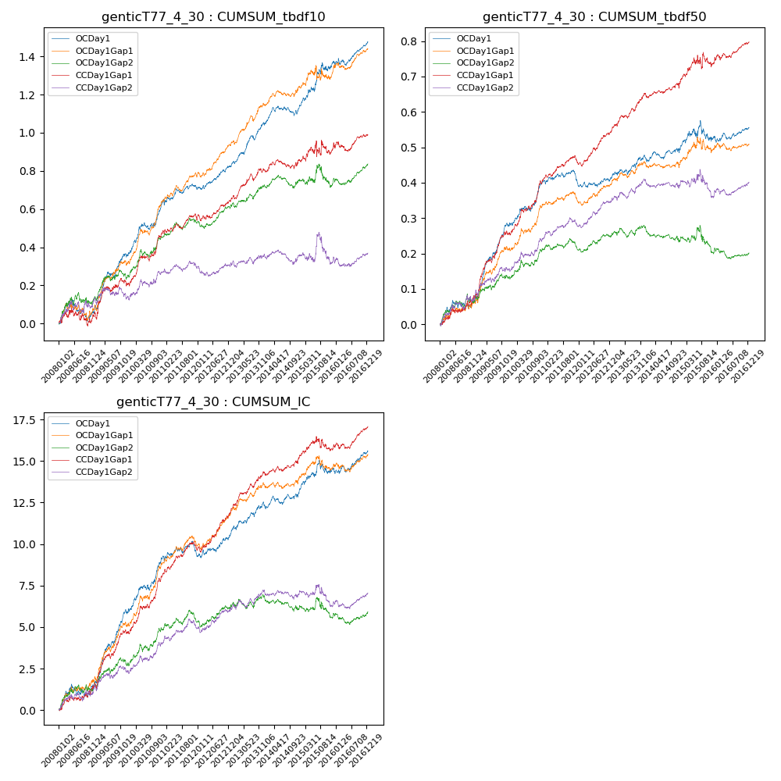

**因子换手率:** 43.32%

**截面指标_OCDay1:**

|  |  |  |  |  |  |  |  |  |
| --- | --- | --- | --- | --- | --- | --- | --- | --- |
| year | annret_tbdf10 | sharpe_tbdf10 | maxdd_tbdf10 | annret_tbdf50 | sharpe_tbdf50 | maxdd_tbdf50 | mean_IC | tstat_IC |
| 2008 | 0.06 | 0.76 | -0.12 | 0.07 | 1.63 | -0.02 | 0.01 | 1.79 |
| 2009 | 0.3 | 4.17 | -0.03 | 0.21 | 6.51 | -0.01 | 0.02 | 6.11 |
| 2010 | 0.27 | 4.09 | -0.04 | 0.12 | 3.65 | -0.01 | 0.01 | 4.02 |
| 2011 | 0.08 | 1.76 | -0.03 | -0.0 | -0.13 | -0.04 | 0.0 | 0.5 |
| 2012 | 0.11 | 2.64 | -0.02 | 0.02 | 0.75 | -0.02 | 0.0 | 1.97 |
| 2013 | 0.23 | 4.42 | -0.02 | 0.06 | 1.98 | -0.01 | 0.01 | 2.83 |
| 2014 | 0.08 | 1.9 | -0.05 | 0.02 | 0.8 | -0.02 | 0.0 | 1.18 |
| 2015 | 0.25 | 2.93 | -0.04 | 0.04 | 0.75 | -0.06 | 0.01 | 1.9 |
| 2016 | 0.1 | 2.29 | -0.04 | 0.02 | 1.08 | -0.02 | 0.0 | 1.89 |

**截面指标_CCDay1Gap1:**

|  |  |  |  |  |  |  |  |  |
| --- | --- | --- | --- | --- | --- | --- | --- | --- |
| year | annret_tbdf10 | sharpe_tbdf10 | maxdd_tbdf10 | annret_tbdf50 | sharpe_tbdf50 | maxdd_tbdf50 | mean_IC | tstat_IC |
| 2008 | 0.04 | 0.49 | -0.09 | 0.08 | 2.07 | -0.02 | 0.01 | 2.02 |
| 2009 | 0.16 | 2.16 | -0.04 | 0.17 | 4.86 | -0.01 | 0.01 | 4.28 |
| 2010 | 0.28 | 4.2 | -0.03 | 0.16 | 4.82 | -0.01 | 0.01 | 4.79 |
| 2011 | 0.07 | 1.63 | -0.03 | 0.05 | 2.1 | -0.02 | 0.01 | 2.98 |
| 2012 | 0.1 | 2.06 | -0.03 | 0.09 | 3.99 | -0.01 | 0.01 | 3.91 |
| 2013 | 0.17 | 3.16 | -0.04 | 0.11 | 3.9 | -0.01 | 0.01 | 4.11 |
| 2014 | 0.05 | 1.01 | -0.05 | 0.03 | 1.38 | -0.01 | 0.0 | 1.72 |
| 2015 | 0.08 | 0.6 | -0.08 | 0.06 | 1.11 | -0.04 | 0.0 | 0.76 |
| 2016 | 0.05 | 0.97 | -0.05 | 0.05 | 2.07 | -0.02 | 0.0 | 2.38 |

**风格暴露:**

|  |  |  |  |  |
| --- | --- | --- | --- | --- |
|  | long | short | corr_OCDay1 | corr_CCDay1Gap1 |
| liquidity10 | 0.11 | -0.11 | -0.23 | -0.23 |
| liquidity20 | 0.08 | -0.08 | -0.18 | -0.2 |
| liquidity5 | 0.14 | -0.14 | -0.26 | -0.21 |
| logmktcap | -0.0 | 0.01 | -0.01 | 0.1 |
| momentum15 | 0.23 | -0.22 | -0.33 | -0.29 |
| momentum30 | 0.25 | -0.25 | -0.28 | -0.22 |
| momentum5 | 0.26 | -0.26 | -0.31 | -0.22 |
| retvolatility30 | 0.08 | -0.07 | -0.13 | -0.15 |