Factors Report 20080102-20161230

**1. genticT77_4_5**

**截面指标累计曲线:**

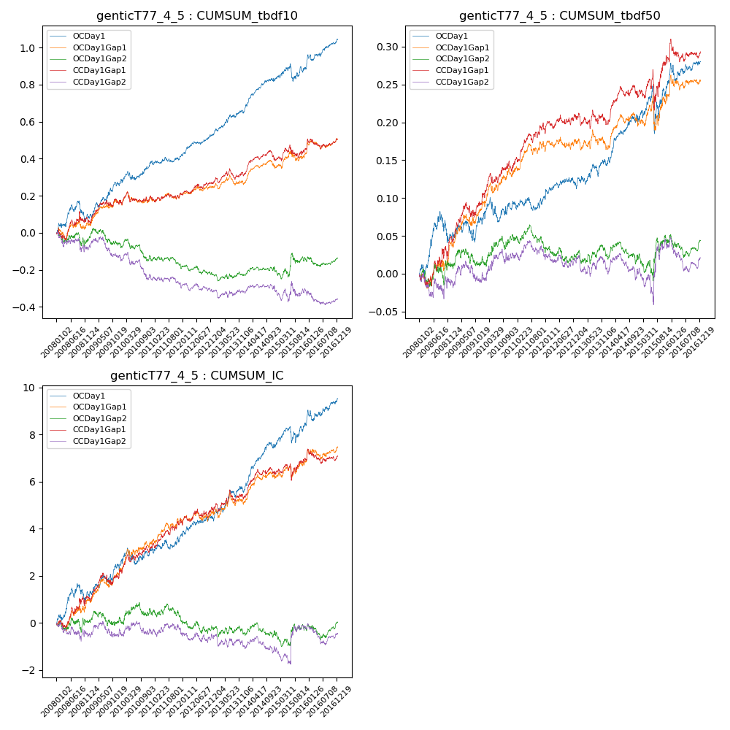

**因子换手率:** 65.95%

**截面指标_OCDay1:**

|  |  |  |  |  |  |  |  |  |
| --- | --- | --- | --- | --- | --- | --- | --- | --- |
| year | annret_tbdf10 | sharpe_tbdf10 | maxdd_tbdf10 | annret_tbdf50 | sharpe_tbdf50 | maxdd_tbdf50 | mean_IC | tstat_IC |
| 2008 | 0.08 | 0.97 | -0.1 | 0.05 | 1.32 | -0.04 | 0.0 | 1.59 |
| 2009 | 0.18 | 2.79 | -0.03 | 0.02 | 0.67 | -0.03 | 0.0 | 1.75 |
| 2010 | 0.12 | 1.86 | -0.05 | 0.02 | 0.74 | -0.03 | 0.0 | 1.0 |
| 2011 | 0.04 | 1.0 | -0.03 | 0.01 | 0.53 | -0.02 | 0.0 | 1.22 |
| 2012 | 0.11 | 2.7 | -0.02 | 0.01 | 0.8 | -0.01 | 0.0 | 1.24 |
| 2013 | 0.13 | 2.64 | -0.02 | 0.03 | 1.26 | -0.02 | 0.0 | 2.15 |
| 2014 | 0.17 | 3.99 | -0.02 | 0.06 | 3.12 | -0.01 | 0.01 | 3.91 |
| 2015 | 0.06 | 0.8 | -0.09 | 0.05 | 1.02 | -0.06 | 0.0 | 1.19 |
| 2016 | 0.16 | 2.92 | -0.03 | 0.03 | 1.16 | -0.02 | 0.0 | 2.01 |

**截面指标_CCDay1Gap1:**

|  |  |  |  |  |  |  |  |  |
| --- | --- | --- | --- | --- | --- | --- | --- | --- |
| year | annret_tbdf10 | sharpe_tbdf10 | maxdd_tbdf10 | annret_tbdf50 | sharpe_tbdf50 | maxdd_tbdf50 | mean_IC | tstat_IC |
| 2008 | 0.06 | 0.61 | -0.06 | 0.05 | 1.28 | -0.02 | 0.0 | 1.36 |
| 2009 | 0.12 | 1.85 | -0.04 | 0.06 | 2.0 | -0.02 | 0.0 | 1.87 |
| 2010 | 0.03 | 0.43 | -0.05 | 0.04 | 1.52 | -0.01 | 0.0 | 1.83 |
| 2011 | 0.01 | 0.19 | -0.03 | 0.05 | 2.35 | -0.01 | 0.0 | 2.09 |
| 2012 | 0.06 | 1.43 | -0.03 | 0.02 | 0.76 | -0.01 | 0.0 | 0.95 |
| 2013 | 0.04 | 0.87 | -0.06 | -0.01 | -0.32 | -0.02 | 0.0 | 0.94 |
| 2014 | 0.08 | 1.74 | -0.06 | 0.03 | 1.61 | -0.02 | 0.0 | 2.16 |
| 2015 | 0.06 | 0.77 | -0.07 | 0.05 | 0.85 | -0.05 | 0.0 | 0.65 |
| 2016 | 0.05 | 1.02 | -0.05 | 0.01 | 0.58 | -0.03 | 0.0 | 0.43 |

**风格暴露:**

|  |  |  |  |  |
| --- | --- | --- | --- | --- |
|  | long | short | corr_OCDay1 | corr_CCDay1Gap1 |
| liquidity10 | -0.01 | -0.01 | -0.03 | -0.03 |
| liquidity20 | -0.01 | -0.0 | -0.02 | -0.01 |
| liquidity5 | -0.02 | -0.0 | -0.02 | 0.01 |
| logmktcap | 0.0 | 0.0 | 0.04 | 0.04 |
| momentum15 | -0.0 | 0.0 | -0.03 | -0.04 |
| momentum30 | -0.0 | -0.0 | -0.03 | -0.04 |
| momentum5 | 0.01 | -0.01 | -0.03 | 0.0 |
| retvolatility30 | -0.01 | -0.01 | -0.03 | -0.02 |