Factors Report 20080102-20161230

**1. genticT7_7**

**截面指标累计曲线:**

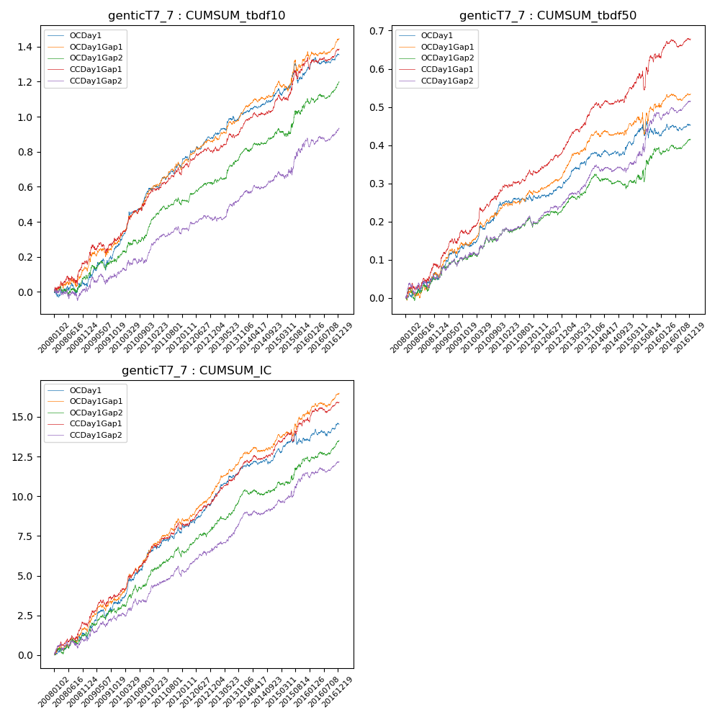

**因子换手率:** 45.35%

**截面指标_OCDay1:**

|  |  |  |  |  |  |  |  |  |
| --- | --- | --- | --- | --- | --- | --- | --- | --- |
| year | annret_tbdf10 | sharpe_tbdf10 | maxdd_tbdf10 | annret_tbdf50 | sharpe_tbdf50 | maxdd_tbdf50 | mean_IC | tstat_IC |
| 2008 | 0.04 | 0.55 | -0.06 | 0.05 | 1.39 | -0.02 | 0.0 | 1.7 |
| 2009 | 0.22 | 2.99 | -0.06 | 0.09 | 3.05 | -0.02 | 0.01 | 3.16 |
| 2010 | 0.33 | 5.21 | -0.02 | 0.11 | 4.04 | -0.01 | 0.01 | 5.09 |
| 2011 | 0.12 | 2.85 | -0.03 | 0.01 | 0.58 | -0.02 | 0.0 | 2.31 |
| 2012 | 0.16 | 3.86 | -0.02 | 0.04 | 2.19 | -0.01 | 0.01 | 3.72 |
| 2013 | 0.15 | 2.98 | -0.03 | 0.08 | 3.94 | -0.01 | 0.01 | 5.03 |
| 2014 | 0.11 | 2.75 | -0.01 | 0.02 | 0.79 | -0.02 | 0.0 | 1.78 |
| 2015 | 0.14 | 1.51 | -0.11 | 0.03 | 0.75 | -0.04 | 0.0 | 1.22 |
| 2016 | 0.08 | 1.95 | -0.04 | 0.02 | 1.08 | -0.02 | 0.0 | 2.06 |

**截面指标_CCDay1Gap1:**

|  |  |  |  |  |  |  |  |  |
| --- | --- | --- | --- | --- | --- | --- | --- | --- |
| year | annret_tbdf10 | sharpe_tbdf10 | maxdd_tbdf10 | annret_tbdf50 | sharpe_tbdf50 | maxdd_tbdf50 | mean_IC | tstat_IC |
| 2008 | 0.17 | 1.99 | -0.05 | 0.09 | 2.3 | -0.02 | 0.01 | 2.86 |
| 2009 | 0.13 | 1.86 | -0.06 | 0.08 | 2.84 | -0.01 | 0.01 | 2.8 |
| 2010 | 0.26 | 3.93 | -0.02 | 0.11 | 4.0 | -0.01 | 0.01 | 4.55 |
| 2011 | 0.11 | 2.44 | -0.04 | 0.04 | 2.14 | -0.01 | 0.01 | 3.0 |
| 2012 | 0.13 | 2.94 | -0.03 | 0.07 | 3.53 | -0.01 | 0.01 | 3.43 |
| 2013 | 0.17 | 3.35 | -0.02 | 0.12 | 5.4 | -0.01 | 0.01 | 5.29 |
| 2014 | 0.14 | 3.2 | -0.02 | 0.03 | 1.2 | -0.01 | 0.0 | 2.37 |
| 2015 | 0.23 | 2.67 | -0.05 | 0.1 | 1.95 | -0.05 | 0.01 | 2.35 |
| 2016 | 0.06 | 1.15 | -0.07 | 0.04 | 2.06 | -0.02 | 0.0 | 2.36 |

**风格暴露:**

|  |  |  |  |  |
| --- | --- | --- | --- | --- |
|  | long | short | corr_OCDay1 | corr_CCDay1Gap1 |
| liquidity10 | 0.05 | -0.05 | -0.06 | -0.03 |
| liquidity20 | 0.02 | -0.02 | -0.06 | -0.01 |
| liquidity5 | 0.05 | -0.05 | -0.07 | -0.0 |
| logmktcap | 0.01 | 0.0 | 0.04 | 0.0 |
| momentum15 | 0.13 | -0.12 | -0.11 | -0.09 |
| momentum30 | 0.06 | -0.05 | -0.09 | 0.0 |
| momentum5 | 0.07 | -0.06 | -0.12 | -0.06 |
| retvolatility30 | 0.02 | -0.02 | -0.04 | 0.02 |