Factors Report 20080102-20161230

**1. genticT80_5_5**

**截面指标累计曲线:**

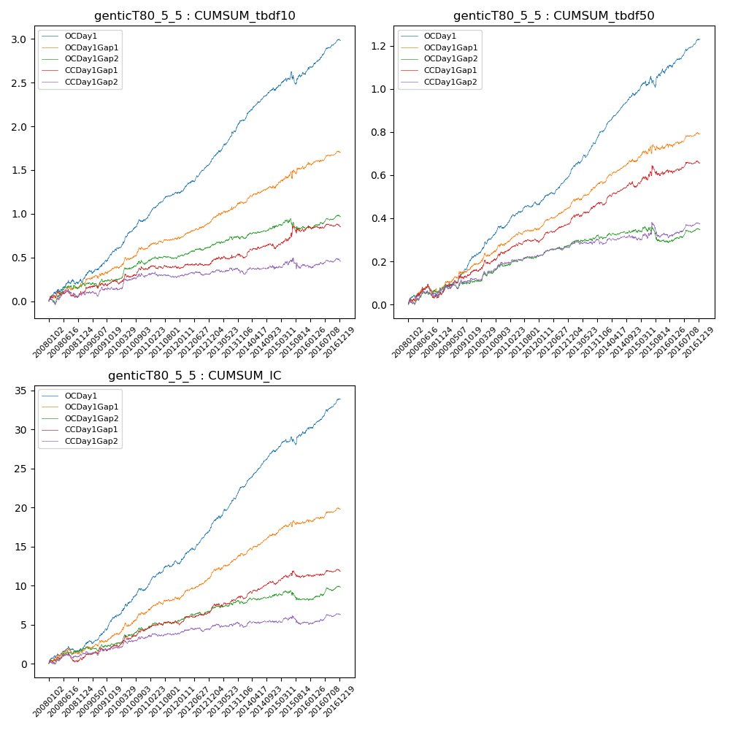

**因子换手率:** 57.25%

**截面指标_OCDay1:**

|  |  |  |  |  |  |  |  |  |
| --- | --- | --- | --- | --- | --- | --- | --- | --- |
| year | annret_tbdf10 | sharpe_tbdf10 | maxdd_tbdf10 | annret_tbdf50 | sharpe_tbdf50 | maxdd_tbdf50 | mean_IC | tstat_IC |
| 2008 | 0.22 | 2.22 | -0.06 | 0.05 | 1.14 | -0.06 | 0.01 | 1.96 |
| 2009 | 0.35 | 4.58 | -0.04 | 0.18 | 5.38 | -0.02 | 0.02 | 5.26 |
| 2010 | 0.38 | 4.94 | -0.02 | 0.14 | 4.33 | -0.01 | 0.02 | 4.36 |
| 2011 | 0.31 | 5.45 | -0.02 | 0.1 | 3.98 | -0.01 | 0.01 | 4.51 |
| 2012 | 0.35 | 5.74 | -0.02 | 0.15 | 6.15 | -0.01 | 0.02 | 6.29 |
| 2013 | 0.49 | 6.38 | -0.02 | 0.2 | 6.7 | -0.01 | 0.02 | 6.71 |
| 2014 | 0.34 | 5.46 | -0.03 | 0.17 | 7.13 | -0.01 | 0.02 | 7.12 |
| 2015 | 0.24 | 2.04 | -0.14 | 0.13 | 2.59 | -0.05 | 0.01 | 3.02 |
| 2016 | 0.33 | 5.43 | -0.02 | 0.13 | 4.97 | -0.01 | 0.02 | 5.72 |

**截面指标_CCDay1Gap1:**

|  |  |  |  |  |  |  |  |  |
| --- | --- | --- | --- | --- | --- | --- | --- | --- |
| year | annret_tbdf10 | sharpe_tbdf10 | maxdd_tbdf10 | annret_tbdf50 | sharpe_tbdf50 | maxdd_tbdf50 | mean_IC | tstat_IC |
| 2008 | 0.09 | 0.92 | -0.09 | 0.05 | 1.12 | -0.06 | 0.0 | 0.75 |
| 2009 | 0.14 | 1.72 | -0.04 | 0.11 | 2.9 | -0.02 | 0.01 | 2.16 |
| 2010 | 0.14 | 1.85 | -0.05 | 0.09 | 2.53 | -0.02 | 0.01 | 2.64 |
| 2011 | 0.02 | 0.38 | -0.04 | 0.05 | 2.13 | -0.01 | 0.0 | 1.22 |
| 2012 | 0.04 | 0.79 | -0.03 | 0.09 | 4.08 | -0.01 | 0.01 | 2.69 |
| 2013 | 0.08 | 0.97 | -0.04 | 0.09 | 2.86 | -0.01 | 0.01 | 2.16 |
| 2014 | 0.1 | 1.46 | -0.06 | 0.08 | 2.92 | -0.03 | 0.01 | 2.8 |
| 2015 | 0.26 | 2.03 | -0.08 | 0.08 | 1.46 | -0.05 | 0.01 | 1.49 |
| 2016 | -0.01 | -0.1 | -0.04 | 0.03 | 1.22 | -0.02 | 0.0 | 0.8 |

**风格暴露:**

|  |  |  |  |  |
| --- | --- | --- | --- | --- |
|  | long | short | corr_OCDay1 | corr_CCDay1Gap1 |
| liquidity10 | 0.01 | -0.03 | -0.09 | -0.1 |
| liquidity20 | 0.0 | -0.02 | -0.09 | -0.11 |
| liquidity5 | 0.05 | -0.07 | -0.07 | -0.09 |
| logmktcap | -0.02 | 0.02 | 0.05 | 0.08 |
| momentum15 | 0.06 | -0.06 | -0.01 | 0.02 |
| momentum30 | 0.03 | -0.04 | -0.03 | 0.0 |
| momentum5 | 0.18 | -0.18 | -0.07 | -0.11 |
| retvolatility30 | -0.0 | -0.02 | -0.11 | -0.12 |