Factors Report 20080102-20161230

**1. genticT80_5_6**

**截面指标累计曲线:**

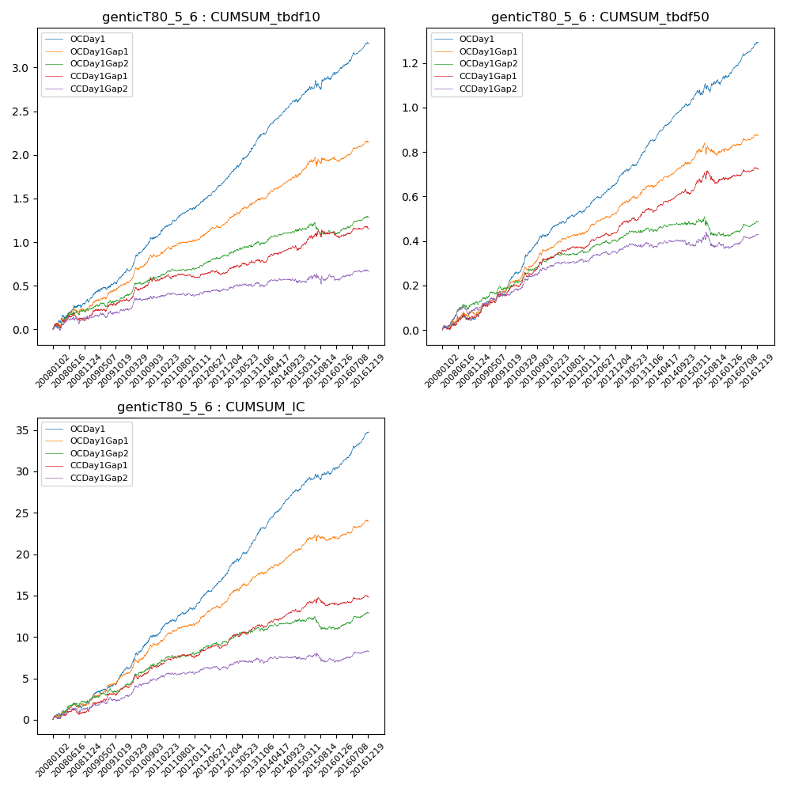

**因子换手率:** 59.25%

**截面指标_OCDay1:**

|  |  |  |  |  |  |  |  |  |
| --- | --- | --- | --- | --- | --- | --- | --- | --- |
| year | annret_tbdf10 | sharpe_tbdf10 | maxdd_tbdf10 | annret_tbdf50 | sharpe_tbdf50 | maxdd_tbdf50 | mean_IC | tstat_IC |
| 2008 | 0.31 | 3.18 | -0.04 | 0.06 | 1.54 | -0.03 | 0.01 | 2.31 |
| 2009 | 0.31 | 3.86 | -0.03 | 0.18 | 5.18 | -0.01 | 0.02 | 4.69 |
| 2010 | 0.46 | 5.62 | -0.03 | 0.19 | 5.4 | -0.01 | 0.02 | 5.16 |
| 2011 | 0.32 | 5.15 | -0.02 | 0.11 | 4.29 | -0.01 | 0.01 | 4.33 |
| 2012 | 0.36 | 5.91 | -0.01 | 0.14 | 6.03 | -0.01 | 0.02 | 6.51 |
| 2013 | 0.51 | 6.73 | -0.02 | 0.19 | 6.63 | -0.01 | 0.02 | 6.68 |
| 2014 | 0.37 | 5.98 | -0.03 | 0.15 | 6.68 | -0.01 | 0.02 | 7.26 |
| 2015 | 0.32 | 2.47 | -0.1 | 0.12 | 2.48 | -0.04 | 0.01 | 2.99 |
| 2016 | 0.35 | 5.27 | -0.03 | 0.16 | 5.77 | -0.01 | 0.02 | 6.36 |

**截面指标_CCDay1Gap1:**

|  |  |  |  |  |  |  |  |  |
| --- | --- | --- | --- | --- | --- | --- | --- | --- |
| year | annret_tbdf10 | sharpe_tbdf10 | maxdd_tbdf10 | annret_tbdf50 | sharpe_tbdf50 | maxdd_tbdf50 | mean_IC | tstat_IC |
| 2008 | 0.12 | 1.25 | -0.09 | 0.06 | 1.61 | -0.03 | 0.0 | 1.4 |
| 2009 | 0.21 | 2.56 | -0.03 | 0.14 | 3.81 | -0.01 | 0.01 | 3.63 |
| 2010 | 0.23 | 2.77 | -0.04 | 0.12 | 3.4 | -0.02 | 0.01 | 3.12 |
| 2011 | 0.05 | 0.84 | -0.05 | 0.05 | 2.26 | -0.01 | 0.01 | 2.0 |
| 2012 | 0.07 | 1.17 | -0.05 | 0.08 | 3.74 | -0.01 | 0.01 | 2.84 |
| 2013 | 0.11 | 1.41 | -0.03 | 0.09 | 2.97 | -0.02 | 0.01 | 2.51 |
| 2014 | 0.13 | 2.08 | -0.06 | 0.08 | 2.88 | -0.02 | 0.01 | 2.91 |
| 2015 | 0.2 | 1.63 | -0.07 | 0.07 | 1.37 | -0.06 | 0.0 | 1.24 |
| 2016 | 0.03 | 0.51 | -0.07 | 0.04 | 1.57 | -0.01 | 0.0 | 1.25 |

**风格暴露:**

|  |  |  |  |  |
| --- | --- | --- | --- | --- |
|  | long | short | corr_OCDay1 | corr_CCDay1Gap1 |
| liquidity10 | 0.02 | -0.04 | -0.11 | -0.09 |
| liquidity20 | 0.01 | -0.02 | -0.12 | -0.1 |
| liquidity5 | 0.06 | -0.09 | -0.08 | -0.07 |
| logmktcap | -0.02 | 0.02 | 0.07 | 0.06 |
| momentum15 | 0.07 | -0.08 | -0.01 | 0.05 |
| momentum30 | 0.04 | -0.04 | -0.03 | 0.04 |
| momentum5 | 0.18 | -0.18 | -0.03 | -0.04 |
| retvolatility30 | 0.0 | -0.03 | -0.12 | -0.13 |