Factors Report 20080102-20161230

**1. genticT80_5_8**

**截面指标累计曲线:**

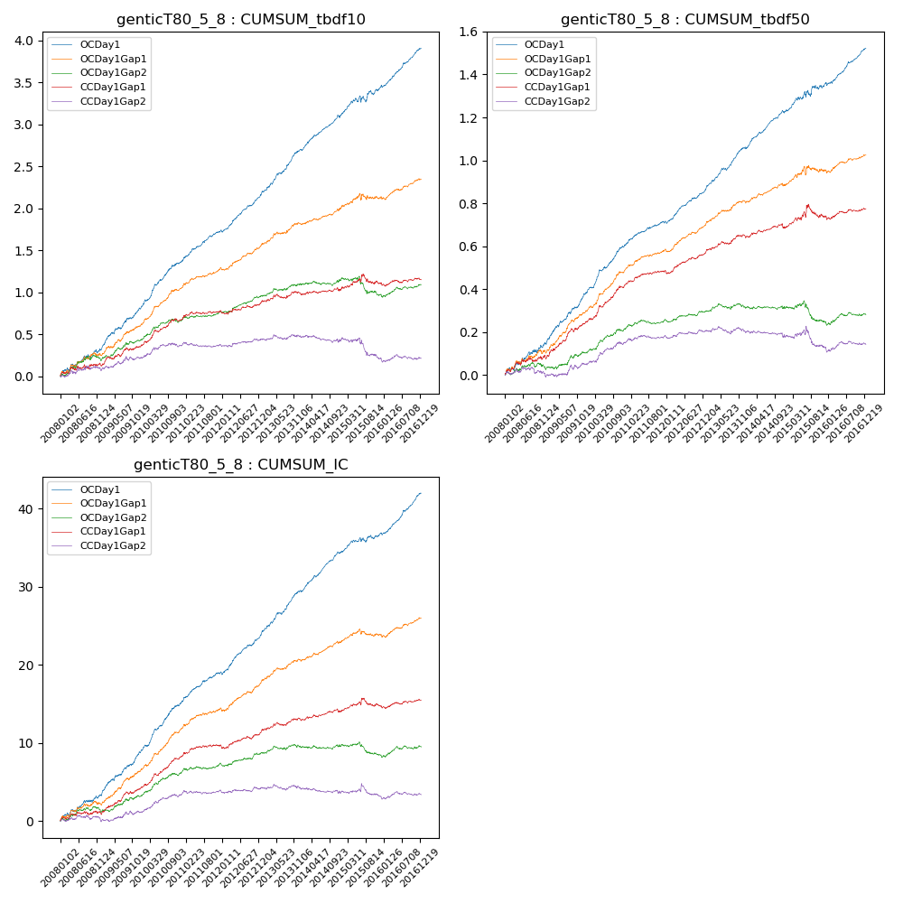

**因子换手率:** 55.46%

**截面指标_OCDay1:**

|  |  |  |  |  |  |  |  |  |
| --- | --- | --- | --- | --- | --- | --- | --- | --- |
| year | annret_tbdf10 | sharpe_tbdf10 | maxdd_tbdf10 | annret_tbdf50 | sharpe_tbdf50 | maxdd_tbdf50 | mean_IC | tstat_IC |
| 2008 | 0.31 | 2.96 | -0.04 | 0.15 | 3.24 | -0.02 | 0.01 | 3.49 |
| 2009 | 0.5 | 5.78 | -0.02 | 0.24 | 6.53 | -0.01 | 0.02 | 6.44 |
| 2010 | 0.55 | 6.69 | -0.02 | 0.23 | 6.82 | -0.01 | 0.02 | 7.21 |
| 2011 | 0.39 | 6.44 | -0.01 | 0.11 | 4.65 | -0.01 | 0.02 | 5.78 |
| 2012 | 0.43 | 7.09 | -0.03 | 0.15 | 6.68 | -0.01 | 0.02 | 6.75 |
| 2013 | 0.55 | 7.37 | -0.02 | 0.2 | 7.2 | -0.01 | 0.02 | 7.51 |
| 2014 | 0.41 | 6.59 | -0.03 | 0.17 | 6.86 | -0.01 | 0.02 | 7.67 |
| 2015 | 0.33 | 2.77 | -0.08 | 0.13 | 2.51 | -0.03 | 0.01 | 2.67 |
| 2016 | 0.46 | 7.32 | -0.03 | 0.16 | 6.31 | -0.01 | 0.02 | 7.75 |

**截面指标_CCDay1Gap1:**

|  |  |  |  |  |  |  |  |  |
| --- | --- | --- | --- | --- | --- | --- | --- | --- |
| year | annret_tbdf10 | sharpe_tbdf10 | maxdd_tbdf10 | annret_tbdf50 | sharpe_tbdf50 | maxdd_tbdf50 | mean_IC | tstat_IC |
| 2008 | 0.13 | 1.25 | -0.05 | 0.08 | 1.98 | -0.02 | 0.0 | 1.26 |
| 2009 | 0.24 | 2.76 | -0.04 | 0.17 | 4.67 | -0.02 | 0.01 | 4.26 |
| 2010 | 0.31 | 4.0 | -0.03 | 0.18 | 5.22 | -0.01 | 0.02 | 5.31 |
| 2011 | 0.11 | 1.84 | -0.03 | 0.06 | 2.59 | -0.01 | 0.01 | 2.23 |
| 2012 | 0.1 | 1.61 | -0.04 | 0.09 | 3.69 | -0.01 | 0.01 | 2.5 |
| 2013 | 0.11 | 1.48 | -0.05 | 0.08 | 2.73 | -0.01 | 0.01 | 2.32 |
| 2014 | 0.04 | 0.6 | -0.04 | 0.04 | 1.4 | -0.02 | 0.0 | 1.51 |
| 2015 | 0.09 | 0.84 | -0.11 | 0.06 | 1.0 | -0.06 | 0.0 | 0.86 |
| 2016 | 0.04 | 0.56 | -0.04 | 0.03 | 1.27 | -0.02 | 0.0 | 1.21 |

**风格暴露:**

|  |  |  |  |  |
| --- | --- | --- | --- | --- |
|  | long | short | corr_OCDay1 | corr_CCDay1Gap1 |
| liquidity10 | 0.02 | -0.05 | -0.1 | -0.08 |
| liquidity20 | 0.0 | -0.03 | -0.1 | -0.1 |
| liquidity5 | 0.06 | -0.09 | -0.08 | -0.06 |
| logmktcap | -0.01 | 0.02 | 0.06 | 0.09 |
| momentum15 | 0.09 | -0.09 | 0.05 | 0.09 |
| momentum30 | 0.04 | -0.05 | 0.03 | 0.07 |
| momentum5 | 0.16 | -0.15 | 0.04 | 0.03 |
| retvolatility30 | -0.01 | -0.03 | -0.14 | -0.13 |