Factors Report 20080102-20161230

**1. genticT80_5_9**

**截面指标累计曲线:**

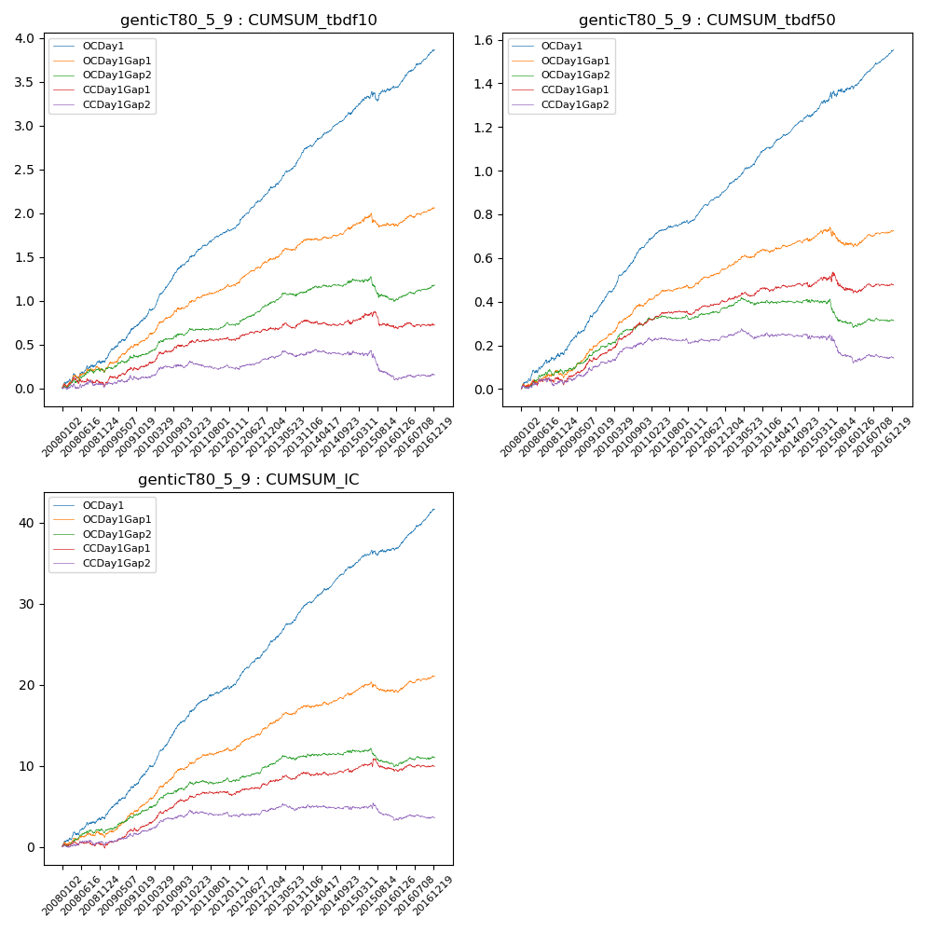

**因子换手率:** 53.72%

**截面指标_OCDay1:**

|  |  |  |  |  |  |  |  |  |
| --- | --- | --- | --- | --- | --- | --- | --- | --- |
| year | annret_tbdf10 | sharpe_tbdf10 | maxdd_tbdf10 | annret_tbdf50 | sharpe_tbdf50 | maxdd_tbdf50 | mean_IC | tstat_IC |
| 2008 | 0.31 | 2.98 | -0.05 | 0.16 | 3.62 | -0.02 | 0.01 | 3.74 |
| 2009 | 0.5 | 5.67 | -0.02 | 0.25 | 6.69 | -0.01 | 0.02 | 6.2 |
| 2010 | 0.65 | 8.37 | -0.02 | 0.25 | 8.22 | -0.01 | 0.03 | 8.62 |
| 2011 | 0.37 | 5.89 | -0.01 | 0.11 | 4.43 | -0.01 | 0.02 | 5.33 |
| 2012 | 0.46 | 6.96 | -0.02 | 0.16 | 6.61 | -0.01 | 0.02 | 6.94 |
| 2013 | 0.52 | 7.4 | -0.02 | 0.18 | 6.9 | -0.01 | 0.02 | 7.36 |
| 2014 | 0.38 | 5.99 | -0.02 | 0.14 | 5.91 | -0.01 | 0.02 | 6.56 |
| 2015 | 0.29 | 2.26 | -0.11 | 0.14 | 2.73 | -0.03 | 0.01 | 2.53 |
| 2016 | 0.43 | 6.47 | -0.02 | 0.17 | 6.79 | -0.01 | 0.02 | 7.33 |

**截面指标_CCDay1Gap1:**

|  |  |  |  |  |  |  |  |  |
| --- | --- | --- | --- | --- | --- | --- | --- | --- |
| year | annret_tbdf10 | sharpe_tbdf10 | maxdd_tbdf10 | annret_tbdf50 | sharpe_tbdf50 | maxdd_tbdf50 | mean_IC | tstat_IC |
| 2008 | 0.04 | 0.36 | -0.09 | 0.03 | 0.68 | -0.03 | 0.0 | 0.05 |
| 2009 | 0.23 | 2.67 | -0.04 | 0.14 | 3.99 | -0.01 | 0.01 | 3.41 |
| 2010 | 0.23 | 2.94 | -0.02 | 0.14 | 3.94 | -0.01 | 0.01 | 4.12 |
| 2011 | 0.09 | 1.69 | -0.03 | 0.05 | 2.34 | -0.01 | 0.0 | 1.63 |
| 2012 | 0.11 | 1.71 | -0.03 | 0.06 | 2.41 | -0.01 | 0.01 | 1.88 |
| 2013 | 0.08 | 1.03 | -0.06 | 0.04 | 1.53 | -0.02 | 0.0 | 1.31 |
| 2014 | -0.02 | -0.3 | -0.05 | 0.01 | 0.51 | -0.02 | 0.0 | 0.41 |
| 2015 | -0.02 | -0.2 | -0.16 | -0.01 | -0.2 | -0.08 | 0.0 | 0.41 |
| 2016 | 0.01 | 0.08 | -0.05 | 0.02 | 0.79 | -0.02 | 0.0 | 0.54 |

**风格暴露:**

|  |  |  |  |  |
| --- | --- | --- | --- | --- |
|  | long | short | corr_OCDay1 | corr_CCDay1Gap1 |
| liquidity10 | 0.02 | -0.05 | -0.09 | -0.03 |
| liquidity20 | -0.01 | -0.02 | -0.1 | -0.06 |
| liquidity5 | 0.06 | -0.09 | -0.07 | -0.04 |
| logmktcap | -0.01 | 0.01 | 0.06 | 0.02 |
| momentum15 | 0.09 | -0.09 | 0.03 | 0.1 |
| momentum30 | 0.04 | -0.05 | 0.02 | 0.06 |
| momentum5 | 0.15 | -0.14 | 0.03 | 0.02 |
| retvolatility30 | -0.02 | -0.02 | -0.14 | -0.07 |