Factors Report 20080102-20161230

**1. genticT80_6_5**

**截面指标累计曲线:**

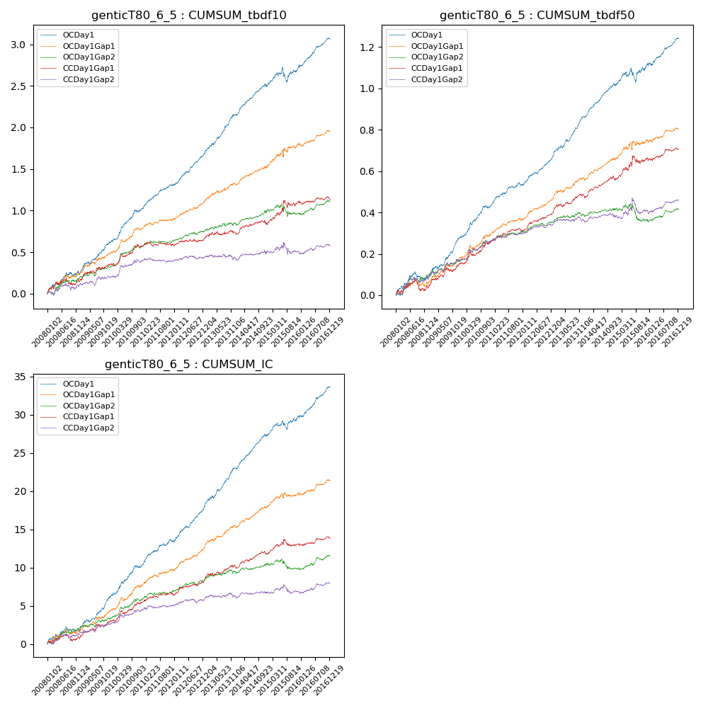

**因子换手率:** 54.28%

**截面指标_OCDay1:**

|  |  |  |  |  |  |  |  |  |
| --- | --- | --- | --- | --- | --- | --- | --- | --- |
| year | annret_tbdf10 | sharpe_tbdf10 | maxdd_tbdf10 | annret_tbdf50 | sharpe_tbdf50 | maxdd_tbdf50 | mean_IC | tstat_IC |
| 2008 | 0.23 | 2.41 | -0.05 | 0.08 | 1.89 | -0.05 | 0.01 | 2.07 |
| 2009 | 0.38 | 4.93 | -0.03 | 0.2 | 5.85 | -0.01 | 0.02 | 5.59 |
| 2010 | 0.41 | 5.23 | -0.03 | 0.16 | 4.6 | -0.01 | 0.02 | 4.74 |
| 2011 | 0.3 | 5.14 | -0.02 | 0.11 | 4.28 | -0.02 | 0.01 | 4.61 |
| 2012 | 0.37 | 6.03 | -0.02 | 0.14 | 6.02 | -0.01 | 0.02 | 6.33 |
| 2013 | 0.48 | 6.39 | -0.02 | 0.19 | 6.55 | -0.01 | 0.02 | 6.56 |
| 2014 | 0.34 | 5.44 | -0.03 | 0.15 | 6.36 | -0.01 | 0.02 | 6.69 |
| 2015 | 0.22 | 1.87 | -0.17 | 0.1 | 1.94 | -0.07 | 0.01 | 2.67 |
| 2016 | 0.34 | 5.25 | -0.03 | 0.13 | 4.91 | -0.01 | 0.02 | 5.8 |

**截面指标_CCDay1Gap1:**

|  |  |  |  |  |  |  |  |  |
| --- | --- | --- | --- | --- | --- | --- | --- | --- |
| year | annret_tbdf10 | sharpe_tbdf10 | maxdd_tbdf10 | annret_tbdf50 | sharpe_tbdf50 | maxdd_tbdf50 | mean_IC | tstat_IC |
| 2008 | 0.14 | 1.55 | -0.09 | 0.04 | 0.9 | -0.06 | 0.0 | 1.04 |
| 2009 | 0.21 | 2.58 | -0.03 | 0.11 | 2.98 | -0.02 | 0.01 | 2.83 |
| 2010 | 0.22 | 2.82 | -0.04 | 0.11 | 2.97 | -0.02 | 0.01 | 3.06 |
| 2011 | 0.03 | 0.43 | -0.05 | 0.06 | 2.42 | -0.01 | 0.0 | 1.76 |
| 2012 | 0.07 | 1.23 | -0.03 | 0.09 | 4.16 | -0.01 | 0.01 | 3.01 |
| 2013 | 0.07 | 0.86 | -0.04 | 0.08 | 2.63 | -0.02 | 0.01 | 2.29 |
| 2014 | 0.11 | 1.61 | -0.05 | 0.08 | 2.99 | -0.02 | 0.01 | 2.71 |
| 2015 | 0.28 | 2.15 | -0.09 | 0.11 | 1.91 | -0.04 | 0.01 | 1.58 |
| 2016 | 0.02 | 0.41 | -0.04 | 0.04 | 1.58 | -0.01 | 0.0 | 1.28 |

**风格暴露:**

|  |  |  |  |  |
| --- | --- | --- | --- | --- |
|  | long | short | corr_OCDay1 | corr_CCDay1Gap1 |
| liquidity10 | 0.03 | -0.05 | -0.11 | -0.12 |
| liquidity20 | 0.01 | -0.03 | -0.11 | -0.13 |
| liquidity5 | 0.06 | -0.09 | -0.1 | -0.11 |
| logmktcap | -0.02 | 0.02 | 0.06 | 0.1 |
| momentum15 | 0.08 | -0.08 | -0.02 | 0.01 |
| momentum30 | 0.04 | -0.05 | -0.04 | 0.0 |
| momentum5 | 0.19 | -0.18 | -0.08 | -0.1 |
| retvolatility30 | 0.01 | -0.03 | -0.13 | -0.14 |