Factors Report 20080102-20161230

**1. genticT80_6_6**

**截面指标累计曲线:**

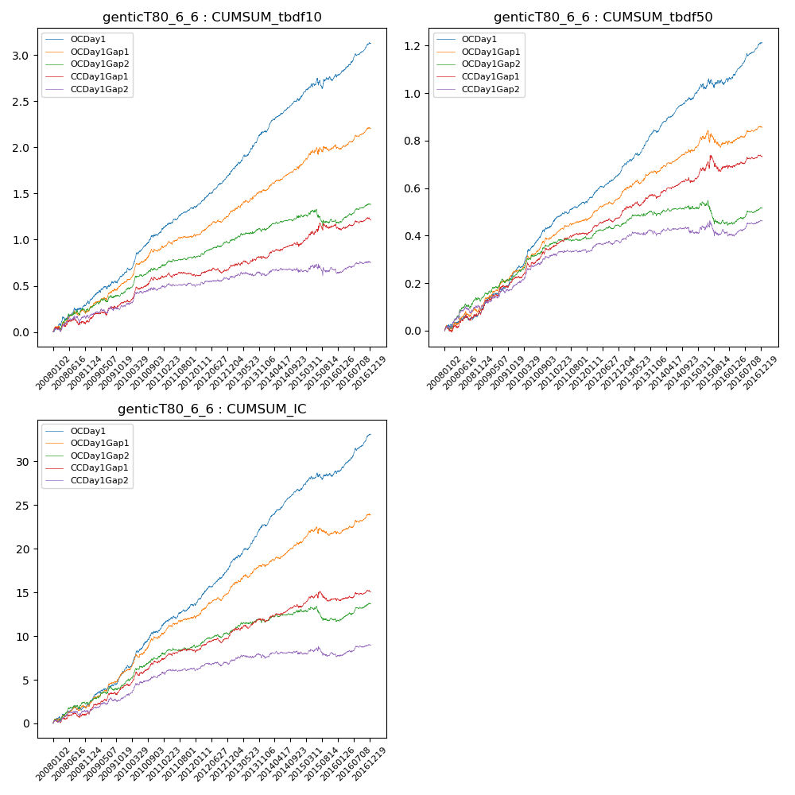

**因子换手率:** 58.5%

**截面指标_OCDay1:**

|  |  |  |  |  |  |  |  |  |
| --- | --- | --- | --- | --- | --- | --- | --- | --- |
| year | annret_tbdf10 | sharpe_tbdf10 | maxdd_tbdf10 | annret_tbdf50 | sharpe_tbdf50 | maxdd_tbdf50 | mean_IC | tstat_IC |
| 2008 | 0.31 | 3.21 | -0.04 | 0.07 | 1.83 | -0.02 | 0.01 | 2.47 |
| 2009 | 0.32 | 3.9 | -0.03 | 0.18 | 5.15 | -0.01 | 0.02 | 4.87 |
| 2010 | 0.45 | 5.62 | -0.02 | 0.19 | 5.46 | -0.01 | 0.02 | 5.38 |
| 2011 | 0.29 | 4.92 | -0.01 | 0.11 | 4.35 | -0.01 | 0.01 | 4.32 |
| 2012 | 0.35 | 6.08 | -0.02 | 0.13 | 5.88 | -0.01 | 0.02 | 6.38 |
| 2013 | 0.48 | 6.25 | -0.02 | 0.17 | 6.23 | -0.01 | 0.02 | 6.26 |
| 2014 | 0.35 | 5.76 | -0.03 | 0.13 | 5.72 | -0.01 | 0.02 | 6.5 |
| 2015 | 0.25 | 2.04 | -0.11 | 0.09 | 1.67 | -0.04 | 0.01 | 2.4 |
| 2016 | 0.35 | 5.32 | -0.03 | 0.15 | 5.64 | -0.01 | 0.02 | 6.1 |

**截面指标_CCDay1Gap1:**

|  |  |  |  |  |  |  |  |  |
| --- | --- | --- | --- | --- | --- | --- | --- | --- |
| year | annret_tbdf10 | sharpe_tbdf10 | maxdd_tbdf10 | annret_tbdf50 | sharpe_tbdf50 | maxdd_tbdf50 | mean_IC | tstat_IC |
| 2008 | 0.11 | 1.1 | -0.08 | 0.07 | 1.81 | -0.02 | 0.0 | 1.53 |
| 2009 | 0.22 | 2.68 | -0.04 | 0.15 | 4.35 | -0.01 | 0.01 | 4.07 |
| 2010 | 0.25 | 3.2 | -0.03 | 0.12 | 3.38 | -0.02 | 0.01 | 3.49 |
| 2011 | 0.05 | 0.83 | -0.05 | 0.07 | 2.93 | -0.01 | 0.01 | 2.2 |
| 2012 | 0.08 | 1.38 | -0.05 | 0.08 | 3.73 | -0.01 | 0.01 | 2.76 |
| 2013 | 0.11 | 1.52 | -0.04 | 0.08 | 2.65 | -0.02 | 0.01 | 2.37 |
| 2014 | 0.14 | 2.06 | -0.05 | 0.06 | 2.27 | -0.02 | 0.01 | 2.43 |
| 2015 | 0.22 | 1.84 | -0.08 | 0.07 | 1.26 | -0.07 | 0.0 | 1.14 |
| 2016 | 0.05 | 0.71 | -0.07 | 0.04 | 1.42 | -0.01 | 0.0 | 1.33 |

**风格暴露:**

|  |  |  |  |  |
| --- | --- | --- | --- | --- |
|  | long | short | corr_OCDay1 | corr_CCDay1Gap1 |
| liquidity10 | 0.03 | -0.05 | -0.14 | -0.1 |
| liquidity20 | 0.01 | -0.03 | -0.15 | -0.11 |
| liquidity5 | 0.07 | -0.09 | -0.12 | -0.08 |
| logmktcap | -0.02 | 0.02 | 0.1 | 0.08 |
| momentum15 | 0.08 | -0.09 | -0.02 | 0.06 |
| momentum30 | 0.04 | -0.05 | -0.05 | 0.05 |
| momentum5 | 0.18 | -0.17 | -0.04 | -0.03 |
| retvolatility30 | 0.01 | -0.03 | -0.16 | -0.15 |