Factors Report 20080102-20161230

**1. genticT80_6_7**

**截面指标累计曲线:**

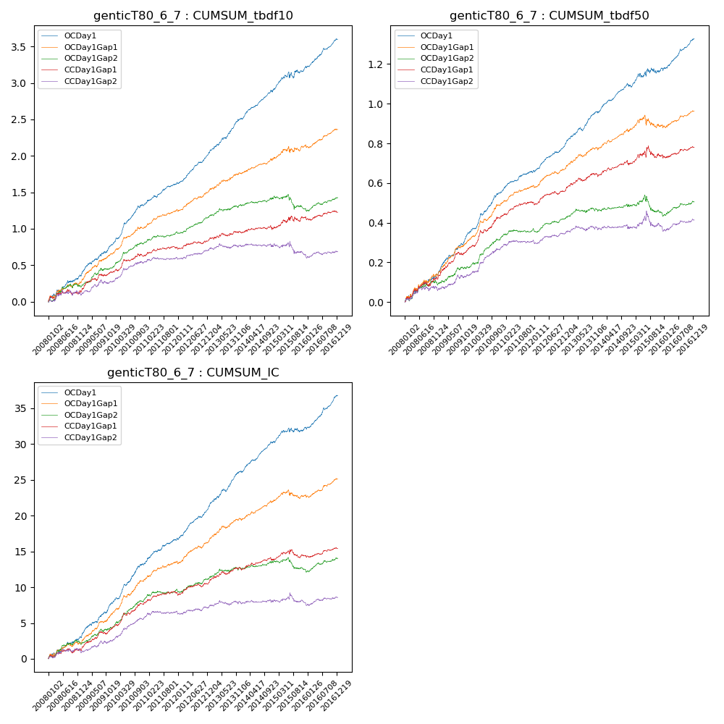

**因子换手率:** 54.01%

**截面指标_OCDay1:**

|  |  |  |  |  |  |  |  |  |
| --- | --- | --- | --- | --- | --- | --- | --- | --- |
| year | annret_tbdf10 | sharpe_tbdf10 | maxdd_tbdf10 | annret_tbdf50 | sharpe_tbdf50 | maxdd_tbdf50 | mean_IC | tstat_IC |
| 2008 | 0.35 | 3.58 | -0.04 | 0.14 | 3.26 | -0.02 | 0.01 | 3.38 |
| 2009 | 0.45 | 5.31 | -0.02 | 0.21 | 6.12 | -0.01 | 0.02 | 5.86 |
| 2010 | 0.55 | 6.89 | -0.02 | 0.2 | 6.04 | -0.01 | 0.02 | 6.4 |
| 2011 | 0.3 | 4.81 | -0.03 | 0.11 | 4.69 | -0.01 | 0.01 | 4.96 |
| 2012 | 0.41 | 7.14 | -0.02 | 0.14 | 6.27 | -0.01 | 0.02 | 6.68 |
| 2013 | 0.48 | 6.44 | -0.02 | 0.17 | 5.92 | -0.02 | 0.02 | 6.53 |
| 2014 | 0.4 | 6.39 | -0.03 | 0.13 | 5.32 | -0.02 | 0.02 | 6.42 |
| 2015 | 0.31 | 2.51 | -0.08 | 0.08 | 1.69 | -0.03 | 0.01 | 2.15 |
| 2016 | 0.39 | 6.13 | -0.02 | 0.15 | 5.73 | -0.01 | 0.02 | 6.48 |

**截面指标_CCDay1Gap1:**

|  |  |  |  |  |  |  |  |  |
| --- | --- | --- | --- | --- | --- | --- | --- | --- |
| year | annret_tbdf10 | sharpe_tbdf10 | maxdd_tbdf10 | annret_tbdf50 | sharpe_tbdf50 | maxdd_tbdf50 | mean_IC | tstat_IC |
| 2008 | 0.13 | 1.33 | -0.08 | 0.12 | 2.77 | -0.02 | 0.0 | 1.6 |
| 2009 | 0.28 | 3.32 | -0.03 | 0.16 | 4.56 | -0.01 | 0.01 | 4.2 |
| 2010 | 0.22 | 2.83 | -0.04 | 0.16 | 4.51 | -0.02 | 0.01 | 4.36 |
| 2011 | 0.12 | 2.01 | -0.03 | 0.07 | 3.1 | -0.01 | 0.01 | 2.25 |
| 2012 | 0.11 | 1.84 | -0.03 | 0.07 | 2.87 | -0.02 | 0.01 | 2.38 |
| 2013 | 0.1 | 1.34 | -0.04 | 0.08 | 2.66 | -0.02 | 0.01 | 2.57 |
| 2014 | 0.05 | 0.68 | -0.06 | 0.05 | 1.89 | -0.02 | 0.0 | 1.82 |
| 2015 | 0.17 | 1.35 | -0.08 | 0.05 | 0.86 | -0.06 | 0.0 | 0.7 |
| 2016 | 0.06 | 0.93 | -0.05 | 0.04 | 1.5 | -0.02 | 0.0 | 1.72 |

**风格暴露:**

|  |  |  |  |  |
| --- | --- | --- | --- | --- |
|  | long | short | corr_OCDay1 | corr_CCDay1Gap1 |
| liquidity10 | 0.03 | -0.06 | -0.1 | -0.09 |
| liquidity20 | 0.01 | -0.03 | -0.11 | -0.11 |
| liquidity5 | 0.07 | -0.1 | -0.08 | -0.07 |
| logmktcap | -0.02 | 0.02 | 0.05 | 0.09 |
| momentum15 | 0.09 | -0.1 | 0.0 | 0.09 |
| momentum30 | 0.04 | -0.05 | 0.0 | 0.09 |
| momentum5 | 0.16 | -0.16 | -0.0 | 0.02 |
| retvolatility30 | 0.0 | -0.03 | -0.12 | -0.14 |