Factors Report 20080102-20161230

**1. genticT80_6_8**

**截面指标累计曲线:**

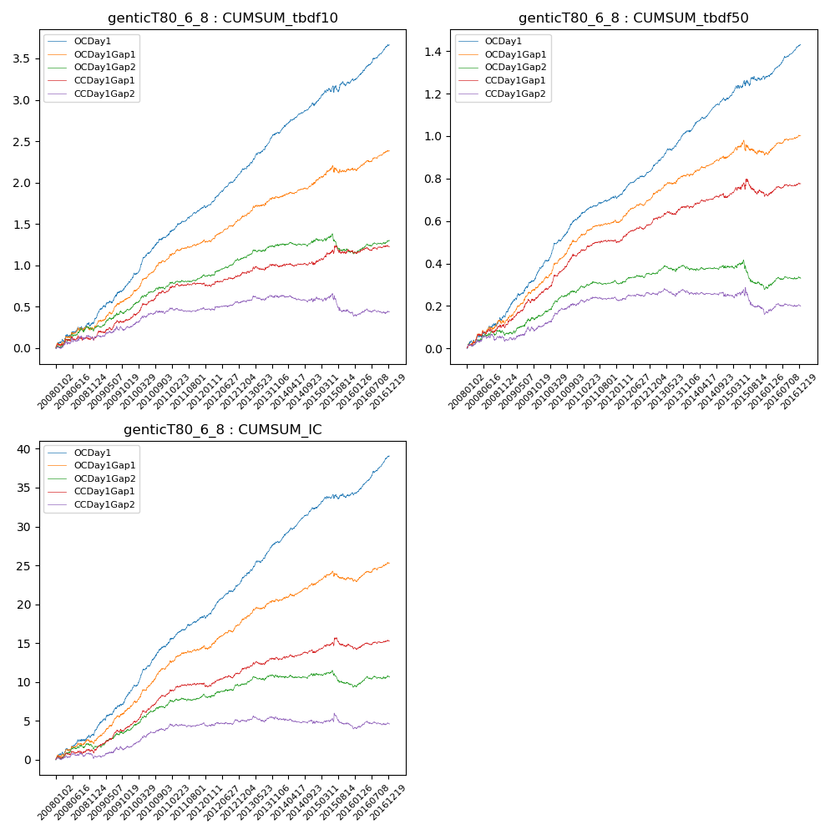

**因子换手率:** 51.53%

**截面指标_OCDay1:**

|  |  |  |  |  |  |  |  |  |
| --- | --- | --- | --- | --- | --- | --- | --- | --- |
| year | annret_tbdf10 | sharpe_tbdf10 | maxdd_tbdf10 | annret_tbdf50 | sharpe_tbdf50 | maxdd_tbdf50 | mean_IC | tstat_IC |
| 2008 | 0.3 | 2.85 | -0.05 | 0.15 | 3.45 | -0.02 | 0.01 | 3.47 |
| 2009 | 0.51 | 5.83 | -0.02 | 0.23 | 6.44 | -0.01 | 0.02 | 6.38 |
| 2010 | 0.55 | 6.81 | -0.02 | 0.23 | 7.13 | -0.01 | 0.02 | 7.34 |
| 2011 | 0.37 | 6.13 | -0.01 | 0.1 | 4.4 | -0.01 | 0.02 | 5.41 |
| 2012 | 0.42 | 6.84 | -0.03 | 0.13 | 5.84 | -0.01 | 0.02 | 6.36 |
| 2013 | 0.48 | 6.64 | -0.02 | 0.18 | 6.75 | -0.01 | 0.02 | 6.85 |
| 2014 | 0.35 | 5.43 | -0.04 | 0.15 | 5.94 | -0.01 | 0.02 | 6.56 |
| 2015 | 0.29 | 2.39 | -0.08 | 0.11 | 2.12 | -0.03 | 0.01 | 2.12 |
| 2016 | 0.43 | 6.63 | -0.03 | 0.15 | 5.87 | -0.02 | 0.02 | 7.18 |

**截面指标_CCDay1Gap1:**

|  |  |  |  |  |  |  |  |  |
| --- | --- | --- | --- | --- | --- | --- | --- | --- |
| year | annret_tbdf10 | sharpe_tbdf10 | maxdd_tbdf10 | annret_tbdf50 | sharpe_tbdf50 | maxdd_tbdf50 | mean_IC | tstat_IC |
| 2008 | 0.11 | 1.07 | -0.06 | 0.1 | 2.48 | -0.02 | 0.0 | 1.29 |
| 2009 | 0.25 | 2.96 | -0.03 | 0.16 | 4.73 | -0.02 | 0.01 | 4.58 |
| 2010 | 0.33 | 4.36 | -0.03 | 0.18 | 5.43 | -0.01 | 0.02 | 5.37 |
| 2011 | 0.1 | 1.74 | -0.03 | 0.06 | 2.63 | -0.01 | 0.01 | 2.16 |
| 2012 | 0.11 | 1.88 | -0.04 | 0.09 | 3.7 | -0.01 | 0.01 | 2.41 |
| 2013 | 0.11 | 1.4 | -0.05 | 0.07 | 2.51 | -0.02 | 0.01 | 2.21 |
| 2014 | 0.02 | 0.3 | -0.04 | 0.04 | 1.56 | -0.02 | 0.0 | 1.16 |
| 2015 | 0.16 | 1.54 | -0.1 | 0.03 | 0.46 | -0.07 | 0.0 | 0.86 |
| 2016 | 0.05 | 0.71 | -0.04 | 0.04 | 1.55 | -0.02 | 0.0 | 1.15 |

**风格暴露:**

|  |  |  |  |  |
| --- | --- | --- | --- | --- |
|  | long | short | corr_OCDay1 | corr_CCDay1Gap1 |
| liquidity10 | 0.03 | -0.06 | -0.1 | -0.07 |
| liquidity20 | 0.01 | -0.03 | -0.11 | -0.09 |
| liquidity5 | 0.07 | -0.1 | -0.08 | -0.06 |
| logmktcap | -0.01 | 0.02 | 0.07 | 0.08 |
| momentum15 | 0.09 | -0.1 | 0.05 | 0.09 |
| momentum30 | 0.04 | -0.05 | 0.04 | 0.08 |
| momentum5 | 0.15 | -0.14 | 0.04 | 0.03 |
| retvolatility30 | -0.0 | -0.03 | -0.14 | -0.12 |