Factors Report 20080102-20161230

**1. genticT80_6_9**

**截面指标累计曲线:**

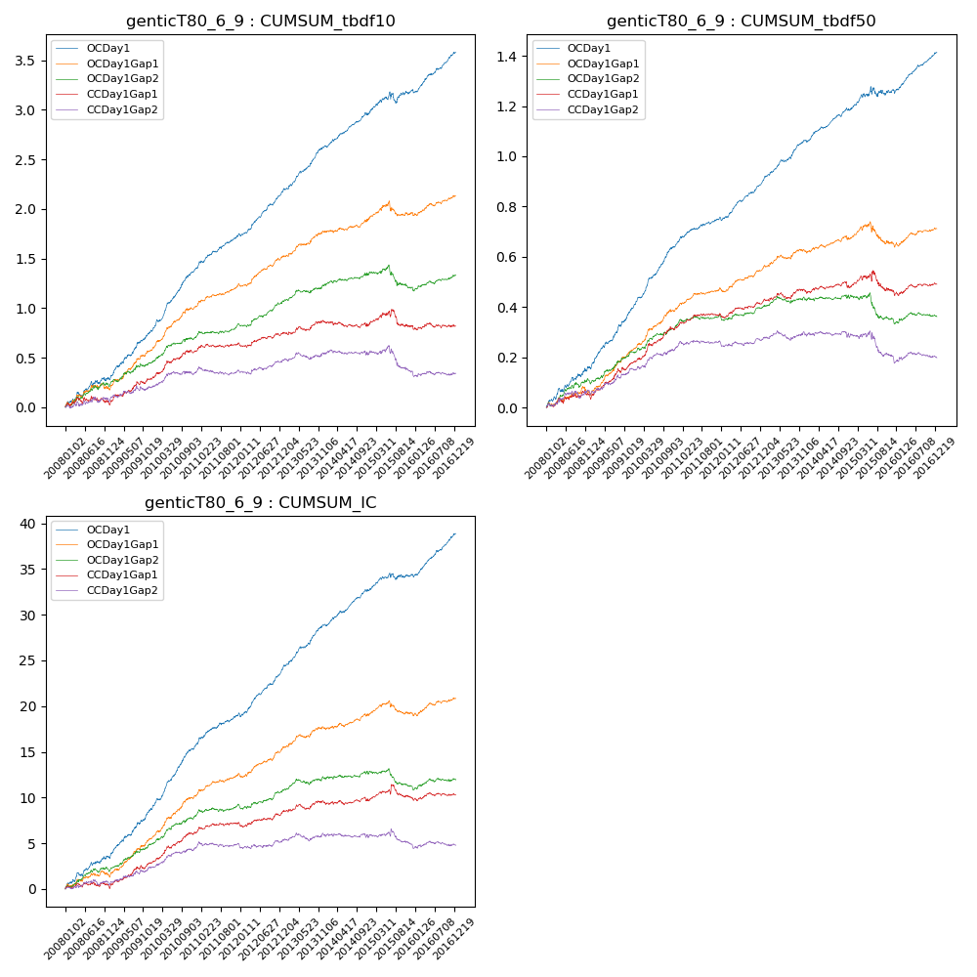

**因子换手率:** 49.97%

**截面指标_OCDay1:**

|  |  |  |  |  |  |  |  |  |
| --- | --- | --- | --- | --- | --- | --- | --- | --- |
| year | annret_tbdf10 | sharpe_tbdf10 | maxdd_tbdf10 | annret_tbdf50 | sharpe_tbdf50 | maxdd_tbdf50 | mean_IC | tstat_IC |
| 2008 | 0.28 | 2.7 | -0.05 | 0.16 | 3.69 | -0.01 | 0.01 | 3.74 |
| 2009 | 0.49 | 5.61 | -0.02 | 0.24 | 6.55 | -0.01 | 0.02 | 6.16 |
| 2010 | 0.63 | 8.16 | -0.02 | 0.25 | 8.21 | -0.01 | 0.03 | 8.63 |
| 2011 | 0.35 | 5.53 | -0.02 | 0.11 | 4.33 | -0.01 | 0.01 | 4.87 |
| 2012 | 0.43 | 6.83 | -0.02 | 0.15 | 6.17 | -0.01 | 0.02 | 6.58 |
| 2013 | 0.47 | 6.68 | -0.02 | 0.16 | 6.15 | -0.01 | 0.02 | 6.82 |
| 2014 | 0.33 | 5.21 | -0.02 | 0.12 | 4.91 | -0.01 | 0.02 | 5.59 |
| 2015 | 0.23 | 1.85 | -0.11 | 0.08 | 1.53 | -0.04 | 0.01 | 1.89 |
| 2016 | 0.39 | 5.87 | -0.03 | 0.15 | 6.06 | -0.01 | 0.02 | 6.76 |

**截面指标_CCDay1Gap1:**

|  |  |  |  |  |  |  |  |  |
| --- | --- | --- | --- | --- | --- | --- | --- | --- |
| year | annret_tbdf10 | sharpe_tbdf10 | maxdd_tbdf10 | annret_tbdf50 | sharpe_tbdf50 | maxdd_tbdf50 | mean_IC | tstat_IC |
| 2008 | 0.03 | 0.33 | -0.08 | 0.04 | 1.05 | -0.03 | 0.0 | 0.29 |
| 2009 | 0.27 | 3.11 | -0.03 | 0.14 | 4.25 | -0.02 | 0.01 | 3.63 |
| 2010 | 0.27 | 3.41 | -0.03 | 0.14 | 3.88 | -0.01 | 0.01 | 4.17 |
| 2011 | 0.08 | 1.47 | -0.03 | 0.05 | 2.44 | -0.01 | 0.0 | 1.81 |
| 2012 | 0.11 | 1.73 | -0.04 | 0.05 | 2.24 | -0.02 | 0.01 | 1.8 |
| 2013 | 0.12 | 1.54 | -0.04 | 0.04 | 1.28 | -0.02 | 0.0 | 1.41 |
| 2014 | -0.04 | -0.53 | -0.06 | 0.01 | 0.52 | -0.03 | 0.0 | 0.27 |
| 2015 | 0.0 | 0.01 | -0.17 | -0.01 | -0.22 | -0.08 | 0.0 | 0.39 |
| 2016 | -0.01 | -0.11 | -0.05 | 0.03 | 0.98 | -0.02 | 0.0 | 0.47 |

**风格暴露:**

|  |  |  |  |  |
| --- | --- | --- | --- | --- |
|  | long | short | corr_OCDay1 | corr_CCDay1Gap1 |
| liquidity10 | 0.02 | -0.06 | -0.09 | -0.04 |
| liquidity20 | -0.0 | -0.03 | -0.1 | -0.07 |
| liquidity5 | 0.06 | -0.09 | -0.08 | -0.05 |
| logmktcap | -0.01 | 0.01 | 0.09 | 0.02 |
| momentum15 | 0.09 | -0.1 | 0.04 | 0.07 |
| momentum30 | 0.04 | -0.05 | 0.03 | 0.05 |
| momentum5 | 0.14 | -0.14 | 0.02 | 0.02 |
| retvolatility30 | -0.01 | -0.02 | -0.15 | -0.08 |