Factors Report 20080102-20161230

**1. genticT80_7_5**

**截面指标累计曲线:**

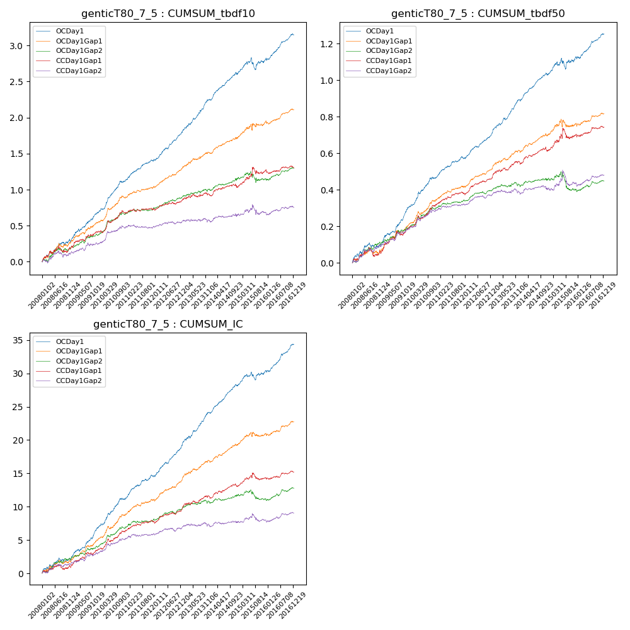

**因子换手率:** 52.33%

**截面指标_OCDay1:**

|  |  |  |  |  |  |  |  |  |
| --- | --- | --- | --- | --- | --- | --- | --- | --- |
| year | annret_tbdf10 | sharpe_tbdf10 | maxdd_tbdf10 | annret_tbdf50 | sharpe_tbdf50 | maxdd_tbdf50 | mean_IC | tstat_IC |
| 2008 | 0.28 | 2.98 | -0.03 | 0.09 | 2.28 | -0.03 | 0.01 | 2.34 |
| 2009 | 0.41 | 5.01 | -0.04 | 0.21 | 6.16 | -0.01 | 0.02 | 6.07 |
| 2010 | 0.46 | 5.79 | -0.02 | 0.16 | 4.85 | -0.01 | 0.02 | 5.2 |
| 2011 | 0.28 | 4.91 | -0.02 | 0.11 | 4.49 | -0.01 | 0.01 | 4.92 |
| 2012 | 0.38 | 6.22 | -0.02 | 0.14 | 6.1 | -0.01 | 0.02 | 6.52 |
| 2013 | 0.47 | 6.19 | -0.02 | 0.19 | 6.37 | -0.01 | 0.02 | 6.47 |
| 2014 | 0.36 | 5.55 | -0.03 | 0.14 | 5.58 | -0.01 | 0.02 | 6.39 |
| 2015 | 0.2 | 1.63 | -0.16 | 0.1 | 1.87 | -0.06 | 0.01 | 2.31 |
| 2016 | 0.35 | 5.28 | -0.03 | 0.13 | 4.98 | -0.01 | 0.02 | 6.01 |

**截面指标_CCDay1Gap1:**

|  |  |  |  |  |  |  |  |  |
| --- | --- | --- | --- | --- | --- | --- | --- | --- |
| year | annret_tbdf10 | sharpe_tbdf10 | maxdd_tbdf10 | annret_tbdf50 | sharpe_tbdf50 | maxdd_tbdf50 | mean_IC | tstat_IC |
| 2008 | 0.18 | 1.84 | -0.08 | 0.06 | 1.36 | -0.05 | 0.0 | 1.23 |
| 2009 | 0.24 | 2.98 | -0.03 | 0.13 | 3.71 | -0.02 | 0.01 | 3.46 |
| 2010 | 0.26 | 3.33 | -0.04 | 0.13 | 3.59 | -0.02 | 0.01 | 3.57 |
| 2011 | 0.05 | 0.95 | -0.04 | 0.06 | 2.56 | -0.01 | 0.01 | 2.13 |
| 2012 | 0.12 | 2.17 | -0.03 | 0.09 | 4.09 | -0.01 | 0.01 | 3.17 |
| 2013 | 0.08 | 1.05 | -0.04 | 0.08 | 2.72 | -0.01 | 0.01 | 2.4 |
| 2014 | 0.1 | 1.53 | -0.05 | 0.06 | 2.36 | -0.03 | 0.01 | 2.56 |
| 2015 | 0.24 | 2.01 | -0.09 | 0.09 | 1.55 | -0.06 | 0.01 | 1.48 |
| 2016 | 0.03 | 0.49 | -0.06 | 0.04 | 1.52 | -0.02 | 0.0 | 1.45 |

**风格暴露:**

|  |  |  |  |  |
| --- | --- | --- | --- | --- |
|  | long | short | corr_OCDay1 | corr_CCDay1Gap1 |
| liquidity10 | 0.04 | -0.06 | -0.13 | -0.12 |
| liquidity20 | 0.02 | -0.04 | -0.13 | -0.13 |
| liquidity5 | 0.08 | -0.1 | -0.12 | -0.11 |
| logmktcap | -0.02 | 0.03 | 0.07 | 0.11 |
| momentum15 | 0.09 | -0.09 | -0.03 | 0.04 |
| momentum30 | 0.05 | -0.06 | -0.05 | 0.03 |
| momentum5 | 0.19 | -0.19 | -0.08 | -0.08 |
| retvolatility30 | 0.02 | -0.04 | -0.15 | -0.15 |