Factors Report 20080102-20161230

**1. genticT80_7_6**

**截面指标累计曲线:**

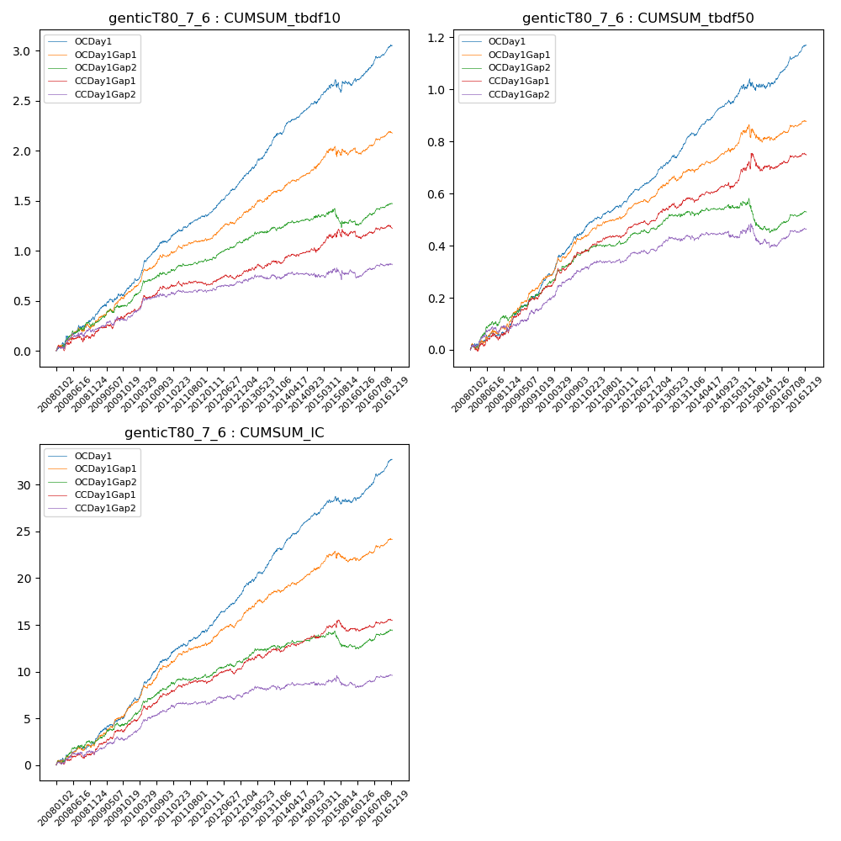

**因子换手率:** 55.35%

**截面指标_OCDay1:**

|  |  |  |  |  |  |  |  |  |
| --- | --- | --- | --- | --- | --- | --- | --- | --- |
| year | annret_tbdf10 | sharpe_tbdf10 | maxdd_tbdf10 | annret_tbdf50 | sharpe_tbdf50 | maxdd_tbdf50 | mean_IC | tstat_IC |
| 2008 | 0.32 | 3.32 | -0.04 | 0.08 | 1.89 | -0.02 | 0.01 | 2.73 |
| 2009 | 0.34 | 4.15 | -0.03 | 0.19 | 5.74 | -0.01 | 0.02 | 5.2 |
| 2010 | 0.45 | 5.67 | -0.02 | 0.18 | 5.37 | -0.01 | 0.02 | 5.79 |
| 2011 | 0.26 | 4.39 | -0.02 | 0.11 | 4.46 | -0.01 | 0.01 | 4.35 |
| 2012 | 0.36 | 6.37 | -0.02 | 0.12 | 5.57 | -0.01 | 0.02 | 6.29 |
| 2013 | 0.47 | 6.38 | -0.02 | 0.16 | 5.69 | -0.01 | 0.02 | 6.07 |
| 2014 | 0.31 | 5.21 | -0.03 | 0.12 | 4.9 | -0.01 | 0.01 | 5.9 |
| 2015 | 0.22 | 1.75 | -0.12 | 0.08 | 1.44 | -0.04 | 0.01 | 1.9 |
| 2016 | 0.34 | 5.31 | -0.03 | 0.15 | 5.51 | -0.02 | 0.02 | 5.9 |

**截面指标_CCDay1Gap1:**

|  |  |  |  |  |  |  |  |  |
| --- | --- | --- | --- | --- | --- | --- | --- | --- |
| year | annret_tbdf10 | sharpe_tbdf10 | maxdd_tbdf10 | annret_tbdf50 | sharpe_tbdf50 | maxdd_tbdf50 | mean_IC | tstat_IC |
| 2008 | 0.15 | 1.46 | -0.07 | 0.07 | 1.74 | -0.03 | 0.0 | 1.65 |
| 2009 | 0.25 | 2.91 | -0.05 | 0.17 | 5.06 | -0.01 | 0.01 | 4.44 |
| 2010 | 0.23 | 3.09 | -0.03 | 0.13 | 3.73 | -0.02 | 0.01 | 3.85 |
| 2011 | 0.05 | 0.92 | -0.05 | 0.07 | 2.98 | -0.01 | 0.01 | 2.33 |
| 2012 | 0.11 | 1.81 | -0.04 | 0.07 | 3.3 | -0.02 | 0.01 | 2.66 |
| 2013 | 0.11 | 1.51 | -0.05 | 0.07 | 2.2 | -0.02 | 0.01 | 2.23 |
| 2014 | 0.11 | 1.67 | -0.05 | 0.05 | 1.75 | -0.02 | 0.01 | 2.07 |
| 2015 | 0.2 | 1.65 | -0.08 | 0.09 | 1.5 | -0.07 | 0.0 | 1.15 |
| 2016 | 0.03 | 0.39 | -0.08 | 0.04 | 1.53 | -0.02 | 0.0 | 1.47 |

**风格暴露:**

|  |  |  |  |  |
| --- | --- | --- | --- | --- |
|  | long | short | corr_OCDay1 | corr_CCDay1Gap1 |
| liquidity10 | 0.04 | -0.06 | -0.15 | -0.1 |
| liquidity20 | 0.02 | -0.04 | -0.16 | -0.12 |
| liquidity5 | 0.08 | -0.1 | -0.13 | -0.09 |
| logmktcap | -0.02 | 0.03 | 0.13 | 0.1 |
| momentum15 | 0.1 | -0.1 | -0.01 | 0.06 |
| momentum30 | 0.05 | -0.06 | -0.03 | 0.07 |
| momentum5 | 0.17 | -0.17 | -0.03 | -0.03 |
| retvolatility30 | 0.01 | -0.04 | -0.17 | -0.15 |