Factors Report 20080102-20161230

**1. genticT80_7_7**

**截面指标累计曲线:**

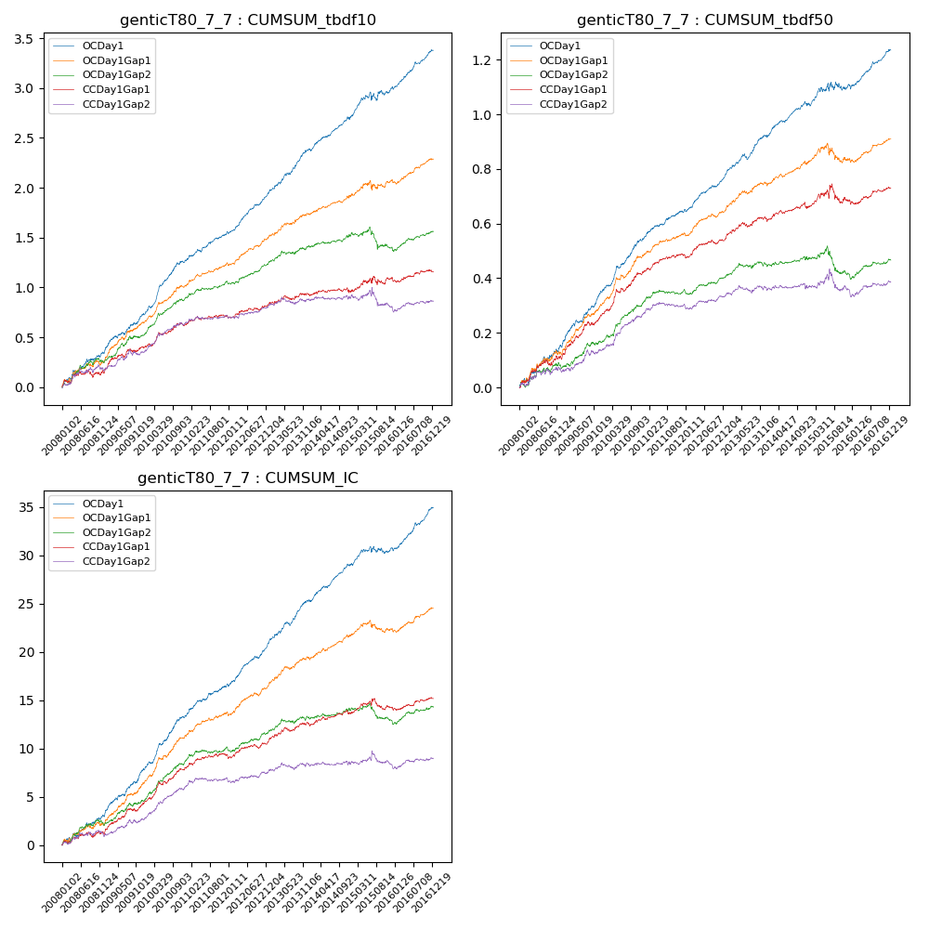

**因子换手率:** 52.79%

**截面指标_OCDay1:**

|  |  |  |  |  |  |  |  |  |
| --- | --- | --- | --- | --- | --- | --- | --- | --- |
| year | annret_tbdf10 | sharpe_tbdf10 | maxdd_tbdf10 | annret_tbdf50 | sharpe_tbdf50 | maxdd_tbdf50 | mean_IC | tstat_IC |
| 2008 | 0.34 | 3.5 | -0.04 | 0.15 | 3.65 | -0.02 | 0.01 | 3.45 |
| 2009 | 0.4 | 4.85 | -0.03 | 0.2 | 5.91 | -0.01 | 0.02 | 5.92 |
| 2010 | 0.54 | 7.02 | -0.02 | 0.19 | 5.85 | -0.01 | 0.02 | 6.49 |
| 2011 | 0.29 | 4.71 | -0.03 | 0.11 | 4.57 | -0.01 | 0.01 | 4.74 |
| 2012 | 0.39 | 6.75 | -0.02 | 0.13 | 6.08 | -0.01 | 0.02 | 6.34 |
| 2013 | 0.45 | 6.13 | -0.02 | 0.15 | 5.28 | -0.02 | 0.02 | 6.04 |
| 2014 | 0.33 | 5.16 | -0.03 | 0.12 | 4.52 | -0.02 | 0.02 | 5.69 |
| 2015 | 0.29 | 2.38 | -0.09 | 0.07 | 1.29 | -0.03 | 0.01 | 1.76 |
| 2016 | 0.38 | 5.9 | -0.03 | 0.13 | 5.06 | -0.02 | 0.02 | 6.12 |

**截面指标_CCDay1Gap1:**

|  |  |  |  |  |  |  |  |  |
| --- | --- | --- | --- | --- | --- | --- | --- | --- |
| year | annret_tbdf10 | sharpe_tbdf10 | maxdd_tbdf10 | annret_tbdf50 | sharpe_tbdf50 | maxdd_tbdf50 | mean_IC | tstat_IC |
| 2008 | 0.14 | 1.46 | -0.08 | 0.11 | 2.61 | -0.02 | 0.0 | 1.58 |
| 2009 | 0.27 | 3.17 | -0.04 | 0.16 | 4.81 | -0.01 | 0.01 | 4.4 |
| 2010 | 0.22 | 2.99 | -0.03 | 0.15 | 4.38 | -0.01 | 0.01 | 4.57 |
| 2011 | 0.09 | 1.62 | -0.04 | 0.06 | 2.8 | -0.01 | 0.01 | 2.16 |
| 2012 | 0.12 | 1.92 | -0.03 | 0.07 | 2.79 | -0.01 | 0.01 | 2.24 |
| 2013 | 0.1 | 1.34 | -0.04 | 0.07 | 2.35 | -0.02 | 0.01 | 2.46 |
| 2014 | 0.02 | 0.34 | -0.05 | 0.04 | 1.46 | -0.02 | 0.0 | 1.57 |
| 2015 | 0.15 | 1.25 | -0.08 | 0.03 | 0.51 | -0.07 | 0.0 | 0.73 |
| 2016 | 0.05 | 0.79 | -0.05 | 0.04 | 1.73 | -0.02 | 0.0 | 1.57 |

**风格暴露:**

|  |  |  |  |  |
| --- | --- | --- | --- | --- |
|  | long | short | corr_OCDay1 | corr_CCDay1Gap1 |
| liquidity10 | 0.04 | -0.07 | -0.09 | -0.08 |
| liquidity20 | 0.02 | -0.04 | -0.1 | -0.1 |
| liquidity5 | 0.07 | -0.1 | -0.08 | -0.07 |
| logmktcap | -0.02 | 0.02 | 0.06 | 0.08 |
| momentum15 | 0.1 | -0.1 | 0.01 | 0.09 |
| momentum30 | 0.05 | -0.05 | 0.01 | 0.09 |
| momentum5 | 0.15 | -0.15 | -0.0 | 0.02 |
| retvolatility30 | 0.01 | -0.04 | -0.14 | -0.13 |