Factors Report 20080102-20161230

**1. genticT80_7_8**

**截面指标累计曲线:**

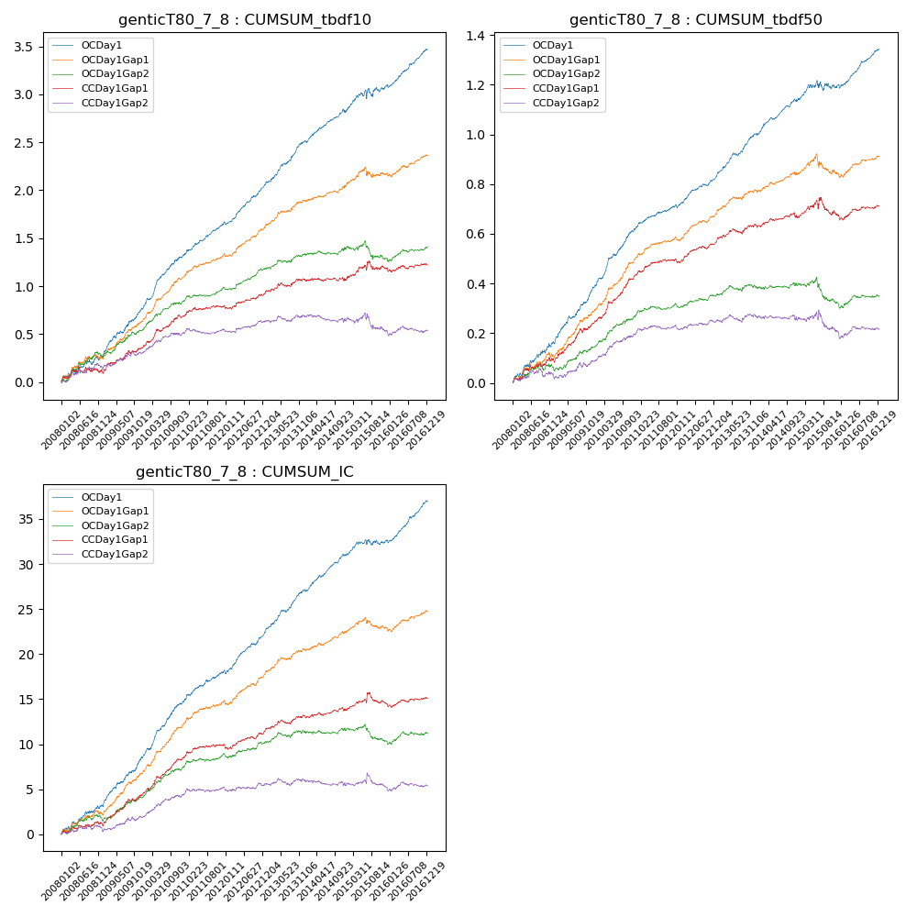

**因子换手率:** 48.34%

**截面指标_OCDay1:**

|  |  |  |  |  |  |  |  |  |
| --- | --- | --- | --- | --- | --- | --- | --- | --- |
| year | annret_tbdf10 | sharpe_tbdf10 | maxdd_tbdf10 | annret_tbdf50 | sharpe_tbdf50 | maxdd_tbdf50 | mean_IC | tstat_IC |
| 2008 | 0.26 | 2.52 | -0.05 | 0.16 | 3.84 | -0.01 | 0.01 | 3.49 |
| 2009 | 0.51 | 5.87 | -0.02 | 0.23 | 6.43 | -0.01 | 0.02 | 6.35 |
| 2010 | 0.55 | 7.01 | -0.02 | 0.23 | 6.95 | -0.01 | 0.02 | 7.43 |
| 2011 | 0.35 | 6.05 | -0.01 | 0.1 | 4.19 | -0.01 | 0.01 | 5.07 |
| 2012 | 0.4 | 6.44 | -0.03 | 0.12 | 5.34 | -0.01 | 0.02 | 6.07 |
| 2013 | 0.46 | 6.51 | -0.02 | 0.17 | 6.5 | -0.01 | 0.02 | 6.44 |
| 2014 | 0.31 | 4.82 | -0.04 | 0.14 | 5.34 | -0.01 | 0.02 | 5.83 |
| 2015 | 0.26 | 2.1 | -0.09 | 0.06 | 1.18 | -0.04 | 0.01 | 1.74 |
| 2016 | 0.38 | 5.99 | -0.03 | 0.15 | 5.73 | -0.02 | 0.02 | 6.62 |

**截面指标_CCDay1Gap1:**

|  |  |  |  |  |  |  |  |  |
| --- | --- | --- | --- | --- | --- | --- | --- | --- |
| year | annret_tbdf10 | sharpe_tbdf10 | maxdd_tbdf10 | annret_tbdf50 | sharpe_tbdf50 | maxdd_tbdf50 | mean_IC | tstat_IC |
| 2008 | 0.1 | 1.01 | -0.06 | 0.09 | 2.22 | -0.02 | 0.0 | 1.37 |
| 2009 | 0.27 | 3.2 | -0.04 | 0.16 | 4.68 | -0.02 | 0.01 | 4.66 |
| 2010 | 0.32 | 4.18 | -0.03 | 0.18 | 5.51 | -0.01 | 0.02 | 5.42 |
| 2011 | 0.11 | 1.89 | -0.03 | 0.07 | 2.75 | -0.01 | 0.01 | 2.24 |
| 2012 | 0.14 | 2.22 | -0.03 | 0.08 | 3.13 | -0.01 | 0.01 | 2.27 |
| 2013 | 0.14 | 1.86 | -0.04 | 0.06 | 2.17 | -0.02 | 0.01 | 2.23 |
| 2014 | -0.01 | -0.08 | -0.04 | 0.03 | 1.13 | -0.02 | 0.0 | 0.96 |
| 2015 | 0.13 | 1.22 | -0.09 | 0.01 | 0.2 | -0.07 | 0.0 | 0.82 |
| 2016 | 0.03 | 0.4 | -0.04 | 0.04 | 1.37 | -0.02 | 0.0 | 0.97 |

**风格暴露:**

|  |  |  |  |  |
| --- | --- | --- | --- | --- |
|  | long | short | corr_OCDay1 | corr_CCDay1Gap1 |
| liquidity10 | 0.03 | -0.07 | -0.11 | -0.07 |
| liquidity20 | 0.01 | -0.03 | -0.13 | -0.09 |
| liquidity5 | 0.07 | -0.1 | -0.1 | -0.06 |
| logmktcap | -0.01 | 0.02 | 0.1 | 0.08 |
| momentum15 | 0.1 | -0.11 | 0.05 | 0.09 |
| momentum30 | 0.05 | -0.05 | 0.03 | 0.08 |
| momentum5 | 0.14 | -0.14 | 0.04 | 0.03 |
| retvolatility30 | -0.0 | -0.03 | -0.16 | -0.11 |