Factors Report 20080102-20161230

**1. genticT80_7_9**

**截面指标累计曲线:**

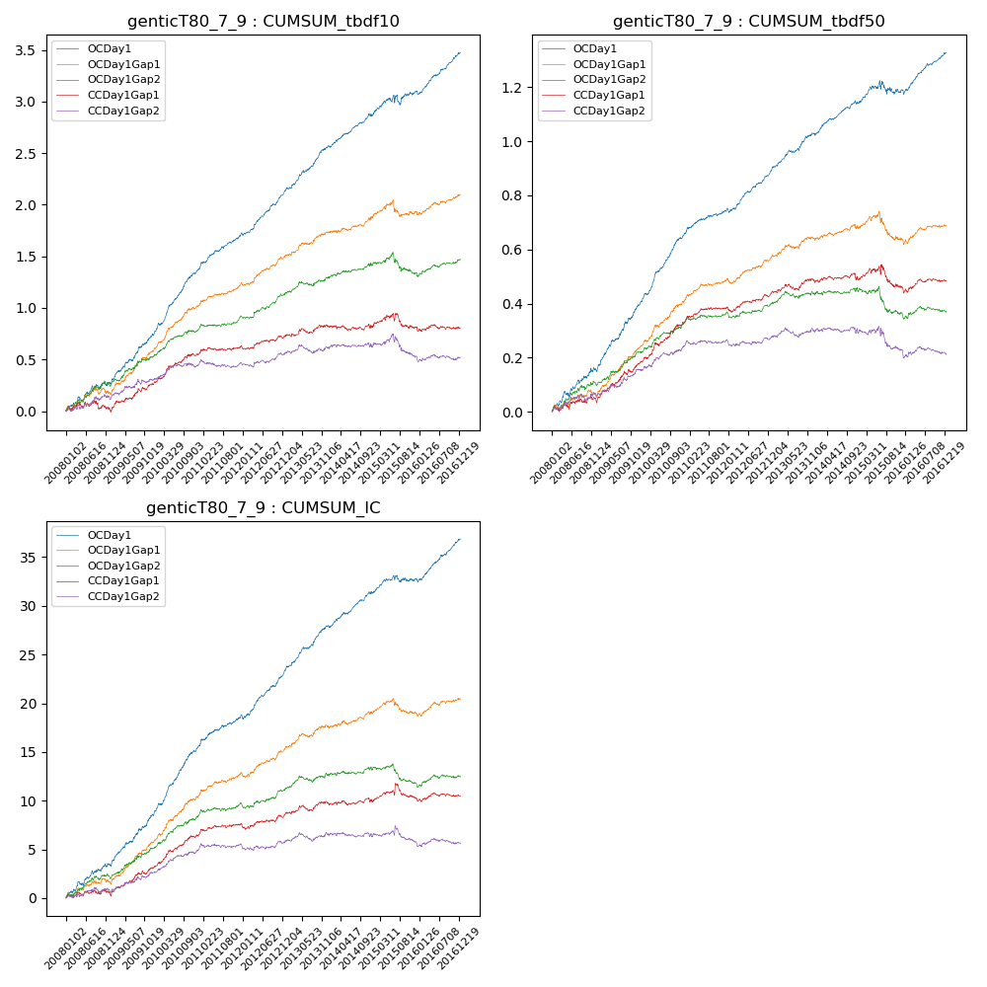

**因子换手率:** 46.95%

**截面指标_OCDay1:**

|  |  |  |  |  |  |  |  |  |
| --- | --- | --- | --- | --- | --- | --- | --- | --- |
| year | annret_tbdf10 | sharpe_tbdf10 | maxdd_tbdf10 | annret_tbdf50 | sharpe_tbdf50 | maxdd_tbdf50 | mean_IC | tstat_IC |
| 2008 | 0.27 | 2.63 | -0.05 | 0.15 | 3.65 | -0.02 | 0.01 | 3.74 |
| 2009 | 0.48 | 5.66 | -0.02 | 0.25 | 6.62 | -0.01 | 0.02 | 6.08 |
| 2010 | 0.62 | 8.3 | -0.02 | 0.25 | 8.4 | -0.0 | 0.03 | 8.54 |
| 2011 | 0.36 | 5.83 | -0.02 | 0.1 | 4.13 | -0.01 | 0.01 | 4.69 |
| 2012 | 0.42 | 6.82 | -0.02 | 0.14 | 5.86 | -0.01 | 0.02 | 6.28 |
| 2013 | 0.44 | 6.15 | -0.02 | 0.14 | 5.27 | -0.01 | 0.02 | 6.37 |
| 2014 | 0.3 | 4.73 | -0.03 | 0.11 | 4.51 | -0.01 | 0.01 | 4.98 |
| 2015 | 0.22 | 1.79 | -0.1 | 0.05 | 0.9 | -0.05 | 0.01 | 1.56 |
| 2016 | 0.38 | 5.76 | -0.03 | 0.14 | 5.56 | -0.02 | 0.02 | 6.22 |

**截面指标_CCDay1Gap1:**

|  |  |  |  |  |  |  |  |  |
| --- | --- | --- | --- | --- | --- | --- | --- | --- |
| year | annret_tbdf10 | sharpe_tbdf10 | maxdd_tbdf10 | annret_tbdf50 | sharpe_tbdf50 | maxdd_tbdf50 | mean_IC | tstat_IC |
| 2008 | 0.0 | 0.03 | -0.09 | 0.04 | 1.02 | -0.02 | 0.0 | 0.51 |
| 2009 | 0.27 | 3.23 | -0.03 | 0.14 | 4.26 | -0.01 | 0.01 | 3.78 |
| 2010 | 0.27 | 3.63 | -0.02 | 0.14 | 4.16 | -0.01 | 0.01 | 4.24 |
| 2011 | 0.08 | 1.5 | -0.03 | 0.06 | 2.59 | -0.01 | 0.0 | 1.98 |
| 2012 | 0.1 | 1.67 | -0.03 | 0.06 | 2.31 | -0.02 | 0.0 | 1.59 |
| 2013 | 0.1 | 1.26 | -0.05 | 0.05 | 1.62 | -0.02 | 0.0 | 1.53 |
| 2014 | -0.01 | -0.19 | -0.05 | 0.0 | 0.04 | -0.03 | 0.0 | 0.15 |
| 2015 | 0.01 | 0.07 | -0.14 | -0.03 | -0.5 | -0.08 | 0.0 | 0.41 |
| 2016 | -0.01 | -0.19 | -0.05 | 0.02 | 0.82 | -0.02 | 0.0 | 0.33 |

**风格暴露:**

|  |  |  |  |  |
| --- | --- | --- | --- | --- |
|  | long | short | corr_OCDay1 | corr_CCDay1Gap1 |
| liquidity10 | 0.03 | -0.06 | -0.1 | -0.03 |
| liquidity20 | 0.0 | -0.03 | -0.11 | -0.06 |
| liquidity5 | 0.07 | -0.09 | -0.09 | -0.05 |
| logmktcap | -0.01 | 0.01 | 0.09 | 0.01 |
| momentum15 | 0.1 | -0.11 | 0.01 | 0.06 |
| momentum30 | 0.04 | -0.05 | 0.01 | 0.05 |
| momentum5 | 0.14 | -0.13 | -0.0 | 0.02 |
| retvolatility30 | -0.01 | -0.03 | -0.15 | -0.06 |