Factors Report 20080102-20161230

**1. genticT8_0**

**截面指标累计曲线:**

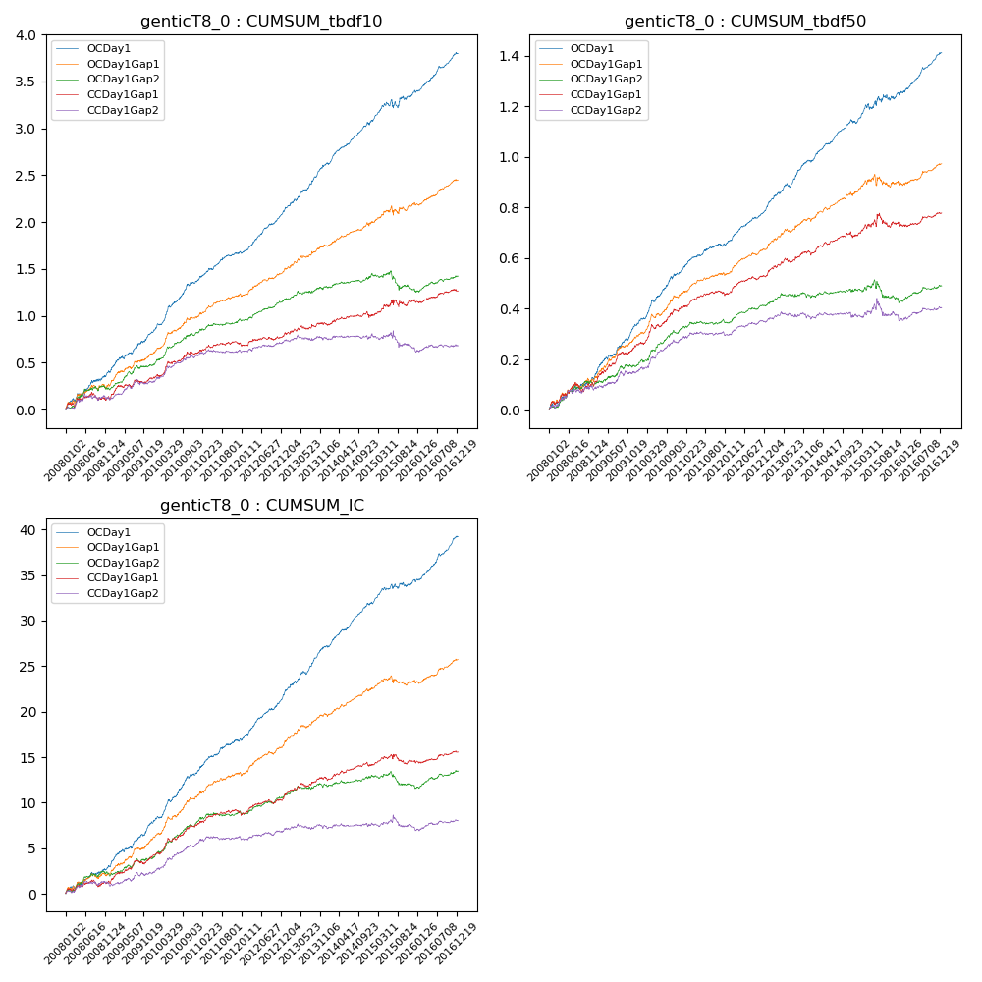

**因子换手率:** 57.94%

**截面指标_OCDay1:**

|  |  |  |  |  |  |  |  |  |
| --- | --- | --- | --- | --- | --- | --- | --- | --- |
| year | annret_tbdf10 | sharpe_tbdf10 | maxdd_tbdf10 | annret_tbdf50 | sharpe_tbdf50 | maxdd_tbdf50 | mean_IC | tstat_IC |
| 2008 | 0.4 | 3.98 | -0.03 | 0.13 | 3.03 | -0.02 | 0.01 | 3.34 |
| 2009 | 0.43 | 5.16 | -0.03 | 0.21 | 6.16 | -0.01 | 0.02 | 5.84 |
| 2010 | 0.54 | 6.61 | -0.02 | 0.21 | 6.12 | -0.01 | 0.02 | 6.17 |
| 2011 | 0.32 | 5.1 | -0.02 | 0.12 | 4.66 | -0.01 | 0.02 | 5.21 |
| 2012 | 0.43 | 7.27 | -0.02 | 0.15 | 6.91 | -0.01 | 0.02 | 7.14 |
| 2013 | 0.53 | 6.89 | -0.02 | 0.19 | 6.42 | -0.02 | 0.02 | 7.06 |
| 2014 | 0.45 | 7.11 | -0.03 | 0.15 | 6.38 | -0.01 | 0.02 | 7.42 |
| 2015 | 0.32 | 2.65 | -0.09 | 0.11 | 2.22 | -0.02 | 0.01 | 2.76 |
| 2016 | 0.41 | 6.4 | -0.02 | 0.16 | 6.22 | -0.01 | 0.02 | 7.0 |

**截面指标_CCDay1Gap1:**

|  |  |  |  |  |  |  |  |  |
| --- | --- | --- | --- | --- | --- | --- | --- | --- |
| year | annret_tbdf10 | sharpe_tbdf10 | maxdd_tbdf10 | annret_tbdf50 | sharpe_tbdf50 | maxdd_tbdf50 | mean_IC | tstat_IC |
| 2008 | 0.11 | 1.13 | -0.08 | 0.1 | 2.29 | -0.04 | 0.0 | 1.57 |
| 2009 | 0.23 | 2.72 | -0.04 | 0.16 | 4.39 | -0.01 | 0.01 | 3.85 |
| 2010 | 0.26 | 3.25 | -0.03 | 0.14 | 4.04 | -0.02 | 0.01 | 4.19 |
| 2011 | 0.11 | 1.86 | -0.03 | 0.06 | 2.81 | -0.01 | 0.01 | 2.25 |
| 2012 | 0.08 | 1.37 | -0.03 | 0.08 | 3.27 | -0.01 | 0.01 | 2.51 |
| 2013 | 0.12 | 1.6 | -0.04 | 0.09 | 3.01 | -0.02 | 0.01 | 2.86 |
| 2014 | 0.08 | 1.2 | -0.07 | 0.06 | 2.32 | -0.02 | 0.01 | 2.24 |
| 2015 | 0.18 | 1.38 | -0.08 | 0.06 | 1.07 | -0.05 | 0.0 | 0.59 |
| 2016 | 0.09 | 1.48 | -0.04 | 0.04 | 1.42 | -0.02 | 0.0 | 1.7 |

**风格暴露:**

|  |  |  |  |  |
| --- | --- | --- | --- | --- |
|  | long | short | corr_OCDay1 | corr_CCDay1Gap1 |
| liquidity10 | 0.02 | -0.05 | -0.1 | -0.1 |
| liquidity20 | 0.01 | -0.03 | -0.1 | -0.11 |
| liquidity5 | 0.06 | -0.09 | -0.08 | -0.07 |
| logmktcap | -0.02 | 0.02 | 0.05 | 0.09 |
| momentum15 | 0.08 | -0.09 | 0.01 | 0.08 |
| momentum30 | 0.04 | -0.05 | -0.0 | 0.07 |
| momentum5 | 0.17 | -0.16 | -0.0 | 0.01 |
| retvolatility30 | 0.0 | -0.03 | -0.12 | -0.14 |