Factors Report 20080102-20161230

**1. genticT8_4**

**截面指标累计曲线:**

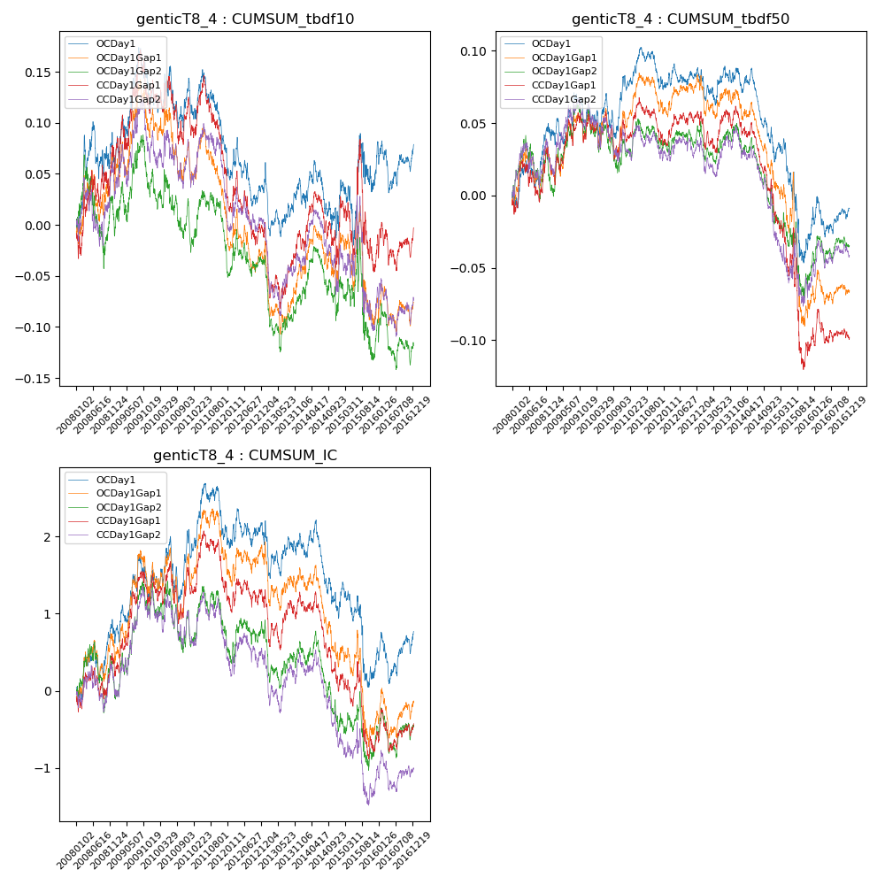

**因子换手率:** 24.27%

**截面指标_OCDay1:**

|  |  |  |  |  |  |  |  |  |
| --- | --- | --- | --- | --- | --- | --- | --- | --- |
| year | annret_tbdf10 | sharpe_tbdf10 | maxdd_tbdf10 | annret_tbdf50 | sharpe_tbdf50 | maxdd_tbdf50 | mean_IC | tstat_IC |
| 2008 | 0.06 | 0.91 | -0.05 | 0.04 | 1.51 | -0.02 | 0.0 | 1.33 |
| 2009 | 0.06 | 1.08 | -0.06 | 0.01 | 0.52 | -0.02 | 0.0 | 1.24 |
| 2010 | 0.01 | 0.28 | -0.06 | 0.03 | 0.96 | -0.03 | 0.0 | 0.97 |
| 2011 | -0.07 | -1.62 | -0.08 | -0.01 | -0.27 | -0.03 | 0.0 | 0.08 |
| 2012 | -0.04 | -1.06 | -0.07 | 0.0 | 0.01 | -0.01 | -0.0 | -0.36 |
| 2013 | 0.0 | 0.08 | -0.07 | 0.01 | 0.34 | -0.02 | 0.0 | 0.05 |
| 2014 | -0.04 | -0.85 | -0.07 | -0.06 | -2.94 | -0.06 | -0.0 | -2.13 |
| 2015 | 0.06 | 0.69 | -0.06 | -0.05 | -1.16 | -0.08 | -0.0 | -0.89 |
| 2016 | 0.03 | 0.74 | -0.05 | 0.01 | 0.57 | -0.03 | 0.0 | 0.96 |

**截面指标_CCDay1Gap1:**

|  |  |  |  |  |  |  |  |  |
| --- | --- | --- | --- | --- | --- | --- | --- | --- |
| year | annret_tbdf10 | sharpe_tbdf10 | maxdd_tbdf10 | annret_tbdf50 | sharpe_tbdf50 | maxdd_tbdf50 | mean_IC | tstat_IC |
| 2008 | 0.07 | 0.99 | -0.03 | 0.03 | 0.85 | -0.03 | 0.0 | 0.7 |
| 2009 | 0.06 | 0.96 | -0.06 | 0.02 | 0.94 | -0.02 | 0.0 | 1.86 |
| 2010 | -0.01 | -0.18 | -0.07 | -0.0 | -0.15 | -0.03 | 0.0 | 0.21 |
| 2011 | -0.07 | -1.69 | -0.1 | -0.01 | -0.55 | -0.03 | -0.0 | -0.53 |
| 2012 | -0.06 | -1.33 | -0.07 | 0.01 | 0.76 | -0.01 | -0.0 | -0.42 |
| 2013 | -0.01 | -0.18 | -0.08 | 0.01 | 0.4 | -0.03 | 0.0 | 0.15 |
| 2014 | -0.02 | -0.34 | -0.07 | -0.07 | -3.24 | -0.07 | -0.0 | -2.67 |
| 2015 | -0.0 | -0.0 | -0.12 | -0.09 | -1.71 | -0.1 | -0.0 | -0.96 |
| 2016 | 0.03 | 0.71 | -0.05 | 0.0 | 0.06 | -0.02 | 0.0 | 0.57 |

**风格暴露:**

|  |  |  |  |  |
| --- | --- | --- | --- | --- |
|  | long | short | corr_OCDay1 | corr_CCDay1Gap1 |
| liquidity10 | -0.02 | 0.02 | 0.02 | 0.04 |
| liquidity20 | -0.03 | 0.03 | 0.02 | 0.05 |
| liquidity5 | -0.02 | 0.02 | -0.0 | 0.03 |
| logmktcap | 0.01 | -0.0 | 0.02 | -0.02 |
| momentum15 | 0.04 | -0.03 | -0.03 | -0.05 |
| momentum30 | -0.04 | 0.04 | 0.05 | 0.07 |
| momentum5 | 0.0 | 0.0 | -0.04 | 0.03 |
| retvolatility30 | -0.03 | 0.03 | 0.06 | 0.07 |