Game entry interface
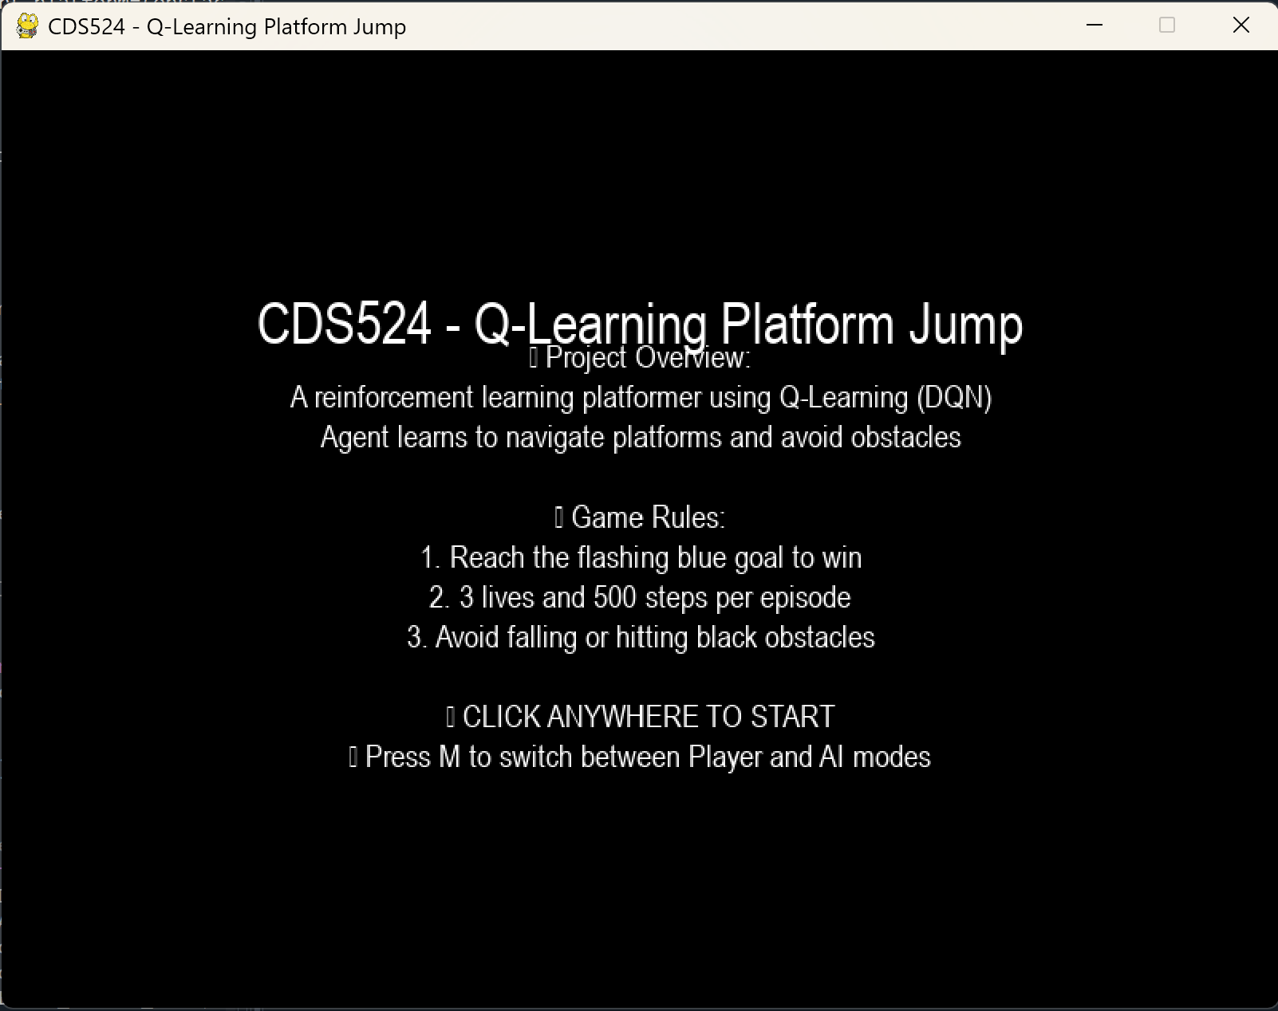
Gameplay interface
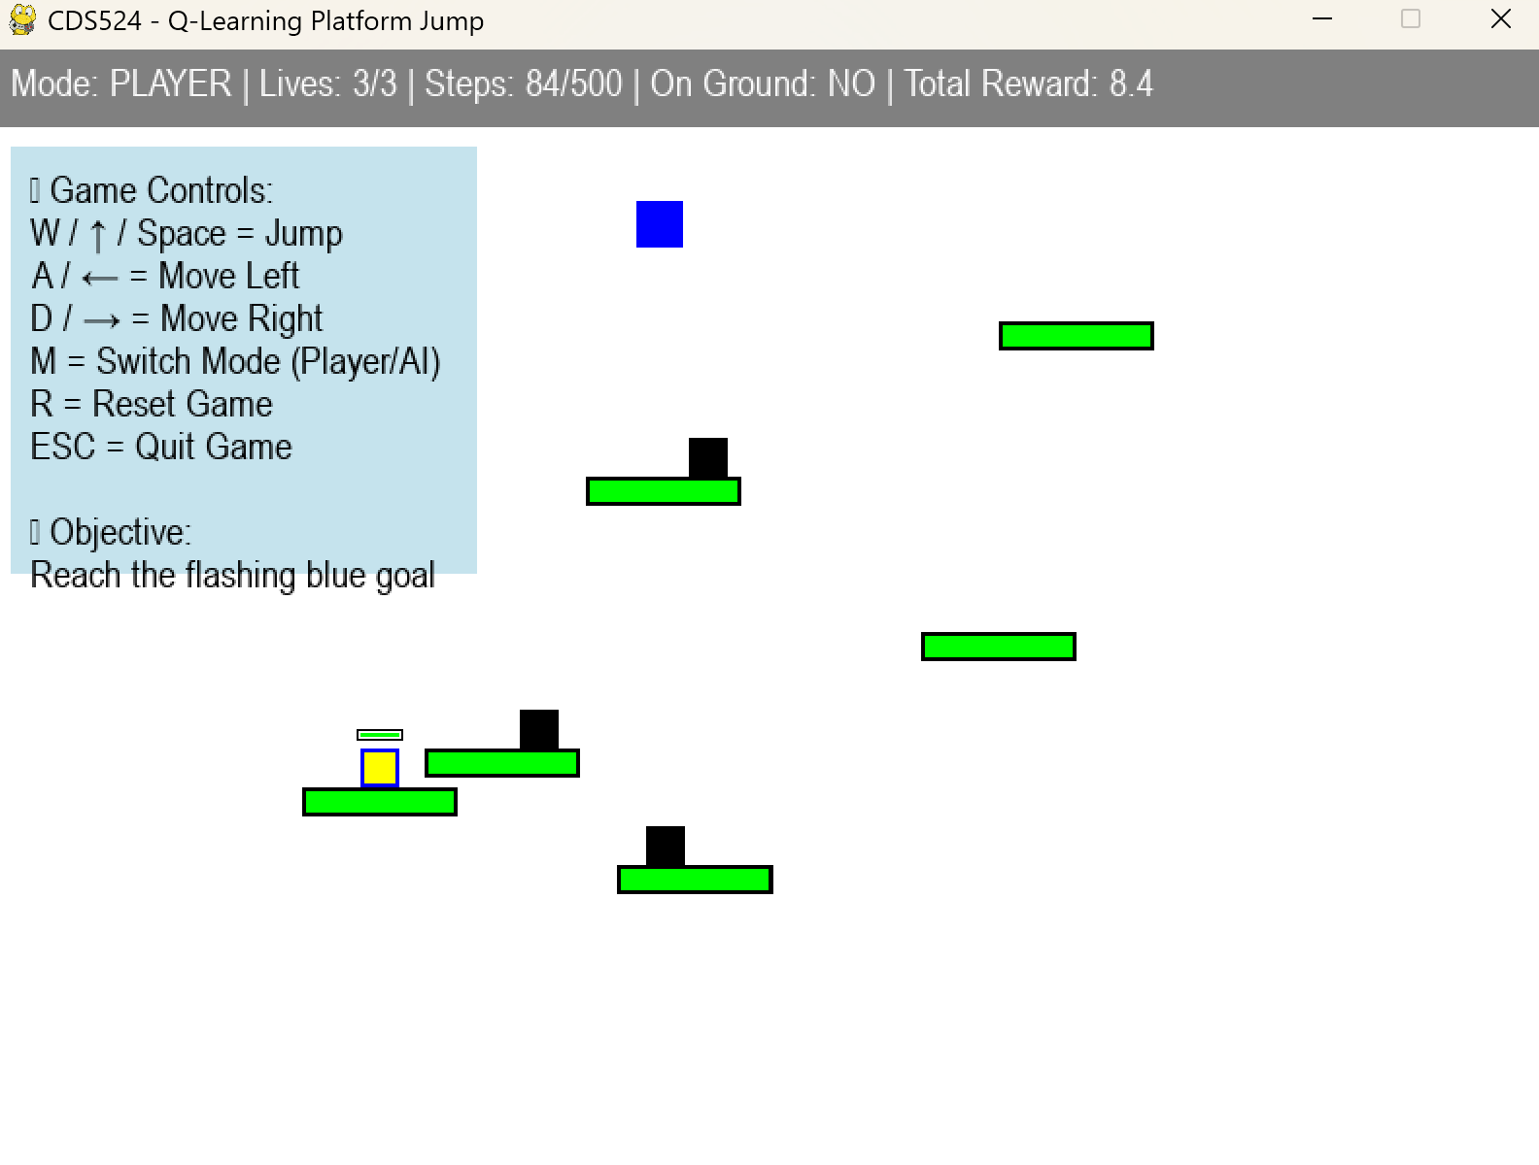
Flowchart of Q-Learning (DQN) algorithm
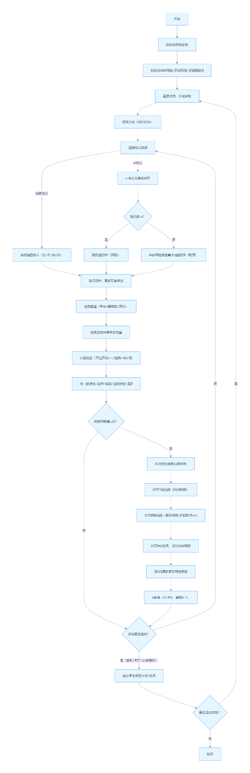
Game Design Diagram Core Elements
Element Type | Visual Style/Color | Code-Related Parameters | Rule Description
Player/AI Agent | Yellow square + border (Player=Blue border, AI=Red border) | PLAYER_SIZE=20, Player class | Spawns on green start platform, 3 lives total, max 500 steps per episode; can move left/right and jump
Start Platform | Green rectangle (no obstacles) | Platform(is_start_platform=True) | Fixed position: WINDOW_WIDTH//4 - PLATFORM_WIDTH//2; no obstacles allowed
Regular Platforms | Green rectangles | PLATFORM_WIDTH=80, PLATFORM_HEIGHT=15 | 6 randomly generated in layers; moving obstacles spawn on some platforms
Moving Obstacles | Black squares | OBSTACLE_SIZE=(20,20), Obstacle class | Move left/right along platforms; collision resets player position and reduces lives
Goal Point | Flashing blue/light-blue rectangle | Goal class, GOAL_FLASH_INTERVAL=1200 | Randomly generated in upper area; collision triggers game victory
Physics Rules | - | MOVE_SPEED=3, JUMP_FORCE=10, GRAVITY=0.5 | Horizontal speed = 3, jump force = 10, gravity = 0.5; death if falling 100px below window bottom
Reward Rules | - | calculate_reward function | +0.8 for approaching goal, +100 for victory, +0.1 per survival step; -50 for death, -0.5 for moving away from goal, -0.3 for timeout

