Required Capstone Checkpoint 5.1: Designing and Evaluating an Agent-Based RAG System

Directions
Download this worksheet and save a copy to your device before you begin working. Use this worksheet to plan, organize, and complete your submission for Required Capstone Checkpoint 5.1. Type your responses directly into the document, save your completed work, and upload the finished file when you are ready to submit.

Completion Checklist
☐ Description of the agent-based system and task
☐ Explanation of how the system coordinates retrieval, reasoning, and multistep execution
☐ Evaluation results from 2-3 representative multistep test cases
☐ Description of refinements made to the system
☐ Analysis of the impact of those refinements
☐ Reflection on system strengths, limitations, and future improvements

Step 1. System Design
Describe the task that your agent-based system is designed to complete.
Examples may include generating reports, answering complex questions, synthesizing information across multiple documents, or completing another multistep task relevant to your capstone scenario.
Task description
Response: Scenario: Research Paper Navigator, a question-answering system over 153 research papers.
Tasks: Answer research questions that need more than one lookup, such as a result buried deep inside a few passages of a paper, gather evidence from unrelated papers, perform comparison of papers.

Agent workflow: Describe how your system works
Consider:
How is retrieval incorporated into the workflow? The planner first decides whether the question needs the papers. If it does, it calls one tool, graph_retrieve, which passes the user's question to my Checkpoint 4.1 graph retrieval in one shot: 4.1 splits it into sub-queries, finds papers through passage matches and “paper compares against tool” relations, searches inside them and adds the passages that follow. It returns 8 labelled passages, and the agent answers from exactly those. Retrieval runs at most once per question.
How does the system perform reasoning or intermediate processing? The planner is one LLM call that returns a schema-enforced JSON decision {action, reasoning, clarifying question, focus}. It chooses graph_retrieve, clarify, or answer directly (greetings, “what can you do”, follow-ups already answered). For a question comparing two or more named papers, it lists them as focus, and retrieval spends its 8 passages inside those papers (refinement, Step 3).
Any iterative or multistep behaviours? plan → (clarify → plan) → graph_retrieve → answer. Clarify pauses once for ambiguous wording (batch mode: states an assumption). The multi-step retrieval happens inside the 4.1 tool: decomposition → find papers → search inside them → read on. A step limit and unparseable decisions default to retrieving once and answering.
Any prompts, tools, or workflow components used to guide agent behaviour? A system prompt that says when to retrieve, clarify or answer directly; a LangGraph state graph (plan, graph_retrieve, clarify, answer); the enforced JSON schema; 4.1's answer prompt with PRIMARY/CONTEXT labels; and a code check that uses focused retrieval only when two or more named papers resolve.
Figure 1. The agent's plan, graph_retrieve and answer steps.
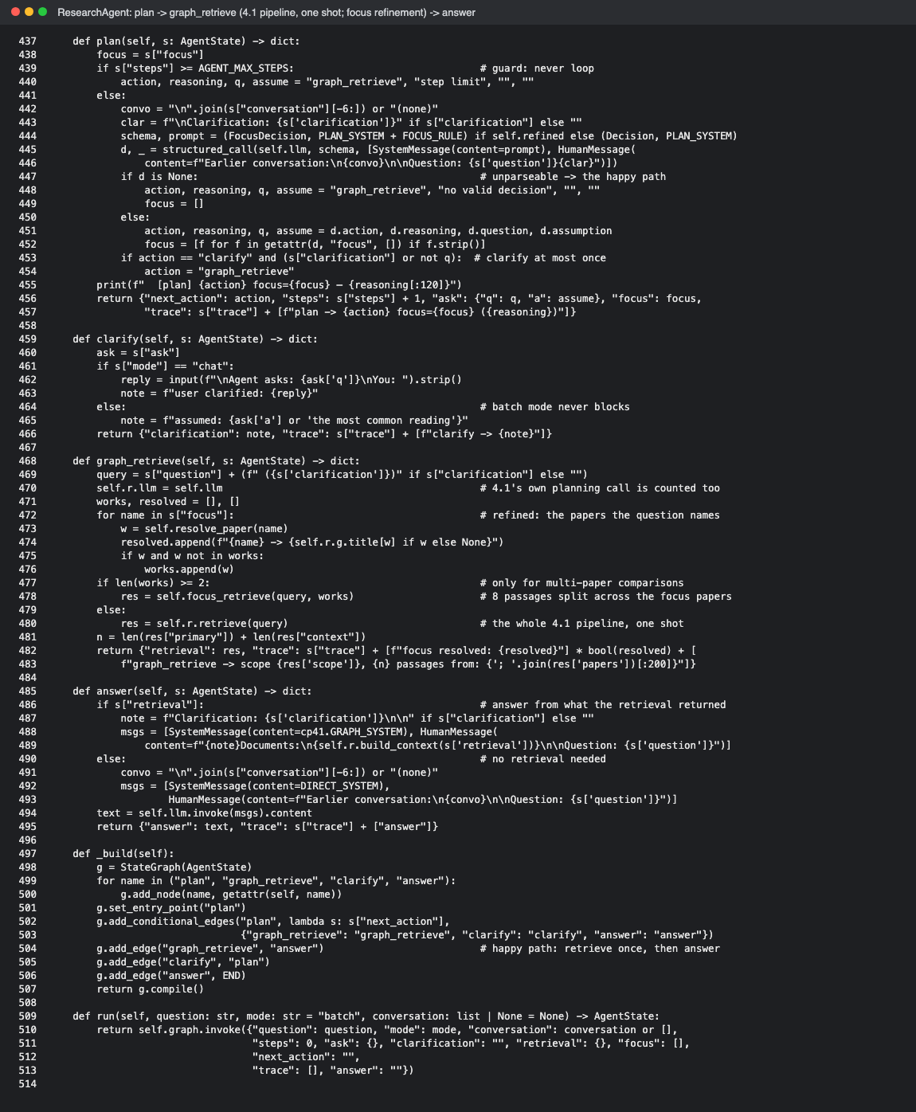

Step 2. Initial Evaluation
Develop and evaluate your system using 2-3 representative test cases for your capstone scenario. Each test case should require more than one retrieval step or action.
For each test case, compare the agent-based system with your fixed retrieval pipeline from Checkpoint 2.1 or 3.1. Record relevant differences in answer quality, completeness, retrieval behavior, model calls, latency, or cost.
Evaluation results
Summarize the results of your testing:

Strengths observed
Response:
Test cases (each needs several retrieval steps): Q1 a result buried in one paper; Q2 evidence across unrelated papers; T3 “What did Castor and Hectare compare themselves against, why do the authors say those tools fall short, and how much better did each do?”. Q1 and Q2 are my 3.1 questions; to test robustness I added 4.1's other four (Q3–Q6). 3 runs each, same 3.1 LLM judge.
Results (7 questions): fixed 2.1 pipeline 2.00/7 passes, evidence reached 31%, 1 LLM call, 2.2 s; initial agent 3.33/7, 58%, 3 calls, 5.7 s; fixed 4.1 pipeline 3.67/7, 58%, 2 calls, 5.6 s.
• Better than the 2.1 baseline: Q1 0/3 → 3/3 (“terminated in 606 seconds and uses 28,000 samples”); evidence 31% → 58%.
• Predictable and cheap: every research question ran plan → graph_retrieve → answer in exactly 3 calls; a greeting was answered without retrieval in 2.
• Grounded: when evidence was missing, answers said so instead of guessing.

Weaknesses or challenges identified
Response:
• No gain over the 4.1 pipeline (3.33 vs 3.67 of 7) for one extra call.
• T3 failed (0/3): 4.1 planned it as a single-paper question and read only Castor's paper; in other runs, multi-paper mode spends its 8 passages on 8 papers, one each, so each named paper gets one shallow passage.
• Fragile to wording: an earlier, more technical T3 wording scored 2/3 after refinement; the natural wording 0/3.
• Evaluation limits: Q2 and Q6 fail for every system (grading notes accept only specific papers; ReaS is valid but unlisted); Q3 fails when the answer omits the name “thermometer continuations”.

Step 3. System Refinement
Based on your evaluation results, make one or more improvements to your system. Examples may include:
- Improving system prompts
- Adjusting workflow structure
- Modifying retrieval behavior
- Improving how the agent uses retrieved information
Changes implemented
Response:
Refinement 1 (workflow + prompt): the planner's decision gains a focus list, the papers the question names. graph_retrieve stays one call with the user's question, but splits its 8 passages across those papers (4 each for two) instead of one passage from each of 8 papers.
Refinement 2 (after the wider test): focus applies only to questions comparing two or more named papers. A prompt rule lists only the papers the question is about, not baselines, and a code check uses focused retrieval only if two or more papers resolve.
Tried and rejected: rewriting 4.1's decomposition prompt so sub-queries read like sentences in a paper (no change: 1.00/3).

Justification
Response:
Refinement 1 targets the T3 diagnosis: spread over 8 papers, Castor's single passage listed “Hyper, Cozy and Chestnut” but not “Cozy uses an SMT solver to verify candidates, which does not scale”. It raised T3 to 2/3, but on the wider set it broke Q4 (3/3 → 0/3): the planner put DreamCoder, a baseline, in focus and retrieval read only DreamCoder's paper. Refinement 2 removes that cause. The prompt rule alone was not reliable (the planner still listed DreamCoder once); the code check caught it.

Step 4. Impact of Refinement
Evaluate the updated system. Describe any changes in task completion, accuracy, relevance, or overall system behavior. Compare the refined agent-based system with both its initial version and the fixed baseline. Explain whether the refinement improved performance and identify any trade-offs.

Impact on system performance
Response:
7 questions, 3 runs each: final agent 3.67/7 passes, evidence reached 69% (best of all systems; initial 58%), papers 67%, 3 calls, 6.9 s. Q4 is back to 3/3; on T3 both papers are found every run (initial: Castor only) and evidence rises from 0/3 to 2/3 per run, but T3 still fails because the Cozy–SMT passage is not reached.
Trade-offs: the pass gain over the initial agent is small (1 of 21 runs; results vary 3–4 passes per run), so the evidence gain is the reliable signal; about 1 s slower. The final agent ties the fixed 4.1 pipeline on pass rate.
Figures 2–3. T3: the planner names Castor and Hectare, one retrieval. Q4: the planner wrongly lists DreamCoder, the code check keeps the 4.1 path, answer correct.
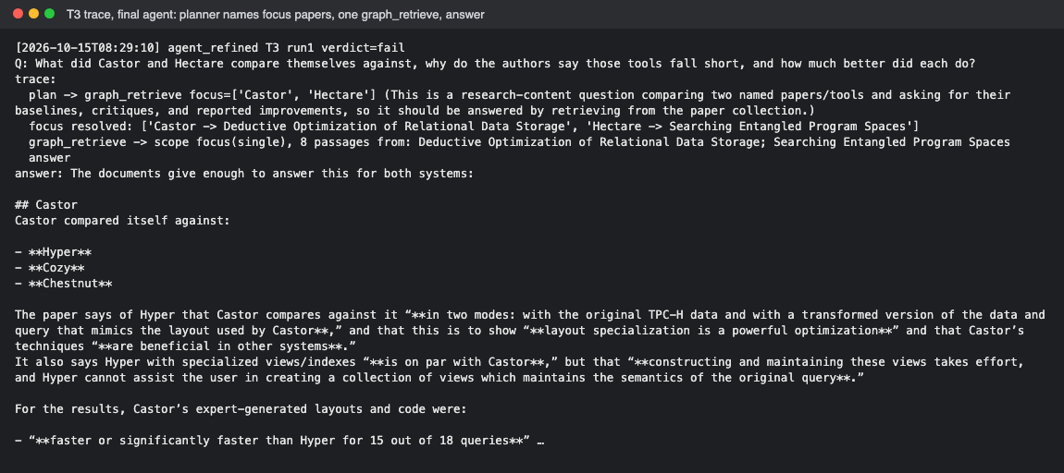
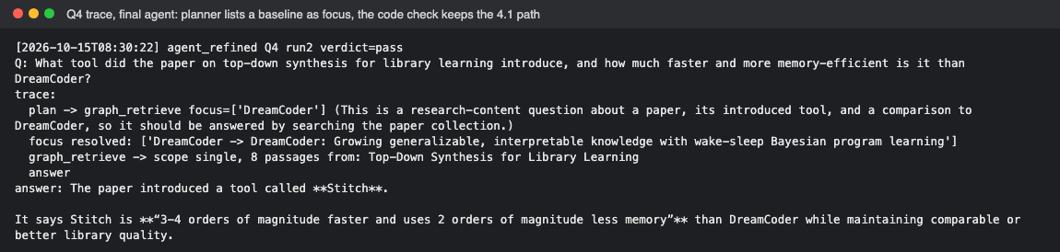

Comparison of initial and refined systems
Response:
Passes (of 7), evidence reached, LLM calls, latency:
• Fixed 2.1 pipeline: 2.00, 31%, 1, 2.2 s
• Fixed 4.1 pipeline: 3.67, 58%, 2, 5.6 s
• Initial agent: 3.33, 58%, 3, 5.7 s
• Refinement 1 (any named paper): 2.00, 56%, 3, 5.8 s (Q4 regressed)
• Final agent (Refinement 2): 3.67, 69%, 3, 6.9 s; no question worse than the initial agent.
Figure 4. Full results.
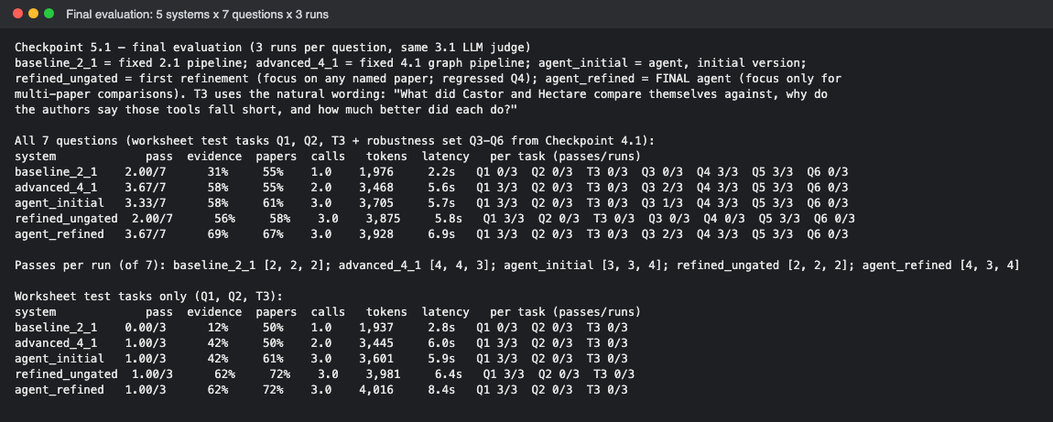

Step 5. Reflection
Reflect on your experience designing and evaluating an agent-based RAG system.
What contributed most to successful task completion?
Response:
Using my 4.1 graph retrieval as one tool, so the agent never rebuilds the retrieval strategy (earlier versions that split retrieval into 4–6 tools scored 0.00–1.00 of 3); an enforced JSON schema for decisions; checks written in code rather than prompt rules; and widening the test set, which exposed the regression.

What limitations remain?
Response:
The agent does not beat the fixed 4.1 pipeline on pass rate and adds one call. Results are sensitive to question wording (T3), grading notes are narrow (Q2, Q6) or demand exact names (Q3), and 7 questions × 3 runs with one judge is still noisy. Answers sometimes report the wrong comparison (Castor vs Hyper instead of Cozy).

What improvements would you prioritize next?
Response:
Route simple questions straight to 4.1 (skip the planner call); rank inside focus papers with the question weighted higher; fix grading notes to accept valid alternatives and add partial credit and a different judge model; build a larger test set with paraphrases of each question; and check that quoted numbers appear in the retrieved passages.

Supporting Materials
Use this section to list, describe, or link to any supporting materials included with your submission.
Supporting material | Location, link, or note
System prompts: | PLAN_SYSTEM, FOCUS_RULE, Decision/FocusDecision in the agent code; answer prompt GRAPH_SYSTEM from Checkpoint 4.1
Evaluation results: | checkpoint_5_1_summary.txt, checkpoint_5_1_results.json (every run)
Screenshots or diagrams: | screenshots/ (Figures 1–4, also embedded above)
Code, notebook, or repository link: | Capstone_Checkpoint_5.1 — run with --tag initial | refined, --chat, --tasks
Other supporting evidence: | checkpoint_5_1_agent.log (every step); experiments/ (refinement options A and B tested); exploration_v1_v4/ (earlier agent versions)

End of Required Capstone Checkpoint 5.1
Return to the assignment page in the learning platform to upload and submit your completed capstone checkpoint worksheet and complete any remaining items in this module.

