Required Capstone Checkpoint 4.1: Advanced Retrieval Implementation

Directions

Download this worksheet and save a copy to your device before you begin working. Use this worksheet to plan, organize, and complete your submission for Required Capstone Checkpoint 4.1. Type your responses directly into the document, save your completed work, and upload the finished file when you are ready to submit.
Completion Checklist
☐ Identification of a meaningful retrieval failure or limitation supported by evaluation evidence
☐ Analysis of the likely cause of the retrieval failure
☐ Selection and justification of an advanced retrieval strategy
☐ Evidence of implementation of the updated retrieval architecture
☐ Evaluation results comparing the updated system against the baseline system
☐ Reflection on the effectiveness of the architectural changes and any remaining limitations

Step 1. Retrieval Failure Identification
Identify a meaningful retrieval limitation in your current retrieval system.
- Describe the failure or limitation.
- Explain how the limitation affects retrieval performance.
- Reference evaluation evidence, test results, queries, or outputs that demonstrate the issue.
Retrieval failure or limitation
Response:
System overview. Research Paper Navigator: Q&A over 153 research papers (mostly program synthesis and PL), for researchers checking specific claims. The 2.1 baseline indexes 148 papers as 8,087 chunks of about 1,500 characters. It runs a single hybrid search (BM25 + vector, blended 50/50) and sends the top 5 chunks to gpt-5.4-mini, which answers only from them. 3.1 evaluated it with an LLM judge on 4 questions.
The limitation: the retriever can't gather evidence that is spread out. Every chunk is scored in isolation, in one pass, by how well it matches the question. The index has no notion of how chunks relate: which ones are the same paper, the next passage, or a related paper. So retrieval works only when the whole answer sits in one chunk worded like the question, usually an abstract. It fails in two ways:
• Within a paper: the section introduction matches best, while the result sentence a few chunks later ranks just outside the top 5.
• Across papers: evidence spread over unrelated papers can't be collected with one query and 5 slots.
Duplicate copies make it worse: 29 papers appear twice, so identical chunks use up slots.
Impact. The system finds the right paper but not the evidence. Since the LLM correctly refuses to guess, each miss becomes an incomplete answer or a “not in the documents” reply.

Evidence supporting the identified limitation
Response:
From checkpoint_3_1_evaluation.log (4 questions, LLM judge validated 3/3 on known-answer cases):
• Overall: pass rate 1/4, but retrieval hit@5 3/4. The right paper was usually found; the evidence was not.
• Q1, within a paper: the start of the benchmark section (chunk 53) ranked 1st; the answer, “terminated in 606 seconds and uses 28,000 samples” (chunk 55), ranked 17th. All 5 slots came from two copies of the paper, so only 3 distinct passages reached the LLM, which replied that the numbers were not in the documents. FAIL.
• Q2, across papers: none of the expected papers (VeriFair vs FairSquare, Castor vs Cozy, Hectare vs Hoogle+) was retrieved; their chunks were outside both retrievers' top 20. MANTRA took 3 of 5 slots by matching the word “SMT”. FAIL.
• Q3, within a paper (paraphrased query): the right paper was found despite the paraphrase, but the timings (GNU Prolog ~20 s vs ML 14 s, chunk 61) ranked 16th, and 2 slots were duplicates. FAIL.
• Q4, control: the answer is in the abstract, which ranked 1st. PASS.

Step 2. Failure Analysis
Analyze why the retrieval failure occurs. Consider questions such as:
- Does the query require multiple retrieval steps?
- Is relevant information distributed across multiple documents, conversations, or entities?
- Is excessive irrelevant information being retrieved?
- Are important relationships within the data not represented effectively?
- Are there other factors contributing to the failure?
Likely cause(s) of the retrieval failure
Response:
• The question needs more than one retrieval step. Q2 needs one lookup per paper (three unrelated papers); Q1 and Q3 need two hops: find the benchmark section, then the result sentence inside it. The baseline runs exactly one search.
• Relationships in the data are not represented. Chunks are stored as a flat list. Nothing records which chunks belong to the same paper, which comes next, which files are copies of the same paper, or which papers are related (e.g. by the tools they compare against). So the system cannot move from a hit to its neighbours.
• Too much irrelevant or redundant context. Generic terms match widely (54 of 148 papers mention “SMT”), so MANTRA filled 3 of Q2's 5 slots; duplicate copies filled 2 slots in Q1 and Q3.
• Wording mismatch (a query problem). Result sentences use different words from the question (“terminated in 606 seconds” vs “how long did the fairness verifier take”), and Q3 paraphrases the technique entirely.
• Other factors: a fixed top-5 budget; only 20 candidates per retriever, so Q2's evidence never entered the pool; and min-max score blending produced exact 0.500 ties (Q3).

Why the current retrieval architecture struggles
Response:
The architecture ranks each chunk independently against one query, keeps the top 5, and stops. Three consequences follow:
• Nothing rewards related evidence. A chunk two passages after a strong hit gets no credit for being next to it, so the result sentence stays at rank 16–17.
• No coverage or diversity. Top-k picks the 5 best-matching chunks even if they are copies of each other or all from one paper, so a multi-paper question cannot be covered.
• No second attempt. If the first query's candidate pool misses a paper (Q2), nothing later can recover it, and the LLM cannot answer from text it never sees.
Better query wording (Lab 4.1) can fix the wording mismatch and give better starting points, but it does not solve the relationship problem. That needs the relationships stored in the data and followed at retrieval time (Lab 4.2).

Step 3. Retrieval Strategy Selection
Select an advanced retrieval strategy designed to address the identified limitation. Examples may include:
- Query rewriting
- Query decomposition
- Retrieval fusion
- Multi-hop retrieval
- Relationship-aware retrieval
- Graph-based retrieval
- Another advanced retrieval approach
Selected retrieval strategy
Response:
Graph-based multi-hop retrieval, seeded by query decomposition. Two techniques, one for each kind of cause in Step 2:
• Primary (data side, Lab 4.2): a paper graph walked in hops. Nodes: paper (one per PDF, with its title), chunk (the text passages) and tool (the systems papers introduce or compare against). Edges: has_chunk and next_chunk (each paper's passages in reading order), duplicate_of (a conference/arXiv copy points to the published paper), introduces and compares_against (paper → tool). Hop 1 finds candidate papers; hop 2 searches inside them for the exact passage; the graph then adds the following passages, labelled PRIMARY or CONTEXT in the prompt.
• Supporting (query side, Lab 4.1): query decomposition. The LLM rewrites the question into 2–4 sub-queries in the vocabulary a paper would use, giving the graph better starting points.
Minor fix: reciprocal rank fusion (RRF) replaces the 50/50 score blending, removing the 0.500 ties; results are summed across sub-queries.
Each part is tested on its own (decomposition only, graph only) to show it earns its place.

Justification for the selected strategy
Response:
Each part targets a cause from Step 2:
• More than one step needed: sub-queries cover each paper in Q2; hop 2 reaches the result sentence inside the paper (Q1, Q3).
• Relationships not represented: the graph stores them, so retrieval can move from a hit to the next passage or to a related paper.
• Redundant context: merging duplicate copies and capping chunks per paper frees slots for distinct evidence.
• Wording mismatch: rewriting sub-queries in the paper's terms.
• Ties and small candidate pool: RRF and a wider first-hop pool.
Why both techniques, not one. Decomposition alone cannot fix Q1: chunk 55 is hard to rank because of where it sits, not how the question is worded. A graph alone starts from the baseline's hits, so a wrong start (MANTRA in Q2) only adds more wrong context, as noted in Lab 4.2. Decomposition supplies better starting points; the graph follows the relationships from there.
Alternatives rejected. Simply raising top-k (e.g. to 20) would include chunk 55 but floods the LLM with loosely related text and still misses Q2, whose evidence was outside the top 20. Other relationships the starter suggests were left out: shared authors (one author is on most papers, so the edge connects almost everything; the parser also did not keep author lists), citations (would need re-parsing reference lists, and no failure involved them), and shared-keyword topics (tried; they linked VeriFair to an unrelated RNA paper via “LSTM”).

Step 4. Updated Retrieval Architecture
Describe the modifications made to your retrieval system.
- Summarize the architectural changes.
- Explain how the updated approach differs from the baseline system.
- Include implementation evidence where appropriate.
Description of architectural changes
Response:
Baseline: one hybrid search, top 5 chunks, each chunk ranked on its own. Updated pipeline (the 2.1 index, LLM and answer prompt are reused):
• Data redesign: a paper graph (networkx, built in ~1 s at startup). Nodes: paper (148, one per PDF), chunk (8,087), tool (458). Edges: has_chunk and next_chunk keep each paper's passages in reading order, like an email thread in Lab 4.2; duplicate_of (29) points each conference/arXiv copy to its published paper, so retrieval searches 119 distinct papers; introduces (95) and compares_against (409) link a paper to its own tool and to the baselines it compares against, storing the baseline's technique and the limitation the paper claims. The tool relations are extracted once by the LLM from each paper's comparison sentences and cached.
• LLM in retrieval (Lab 4.1): one call rewrites the question into 2–4 sub-queries in the papers' vocabulary and plans the scope: one paper in depth (“single”) or several papers (“multi”).
• Hop 1, find papers (over-fetch): each query is matched with BM25 + vectors, fused by reciprocal rank fusion, against all chunks (top 50) and all compares_against relations (top 10). Matches vote for their paper; duplicates count once.
• Hop 2, narrow down: single → search inside the top paper for 5 PRIMARY chunks, then add the 3 passages that follow PRIMARY 1 (Lab 4.2's closest thread neighbours) as CONTEXT. Multi → the best passage from each of 8 papers, preferring the passage that names the matched baseline.
• Prompt: always 5 PRIMARY + 3 CONTEXT chunks, each labelled with how it was reached (e.g. “passage 2 after PRIMARY 1”, “paper reached via relation: Castor is compared against Cozy…”).
How it differs from the baseline: retrieval now follows relationships (same paper, reading order, compared-against) instead of scoring chunks in isolation, and sends 8 distinct passages instead of slots wasted on duplicate copies.
Tried and dropped: shared-keyword topic edges (they linked VeriFair to an unrelated RNA paper via “LSTM”), and re-ranking neighbours by similarity (it skipped chunk 56, and once the LLM invented “34,000 samples” from a cut-off sentence).

Implementation evidence (e.g., screenshots, code snippets, retrieval outputs, notebook excerpts)
Response:
Repository: github.com/Tsingh315/llm-rag-capstone → Capstone_Checkpoint_4.1
• Code: capstone_checkpoint_4_1_advanced_retrieval_starter.py (PaperGraph, extract_relations, plan_query, GraphMultiHopRetriever)
• Retrieval log: checkpoint_4_1_responses.log (per question and system: sub-queries, scope, papers, PRIMARY/CONTEXT chunks, answer, verdict)
• Results: checkpoint_4_1_run_output.txt (summary tables) and checkpoint_4_1_results.json (every run)
• Unmodified course starter, for comparison: capstone_checkpoint_4_1_advanced_retrieval_starter_ORIGINAL.py
Figure 1. Graph built at startup and the my_advanced_plan() output.
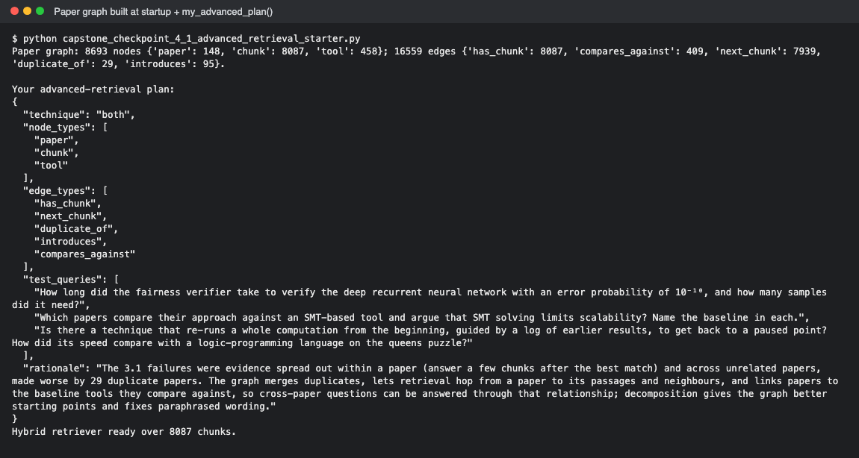
Figure 2. The new retrieve() method: plan → hop 1 → hop 2 (single / multi) → labelled context.
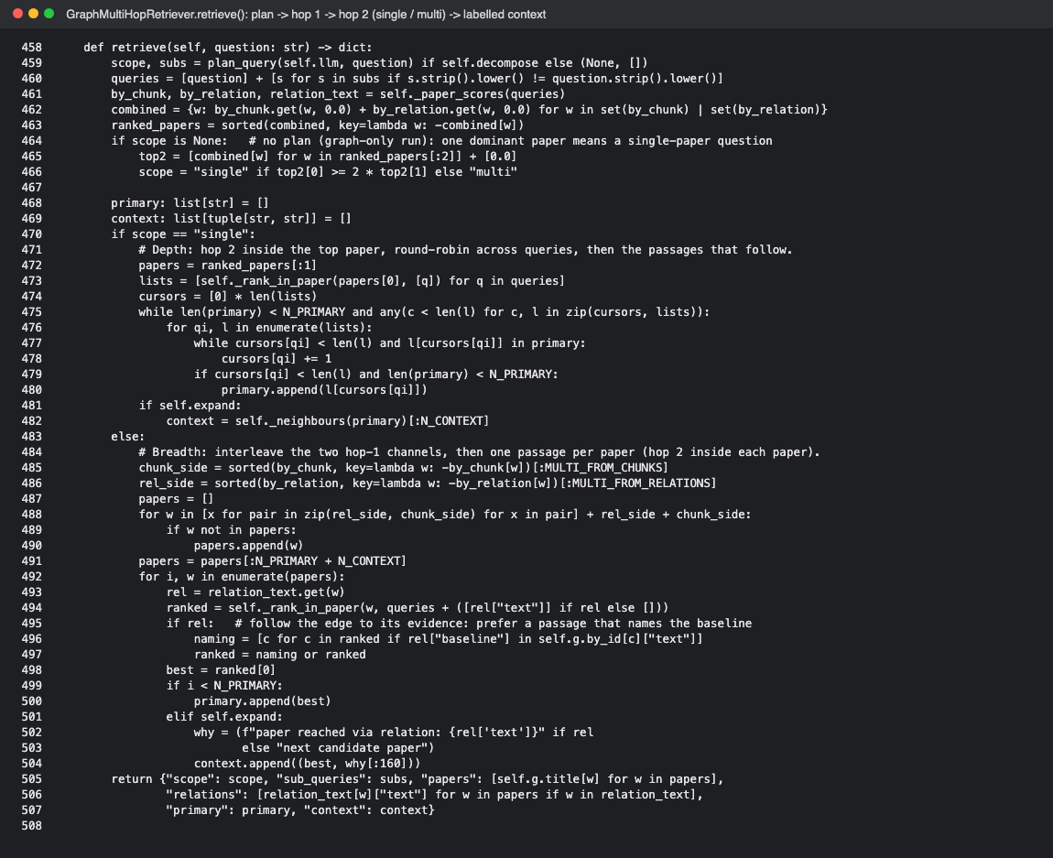
Figure 3. Q1 trace: scope single, one paper, PRIMARY chunks plus passages 1–3 after PRIMARY 1. Chunk 56 holds the answer, which the baseline never retrieved.
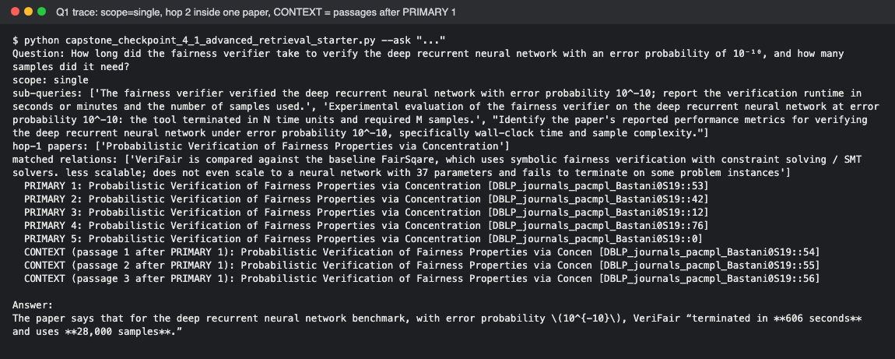

Step 5. Evaluation Results
Evaluate the updated system using the evaluation framework developed in previous modules.
- Present evaluation results.
- Compare performance against the baseline system.
- Include representative examples.
Evaluation Metric | Baseline Result | Updated Result
Judge pass rate (3.1 set Q1–Q4, mean of 3 runs) | 1.00 / 4 (same at k=5 and k=8) | 3.00 / 4
Passes per question, Q1 / Q2 / Q3 / Q4 (out of 3 runs) | 0 / 0 / 0 / 3 | 3 / 0 / 3 / 3
Answer evidence reached the LLM (exact answer sentence among the retrieved chunks) | 22% | 78%
Expected papers retrieved | 50% | 72%
Distinct passages sent (out of 8) | 6.5 (duplicate copies) | 8.0
Cost per question: LLM calls / latency | 1 / 1.7 s | 2 / 4.9 s (+ one-time ~119 calls to extract tool relations, cached)
Extended set Q1–Q6 pass rate (adds Q5 Hectare, Q6 Sketch) | 2.00 / 6 | 4.00 / 6
Judge validation (known-answer cases, same 3.1 judge) | 3 / 3 | 3 / 3

Example 1: Query, retrieved information, and result
Response:
Q1 (within a paper): How long did the fairness verifier take to verify the deep recurrent neural network with an error probability of 10⁻¹⁰, and how many samples did it need?
• Baseline (k=8): the 8 slots held only 4 distinct passages (chunks 53, 0, 42, 43, each from both copies of the paper). Answer: “The provided documents do not give the specific running time or sample count.” FAIL (0/3 runs).
• Advanced: scope single → one paper (the arXiv copy skipped via duplicate_of). PRIMARY: chunks 53, 42, 0, 76, 5; CONTEXT: passages 1–3 after PRIMARY 1 = chunks 54, 55, 56. Chunk 56 holds the answer. Answer: VeriFair “terminated in 606 seconds and uses 28,000 samples.” PASS (3/3 runs). See Figure 3.

Example 2: Query, retrieved information, and result
Response:
Q3 (paraphrased question, answer deep in the paper): Is there a technique that re-runs a whole computation from the beginning, guided by a log of earlier results… How did its speed compare with a logic-programming language on the queens puzzle?
• Baseline (k=8): an unrelated paper (StatusQuo) ranked first and both copies of the right paper took slots; the timings chunk (61) was not retrieved. The answer described the replay idea but gave no Prolog comparison. FAIL (0/3).
• Advanced: the sub-queries rephrased the question in technical terms (“replaying … from the initial state using a log of intermediate results”, “N-queens benchmark”); scope single → hop 2 inside the right paper put chunk 61 among the PRIMARY chunks. The run-1 answer named “thermometer continuations” and quoted “For N=13, GNU Prolog takes around 20s, while our slowest ML versions run in 14s.” PASS (3/3).

Example 3 (optional)
Response:
Q2 (across papers, still failing): Which papers compare their approach against an SMT-based tool and argue that SMT solving limits scalability? Name the baseline in each.
• Baseline (k=8): MANTRA, which only matches the word “SMT”, filled 4 of 8 slots; none of the expected papers was retrieved. Answer named ReaS (dReal) and Metric Program Synthesis. FAIL.
• Advanced: scope multi; papers reached through compares_against relations, e.g. “Castor is compared against the baseline Cozy, which uses an SMT solver…”. Answer named Castor vs Cozy, quoting “Cozy uses an SMT solver to verify candidates, which does not scale”, and ReaS vs dReal. Expected papers retrieved rose from 0/3 to 2/3, but only one listed pair was named, so FAIL (0/3; 1/3 in an earlier run). ReaS is a valid answer missing from the grading notes. See Figure 4.
Figure 4. Q2 trace: scope multi, papers reached via compares_against relations.
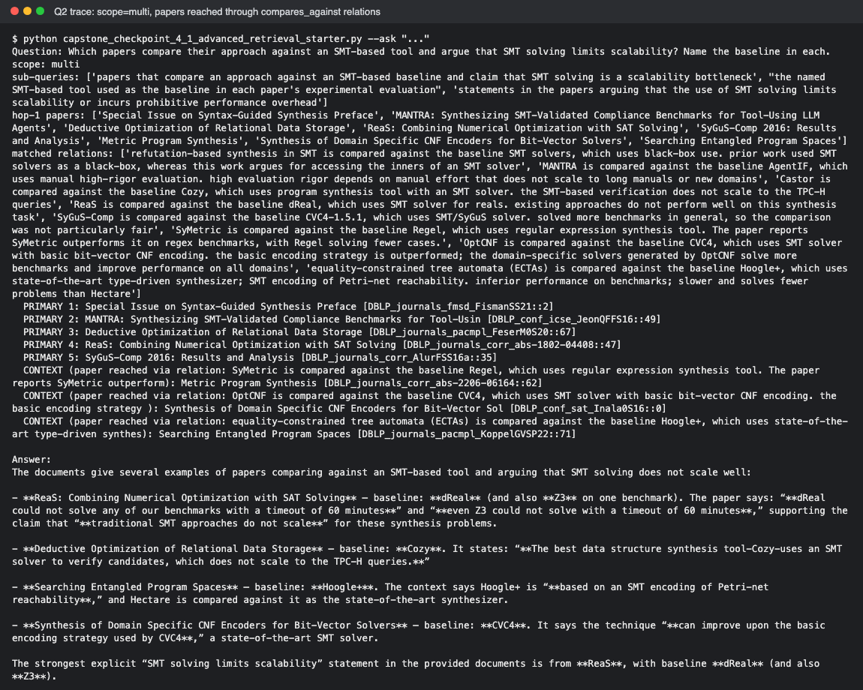
Figure 5. Full evaluation output (5 systems, 3 runs each, matched 8-chunk budget).
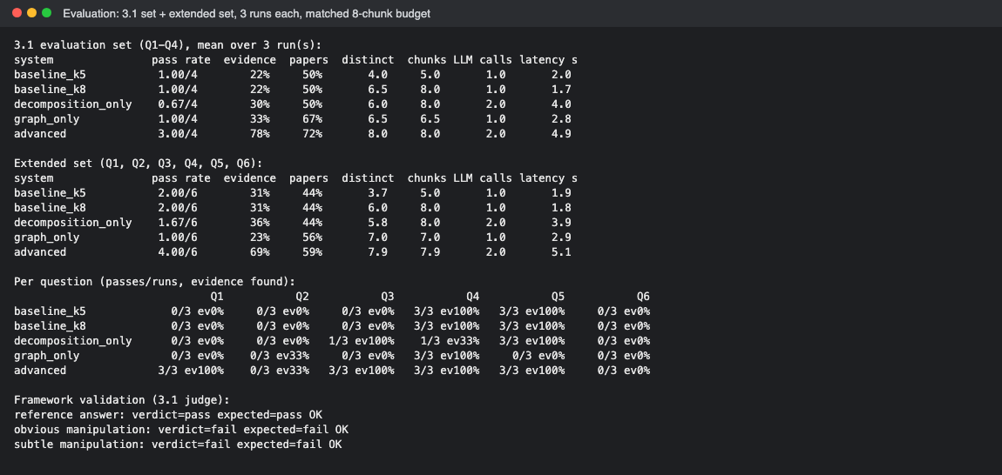

Step 6. Architectural Impact Analysis
Analyze the impact of the retrieval strategy.
- What improved?
- What remained challenging?
- Did the strategy address the original failure?
Improvements observed
Response:
• Pass rate: 1.00 → 3.00 / 4 at the same 8-chunk budget; answer evidence reached the LLM 22% → 78%.
• Within a paper: Q1 and Q3 went from 0/3 to 3/3 (next_chunk reached chunk 56; searching inside the paper found chunk 61).
• Duplicates: eliminated by duplicate_of; 8 distinct passages instead of 6.5.
• Across papers (partly): expected papers retrieved 50% → 72%; Q2 now finds Castor vs Cozy through compares_against.
• Both techniques were needed: decomposition only 0.67/4, graph only 1.00/4, combined 3.00/4.

Remaining limitations or challenges
Response:
• Q2 still fails (0/3): many papers compare against SMT solvers, so VeriFair and Hectare often miss the 8-paper cut.
• Cost: 2 LLM calls and ~5 s per question vs 1 call and ~2 s, plus a one-time extraction (~119 calls).
• Noisy context: topic edges linked unrelated papers (dropped); a cut-off passage once led the LLM to invent “34,000 samples”.
• LLM-made data: extracted relations can be wrong (e.g. “FairSqare”), and the single/multi plan can misclassify.
• Evaluation: 4 questions, 3 runs, results vary between runs; same model answers and judges; grading notes miss valid answers (ReaS in Q2, Q6).

Did the strategy address the original failure?
Response:
Mostly. The within-paper failure is fixed reliably (Q1, Q3: 0/3 → 3/3) and duplicate slots are gone. The across-paper failure is only partly fixed: the right papers reach the LLM more often, but not reliably enough for Q2 to pass.

Step 7. Reflection and Next Steps
Reflect on the effectiveness of the architectural redesign.
- What did you learn from implementing this strategy?
- What would you improve next?
- Are there additional retrieval failures that still need to be addressed?
Reflection on the architectural redesign
Response:
• The problem was the data, not the wording. Rewriting queries alone helped little and inconsistently (0.67/4 in the final run, 1.67/4 in an earlier one); representing relationships made the difference.
• A graph needs good starting points. Alone it scored 1.00/4, as Lab 4.2 warned; decomposition supplies the starting papers and the single/multi plan.
• Every edge must earn its place. Generic edges (shared topics) added noise; specific ones (next_chunk, compares_against) fixed measured failures.
• More context is not better. A fixed, labelled budget beat simply raising k, and following reading order beat re-ranking by similarity.

Specific improvements or next steps
Response:
• Q2: a larger budget or a reranker for multi-paper questions; citation edges from GROBID reference lists.
• Grounding check: verify quoted numbers against the retrieved chunks to catch invented values.
• Evaluation: more questions (trend, follow-up, out-of-corpus), grading notes that accept valid alternatives, a “partial” verdict, a different judge model, more runs.
• Engineering: store the graph instead of rebuilding it, and cache sub-queries to reduce latency.

End of Required Capstone Checkpoint 4.1
Return to the assignment page in the learning platform to upload and submit your completed capstone checkpoint and complete any remaining items in this module.

