Documentation & Validation:

Documentation:
Innovation Brefing:
1. Same user’s barcode is not accepted.
2. If this user has borrowed a book, this user’s ID cannot be removed before he/she returns the book.
3. Same book’s ISBN is not accepted.
4. If a book has been loaned, it cannot be remove before it is returned.
5. Due date calculated by my code is 30 days after the borrow date(today).
6. If the book has been loaned, it cannot be loand again before it is returned.
7. I added a function of returning a book.

Details:
Please use firefox browser to open these page, because I use grid to divide the input and the result section. Here is a page example:
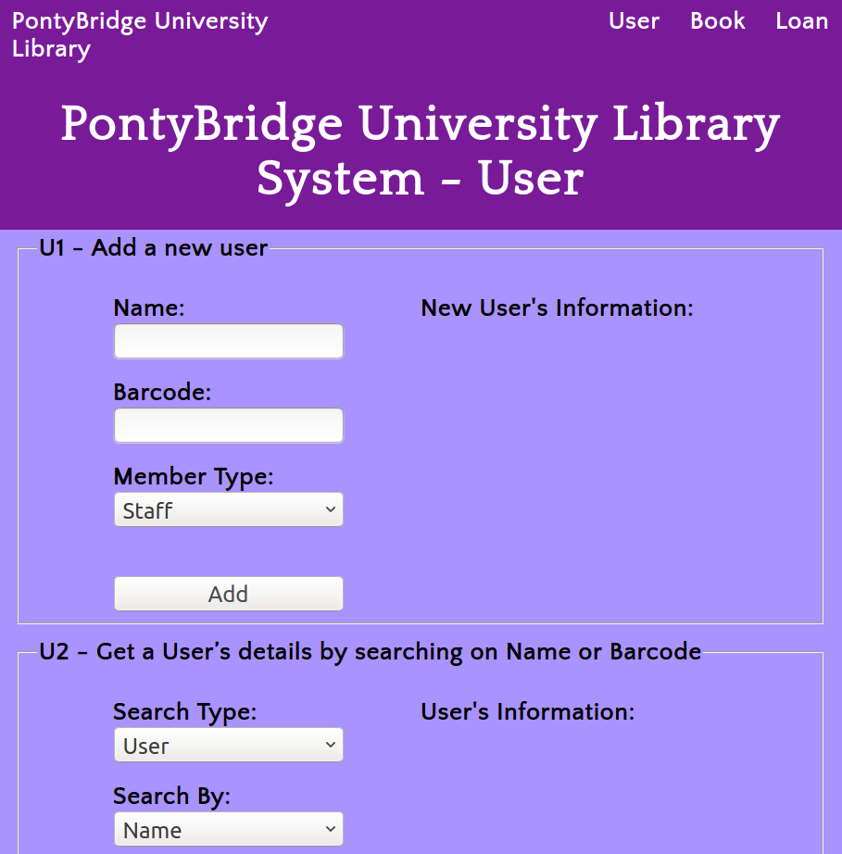

U1:
Enter the name, barcode and choose a member tyep to add a user.The result will be shown on the right if new user is added successfully.
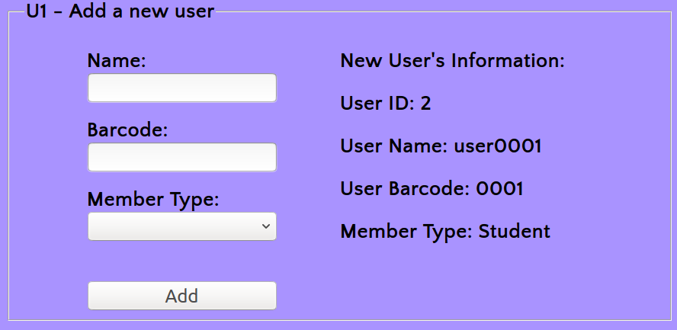
Error alert: If one of these information is null, new user cannot be added. Plus, I think barcode is the primary key and that’s why I set a limitation on entering an existed barcode.
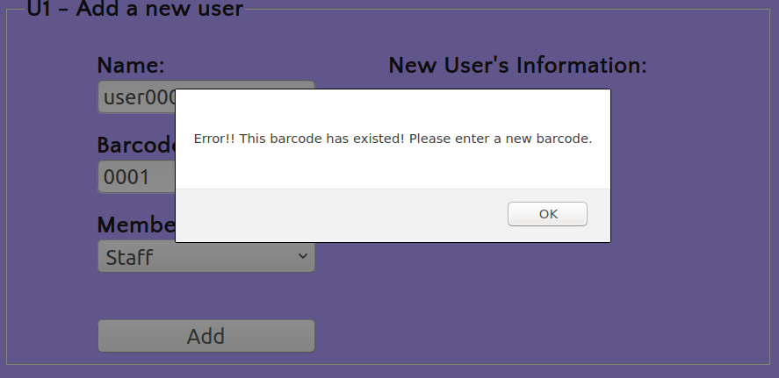

U2:
You should enter the name or barcode first the you can search user’s information.
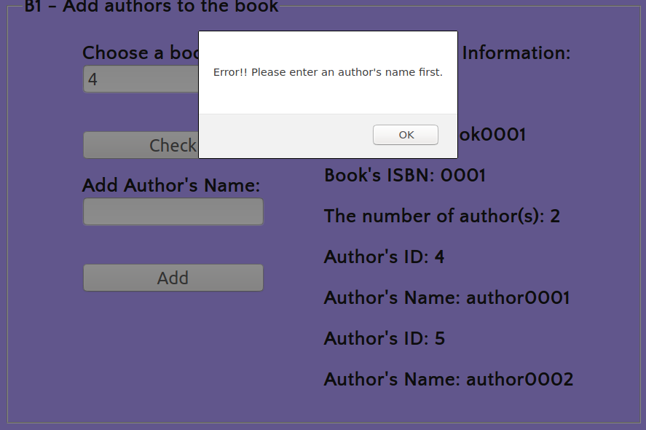

U3:
You shoule enter an user’s ID first, then you can update the name or the member type. Otherwise, this website will alert you a error.
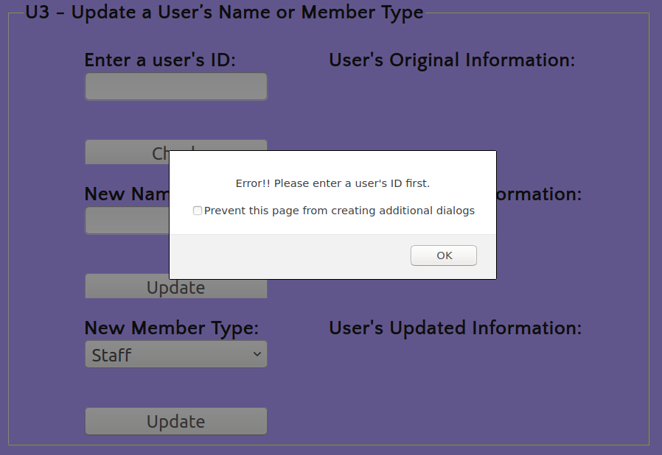

U4:
You shoule enter an user’s ID first, then you can remove the user. Otherwise, this website will alert you a error.
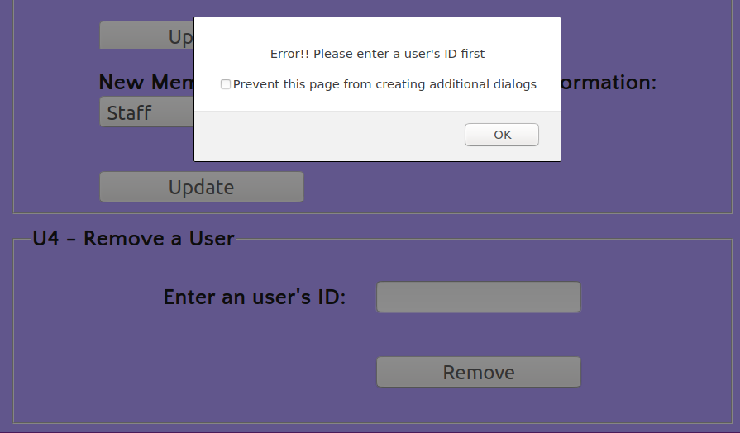
Plus, if this user has borrowed a book, this user’s ID cannot be removed directly. After this user return the book(s), you can remove this user.
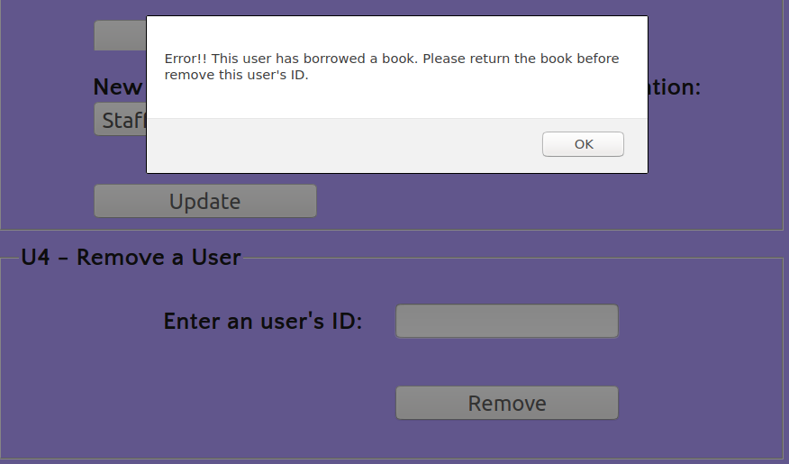
B1 – Add a new book with Title & ISBN:
The instruction is similar to U1’s. Especially, I think ISBN is the primary key and that’s why I set a limitation on entering an existed ISBN.
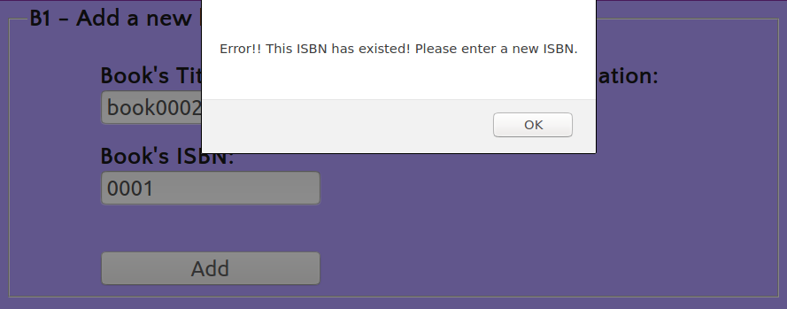
B1 – Add authors to the book:
I seperate the function of add authors to the book from adding a new book function above, because I think it is convenient to add multiple arthors to the same book.
You should enter a book’s ID first, then you can add author’s name one by one.
What is more, you can press ‘check’ first to check the book’s information before adding an author.
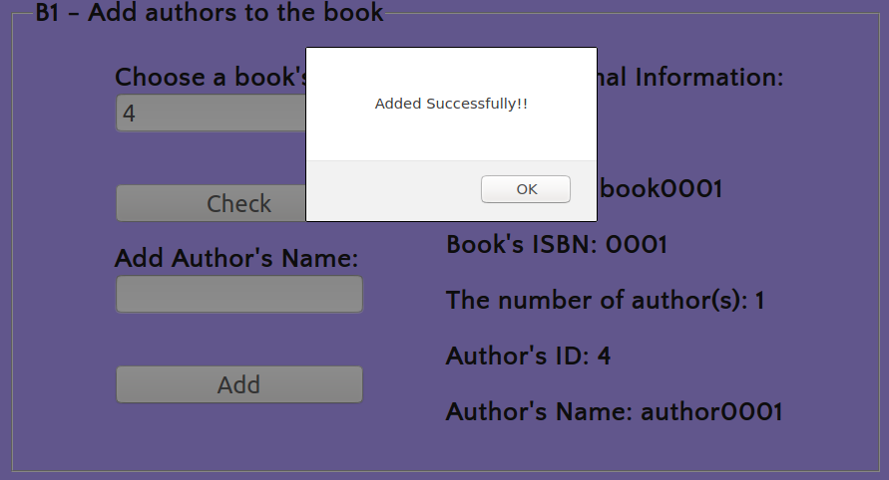
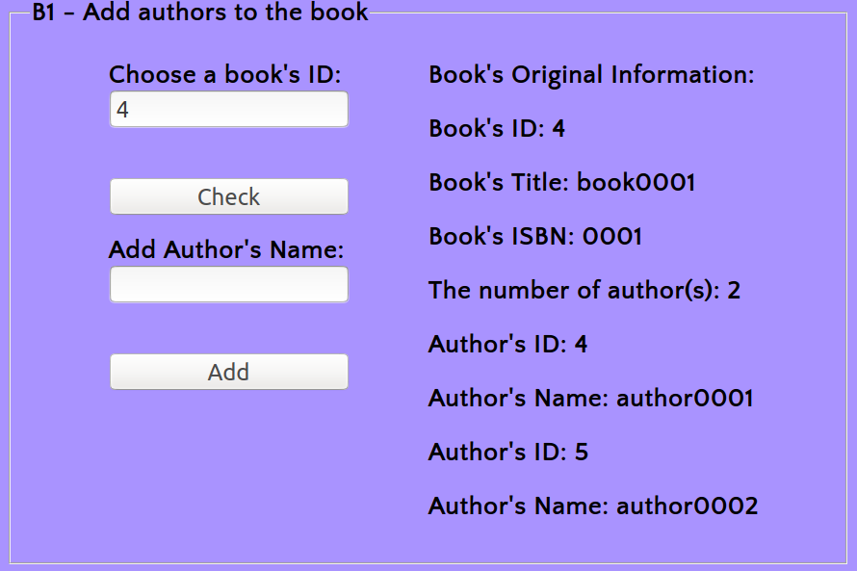

B2:
The instruction is similar to U2’s.

B3:
The instruction is similar to U4’s.
Also, if a book has been loaned, it cannot be remove directly.
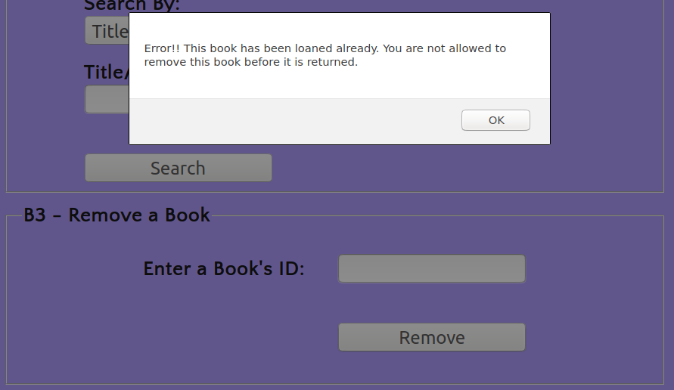

L1:
The instruction is similar to U1’s.
Caution: Due date calculated by my code is 30 days after the borrow date(today).
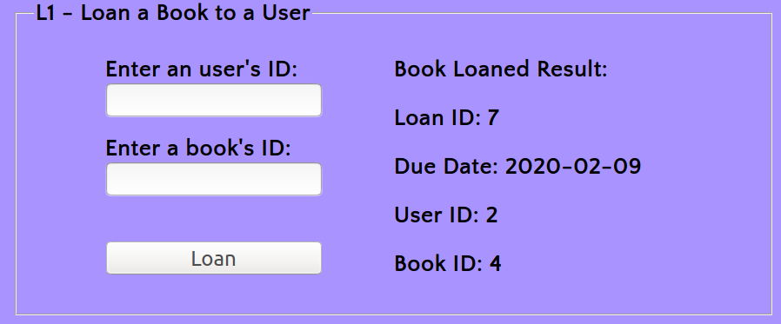
Caution: If the book has been loaned, it cannot be loand again before it is returned.
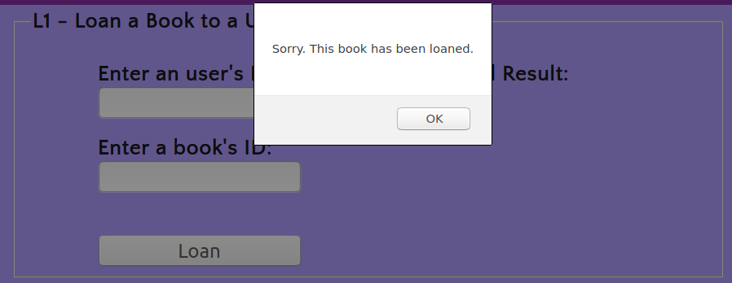

L2:
You should enter an user’s ID first, then you can search the user’s loan record.

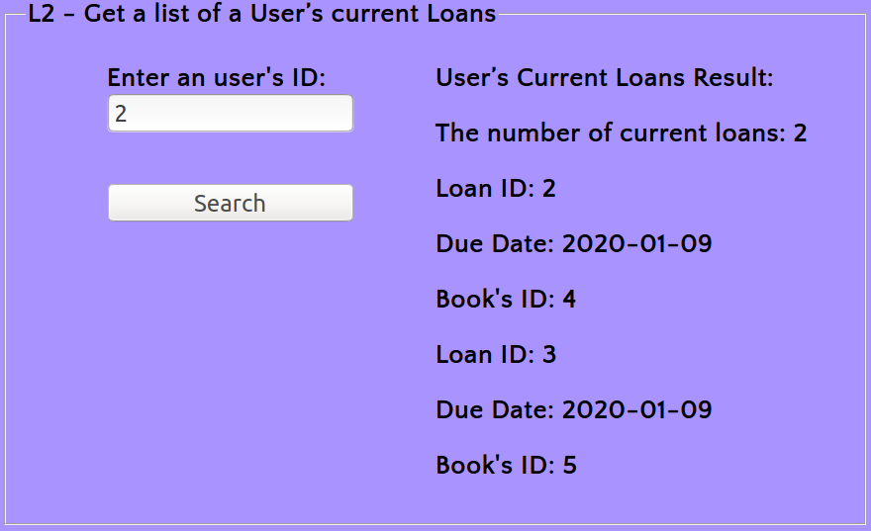

L3:
Just press the ‘search’ button, and the page will show you all the users who currently borrowing a book or more than one book.
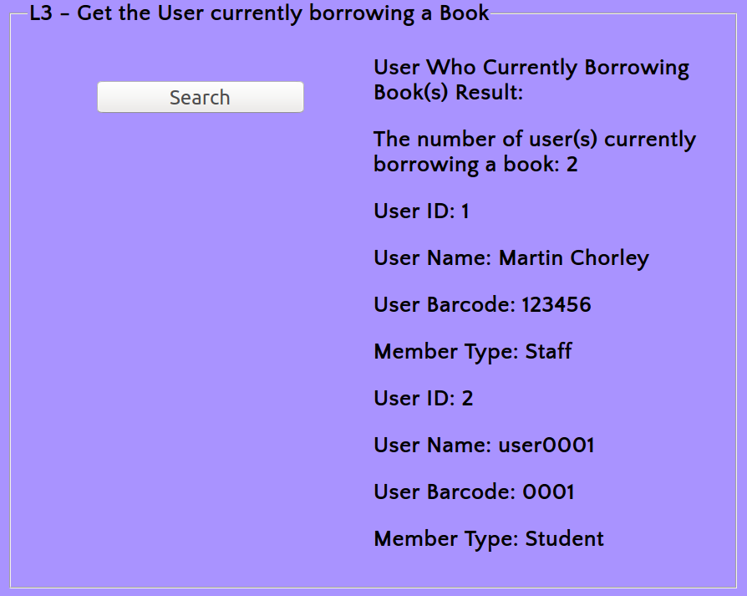

Extra Function – Return a book
You should enter a loan’s ID first, then you can return a book. Otherwise, this page will warn you about that.
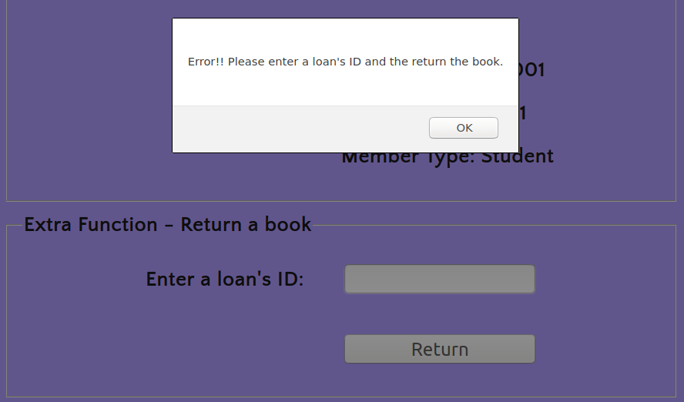

Validation:
index.html
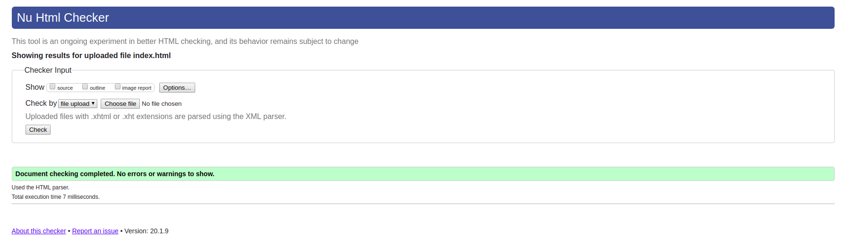
Error alert: If the book’s ID or the author’s name is null, you cannot add the author’s name to the book.

userpage.html
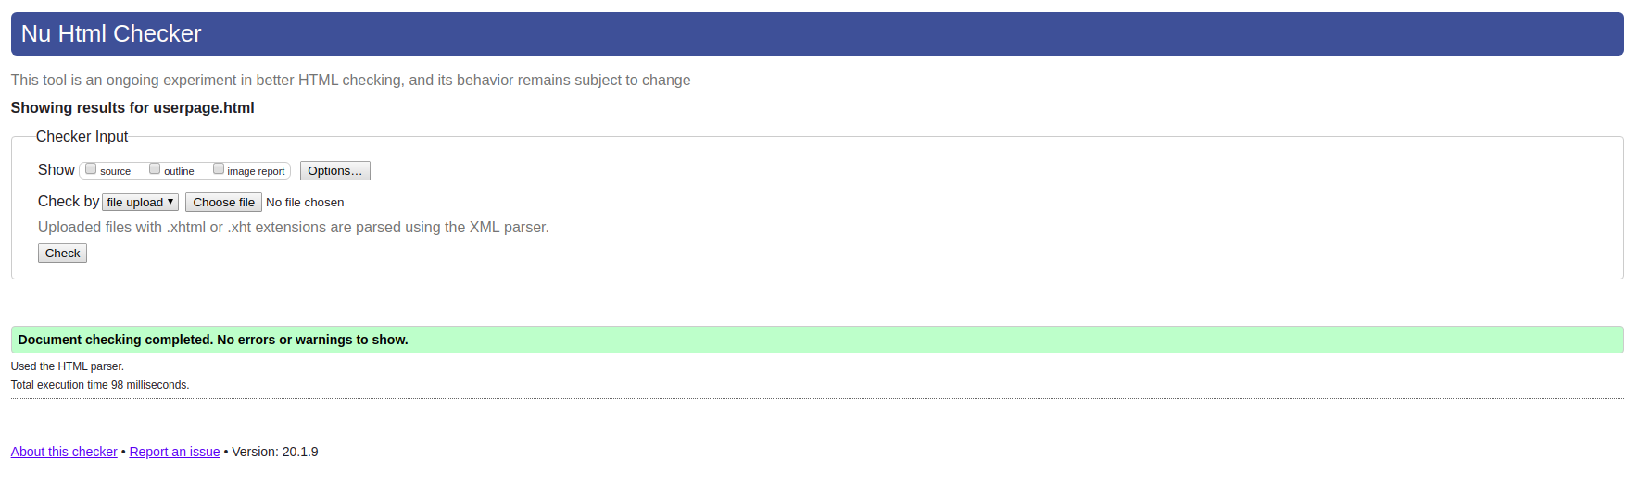

bookpage.html
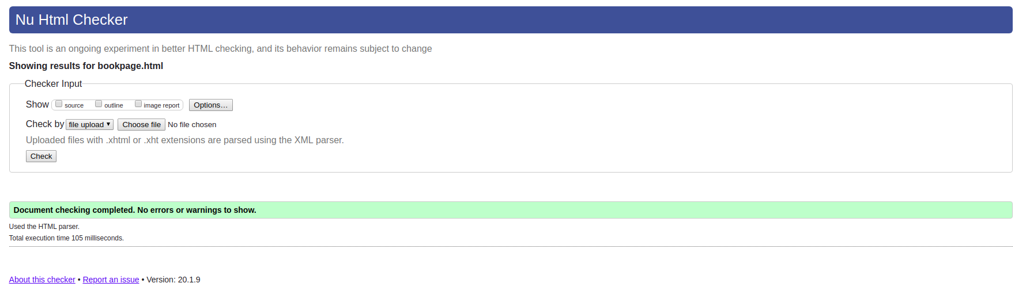

loanpage.html
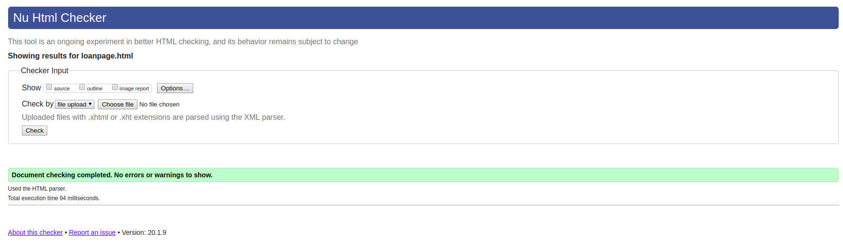

style.css
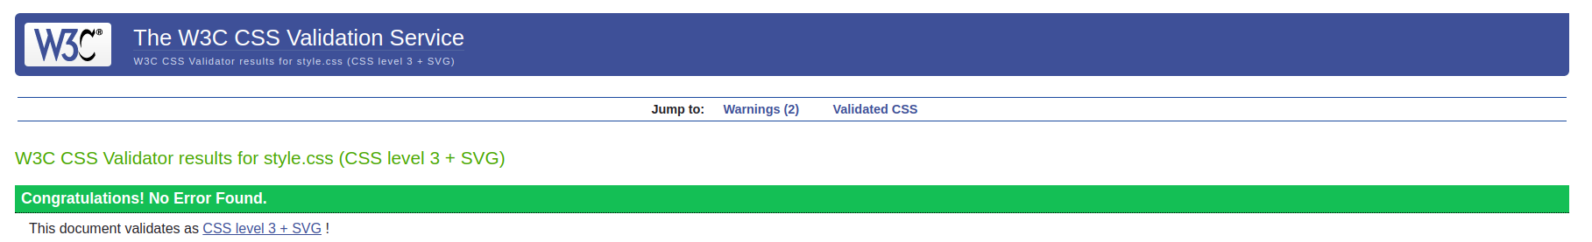
I am not going to delete these two code above since they are added to ensure the box-sizing property can be shown correctly on different browsers.

