Advanced Control Lab 3- Final Report

*Yameng Bing 941180283*

*Shulang Shen 941180473*

• Experiment Objective

In this control lab, we designed 2 different controllers satisfying different requirements and tested the close loop response of both controllers. We studied their stability margins, step input response and frequency response behaviour.

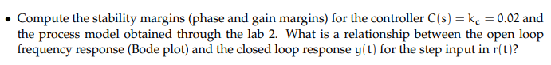• Experiment Results Part 1

The stability merging and cross over frequency for the proportional controller C(s) = 0.02 were found by using Matlab. We can see that the cross over frequency is and the phase margin is

We can see from the bode plot that when , the magnitude of L goes to infinity. Meaning that . As we can see in the following step response plot. After reaching steady state, the system reaches 1.

Another relation between the open loop frequency response and the close loop response is that. The bandwidth of the system is proportional to the cross over frequency. And that the larger the bandwidth, the faster is the response.

We have from last question that the controller is , now that we want zero steady state error for the step input for both . So we need a integrator in the controller. We know that for a lag controller, if we choose the parameter then the lag controller can serve as a integrator. We choose the parameter .

The bode plot and the margins of the system with this new controller is shown below:

The phase change is 5.7, which fits the requirement. And the step response have the following properties:

Rise Time: 0.0921

Transient Time: 4.8314

Settling Time: 4.8314

Settling Min: 0.3440

Settling Max: 1.8298

Overshoot: 82.9809

Undershoot: 0

Peak: 1.8298

Peak Time: 0.2657

For the second controller, we have the requirement that the phase margin should be 45 degrees. So we need to add a lead controller to the system.

Now we need to find the parameter for

From the plot we see that the phase margin is 44.5 degrees and the following are the step response of the system with the new controller.

Rise Time: 0.0951

Transient Time: 0.4941

Settling Time: 0.4941

Settling Min: 0.9367

Settling Max: 1.3158

Overshoot: 31.5780

Undershoot: 0

Peak: 1.3158

Peak Time: 0.2470

Then we use Simulink to run both controllers and below are the signals for the u and y.

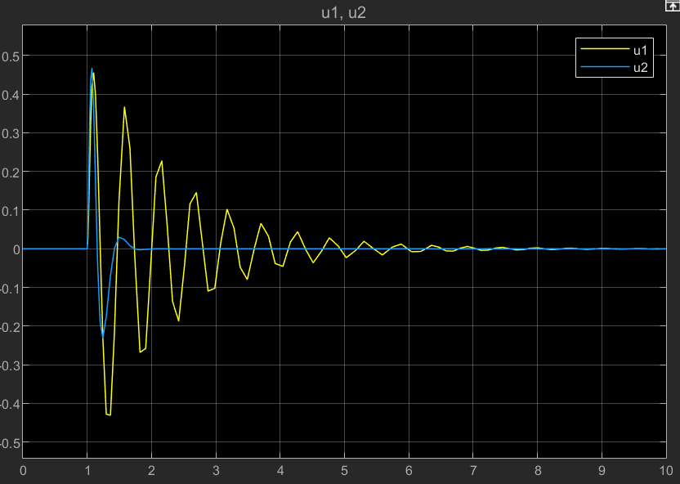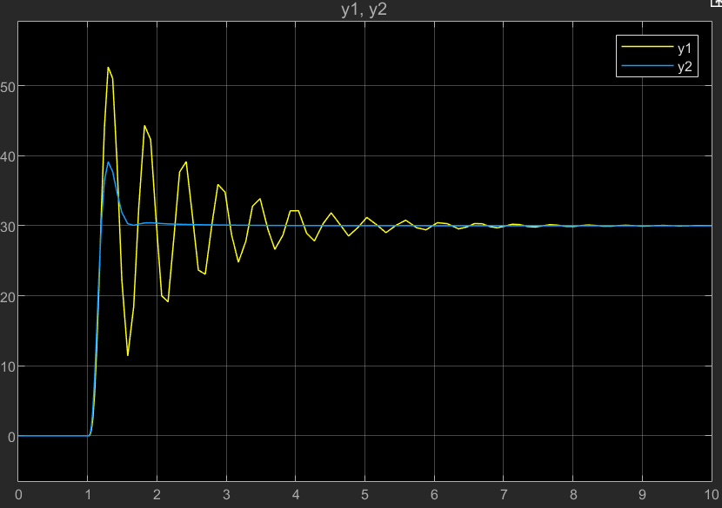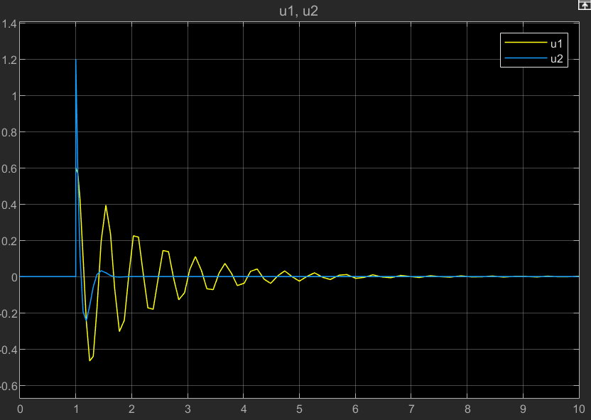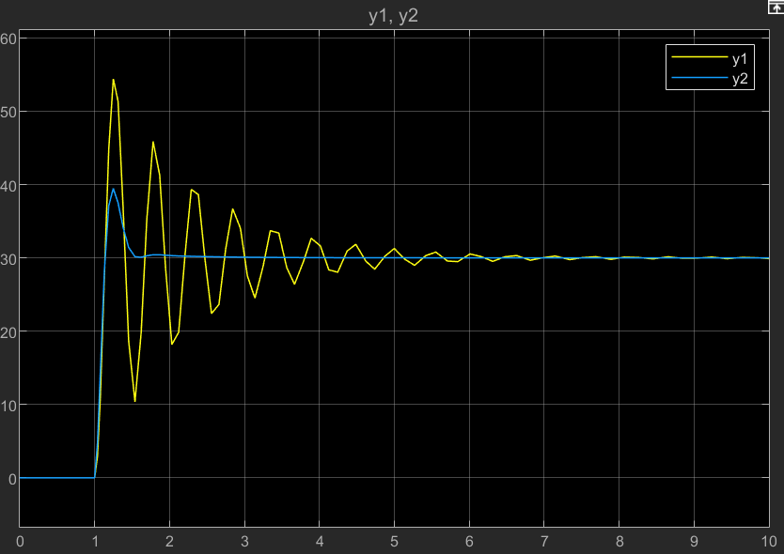

We see from the signals, indeed with the prefilter the control signal is in the interval [-1, 1].

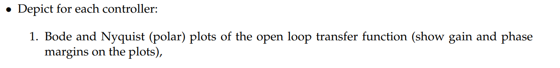• Experiment Results Part 2

For the proportional controller:

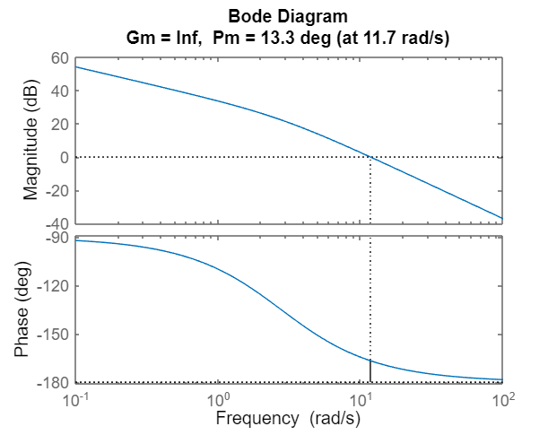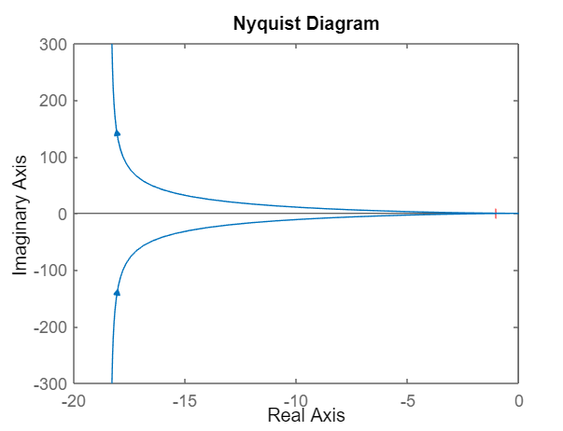

For the fist controller that we designed:

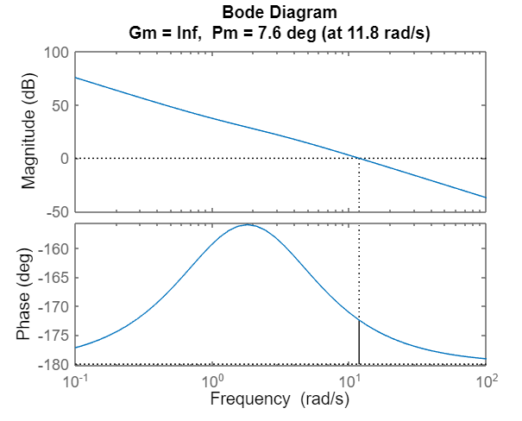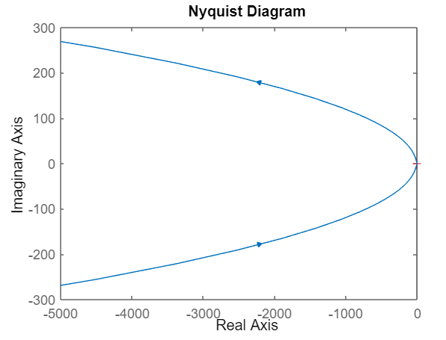

The for the second controller :

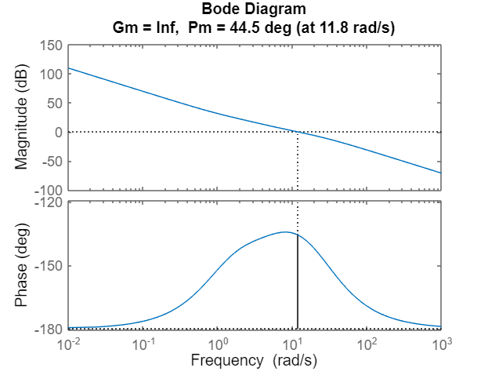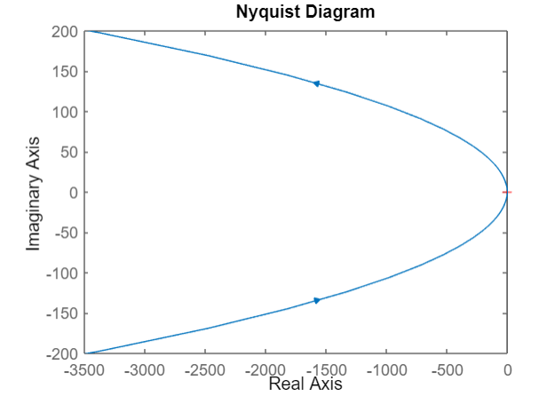



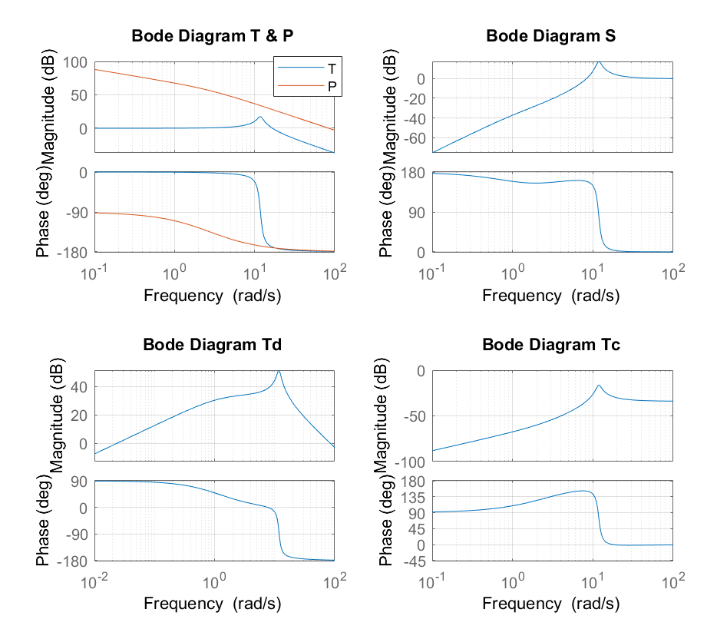

Above are the 4 bode plots for the system with the first controller.

And the graph below is the 4 bode plots for the system with the second controller.

The information we can deduct from the Bode graph are:

Firstly, we can see that the gain and phase for T is quite ideal for low frequencies. So that we get good tracking for low frequencies. Then for the second controller, we see that the peak is reduced a lot and the bandwidth is extended, meaning faster tracking. Also the second controller will result in a smaller error when the system reaches stability and also less control effort. But the effort to resist disturbance is higher.

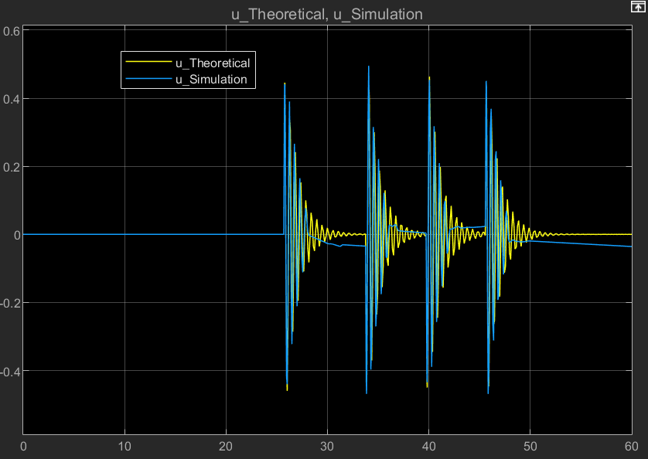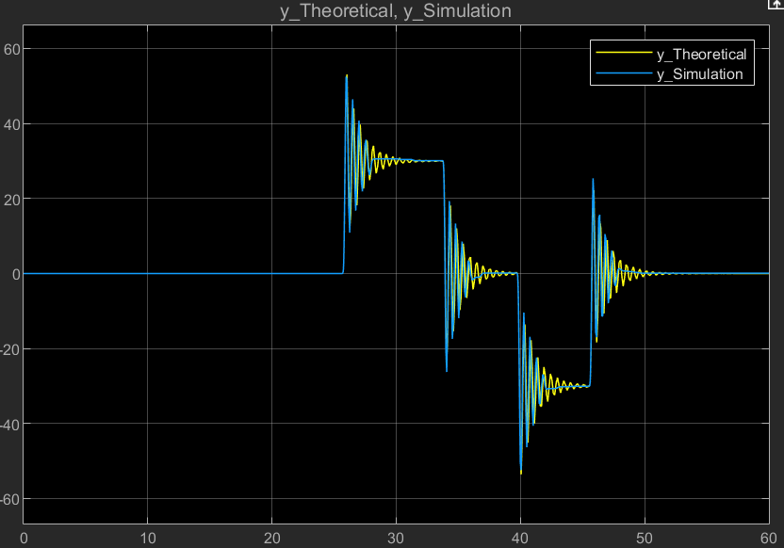

Above is the response u(t) and y(t) for the system with the first controller, the blue line in both graph is the simulated result and the yellow line is the theoretical result.

Above is the response u(t) and y(t) for the system with the second controller, the blue line in both graph is the simulated result and the yellow line is the theoretical result.

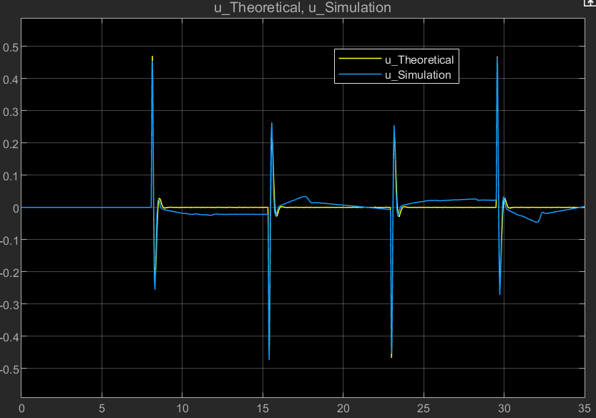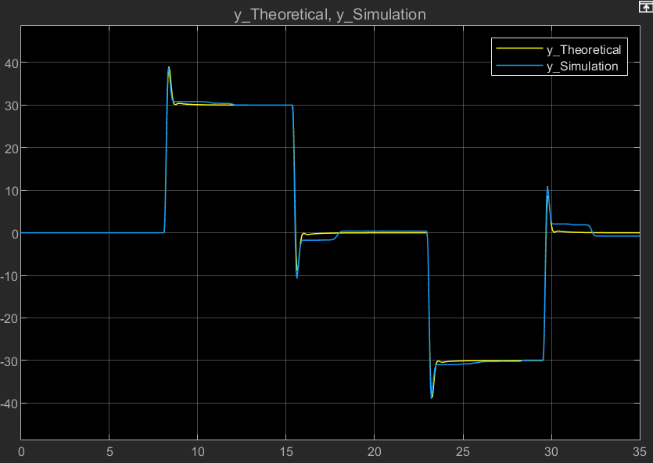

Judging from both graphs, we can say that our model fits the experimental setup quite accurately. But still there is a clear deviation of the response both in the control signal, and in the final output of the system. The reasons for it is:

Firstly, we have frication in our system and the existence of it can result in less oscillation in the systems response.

Secondly, there are noise in the system that can be recorded and resulted a deviation of the simulation result and the theoretical one.

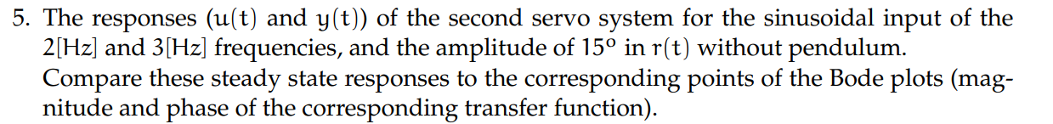Thirdly, the error from measurement for example the sensor.

The following is the responds u(t) and y(t) of the second servo system with the input of 2[Hz]. The amplitude of output is 19.56.

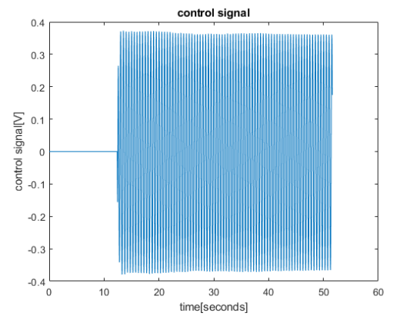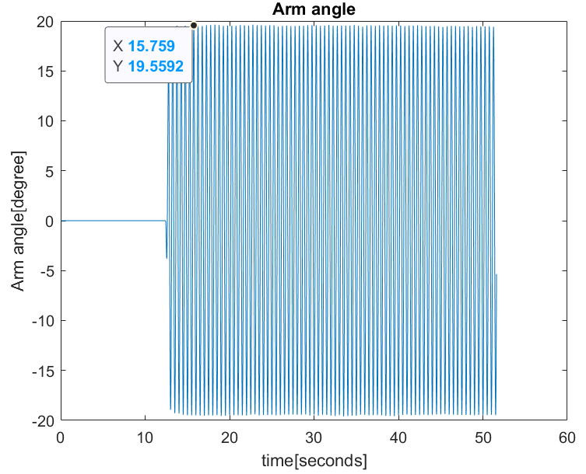

The following is the responds u(t) and y(t) of the second servo system with the input of 3[Hz]. The amplitude of output is 11.97.

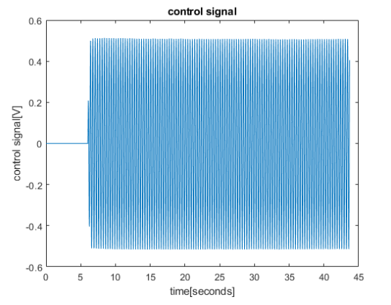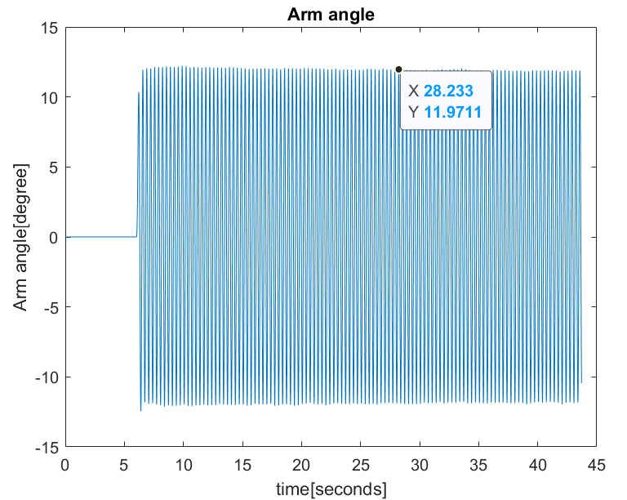

We now observe the bode plot of the close loop transfer function:

We know that

In the bode plot, for the frequency 2Hz, the gain is around 2 dB=1.26 and for the frequency 3Hz, the gain is about -2.3 dB = 0.767. These ratios do match the simulated response that we got for the 2 frequencies.

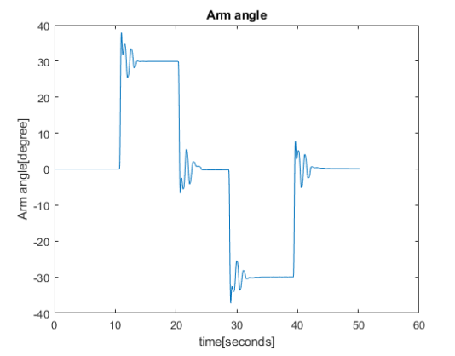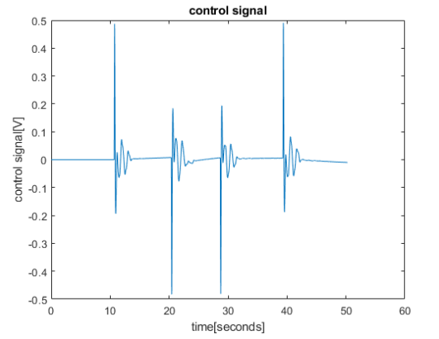

Firstly, we can see that the arm angle is keeping track with the systems input signal. Meaning that the controller is doing its job. But from the control signal and also the output arm angle, we can see that they are more oscillatory compared with the result without a pendulum. These differences are mainly caused by the passive pendulum. And the existence of this passive pendulum decreases the systems robustness.

• Conclusion In this experiment

Different controller design for a DC motor can result in different response while tracking step input and sin inputs. The response is closely related to the bode plot of the system and the margins. We can adjust the parameters with the help of those plots and achieve the requirement. We also see that the robustness of the system can be affected by the passive pendulum and the systems response changes also.