1. Consider the employee database of figure below. Give an expression in the relational algebra to express each of the following queries:

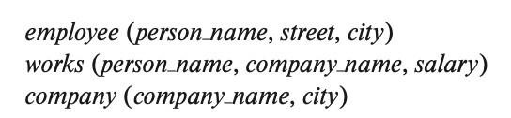

**Figure**

* + Find the ID and name of each employee who works for “BigBank”.

П*ID,name*(σ *company_name=“BigBank”* (works))

* + Find the ID, name, and city of residence of each employee who works for “BigBank”.

П*ID,name, city*(σ *company_name= “BigBank”* (works ⋈ employee))

* + Find the ID, name, street address, and city of residence of each employee who works for “BigBank” and earns more than $10000.

П*ID,name, street, city*(σ *company_name=“ BigBank”* ∧ *salary > 10000* (works ⋈ employee))

* + Find the ID and name of each employee in this database who lives in the same city as the company for which she or he works.

П*ID, name*(employee ⋈ works ⋈ company)

1. Consider the employee database of figure above. Give an expression in the relational algebra to express each of the following queries:
   * Find the ID and name of each employee who does not work for “BigBank”.

П*ID,name*(σ *company_name*≠*“BigBank”* (works))

* + Find the ID and name of each employee who earns at least as much as every employee in the database.

1. Consider the foreign-key constraint from the *dept_name* attribute of instructor to the *department* relation. Give examples of inserts and deletes to these relations that can cause a violation of the foreign-key constraint.

instructor(name, dept name, salary)

department(dept_name, city, street)

If we insert:

(Faraday, Physicist, 10000) into the instructor table, where the department Physicist does not exists in the department table, we can cause the violation of the foreignkey constraint.

If we delete :

(Physics, Astana,Tole Bi Street) from the department table, where at least one instructoror student tuple has dept_name Physics, we can cause the violation of the foreign-key constraint.

1. Consider the employee database of figure above. What are the appropriate primary keys?

employee (person_name, street, city)

works (person_name,company_name,salary)

company (company_name, city)