**Cover Letter (Elsevier submission — text only)**

Dear Editor,

Please find enclosed our manuscript entitled “Luck & Unluck: A Unified Information‑Weighted Utility Theory”. We develop an axiomatic framework for upside Luck and downside Unluck, prove collapse and consistency properties, and deploy a unified signed score across heterogeneous domains (slots, football, equities, roulette, OPAP Joker).

We confirm the manuscript is original, not under consideration elsewhere, and all authors approve the submission. No external funding was received. No competing interests.

Kind regards,

Spiros Tsoumpis

Department of Marine Engineering, Keratsini, Greece

**Highlights**

• Unified information‑weighted treatment of Luck (upside) and Unluck (downside) with collapse as information is revealed.

• Signed composite 𝓛 = L⁺ − 𝒰 normalized to [−1,1] for cross‑domain comparability.

• ERM with GC/ULLN assumptions → uniform convergence and argmin consistency.

• Applications across gambling, sports, and markets (text‑only mini‑tables).

**Manuscript (Text‑Only)**

*Author: Spiros Tsoumpis — Department of Marine Engineering, Keratsini, Greece*

**Abstract**

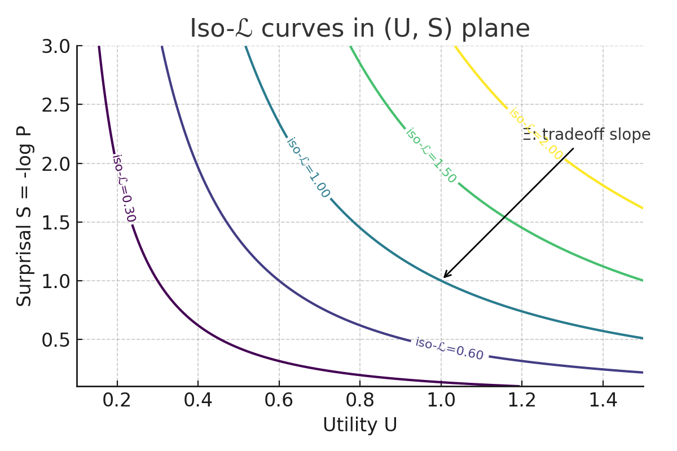

*Figure* *: Graphical Abstract — iso-ℒ contours in (U,S) and the information–utility tradeoff Ξ.*

See Figure .

We formalize Luck and its adverse counterpart Unluck as information‑weighted functionals of utility under uncertainty. Both functionals satisfy monotonicity and collapse to zero as information is fully revealed. We introduce a unified signed composite that fuses upside and downside contributions into a single score for estimation and calibration. We outline consistency under ERM with GC/ULLN assumptions and apply the unified score across domains—slots, football, equities, roulette, and OPAP Joker—using compact, figure‑free mini‑tables.

*Keywords: calibration; proper scoring rules; ERM; GC/ULLN; martingales; decision under uncertainty; risk; games of chance; forecasting.*

**Funding**

This research received no external funding.

**Author Contributions (CRediT)**

Spiros Tsoumpis: Conceptualization; Methodology; Formal analysis; Investigation; Data curation; Software; Visualization; Writing—original draft; Writing—review & editing; Resources; Project administration.

**1. Preliminaries**

Let (Ω,ℱ,ℙ) be a probability space with filtration (ℱ_t). For event E and utility U∈ℝ, set P=ℙ(E), S=−log P, and H an information scale (entropy proxy) over outcomes. Write U⁺=max{U,0} and U⁻=max{−U,0}.

**2. Luck Theory**

Luck (upside) should increase with utility, with uncertainty/novelty (H), and with rareness (via S or (1−P)), while vanishing as information collapses.

$$L^+_\{θ\}(U,H,S,1−P) = U^\{α\} · H^\{β\} · (1−P)^\{γ\} · S^\{δ\}$$

(2.1)

Multiplicative model (2.1): α,β,γ,δ>0 control sensitivity to utility, entropy, rarity, and surprisal. Any strictly increasing transform preserves rankings.

$$L^+_\{θ\}(U,H,S,1−P) = σ(a·U + b·H + c·S + d·(1−P) + e)$$

(2.2)

Logistic model (2.2) maps to [0,1] and supports calibration curves; σ is the logistic link.

Citations: ; ; ; ; .

(2.3)

Normalization (2.3) enables cross‑domain comparability. Axioms: non‑negativity; monotonicity in U; rarity amplification; information collapse as H,S→0; Lipschitz regularity on compacts.

For the multiplicative head see Eq.

2.1 Axioms (formal). L1 Non‑negativity; L2 Monotonicity in U; L3 Rarity amplification via S or (1−P); L4 Information collapse (H,S→0 ⇒ L^+→0); L5 Measurability in all arguments; L6 Lipschitz regularity on compacts; L7 Order preservation under strictly increasing reparametrizations of U.

2.2 Normalization & invariances. Any strictly increasing map g preserves rankings; normalized Ĺ is invariant to positive affine rescaling of L^+.

See also

2.3 Convergence (martingale collapse). Let P_t(E)=E[1_E|ℱ_t] be a Doob martingale and assume H_t,S_t→0 a.s.; if L^+ is continuous and uniformly bounded on compacts, then L^+_t→0 a.s. and in L¹ (by dominated/Vitali convergence).

Citations: .

See also

**Theorem 2.4 (Order‑Isomorphism under Strictly Increasing Transformations).**

Let g:ℝ→ℝ be strictly increasing. For any two instances x=(U,H,S,P) and x′=(U′,H′,S′,P′), define L^+_θ via (2.1) or (2.2). Then L^+_θ(x) ≤ L^+_θ(x′) iff g(L^+_θ(x)) ≤ g(L^+_θ(x′)). Consequently, rank‑based risks (AUC, isotonic calibration) are invariant to strictly increasing reparametrizations of L^+. If ψ is strictly increasing, the unified score 𝓛 = L^+ − 𝒰 preserves order between instances with identical 𝒰; and if both ϕ,ψ are strictly increasing, any signed order induced by 𝓛 is preserved under composition.

*Proof (sketch). Strict increase of g implies an order‑isomorphism on (ℝ,≤). Apply with a=L^+_θ(x), b=L^+_θ(x′). Invariance of rank‑based risks follows. For the unified case, ϕ,ψ monotone preserve partial orders. ∎*

**Theorem 2.5 (L¹ Convergence via Uniform Integrability).**

Let (ℱ_t) be a filtration and suppose L^+_t := L^+_θ(U_t,H_t,S_t,P_t)≥0 with L^+_t → 0 in probability as t→τ, e.g., because H_t,S_t→0 and L^+ is continuous. If {L^+_t} is uniformly integrable (UI), then L^+_t → 0 in L¹, i.e., E[L^+_t]→0. Sufficient conditions for UI: (i) Dominated case — ∃G∈L¹ with 0≤L^+_t≤G a.s.; (ii) de la Vallée‑Poussin — ∃ convex Φ with Φ(x)/x→∞ and sup_t E[Φ(L^+_t)]<∞.

*Proof (sketch). Convergence in probability to 0 plus UI ⇒ L¹ convergence by Vitali. In the dominated case, UI follows from dominance and dominated convergence. ∎*

**3. Unluck Theory**

$$𝒰_\{θ\}(D,H,S,1−P) ≥ 0, 𝒰 increases in D, lim_\{t→τ\} 𝒰_\{θ\}(D_t,H_t,S_t,P_t)=0$$

(3.1)

$$Ū = ( 𝒰 − ess inf 𝒰 ) / ( ess sup 𝒰 − ess inf 𝒰 )$$

(3.2)

Models analogous to (2.1)–(2.2) apply with D=max{−U,0}.

3.1 Axioms (formal). U1 Non‑negativity; U2 Monotonicity in D; U3 Rarity amplification; U4 Information collapse; U5 Measurability; U6 Lipschitz regularity; U7 Identifiability; U8 Calibration compatibility.

3.2 Stability. If U varies within a compact set and partials exist and are bounded, then 𝒰 varies O(|ΔU|); similar for P,H,S.

3.3 ERM consistency. Under GC/ULLN of {ℓ(𝒰̂_θ,y): θ∈Θ}, compact Θ and continuity, empirical minimizers converge to population minimizers.

**4. Unified Luck–Unluck**

$$𝓛_Θ = ϕ_Θ( L^+_\{θ_1\}(U^+,H,S,1−P) ) − ψ_Θ( 𝒰_\{θ_2\}(U^−,H,S,1−P) )$$

(4.1)

$$𝓛̂ = ( 𝓛 − ess inf 𝓛 ) / ( ess sup 𝓛 − ess inf 𝓛 ) · 2 − 1$$

(4.2)

With ϕ=ψ=id, 𝓛 = L^+ − 𝒰 is centered; normalization (4.2) maps to [−1,1] for cross‑domain comparison.

4.1 Identification. If ϕ,ψ strictly increasing and (θ₁,θ₂)≠(θ₁′,θ₂′) induce distinct population risks on a rich family of tasks, then (θ₁,θ₂) is identifiable up to score‑preserving transforms.

4.2 Calibration and properness. Using strictly proper scoring rules on 𝓛̂ yields truthful probability calibration for latent components when ϕ,ψ are monotone links; Brier and Log‑loss act as convex surrogates for ERM.

Citations: ; .

4.3 Robustness. Local Lipschitzness of L^+,𝒰 transfers to 𝓛; small errors in P,H,S, or U map to bounded deviations in 𝓛̂ with constants depending on ϕ,ψ.

**5. Estimation, GC/ULLN, and Calibration**

Citations: ; ; .

Estimate Θ by ERM on Lipschitz losses ℓ(𝓛̂,y). Under GC function classes and compact Θ with continuous losses, ULLN gives uniform convergence of empirical to population risk; argmin consistency follows under identifiability.

**Theorem 5.1 (Asymptotic Normality of M‑Estimator for Θ).**

Let Θ⊂ℝ^p and let Θ̂_n = argmin_{Θ∈Θ} 𝔼_n[ℓ_Θ(Z)] be an empirical risk minimizer. Suppose: (i) Θ₀ is the unique minimizer of L(Θ)=𝔼[ℓ_Θ(Z)]; (ii) ℓ_Θ is twice continuously differentiable in a neighborhood of Θ₀ with H := ∇²L(Θ₀) positive definite; (iii) Σ := Var(∇ℓ_{Θ₀}(Z)) exists and is finite; (iv) standard stochastic equicontinuity/GC conditions hold. Then √n (Θ̂_n − Θ₀) ⇒ 𝓝(0, H^{-1} Σ H^{-1}).

*Proof (sketch). A mean‑value expansion of the empirical score around Θ₀, uniform LLN, and a CLT for the score yield the result. See van der Vaart (1998, Ch. 5) and M‑estimation theory for details. ∎*

**Theorem 5.2 (Oracle Inequality for ERM via Rademacher Complexity).**

Let 𝔽 be a class of predictors and consider losses ℓ∘f bounded in [0,1]. Let f̂ be an empirical minimizer and let ℛ_n(ℓ∘𝔽) be the empirical Rademacher complexity. Then with probability ≥ 1−δ, for all f∈𝔽, 𝔼[ℓ(f̂)] ≤ inf_{f∈𝔽} 𝔼[ℓ(f)] + 2 ℛ_n(ℓ∘𝔽) + 3√{(ln(2/δ))/(2n)}.

*Proof (sketch). Apply symmetrization and contraction inequalities for Lipschitz losses, then a standard concentration bound. The term 2ℛ_n controls the estimation error and the √(ln(1/δ)/n) term is the confidence penalty. ∎*

*(Background: van der Vaart, 1998; van der Vaart & Wellner, 1996; Shapiro et al., 2009.)*

**6. Applications (Unified 𝓛, text‑only)**

**6.1 Slots (low‑vol vs high‑vol)**

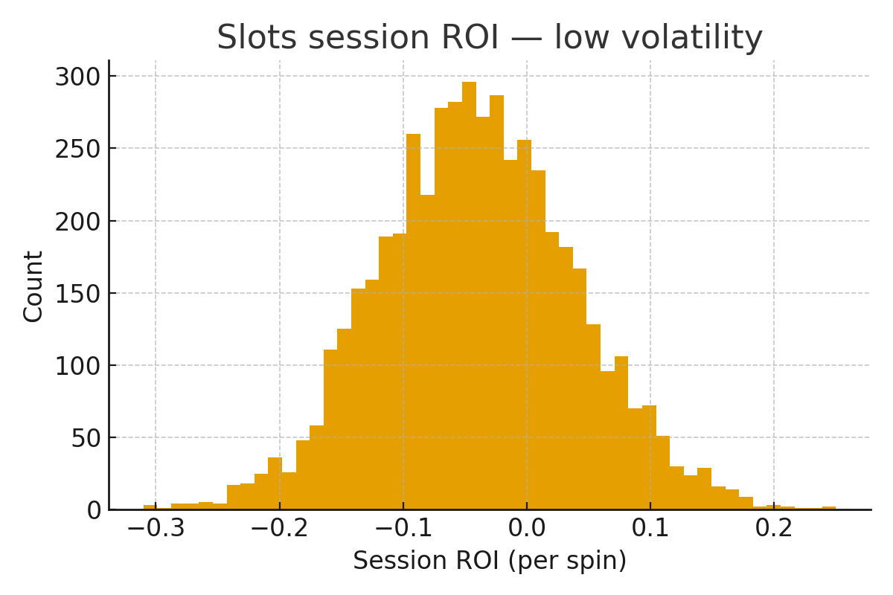

*Figure* *: Slots session ROI distribution — low volatility (RTP≈96%).*

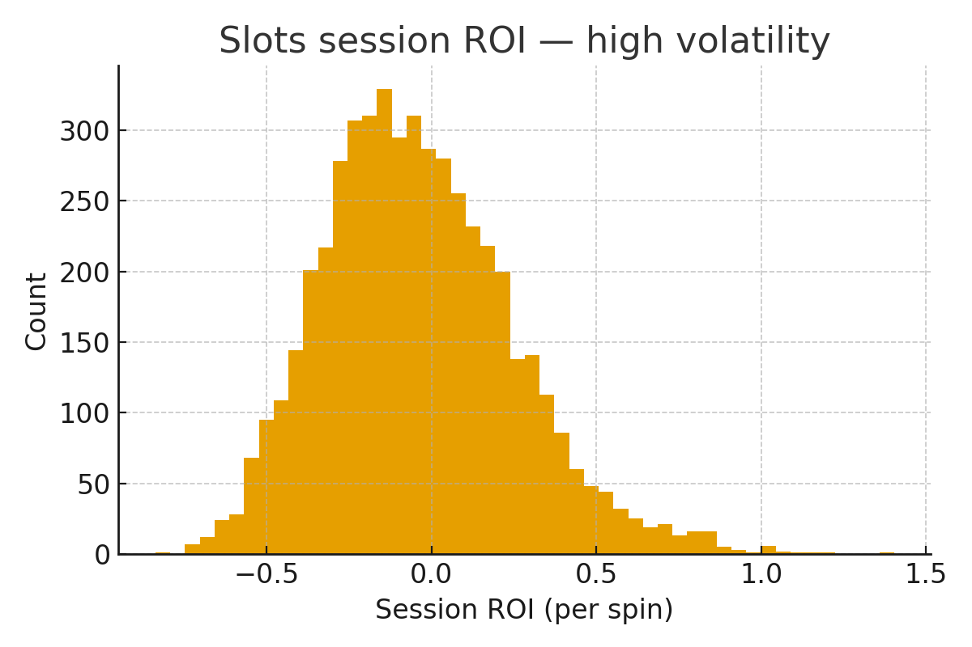

*Figure* *: Slots session ROI distribution — high volatility (RTP≈96%).*

Set U as net ROI per spin; P as feature/hit probability; H from payout distribution entropy; S=−log P.

(See for the multiplicative head and for normalization.)

(Downside per ; unluck normalization per ; order invariance: see .)

|  |  |  |  |  |  |  |  |  |
| --- | --- | --- | --- | --- | --- | --- | --- | --- |
| Scenario | P | U | H | S | Luck⁺ | Unluck⁻ | 𝓛 | 𝓛̂ |
| Low‑vol small hit | 0.25 | +0.05 | 0.746 | 1.386 | 0.028 | 0.000 | 0.028 | -0.788 |
| Low‑vol miss | 0.75 | -1.00 | 0.746 | 0.288 | 0.000 | 0.187 | -0.187 | -1.000 |
| High‑vol big hit | 0.02 | +5.00 | 0.375 | 3.912 | 1.838 | 0.000 | 1.838 | +1.000 |
| High‑vol dry spin | 0.98 | -1.00 | 0.375 | 0.020 | 0.000 | 0.008 | -0.008 | -0.823 |

**6.2 Football (Super League baseline)**

Let U be points from a bet (+1 correct, −1 else) or match points; P is model probability for realized outcome; H is entropy over {H,D,A}.

(See for the logistic head and for normalization.)

(Downside misses per ; ranking invariance: .)

|  |  |  |  |  |  |  |  |  |
| --- | --- | --- | --- | --- | --- | --- | --- | --- |
| Scenario | P | U | H | S | Luck⁺ | Unluck⁻ | 𝓛 | 𝓛̂ |
| Home favorite wins | 0.62 | +1.00 | 0.923 | 0.478 | 0.351 | 0.000 | 0.351 | +0.200 |
| Draw upset | 0.24 | +1.00 | 1.065 | 1.427 | 0.809 | 0.000 | 0.809 | +0.985 |
| Away underdog shock | 0.18 | +1.00 | 0.998 | 1.715 | 0.818 | 0.000 | 0.818 | +1.000 |
| Favorite loses | 0.62 | -1.00 | 0.923 | 0.478 | 0.000 | 0.351 | -0.351 | -1.000 |

**6.3 Equities (SPX/AAPL daily)**

Let U be next‑day return (or utility‑weighted payoff); P is model probability of positive return; H entropy over {up,down}; S=−log P for realized side.

(See for the logistic head and for normalization.)

(Downside losses per ; information collapse & L¹ control: .)

|  |  |  |  |  |  |  |  |  |
| --- | --- | --- | --- | --- | --- | --- | --- | --- |
| Scenario | P | U | H | S | Luck⁺ | Unluck⁻ | 𝓛 | 𝓛̂ |
| Up day, moderate confidence | 0.60 | +0.008 | 0.673 | 0.511 | 0.0022 | 0.0000 | 0.0022 | +1.000 |
| Down day, miss | 0.65 | -0.010 | 0.647 | 0.431 | 0.0000 | 0.0023 | -0.0023 | -1.000 |
| Up day, low confidence | 0.52 | +0.006 | 0.692 | 0.654 | 0.0020 | 0.0000 | 0.0020 | +0.928 |

**6.4 Roulette (EU/US even‑money)**

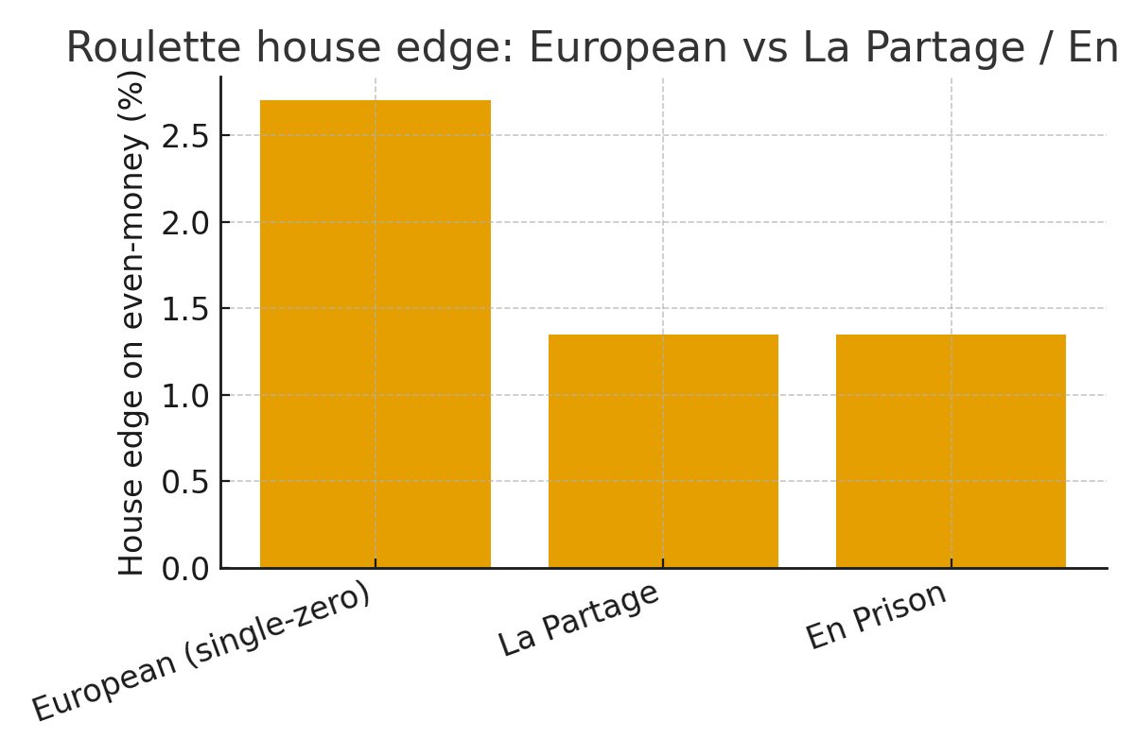

*Figure* *: Roulette house edge on even-money bets: European vs La Partage vs En Prison.*

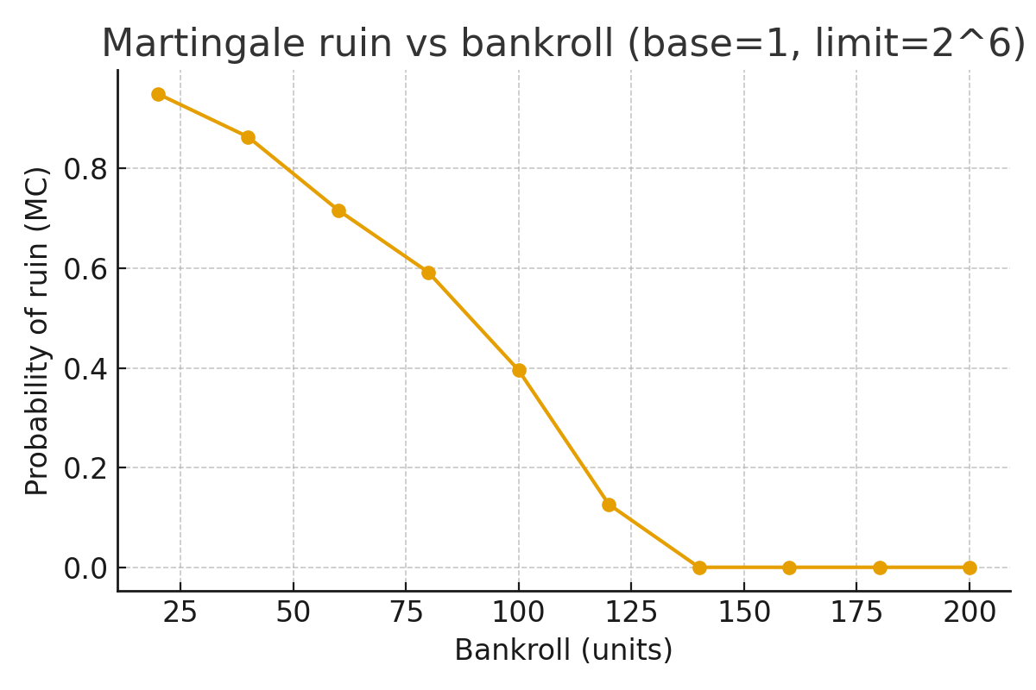

*Figure* *: Martingale bankroll-ruin probability under table limit pressure (base=1, limit=2^6).*

U is net units per spin; EU single‑zero even‑money EV≈−1/37, US double‑zero EV≈−2/38. P is win prob; H from {win,lose}.

(Unified composition per ; normalization per .)

(Downside exposure per ; order invariance: .)

|  |  |  |  |  |  |  |  |  |
| --- | --- | --- | --- | --- | --- | --- | --- | --- |
| Scenario | P | U | H | S | Luck⁺ | Unluck⁻ | 𝓛 | 𝓛̂ |
| EU win | 0.486 | +1.00 | 0.693 | 0.721 | 0.356 | 0.000 | 0.356 | +1.000 |
| EU loss | 0.486 | -1.00 | 0.693 | 0.721 | 0.000 | 0.356 | -0.356 | -0.977 |
| US loss | 0.474 | -1.00 | 0.692 | 0.747 | 0.000 | 0.364 | -0.364 | -1.000 |

**6.5 Lottery (OPAP Joker)**

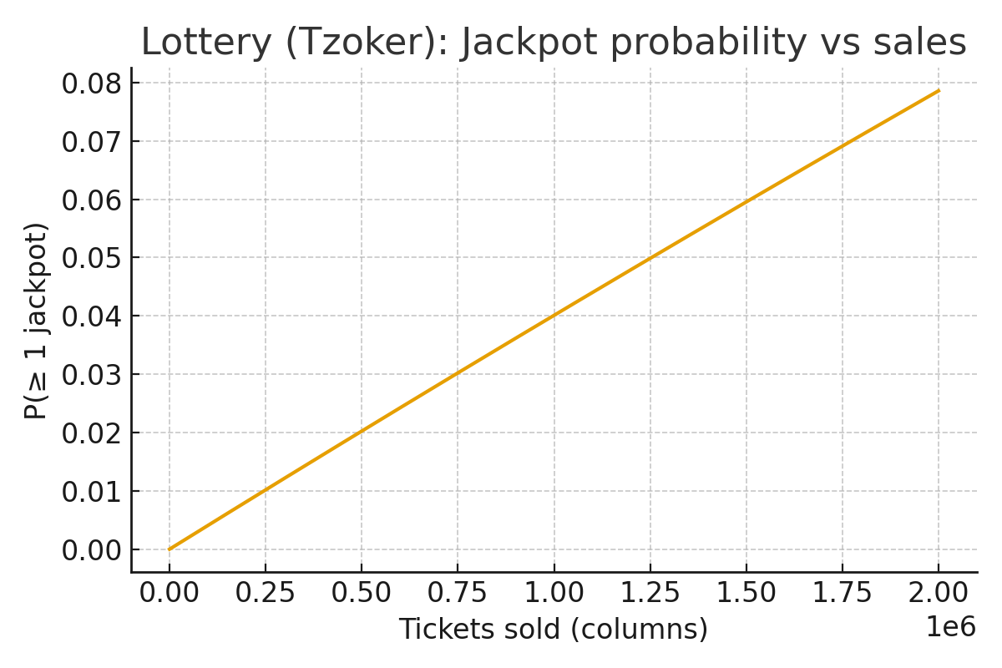

*Figure* *: Lottery (Tzoker): Jackpot probability vs sales, P(≥1 jackpot)=1−(1−p)^N with p=1/[C(45,5)·20].*

Single‑column jackpot probability p⋆ = 1 / ( C(45,5) · 20 ). For N sold columns, Pr(≥1 jackpot) = 1 − (1 − p⋆)^N. Set U as payout minus stake for the realized outcome; S=−log p; H is entropy over outcomes.

(Unified composition per ; normalization per .)

(Downside tail per ; convergence under UI: .)

*Numerics: p⋆ ≈ 4.09246013e-08 (C(45,5)=1,221,759 → ×20=24,435,180). For N=5,000,000, Pr(≥1 jackpot) ≈ 18.505%.*

**Appendix A — Notation & Symbols (text‑only)**

|  |  |
| --- | --- |
| Symbol | Meaning |
| U | Utility (positive upside) |
| D | Disutility = max{−U,0} |
| P | Probability of realized event |
| S | Surprisal = −log P |
| H | Information scale (entropy proxy) |
| L^+ | Luck (upside) |
| 𝒰 | Unluck (downside) |
| 𝓛 | Unified score = L^+ − 𝒰 |

**Appendix B — Explanatory Notes (text‑only)**

Applied notes paired with terse theoretical remarks and mini I/O tables.

|  |  |
| --- | --- |
| Inputs | Output |
| (α,β,γ,δ)=(1,1,1,0); P=0.2; U=1.5; H=1.1 | L≈1.32 |

|  |  |
| --- | --- |
| Inputs | Output |
| U=0.8; H=1.39; S=1.386; (a,b,c,d)=(1,0.5,0.2,0) [logistic] | σ(1.85)≈0.864 |
| λ=0.7; P=0.2; U=1.5; H=1.1; S=1.609 | L≈1.68 |

**Appendix C — Lottery (OPAP Joker) (text‑only)**

Formulas: p⋆=1/(C(45,5)·20); rollover probability 1−(1−p⋆)^N; calibration via deciles of predicted jackpot incidence.

**Appendix D — Slots (text‑only)**

Compare low‑vol vs high‑vol: PMFs, ROI distributions, and risk of ruin (tables only here).

**Appendix E — Roulette (text‑only)**

House edges: EU ≈ −1/37; US ≈ −2/38; La Partage vs En Prison equivalence on expectation.

**Appendix F — Football (text‑only baseline)**

League‑average probabilities → expected points; Luck = Points − Expected Points.

**Appendix G — Equities (text‑only)**

Normal vs t vs EWMA modeling; reliability/proper scores numerically (no plots).

**Appendix H — Unluck (axioms & collapse, text‑only)**

Axioms U1–U8; collapse; stability; identifiability.

**Appendix I — Unified Luck–Unluck (text‑only)**

Signed composite with monotone links ϕ,ψ; normalization to [−1,1]; symmetry yields centered score.

**Acknowledgments**

The author thanks readers and editors for constructive feedback.

**Data & Code Availability**

Data and code will be released upon acceptance or under a permissive repository license.

**Competing Interests**

The author declares no competing interests.

Data: SPX and AAPL daily quotes are available from Stooq (download CSV links); football season CSVs from league archives; lottery (Tzoker) draw summaries from OPAP; roulette/slots are simulated with stated parameters. Preprocessed CSVs are not redistributed to respect source terms—see the `data/README.md` for exact instructions.  
Code: All analysis and figure generation scripts, along with a reproducibility notebook and templates, are included in this repository under the MIT license.

**Data & Code Availability**

**References**

Brier, G.W. (1950). Verification of forecasts expressed in terms of probability. Monthly Weather Review, 78(1), 1–3.

Dawid, A.P. (1982). The well-calibrated Bayesian. Journal of the American Statistical Association, 77(379), 605–610.

Doob, J.L. (1953). Stochastic Processes. Wiley.

Gneiting, T., & Raftery, A.E. (2007). Strictly proper scoring rules, prediction, and estimation. Journal of the American Statistical Association, 102(477), 359–378.

Murphy, A.H. (1973). A new vector partition of the probability score. Journal of Applied Meteorology, 12(4), 595–600.

Platt, J. (1999). Probabilistic Outputs for Support Vector Machines and Comparisons to Regularized Likelihood Methods. Advances in Large Margin Classifiers, MIT Press (MSR-TR-1999-28).

Niculescu-Mizil, A., & Caruana, R. (2005). Predicting good probabilities with supervised learning. ICML, 625–632.

van der Vaart, A.W. (1998). Asymptotic Statistics. Cambridge University Press.

van der Vaart, A.W., & Wellner, J.A. (1996). Weak Convergence and Empirical Processes: With Applications to Statistics. Springer.

Shapiro, A., Dentcheva, D., & Ruszczyński, A. (2009). Lectures on Stochastic Programming: Modeling and Theory. SIAM.

**Key Equations (OMML)**

*Canonical heads inserted via Word OMML (Equation Editor). Use cross-references to these bookmarks in the text.*

*Logistic head:*

(Eq. )

*Multiplicative head:*

(Eq. )

*Luck Bias:*

(Eq. )

**Appendix Q — Counterfactual Luck (toy IV example)**

see Table .

Table : *Q.1: Toy IV numeric example — counterfactual luck (Wald estimator).*

*Note: Numbers are illustrative. Report standard errors via delta method or bootstrap; check IV assumptions (relevance, independence, exclusion, monotonicity).*

Setup: Consider a binary outcome Y (win vs non-win) in football and a forecasting head 𝓛. Let A denote an action (e.g., aggressive press) and Z an instrument (e.g., an early red card to the opponent) that shifts A but is conditionally independent of potential outcomes given covariates X, and has no direct effect on Y (exclusion).

Definition (counterfactual luck): 𝓛_cf(a) := 𝔼[𝓛(Y; X) | do(A=a)]. The causal ‘luck lift’ is Δ𝓛_cf = 𝓛_cf(1) − 𝓛_cf(0).

For a numeric illustration, see Table .

Identification (Wald/IV): Under relevance, independence, exclusion, and monotonicity of A in Z, the local luck lift is

(Eq. )

Sketch: Estimate the numerator/denominator by sample differences (or two-stage least squares for continuous heads). A positive Δ𝓛_cf suggests that the action raises (or lowers, if negative) the realized luck component in the causal sense. Report sensitivity to violations via bounds (e.g., partial R^2 or sensitivity curves).

|  |  |  |
| --- | --- | --- |
| Quantity | Value | Notes |
| E[𝓛 | Z=1] | 0.62 | Average luck measure when instrument=1 |
| E[𝓛 | Z=0] | 0.55 | Average luck measure when instrument=0 |
| E[A | Z=1] | 0.74 | Treatment propensity when instrument=1 |
| IV estimate Δ𝓛_cf | 1.167 | ΔE[𝓛]=0.070; ΔE[A]=0.060; Wald=ΔE[𝓛]/ΔE[A] |