Download Ubuntu 16.04 server tai trang chu

<http://releases.ubuntu.com/16.04/>

Cau hinh cai dat tai may ao vmware

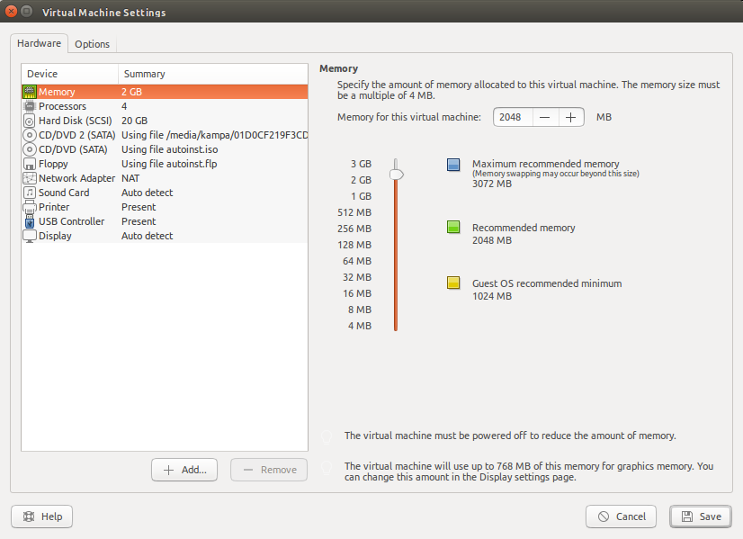

Cai dat SSH-server de remote tu may that

$sudo apt-get install openssh-server

Xem dia chi ip

$ifconfig

Vi du may ao da duoc dhcp cap ip va co dia chi la 192.168.184.158

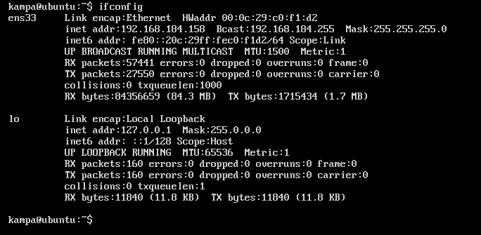

Sau do tren may that ssh vao server may ao bang lenh

$ssh -l <userdatao> 192.168.184.158

$sudo apt install curl

$sudo apt-get install software-properties-common

$curl -O https://hyperledger.github.io/composer/v0.19/prereqs-ubuntu.sh

$chmod u+x prereqs-ubuntu.sh

Cai dat nodejs 10

$curl -sL https://deb.nodesource.com/setup_**10**.x | sudo -E bash -

$sudo apt install nodejs

$nodejs -v

$npm -v

(Go cai dat nodejs sudo apt-get purge --auto-remove nodejs)

$./prereqs-ubuntu.sh

Neu bi loi cdrom thi sua file

$sudo nano /etc/apt/sources.list

Commend dong cdrom bang dau #

#deb cdrom:[Ubuntu-Server 16.04 LTS _Xenial Xerus_ - Release amd64 (20160420.3)]/ xenial main restricted

Nếu như bị lỗi npm eacces

<https://docs.npmjs.com/resolving-eacces-permissions-errors-when-installing-packages-globally>

$npm install -g composer-cli

$npm install -g composer-rest-server

$npm install -g generator-hyperledger-composer

$npm install -g yo

$npm install -g composer-playground

$mkdir ~/fabric-dev-servers && cd ~/fabric-dev-servers

$curl -O https://raw.githubusercontent.com/hyperledger/composer-tools/master/packages/fabric-dev-servers/fabric-dev-servers.tar.gz

$tar -xvf fabric-dev-servers.tar.gz

$export FABRIC_VERSION=hlfv12

$./downloadFabric.sh

Cai dat tftp-server de chuyen file

### TFTP Server Install and Setup

Install following packages

sudo apt-get install xinetd tftpd tftp

Create /etc/xinetd.d/tftp and put this entry

service tftp

{

protocol = udp

port = 69

socket_type = dgram

wait = yes

user = nobody

server = /usr/sbin/in.tftpd

server_args = /tftpboot

disable = no

}

Create a folder /tftpboot this should match whatever you gave in server_args. mostly it will be tftpboot

sudo mkdir /tftpboot

sudo chmod -R 777 /tftpboot

sudo chown -R nobody /tftpboot

Restart the xinetd service.

newer systems:

sudo service xinetd restart

older systems:

sudo /etc/init.d/xinetd restart

Now our tftp server is up and running.

### Testing our tftp server

Create a file named test with some content in /tftpboot path of the tftp server

Obtain the ip address of the tftp server using ifconfig command

Now in some other system follow the following steps.

tftp 192.168.1.2

tftp> get test

Sent 159 bytes in 0.0 seconds

tftp> quit

cat test

Nen file

$**tar -czvf <tencannen>.tar.gz <tenfolder>**

Giai nen

$**tar -xzvf <tenfile>.tar.gz**

$  
$  
$

$