**Non-Euclidean Geometry**

1. It is a quadrilateral with three right angles.
2. Saccheri quadrilateral
3. Euclidean quadrilateral
4. elliptic quadrilateral
5. Lambert quadrilateral

**EXPLANATION:**

A Lambert quadrilateral is a quadrilateral in hyperbolic and spherical geometry with three right angles.



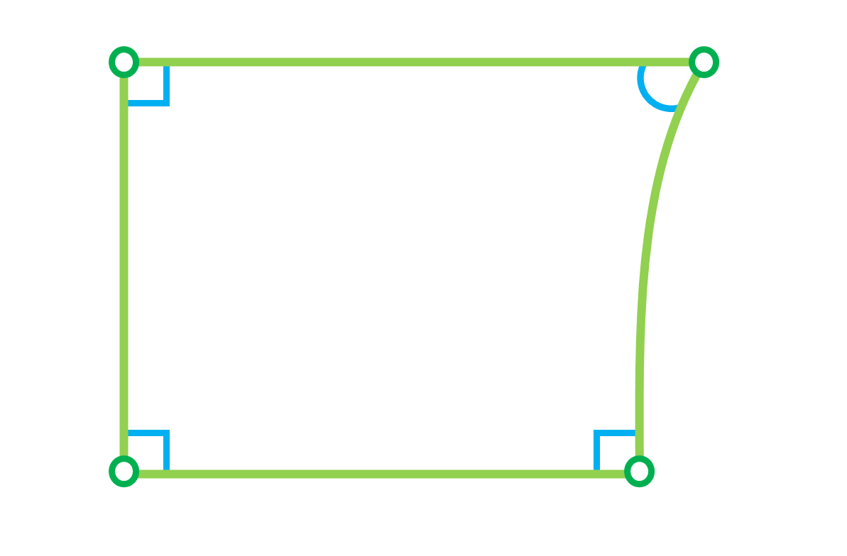

1. What is the distance between P = $\left(\frac{\sqrt{5}}{2} , \frac{\sqrt{5}}{7}, -\frac{\sqrt{3}}{14}\right)$ and Q = in S2?
   1. 0.773
   2. 1.773
   3. 2.773
   4. 3.773

**EXPLANATION:**

The distance between P and Q in S2 is  
d(P, Q) =

d(P, Q) = $\sqrt{{\left(-\frac{\sqrt{2}}{3}-\frac{\sqrt{5}}{2}\right)}^{2}+ {\left(\frac{\sqrt{2}}{5}-\frac{\sqrt{5}}{7}\right)}^{2}+ {\left(\frac{\sqrt{7}}{4}+\frac{\sqrt{3}}{14}\right)}^{2}}$

d(P, Q) ≈ 1.773

1. The Schlafli symbol of a regular tessellation is given by {4, 5}. The tessellation is
   1. Hyperbolic
   2. Euclidean
   3. Spherical
   4. Klein-Beltrami

**EXPLANATION:**

Let {n, k} be the Schlafli symbol of a regular tessellation. Note that if $\frac{1}{n}+\frac{1}{k}< \frac{1}{2}$ 
 , then the tessellation is hyperbolic.

Now, let {4, 5} be the Schlafli symbol, then

$\frac{1}{4}+\frac{1}{5}= \frac{9}{20}<\frac{1}{2}$. Thus, the tessellation is hyperbolic.

1. It is the difference between π and the angle sum of a hyperbolic triangle.
   1. ideal point
   2. excess
   3. tessellation
   4. defect

**EXPLANATION:**

The defect of the triangle is the difference between π and the angle sum of a hyperbolic triangle, which is also equivalent to its area.

1. The angles at the summit of an elliptic Saccheri quadrilateral are
   1. congruent and acute
   2. congruent and right
   3. congruent and obtuse
   4. congruent and straight

**EXPLANATION:**

By Theorem 2.1, the angles at the summit of a Saccheri quadrilateral in spherical geometry are congruent and obtuse.

1. Which of the following is NOT true?
   1. Poincaré disk model preserves angles while transforming hyperbolic straight lines into circle arcs.
   2. In hyperbolic geometry, the two angles of parallelism for the same segment are congruent and acute.
   3. The distance between P and Q in S2 is the arc length of the shortest path along the surface of the sphere from P to Q.
   4. A circle on the sphere whose center does not coincide with the sphere's center is a small circle.

**EXPLANATION:**

The distance is the measure of how far apart the two points are in a given space, whereas the spherical distance is the arc length of the shortest path along the surface of the sphere from one point to another.

1. Let {7, 3} be the Schlafli symbol of a hyperbolic tessellation. What is the angle sum of each heptagon in the tessellation?

$\frac{14π}{3}$

$\frac{2π}{3}$

$\frac{6π}{7}$

$\frac{2π}{7}$

**EXPLANATION:**

Let {n, k} be the Schlafli symbol of a regular tessellation. The angle sum is:

$\sum{θ}= \frac{2πn}{k}$

Now, let {7, 3} be the Schlafli symbol, then

$\sum{θ}= \frac{2π(7)}{3}= \frac{14π}{3}$

1. Let {5, 6} be the Schlafli symbol of a hyperbolic tessellation. What is the area of each pentagon in the tessellation?

$\frac{5π}{3}$

$\frac{4π}{3}$

$\frac{3π}{5}$

$\frac{3π}{4}$

**EXPLANATION:**

Let {n, k} be the Schlafli symbol of a regular tessellation. The area of the n-gon is:

An-gon = (n-2)(π) $- \sum{θ}$, where $\sum{θ}= \frac{2πn}{k}$ is the angle sum.

Now, let {5, 6} be the Schlafli symbol, then

A⬠ = (5-2)(π) $- \frac{2π(5)}{6}$

1. Let △ABC be a right spherical right triangle where C = π/2, such that p = AB, q = AC, and r = BC. If r = 43°18’ and B = 67°, what is the angle measure of q?
   1. 50° 51’ 14.28’’
   2. 26° 46’ 19.3’’
   3. 16° 31’ 14.89’’
   4. 39° 8’ 45.72’’

**EXPLANATION:**

Note that we have the values for r and B. In Napier’s Mnemonic, q is the opposite part of (π/2 - B) and (π/2 - r). By Napier’s Rule,

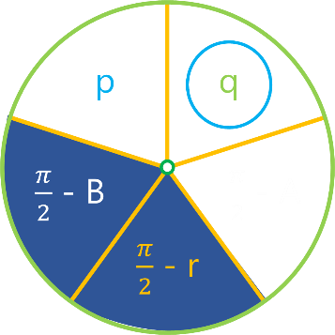

sin q = (cos (π/2 - B)) (cos (π/2 - r))

sin q = (cos (90° - 67°)) (cos (90° - 43°18’))

q = sin-1 [(cos 23°) (cos 46°42’)]

q = 39° 8’ 45.72’’

**EXPLANATION:**

For us to be able to obtain the excess of the triangle, we need to find the angle measures of its interior angles A, B, and C. We already have the value for C which is 90° (or π/2)

**For A:**

Note that we have the values for p and q. In Napier’s Mnemonic, q is adjacent to p and (π/2 - A). By Napier’s Rule,

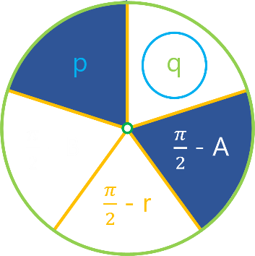sin q = (tan p) (tan (π/2 - A))

sin 67° = (tan 15° 49’ 20’’) (tan (90° - A))

tan (90° - A) = $\frac{sin 67°}{tan 15° 49’ 20’’}$

90° - A = tan-1

A = 90° - tan-1

A = 17° 6’ 42.2’’

**For B:**

Note that we have the values for p and q. In Napier’s Mnemonic, p is adjacent to q and (π/2 - B). By Napier’s Rule,

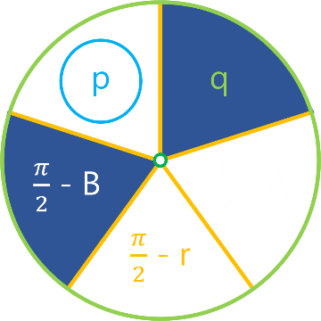sin p = (tan q) (tan (π/2 - B))

sin 15° 49’ 20’’ = (tan 67°) (tan (90° - B))

tan (90° - B) = $\frac{sin 15° 49’ 20’’}{tan 67°}$

90° - B = tan-1

B = 90° - tan-1

B = 83° 23’ 53.78’’

The excess of the triangle is equal to its area. The area of an n-gon is

An-gon = (θ1 + θ2 + … + θn) – (n - 2)(π), where θare interior angles.

A△ = (A + B + C) – (3 - 2)(π)

Note that A = 17° 6’ 42.2’’, B = 83° 23’ 53.78’’, and C = 90°. Thus,

A△ = (17° 6’ 42.2’’ + 83° 23’ 53.78’’ + 90°) – 180°

A△ = (17° 6’ 42.2’’ + 83° 23’ 53.78’’ + 90°) – 180°

A△ = 10° 30’ 35.98’’