Practice 4 – Smart Home System
Błażej Drozd
20.11.2025
Project repository: https://github.com/Tsugumik/programacion-uja

Changes
- A Device base class was introduced to hold common logic (like status, intensity, and on/off methods). SmartBulb and AirConditioner now inherit from Device, which eliminates code duplication and improves the object-oriented design.
- Implemented a new persistence.py module to save and load the application's state to a JSON file. All core classes (Home, Device subclasses, Scheduler) now support serialization via to_dict() and from_dict() methods. This makes the home's configuration persistent between sessions.
- Based on feedback, I have also reviewed the project. Two methods in the Scheduler class, which don’t depend on instance state, have been correctly changed to class methods.

UML Diagram
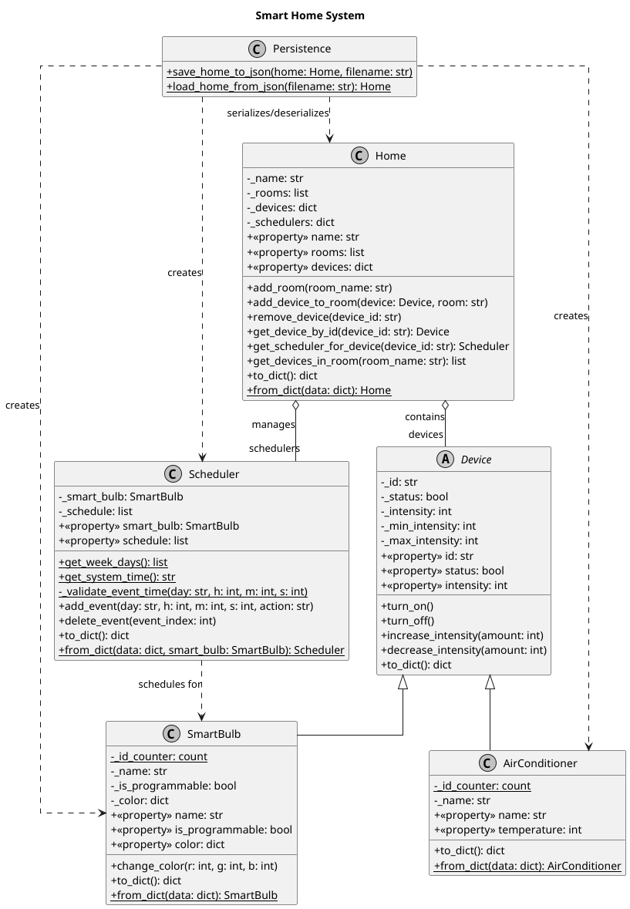
The repository also includes a diagram.puml file containing PlantUML diagram for the entire system, illustrating the relationship between classes.

User Stories Validation
Also I verified that the current implementation of the Smart Home meets all the criteria defined in the user stories.
- HU01: Smart Bulb Management
  - Can be turned on and off:
    - Fulfilled: Implemented via SmartBulb.turn_on() and SmartBulb.turn_off() methods (inherited from the Device base class).
  - Know its status:
    - Fulfilled: Implemented via the @property SmartBulb.status (inherited from Device).
  - Change the intensity:
    - Fulfilled: Implemented via SmartBulb.increase_intensity() and SmartBulb.decrease_intensity() methods (inherited from Device).
  - Change the color:
    - Fulfilled: Implemented via the SmartBulb.change_color(r, g, b) method, which validates and sets the bulb's RGB color. The current color is accessible via the @property SmartBulb.color.
- HU02: Air Conditioner Management
  - Be able to know the air temperature:
    - Fulfilled: Implemented via the @property AirConditioner.temperature. For this device, 'intensity' represents temperature.
  - Be able to change the temperature:
    - Fulfilled: Implemented via AirConditioner.increase_intensity() and AirConditioner.decrease_intensity().
  - Be able to know if it is off or on:
    - Fulfilled: Implemented via the @property AirConditioner.status.
  - Be able to turn it off or on:
    - Fulfilled: Implemented via AirConditioner.turn_on() and AirConditioner.turn_off().
- HU03: Device Distribution in the Home
  - Be able to tell how many rooms the home has and what rooms they are:
    - Fulfilled: Implemented in the Home class via the @property Home.rooms.
  - Be able to tell what devices are in the home:
    - Fulfilled: Implemented in the Home class via the @property Home.devices.
  - Be able to add a device:
    - Fulfilled: Implemented via Home.add_device_to_room(...).
  - Be able to remove a device:
    - Fulfilled: Implemented via a Home.remove_device(...) method.
  - Be able to modify a device:
    - Fulfilled: Implemented indirectly. The user (via main.py) can retrieve a device (e.g., home.get_device_by_id(...)) and then call its public methods (.turn_on(), .change_color(), .increase_intensity()).
  - Be able to know the number of devices in the home and in each room:
    - Fulfilled: Implemented in the Home class via len(home.devices) and the get_devices_in_room(...) method.
  - Be able to identify the device that is in each location:
    - Fulfilled: Ensured by the unique device ID and the Home data structure, which maps rooms to device lists.
- HU04: Permanent Storage of the Home's Rooms
  - Can be recovered from a file
    - Fulfilled: Implemented by the persistence.load_home_from_json(filename) function. This function uses the @classmethod from_dict() methods defined in the Home, SmartBulb, and AirConditioner classes to restore the complete object state.
  - Can be saved to a file
    - Fulfilled: Implemented by the persistence.save_home_to_json(home_object, filename) function. This function uses the to_dict() methods defined in the classes to serialize the object state to JSON.

