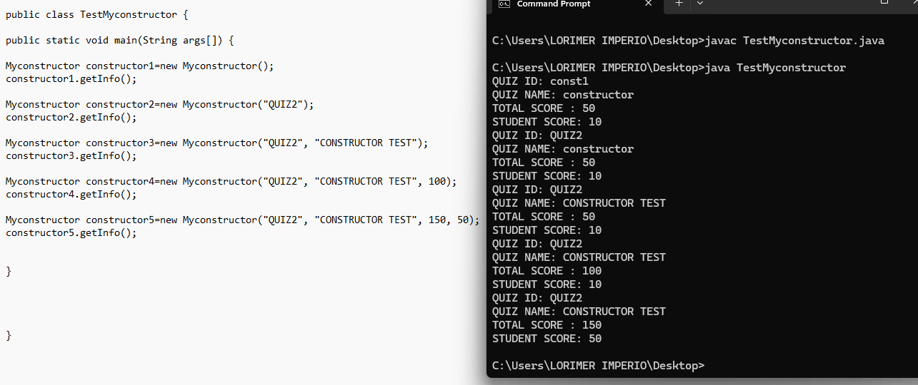

BASED ON THE ABOVE CODES (TestMyconstructor) and the output as displayed on the right side , provide the codes for the class Myconstructor.java

