AGRICULTURE & AGRIBUSINESS | DATA ANALYTICS PROJECT
Week 3 Task
Exploratory Data Analysis and Visualization in Agribusiness
Patterns, trends and anomalies in crop yield, weather and price data
Prepared by: Junior Data Analyst (Intern)
Client scenario: GreenHarvest Agri Co-operative (hypothetical), Karnataka, India
Date: November 2026
Note: All datasets in this project are synthetic and created for demonstration.

Contents
1. Dataset Context and Variables
2. EDA Plan
3. Summary Statistics
4. Distributions
5. Relationships and Correlation Analysis
6. Trends and Seasonality
7. Spatial and Segment Comparison
8. Anomalies and Unexpected Patterns
9. Business Implications of the Trends
10. Challenges in Identifying Meaningful Trends
11. Recommendations for Further Analysis
12. Visualization Principles Applied
13. Conclusion

1. Dataset Context and Variables
The analysis uses the cleaned, simulated dataset from Week 2: 1425 farm-season records for GreenHarvest Agri Co-operative, covering rice, maize, ragi and tomato in eight Karnataka districts between 2019 and 2024. The data are synthetic; their value here is to practise and demonstrate a full exploratory workflow.
Variable group | Variables | Role in the analysis
Crop performance | yield_t_ha, yield index (yield / crop average), total production | Outcome of interest
Weather patterns | rainfall_mm (season total), avg_temp_c | Natural drivers of yield
Pricing trends | farm-gate price (INR/quintal), price index, transport cost, net price | Market outcome and cost
Farm practice and soil | irrigation type, fertiliser (kg/ha), soil pH, farm area | Controllable drivers
Context | district, crop, season, year, month | Segments and time

Record counts by crop are balanced (ragi 374, rice 367, maize 350, tomato 334), so no crop dominates simply through sample size.

2. EDA Plan
Step | Question | Techniques | Visual aid
1. Summary statistics | What are typical values and how variable are they? | Mean, median, SD, CV, min, max, skewness, kurtosis | Table
2. Distributions | Are variables symmetric, skewed or multi-modal? | Histograms, box plots | Histogram grid, box plot
3. Relationships | Which variables move together with yield? | Pearson and Spearman correlation, binned means, group comparisons | Heat map, scatter, box plot
4. Trends and seasonality | How do price, yield and rainfall change over years and seasons? | Yearly means, monthly index | Line and bar charts
5. Segments | Which districts and crops perform best or worst? | Group means, cross-tabulation | Heat map, stacked bar
6. Anomalies | What is surprising or suspicious? | Residual checks, pooled vs within-group comparisons | Annotated charts

3. Summary Statistics
Variable | Mean | Median | SD | CV % | Min | Max | Skew | Kurt.
Farm area (ha) | 2.51 | 2.14 | 1.57 | 62.6 | 0.34 | 11.58 | 1.58 | 3.97
Rainfall (mm) | 346.62 | 339.39 | 158.5 | 45.7 | 80 | 867.28 | 0.26 | -0.56
Temperature (C) | 26 | 26.23 | 2.53 | 9.8 | 17.34 | 34.75 | -0.12 | -0.26
Fertiliser (kg/ha) | 108.67 | 108.28 | 32.2 | 29.6 | 20 | 230.26 | 0.07 | 0.41
Soil pH | 6.6 | 6.58 | 0.48 | 7.2 | 4.84 | 8.13 | 0.03 | 0.23
Yield (t/ha) | 8.2 | 4.38 | 8.15 | 99.5 | 1.28 | 32.06 | 1.34 | 0.15
Farm-gate price (INR/qtl) | 2,542.65 | 2,339.96 | 764.83 | 30.1 | 1,331.76 | 4,909.49 | 0.89 | -0.09
Transport cost (INR/qtl) | 96.19 | 96.5 | 24.67 | 25.6 | 3.8 | 164.2 | -0.1 | -0.09
Yield index | 1 | 1 | 0.16 | 16.4 | 0.53 | 1.47 | 0.08 | -0.27
CV = coefficient of variation (SD / mean). Skew: 0 is symmetric. Kurt. = excess kurtosis (0 is normal-like tails).

Interpretation
- Yield is a mixture. The raw yield has mean 8.2 but median 4.38 t/ha and a CV near 100%, because tomato (about 22 t/ha) is mixed with cereals (2.5 to 5 t/ha). The crop-normalised yield index has mean 1.00 and CV of 16.4%, a far more meaningful measure.
- Farm area is right-skewed (skew 1.58): most farms are small, with a few large plots. Medians describe typical farms better than means.
- Rainfall varies strongly (CV 46%), which is the widest spread among the weather and input variables, so it has the most room to explain differences.
- Soil pH and temperature are tightly clustered (CV under 10%), leaving little variation to explain yield.
- Price is right-skewed (skew 0.89) because ragi is priced far above the other crops.

4. Distributions
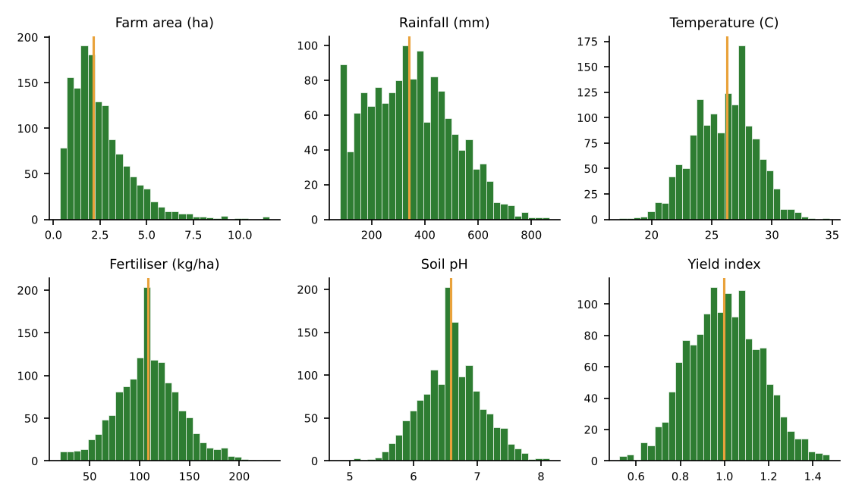
Figure 1: Distributions of key variables (amber line = median). Farm area is skewed; the others are roughly symmetric.
Rainfall, fertiliser, temperature, soil pH and the yield index are roughly bell-shaped. Farm area has a long right tail. The distributions show no signs of the impossible values removed in Week 2.
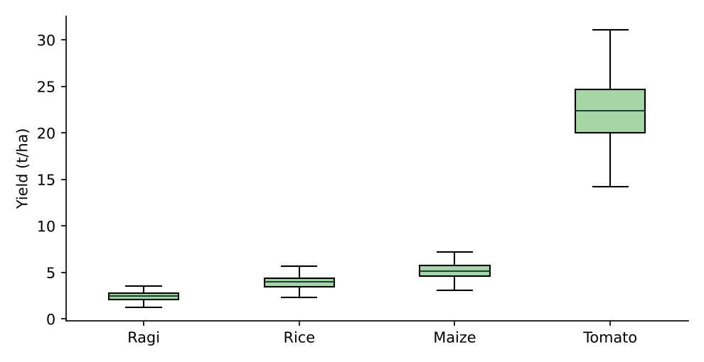
Figure 2: Yield by crop. Scales differ by an order of magnitude, so crops must be compared through an index.
Crop | Yield CV % | Price CV % | Gross revenue (INR lakh/ha)
Rice | 16.2 | 9.2 | 0.94
Maize | 16.3 | 9.3 | 1.18
Ragi | 16.9 | 15.8 | 0.88
Tomato | 16 | 14.3 | 3.95
Yield variability is similar across crops (16 to 20%), but ragi and tomato prices vary most (15.8% and 14.3%), while rice and maize prices are steadier (about 9%). Tomato also generates roughly four times the gross revenue per hectare of rice, which is the combination of high yield and high price risk typical of horticulture.

5. Relationships and Correlation Analysis
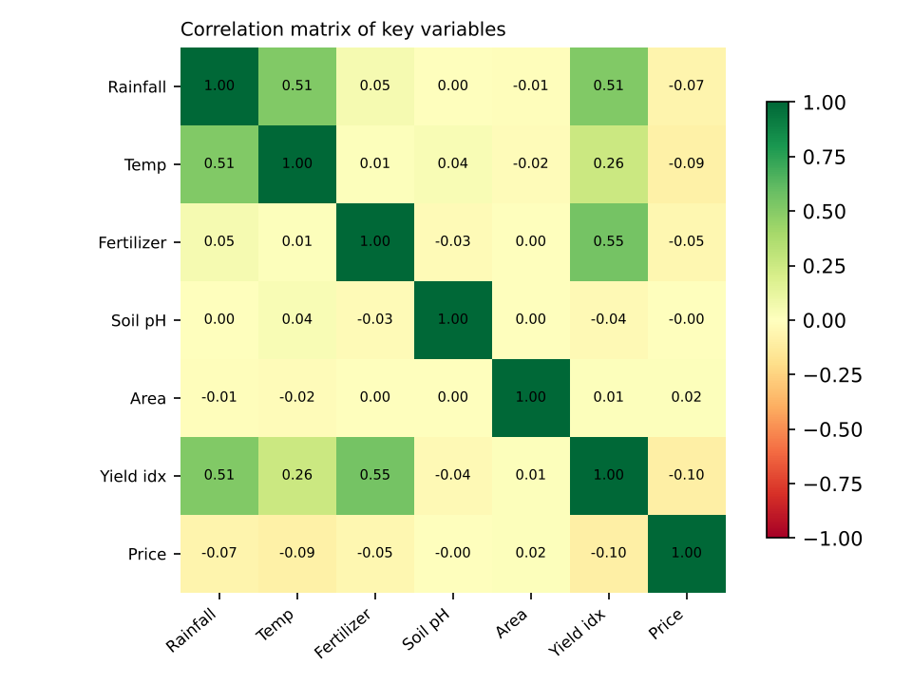
Figure 3: Correlation matrix (Pearson). Green = positive, red = negative.
Variable vs yield index | Pearson r | Spearman rho | Reading
Rainfall (mm) | 0.509 | 0.507 | Moderate association
Temperature (C) | 0.257 | 0.26 | Weak association
Fertiliser (kg/ha) | 0.547 | 0.523 | Moderate association
Soil pH | -0.037 | -0.025 | No clear association
Farm area (ha) | 0.013 | 0.016 | No clear association
Transport cost (INR/qtl) | 0.047 | 0.031 | No clear association

Pearson and Spearman values are close for every variable, which indicates the relationships are broadly monotonic and not driven by a few extreme points. Fertiliser and rainfall show the strongest association with yield; soil pH, farm area and transport cost show none.
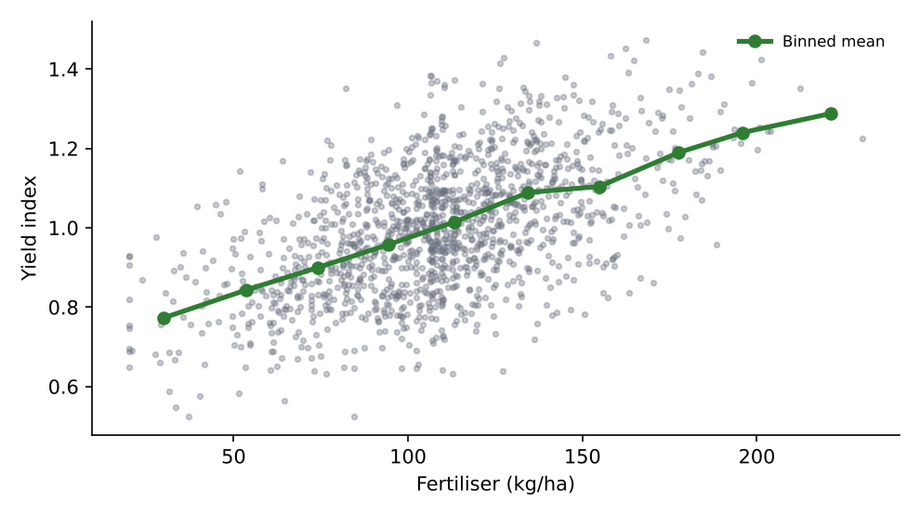
Figure 4: Fertiliser rate vs yield index. The binned means (green) rise steadily without an obvious plateau within the observed range.
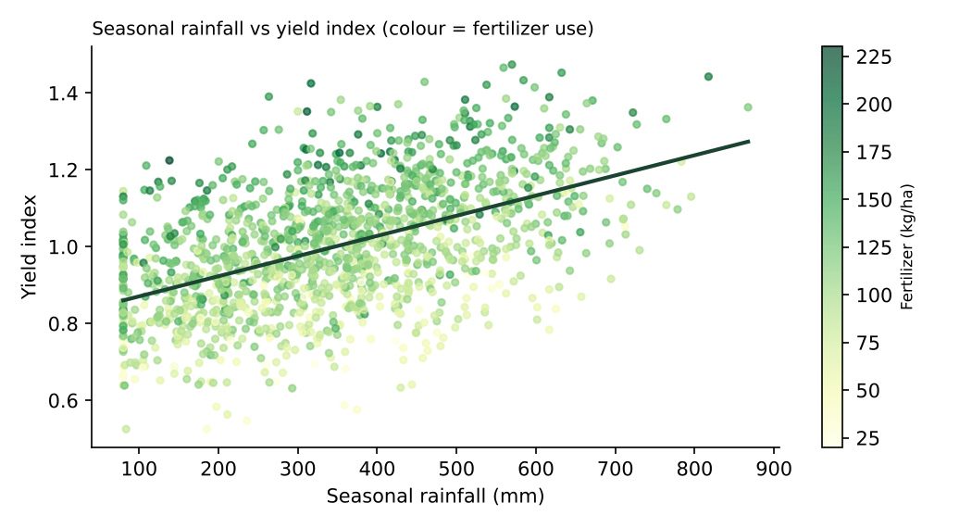
Figure 5: Seasonal rainfall vs yield index (colour = fertiliser).
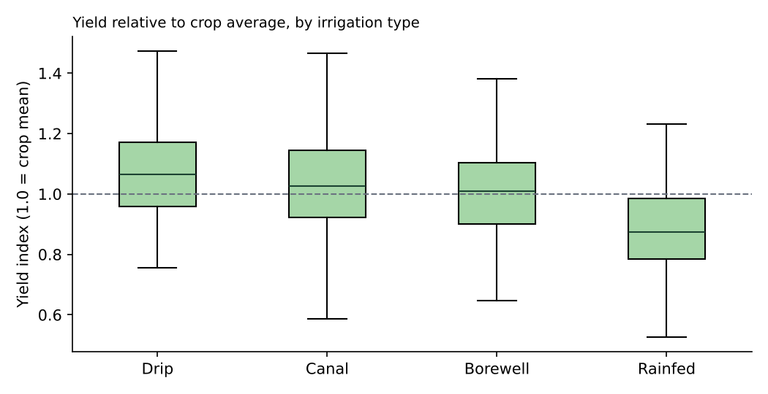
Figure 6: Yield index by irrigation type.
Irrigation shows a clear gradient: drip 1.068, canal 1.035, borewell 1.004, rainfed 0.885 (1.0 = crop average). Boxes overlap, so irrigation matters but does not decide the outcome alone.

6. Trends and Seasonality
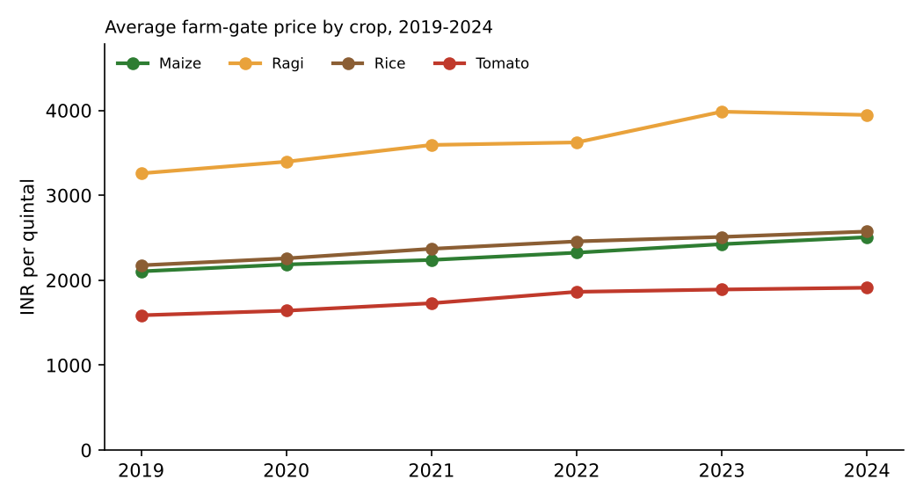
Figure 7: Average farm-gate price by crop, 2019-2024.
All crops show a steady rise. Across the dataset, average farm-gate price grew from about INR 2,312 (2019) to INR 2,776 (2024) per quintal, roughly 3.38% a year on a linear trend. Note that the overall average mixes crops, so crop-level lines are more reliable than the pooled figure.
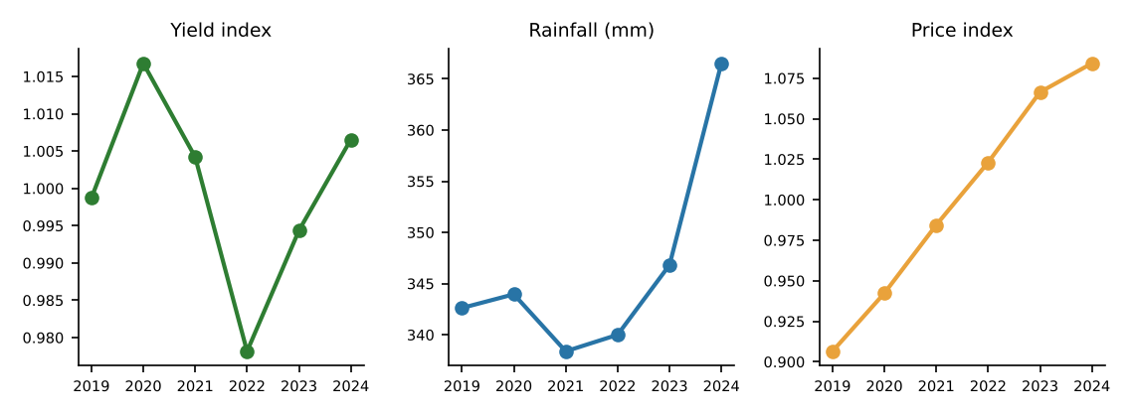
Figure 8: Yearly yield index, rainfall and price index.
Year | Yield index | Mean rainfall (mm) | Price index
2019 | 0.999 | 343 | 0.906
2020 | 1.017 | 344 | 0.942
2021 | 1.004 | 338 | 0.984
2022 | 0.978 | 340 | 1.023
2023 | 0.994 | 347 | 1.066
2024 | 1.007 | 367 | 1.084

The price index rises about 3.7% of the crop average per year, while the yield index is flat around 1.0 (no long-term yield trend). Rainfall is stable until 2023 and then higher in 2024. With only six years, a trend can be described but not firmly forecast.
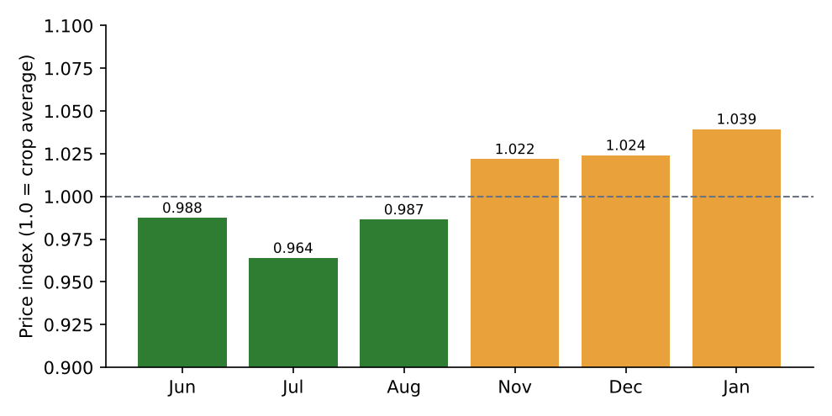
Figure 9: Price index by sowing month (green = Kharif months, amber = Rabi months).
Rabi-season sowing months carry a higher price index (about 1.028) than Kharif months (about 0.98), a premium of roughly 4.9 percentage points. This pattern is consistent with seasonal supply. Part of the monthly shape is also the upward price trend mixing into the month profile, which is why seasonality should be re-tested with detrended data.

7. Spatial and Segment Comparison
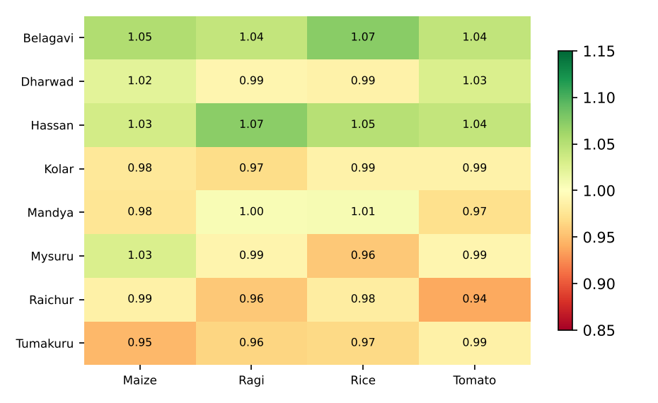
Figure 10: Mean yield index by district and crop.
District averages range from 0.965 (Tumakuru) to 1.053 (Belagavi). Belagavi and Hassan, the districts with the highest average rainfall, lead; Tumakuru, Raichur and Kolar trail. Cell values in the district-by-crop map run only from 0.94 to 1.07, so geography matters less than practice: the spread between irrigation types is almost double the spread between districts.
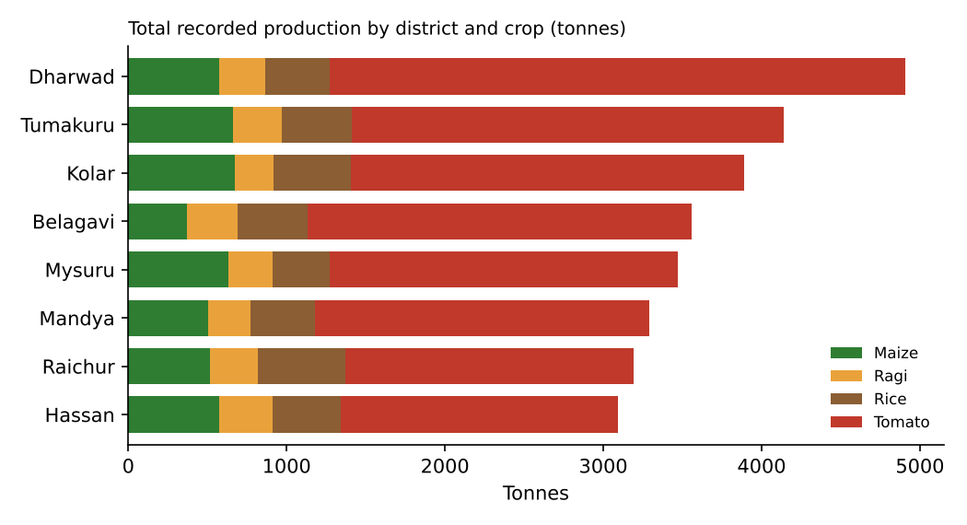
Figure 11: Total recorded production by district and crop (tonnes).
Tomato dominates tonnage because of its yield per hectare. Volume and value are different things, and neither reflects the quantity of farms involved; a district can lead in tonnes simply by growing more tomato.

8. Anomalies and Unexpected Patterns
Observation | Evidence | Explanation / action
Yield is much lower in Rabi | Yield index: Kharif 1.052, Rabi 0.929 | Rabi has about half the rainfall (213 mm vs 444 mm). Season and rainfall overlap, so the effect cannot be read from the season difference alone (tested in Week 4).
Rabi price is higher but yield is lower | Price premium and yield deficit move in opposite directions | Consistent with supply effects: lower supply, higher price.
Pooled correlations exaggerate | Yield vs price correlation: -0.63 pooled, but only -0.3 (rice), -0.31 (maize), -0.19 (ragi), -0.25 (tomato) within crop | Crop differences (high-yield crops with low per-quintal prices) inflate the pooled link. Always analyse within crop or on indices.
Mislabelled crop records | A few 'ragi' records with 4+ t/ha yield showed up as extreme residuals | Fixed in Week 2 with a cross-field plausibility rule; shows that EDA and cleaning inform each other.
2024 rainfall jump | Mean rainfall rose to about 367 mm from about 347 mm | Possible weather shift or sampling variation; flag for monitoring.
Soil pH has almost no relationship with yield | Pearson r = -0.037 | pH varies little (CV about 7%); the relationship may be non-linear or visible only at extremes.

9. Business Implications of the Trends
Trend or pattern | Implication for the business | Possible action
Fertiliser and rainfall track yield | Output is partly predictable from controllable and observable factors | Track rainfall in season; use soil-test-based fertiliser advice
Rainfed farms about 11% below average | Largest gap between farm groups | Prioritise irrigation support and water harvesting for rainfed farms
Prices rising about 3.4% a year | Income growth is possible, but input costs may rise faster | Monitor margin, not just price
Rabi price premium | Timing of sale can raise realised price | Reserve storage and arrange contracts for Rabi sales where feasible
Ragi and tomato price volatility | Higher revenue risk for these crops | Use staggered selling and forward contracts for tomato; diversify
Tomato gross revenue per hectare is about four times rice | Crop mix strongly affects farmer income | Collect cost data; assess net margin before advising a switch
Small spread between districts | District-level programmes are less effective than practice-level ones | Target by farm characteristics

10. Challenges in Identifying Meaningful Trends
Challenge | Why it matters | How it was addressed
Mixing crops with different scales | Pooled yield and price statistics are dominated by tomato and ragi | Used crop-normalised indices and within-crop comparisons
Confounding (season and rainfall overlap) | A season effect can really be a rainfall effect | Examined season and rainfall together; planned regression with both (Week 4)
Correlation versus causation | Associations can reflect unmeasured differences between farms | Described patterns as associations; recommended pilots and controlled tests
Short time series | Six annual points limit trend reliability | Reported direction, avoided precise forecasts
Skewed variables | Means mislead for skewed variables such as area | Reported medians and used Spearman as a check
Hidden data errors | Mislabelled records distort relationships | Residual review and a new plausibility rule
Visual over-interpretation | Eye sees patterns in noise | Added binned means and trend lines; checked with correlation coefficients
Synthetic data | Real data will be messier | Treat findings as method demonstration

11. Recommendations for Further Analysis
- Formal hypothesis tests and regression (Week 4) to separate the effects of rainfall, season, fertiliser and irrigation and to attach confidence intervals.
- Detrended seasonality. Remove the price trend, then estimate monthly seasonal indices for each crop separately.
- Interaction effects. Test whether the benefit of irrigation is larger in dry districts or low-rainfall seasons.
- Non-linear response. Check whether fertiliser benefits flatten at higher doses (for example with polynomial or spline terms).
- Weather timing. Replace seasonal totals with monthly rainfall, dry spells and heat-stress days.
- Net margin analysis. Add cost of cultivation to compare crops on profit, not revenue.
- Supply-chain detail. Collect distance, storage time and spoilage to explain transport and loss costs.
- Clustering of farms. Group farms by practices and outcomes to design tailored advice.
- Real-data validation. Repeat the EDA with public data from Agmarknet, data.gov.in and IMD.

12. Visualization Principles Applied
Principle | How it was used
Match chart to question | Line for trends, box plot for group distributions, scatter for relationships, heat map for two-way comparison, stacked bar for composition
Compare like with like | Indices instead of raw yield or price across crops
Show the data, not just the summary | Scatter points behind binned means; box plots rather than bar averages
Reduce clutter | No 3-D, no pie charts, light gridlines, one highlight colour
Label for non-technical readers | Units on axes, plain language in captions, a one-line takeaway under each figure
Accessible colour | Green-amber palette with direct labels; meaning not carried by colour alone

13. Conclusion
Key takeaways from the exploration
Fertiliser, rainfall and irrigation show the strongest links to yield; soil pH, farm area and transport cost show none.
Rainfed farms lag (yield index 0.885); drip farms lead (1.068).
Prices rise about 3.38% a year and are higher for Rabi sowing months; ragi and tomato prices are the most volatile.
Pooled statistics mislead when crops differ; indices and within-crop comparisons are essential.
EDA exposed a data error (mislabelled records) that range checks had missed, which led to an improved cleaning rule.

These patterns are hypotheses to be tested, not conclusions. Week 4 applies formal statistical tests and regression to quantify them and to examine the assumptions behind the model.

