AGRICULTURE & AGRIBUSINESS | DATA ANALYTICS PROJECT
Week 4 Task
Statistical Analysis and Predictive Modeling in Agribusiness
Hypothesis tests, regression, assumption checks and limitations for crop yield
Prepared by: Junior Data Analyst (Intern)
Client scenario: GreenHarvest Agri Co-operative (hypothetical), Karnataka, India
Date: November 2026
Note: All datasets in this project are synthetic and created for demonstration.

Contents
1. Objective, Variables and Data
2. Methodology
3. Statistical Analysis: Hypothesis Tests
4. Predictive Modeling: Regression Results
5. Model Assumptions and Diagnostics
6. Predictive Performance and Validation
7. Extension: Modeling Price (Market) Outcomes
8. Discussion and Business Implications
9. Limitations and Reliability
10. Conclusions

1. Objective, Variables and Data
This report applies statistical analysis and a predictive model to the cleaned, simulated dataset of 1425 farm-season records from GreenHarvest Agri Co-operative. The aim is to understand how weather, farm practices and inputs relate to crop yield, to predict yield, and to state clearly how far the results can be trusted.
Role | Variable | Notes
Target (dependent) | Yield index = yield / average yield of the same crop | Unit-free; 1.0 is average for the crop. Allows four crops in one model.
Predictor | Rainfall (mm, season total) | Weather driver
Predictor | Average temperature (C) | Weather driver
Predictor | Fertiliser rate (kg/ha) | Used as the input-cost proxy: spend scales with quantity at a given price
Predictor | Soil pH | Soil condition
Predictor | Farm area (ha) | Scale
Predictor (categorical) | Irrigation type (borewell = reference) | Canal, drip, rainfed indicators
Predictor (categorical) | Season (Kharif = reference) | Rabi indicator
Market outcome (Section 7) | Price index = price / average price of the same crop | Second model for price

Transport cost was tested separately (Week 3: correlation with yield about 0.05) and is not a yield driver; it belongs to the market and supply-chain side of the analysis.

2. Methodology

2.1 Theoretical walkthrough of data processing and analysis
Stage | What happens | Why
1. Ingest and clean | Load cleaned data (Week 2); confirm no missing values and valid ranges | Models assume complete, valid inputs
2. Define target and features | Compute crop-normalised yield index; list predictors; choose reference categories | Comparable target; clear interpretation
3. Encode and scale | One-hot encode irrigation and season; standardise numeric predictors for the machine-learning comparison | Regression needs numeric inputs; scaling aids comparison of effects
4. Hypothesis testing | Test relationships and group differences with pre-stated hypotheses | Separate real effects from random variation
5. Fit the regression | Estimate coefficients by ordinary least squares (OLS) with standard errors and confidence intervals | Interpretable, quantified effects
6. Check assumptions | Residual analysis, multicollinearity, influence | Validity of p-values and intervals depends on assumptions
7. Validate predictions | 80/20 train-test split; 5-fold cross-validation; compare with baseline and other models | Estimate performance on unseen data
8. Interpret | Convert coefficients to business meaning; discuss limits | Decision support
9. Monitor | Re-fit with new seasons; watch error by group | Models drift as conditions change

2.2 Model specification
The main model is a multiple linear regression:
YieldIndex = b0 + b1*Rainfall + b2*Temperature + b3*Fertiliser + b4*SoilpH + b5*Area
+ b6*Canal + b7*Drip + b8*Rainfed + b9*Rabi + error

Why regression? It gives interpretable coefficients (the change in yield index for a one-unit change in a predictor with others held fixed), standard errors and confidence intervals, and allows assumption checks. Decision tree and random forest models are used as comparators to test whether non-linear structure was missed.

2.3 Tools and settings
Python with pandas, SciPy and statsmodels for tests and OLS; scikit-learn for train-test split, cross-validation and comparison models. Significance level 0.05; random seed 42; all code in the project folder (scripts 03 and 06).

3. Statistical Analysis: Hypothesis Tests

3.1 Hypotheses
ID | Null hypothesis (H0) | Alternative (H1) | Test
H1 | Fertiliser rate is unrelated to yield index | Positively related | Pearson correlation
H2 | Rainfall is unrelated to yield index | Positively related | Pearson correlation
H3 | Mean yield index is equal across irrigation types | At least one mean differs | One-way ANOVA; Kruskal-Wallis as non-parametric check; Tukey HSD post hoc
H4 | Rabi and Kharif price indices are equal | They differ | Welch t-test
H5 | Soil pH is unrelated to yield index | Linearly related | Pearson correlation

3.2 Results
ID | Test | Statistic | p-value | Decision at 5%
H1 | Pearson correlation | r = 0.547 | < 0.001 | Reject H0
H2 | Pearson correlation | r = 0.509 | < 0.001 | Reject H0
H3 | One-way ANOVA | F = 90.85 | < 0.001 | Reject H0
H3b | Kruskal-Wallis | H = 221.73 | < 0.001 | Reject H0
H4 | Welch t-test | t = 7.35 | < 0.001 | Reject H0
H5 | Pearson correlation | r = -0.037 | 0.160 | Fail to reject H0

Interpretation. Fertiliser (r about 0.55) and rainfall (r about 0.51) are both strongly and significantly related to yield, so H1 and H2 are rejected. Irrigation type clearly matters: the parametric ANOVA and non-parametric Kruskal-Wallis tests agree (H3). Rabi prices differ from Kharif prices (H4). Soil pH shows no significant linear link (H5 is not rejected).
A caution on p-values. With over 1,400 records, even small differences become 'significant'. The size of an effect (and its confidence interval) matters more to a business than the p-value alone, so Section 4 emphasises effect sizes.

3.3 Which irrigation types differ? (Tukey HSD)
Comparison | Difference in mean yield index | Adjusted p-value
Borewell vs Canal | -0.031 | 0.017
Borewell vs Drip | -0.065 | < 0.001
Borewell vs Rainfed | 0.119 | < 0.001
Canal vs Drip | -0.033 | 0.016
Canal vs Rainfed | 0.150 | < 0.001
Drip vs Rainfed | 0.184 | < 0.001
All pairs differ significantly. Rainfed farms are about 0.12 to 0.18 index points below the others, which is the largest gap; the differences among canal, borewell and drip are smaller (0.03 to 0.07).

4. Predictive Modeling: Regression Results
The OLS model has R-squared 0.704 (adjusted 0.702) on 1425 records; the overall F-test is highly significant (F = 374.6, p < 0.001). The residual standard error is 0.0892 yield-index points, so a typical prediction misses by about nine percentage points of the crop-average yield.
Predictor (unit change) | Effect on yield index | 95% CI | p-value
Fertiliser (+10 kg/ha) | +0.026 | 0.025 to 0.028 | < 0.001
Rainfall (+100 mm) | +0.049 | 0.045 to 0.054 | < 0.001
Temperature (+1 C) | 0.000 | -0.003 to 0.002 | 0.746
Soil pH (+1 unit) | -0.007 | -0.017 to 0.002 | 0.140
Farm area (+1 ha) | +0.002 | -0.001 to 0.005 | 0.159
Canal vs borewell | +0.031 | 0.019 to 0.043 | < 0.001
Drip vs borewell | +0.075 | 0.061 to 0.089 | < 0.001
Rainfed vs borewell | -0.118 | -0.132 to -0.105 | < 0.001
Rabi vs Kharif | -0.012 | -0.028 to 0.005 | 0.162

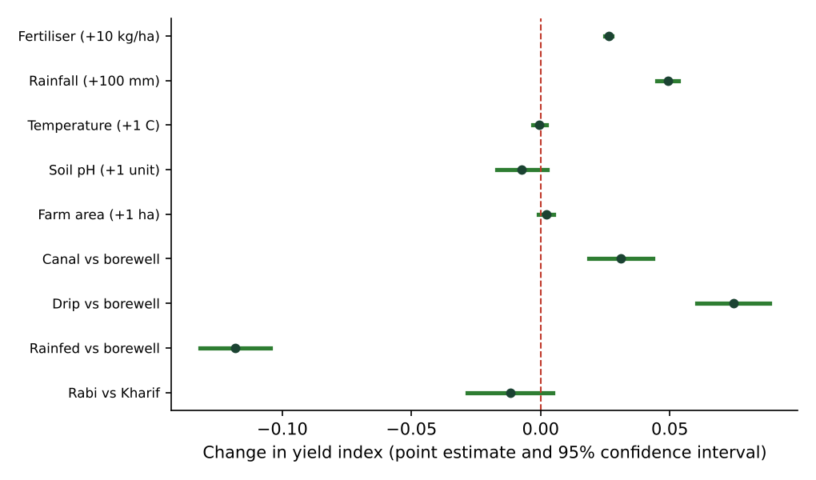
Figure 1: Estimated effects with 95% confidence intervals. Intervals that cross the red zero line are not significant.

4.1 Interpretation of coefficients
- Fertiliser: each extra 10 kg/ha is associated with about +2.6% of crop-average yield, holding other factors fixed.
- Rainfall: each extra 100 mm is associated with about +4.9%.
- Irrigation (versus borewell): drip +7.5%, canal +3.1%, rainfed -11.8%.
- Temperature, soil pH, farm area and Rabi season: not statistically distinguishable from zero. The Rabi yield deficit seen in raw averages (Week 3) is explained by lower rainfall once rainfall is in the model.

4.2 Relative importance (standardised effects)
Predictor | Standardised beta | Meaning
Fertiliser | 0.518 | One SD more fertiliser: about half an SD more yield
Rainfall | 0.477 | One SD more rainfall: about 0.48 SD more yield
Area | 0.020 | Negligible
Soil pH | -0.021 | Negligible
Temperature | -0.007 | Negligible

5. Model Assumptions and Diagnostics
OLS estimates are valid without special assumptions, but the p-values and confidence intervals rely on several. Each assumption was tested and is reported with its verdict.
Assumption | Check | Result | Verdict
Linearity of relationships | Ramsey RESET test; residual vs fitted plot | t = 0.80, p = 0.43; no curve in residual plot | Met
Independent errors | Durbin-Watson statistic (about 2 = no autocorrelation) | DW = 1.97 | Met (but see farm clustering in Section 9)
Constant variance (homoscedasticity) | Breusch-Pagan test | LM = 6.92, p = 0.65 | Met
Normal residuals | Jarque-Bera, Q-Q plot | Skewness 0.19, kurtosis 3.95 (normal = 3); JB p < 0.001 | Mildly violated: slightly heavy tails
No severe multicollinearity | Variance inflation factors | Highest VIF 3.12 (season); all below 5 | Met
No dominant influential points | Cook's distance | Maximum 0.018 (concern above 1); 76 points above 4/n | Met

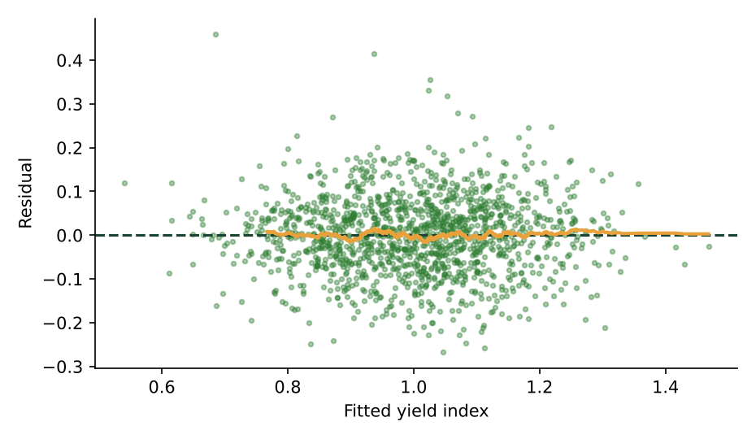
Figure 2: Residuals vs fitted values. The amber line stays close to zero, showing no curvature or funnel shape.
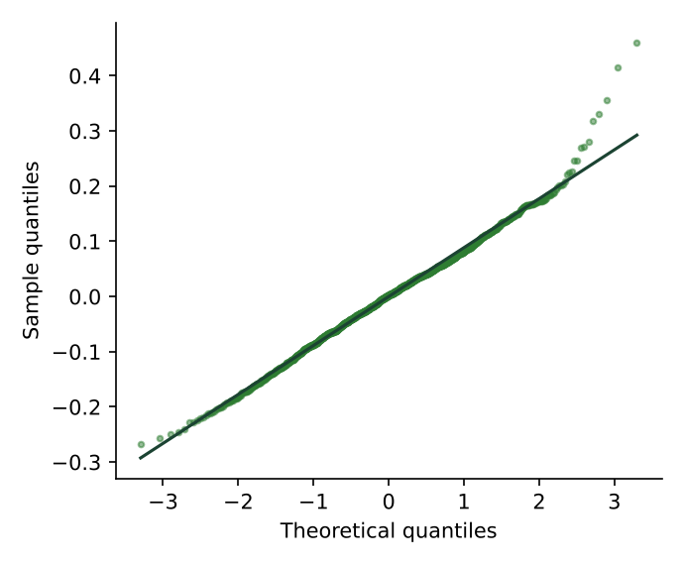
Figure 3: Normal Q-Q plot of residuals. Points follow the line except slightly in the tails.
Handling the normality departure. Residuals are nearly symmetric (skewness 0.19) but with slightly heavier tails than a normal curve. The Jarque-Bera test flags this because the sample is large, but with 1,400+ records the coefficient estimates are still reliable and confidence intervals are approximately valid by the central limit theorem. As a check, heteroscedasticity-robust (HC3) standard errors were computed: for fertiliser the standard error is 7.4e-5 (classic) versus 6.9e-5 (robust), and for rainfall the two are essentially identical, so conclusions do not change.
Diagnostics as a cleaning tool
An earlier run of this model on data without the cross-field plausibility rule gave a heavy right tail (skewness above 2, kurtosis above 18). Tracing the largest residuals revealed mislabelled crop records. After adding that rule in Week 2, R-squared rose from about 0.62 to 0.70 and the residuals became much closer to normal.

6. Predictive Performance and Validation
The data were split 80/20 (1140 training and 285 test records). Models were fitted on the training set and scored on the test set, with 5-fold cross-validation on the training set as a stability check. The baseline predicts the training mean for every record.
Model | MAE | RMSE | R-squared (test) | R-squared (5-fold CV)
Baseline (mean) | 0.134 | 0.163 | -0.006 | n/a
Linear Regression | 0.068 | 0.086 | 0.719 | 0.693
Decision Tree (depth 5) | 0.077 | 0.097 | 0.642 | 0.56
Random Forest (200 trees) | 0.069 | 0.086 | 0.721 | 0.666

Linear regression (R-squared 0.719) and the random forest (0.721) are effectively tied; the decision tree is weaker (0.642). Because the flexible random forest adds nothing, the straight-line additive model is adequate and preferred for its interpretability. The cross-validated score (0.693) is a little below the test score, which suggests the test split was slightly favourable and that about 0.69 is a more cautious expectation for new data.
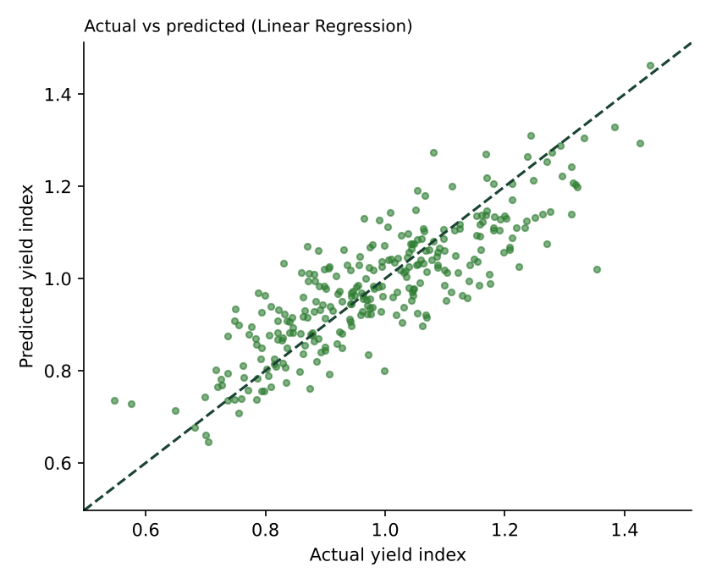
Figure 4: Actual vs predicted yield index on the test set.

6.1 Is accuracy uniform?
Group | Mean absolute error (index points)
Irrigation: Borewell | 0.075
Irrigation: Canal | 0.078
Irrigation: Drip | 0.068
Irrigation: Rainfed | 0.048
Crop: Maize | 0.066
Crop: Ragi | 0.067
Crop: Rice | 0.060
Crop: Tomato | 0.078
Errors are similar across groups (about 0.05 to 0.08), with the highest errors for tomato and for canal farms. No group is badly predicted, but tomato is the least precise crop.

6.2 Robustness: does the model work crop by crop?
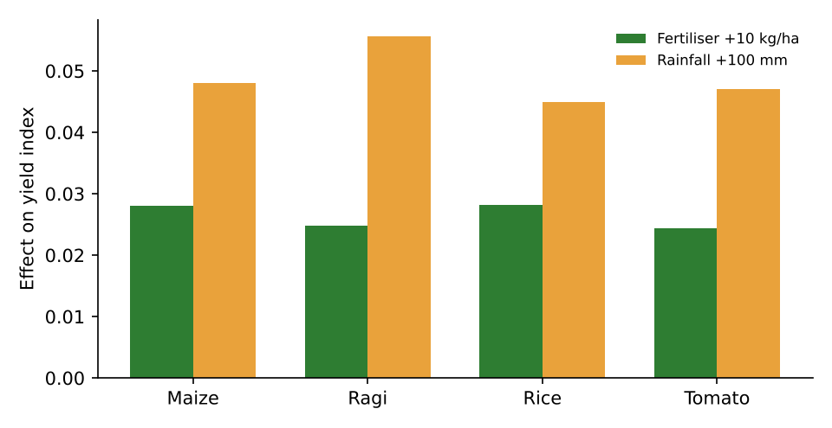
Figure 5: Fertiliser and rainfall effects estimated separately for each crop.
Crop | n | Fertiliser +10 kg/ha | Rainfall +100 mm | R-squared
Maize | 350 | 0.028 | 0.048 | 0.66
Ragi | 374 | 0.025 | 0.056 | 0.73
Rice | 367 | 0.028 | 0.045 | 0.75
Tomato | 334 | 0.024 | 0.047 | 0.71
The effects have the same sign and similar size in all four crops (fertiliser about +0.025 to +0.028; rainfall about +0.045 to +0.056), which supports pooling crops through the yield index.

7. Extension: Modeling Price (Market) Outcomes
To address market outcomes as well as yield, a second regression models the price index using yield index, a year trend and season.
Term | Coefficient | 95% CI | p-value
Intercept | +1.0382 | 0.9999 to 1.0764 | < 0.001
season: Rabi | +0.0326 | 0.0211 to 0.0442 | < 0.001
yidx | -0.1434 | -0.1783 to -0.1085 | < 0.001
year trend (per year) | +0.0369 | 0.0339 to 0.0400 | < 0.001

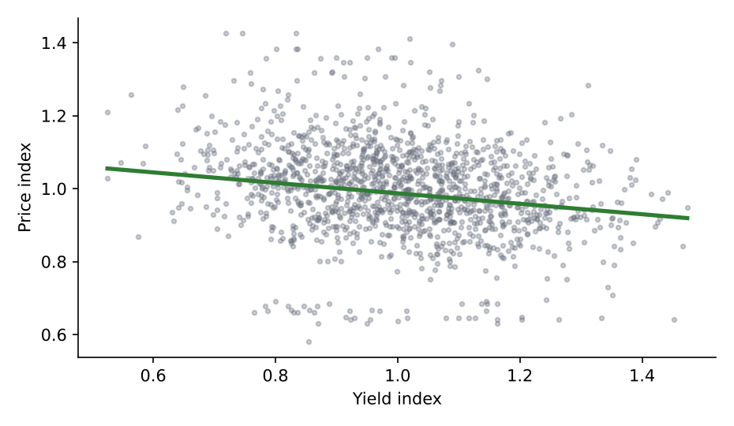
Figure 6: Price index vs yield index (fitted line at mid-period).
The model explains about 34% of the variation in the price index. Three results stand out: prices trend up about 3.7% of the crop average per year; Rabi prices are about 3% higher than Kharif; and a better harvest is associated with a slightly lower price (a 0.1 rise in yield index goes with about 1.4% lower price), the expected supply effect. The remaining variation reflects factors not in the data, such as demand, arrivals and policy, so this model is a description, not a price forecast.

8. Discussion and Business Implications
Result | Business meaning | Action
Rainfed farms about 12 index points below borewell farms | Water access is the largest controllable gap | Targeted irrigation support; pilot with control farms
+10 kg/ha fertiliser is about +2.6% yield | Fertiliser is productive in this range, but returns must be set against cost and diminishing effects | Soil-test-based advice and return-per-rupee tracking
+100 mm rainfall is about +4.7% yield | Rainfall is a leading indicator | In-season procurement forecasts using rainfall
Temperature, pH and area have no practical effect | Do not spend advisory effort on these | Focus on rainfall, fertiliser and irrigation
Model error about 0.07 index points | Usable for planning ranges, not guarantees | Report low/base/high scenarios
Prices rise and Rabi premium is positive | Timing of sales matters | Seasonal storage and contract planning

9. Limitations and Reliability

9.1 Critical discussion of limitations
Limitation | Why it matters | How to address it
Synthetic data with designed relationships | The model recovering them shows the method works, not that these effects exist in reality; real R-squared will be lower | Re-estimate on real farm records before decisions
Association is not causation | Better-resourced farms may adopt drip and also manage land better (confounding); irrigation coefficient may include these effects | Matched pilots; collect farm characteristics; consider instrumental or difference-in-differences designs
Repeated farms (clustering) | The same farm can appear in several seasons, so errors are not fully independent; standard errors may be too small | Use cluster-robust standard errors or mixed-effects models with real farm IDs
Omitted variables | Pests, disease, seed variety, planting date and labour are absent | Add variables; treat unexplained variance as real uncertainty
Linear additive form | Real fertiliser response flattens at high doses; interactions (irrigation x rainfall) are possible | Test splines, polynomial terms and interactions
Seasonal totals only | Timing of rain (a dry spell at flowering) matters more than the total | Use monthly or weekly weather features
Mild non-normality of errors | Intervals approximate rather than exact | Robust standard errors and bootstrap intervals
Imputed values | Median filling reduces variability and can attenuate effects slightly | Sensitivity analysis excluding imputed rows
Extrapolation | Predictions outside observed ranges (very high rain, very high fertiliser) are unreliable | State valid ranges; refuse out-of-range predictions
Multiple testing | Many tests raise the chance of false positives | Pre-state hypotheses; apply Bonferroni or similar when exploring
Short time span | Six years cannot capture long-run climate change | Extend history; time-based validation
Single random split | Score depends on the split | Repeated cross-validation; time-based splits for forecasting

9.2 Evidence that the model is reasonably reliable
- Test performance (R-squared 0.719) is close to training and cross-validated performance, so there is no sign of serious over-fitting.
- Two very different models (linear and random forest) reach the same accuracy and agree on the main drivers.
- The effects have the same direction and size in each of the four crops.
- Residual diagnostics show no curvature, no changing variance and no dominant outliers.

9.3 Evidence of where care is needed
- About 30% of yield variation is unexplained; any single farm's yield can differ by far more than the average error.
- Accuracy is lowest for tomato; use wider planning ranges for that crop.

10. Conclusions
Summary
Drivers: fertiliser, rainfall and irrigation type are significant and practically important; temperature, soil pH and farm area are not.
Model: a transparent linear model explains about 70% of yield variation (R-squared 0.719 on unseen data), matching a random forest.
Validity: key regression assumptions are met; normality is only mildly violated and does not change conclusions.
Business use: supports targeted irrigation support, soil-test-based fertiliser advice and in-season procurement ranges.
Caution: results come from synthetic data and describe associations; they must be revalidated on real records, ideally with clustered errors and a controlled pilot.

Week 5 translates these results into strategic recommendations, with benefits, pitfalls, a roadmap and suggested further research.

