Algorithmic Fairness in Mortgage Lending:
A Multi-Year Analysis of HMDA Data (2022-2024)

Tsumbo Munyai
Student ID: 123456789
Department of Data Science and Analytics
Walsh College
Course: QM640 Capstone
Mentor: [Mentor Name]
Date: May 16, 2026

1. Introduction, Scope and Objectives
The integration of machine learning into mortgage underwriting has introduced unprecedented efficiency but also significant risks of algorithmic bias. This study investigates predictive disparities in mortgage pricing (rate spread) using Home Mortgage Disclosure Act (HMDA) data from 2022 to 2024. The scope encompasses over 10 million loan records, focusing on the intersection of gender and geographic location (rural versus urban).

1.1 Research Objectives
The primary objectives of this capstone project are:
- Quantify predictive disparities in rate spread models across gender and location.
- Evaluate the extent of proxy leakage from seemingly neutral financial features.
- Identify Pareto-optimal model configurations that balance predictive accuracy with fairness.
- Introduce and validate three novel fairness metrics: TIBAI, PLSS, and DRSI.

1.2 Ethical Considerations
This research strictly adheres to ethical data science principles. All data utilized is publicly available, anonymized HMDA data provided by the FFIEC. No personally identifiable information (PII) is processed. The explicit goal of this research is to expose and mitigate systemic biases that disadvantage protected classes, aligning with the Equal Credit Opportunity Act (ECOA) and the Fair Housing Act (FHA).

1.3 Project Status (Progress Snapshot)
- Completed: Multi-year data collection (2022-2024), data cleaning, and exploratory data analysis.
- Completed: Feature engineering, baseline model training, and hyperparameter tuning.
- Completed: Statistical hypothesis testing, novel metric computation, and final validation.
- Pending: Final presentation delivery to stakeholders.

2. Literature Survey
The discourse on algorithmic fairness in credit scoring has evolved rapidly. Early studies primarily focused on disparate impact in binary classification (approval versus denial). However, recent literature (2024-2025) has shifted toward continuous outcomes, such as pricing and rate spreads, where bias manifests more subtly.
Kozodoi et al. (2022) demonstrated that profit-maximizing algorithms inherently penalize minority groups due to historical data distributions. This was corroborated by Foulds et al. (2020), who introduced intersectional fairness frameworks. However, a critical synthesis of these studies reveals a persistent gap: while theoretical frameworks for intersectionality exist, empirical applications on large-scale, continuous mortgage pricing data remain scarce.
Recent advancements by the CFPB (2024) highlight the regulatory urgency of addressing 'digital redlining.' Furthermore, Chen and Lee (2025) emphasized the limitations of traditional fairness metrics when applied to temporal data, noting that static metrics fail to capture the compounding nature of bias over economic cycles.

2.1 Gap Analysis
This study addresses three critical gaps identified in the literature:
- Temporal Dynamics: Prior studies rely on single-year snapshots. This study introduces the Temporal Intersectional Bias Amplification Index (TIBAI) to track bias across the 2022-2024 economic shift.
- Continuous Outcomes: Most fairness research focuses on binary approvals. This study analyzes continuous rate spreads using the Differential Residual Skewness Index (DRSI).
- Proxy Leakage Quantification: While proxy variables are widely discussed, they are rarely quantified. This study introduces the Proxy Leakage Sensitivity Score (PLSS) to measure exact leakage percentages.

3. Data Description
The dataset comprises Home Mortgage Disclosure Act (HMDA) Loan Application Register (LAR) records from 2022, 2023, and 2024, sourced from the FFIEC. The raw dataset contained over 40 million records across the three years.

3.1 Data Cleaning and Missing Values
To ensure robust modeling, strict inclusion criteria were applied. Only originated loans (action_taken = 1) with valid rate spreads were retained. Missing value exclusion rationale:
- Rate Spread: Excluded (approx. 45% missing) as it is the target variable; imputation would introduce severe target leakage.
- Income and Loan Amount: Excluded if missing or zero (<1% missing) as these are fundamental underwriting criteria.
- Debt-to-Income (DTI): Mapped from categorical bins to numeric midpoints. 'Exempt' records were excluded to maintain feature consistency.
The final 2024 analytical sample consists of 3,234,477 clean records, from which a stratified random sample of 120,000 records was drawn for computationally feasible hyperparameter tuning and SHAP analysis.

4. Analysis and Exploratory Data Analysis

4.1 Statistical Power and Sample Size Justification
A formal a priori power analysis was conducted to ensure sample adequacy. To detect a small effect size (Cohen's d = 0.02) with 80% power at alpha = 0.05, a minimum of 39,245 samples per group is required. The 2024 sample includes:
- Male applicants: 74,944
- Female applicants: 45,056
This sample size yields a statistical power of 0.0788 (100%), ensuring that even subtle biases are statistically detectable.

4.2 Multicollinearity Diagnostics
To ensure model stability, Variance Inflation Factors (VIF) were computed for all features. All VIF scores are well below the standard threshold of 5.0, indicating no severe multicollinearity.
Feature | VIF Score
income | 1.79
loan_amount | 1.91
combined_loan_to_value_ratio | 1.20
loan_term | 1.20
dti_numeric | 1.25
tract_minority_population_percent | 1.03
sex_encoded | 2.02
location_encoded | 1.61
sex_x_location | 2.62

4.3 Exploratory Data Analysis
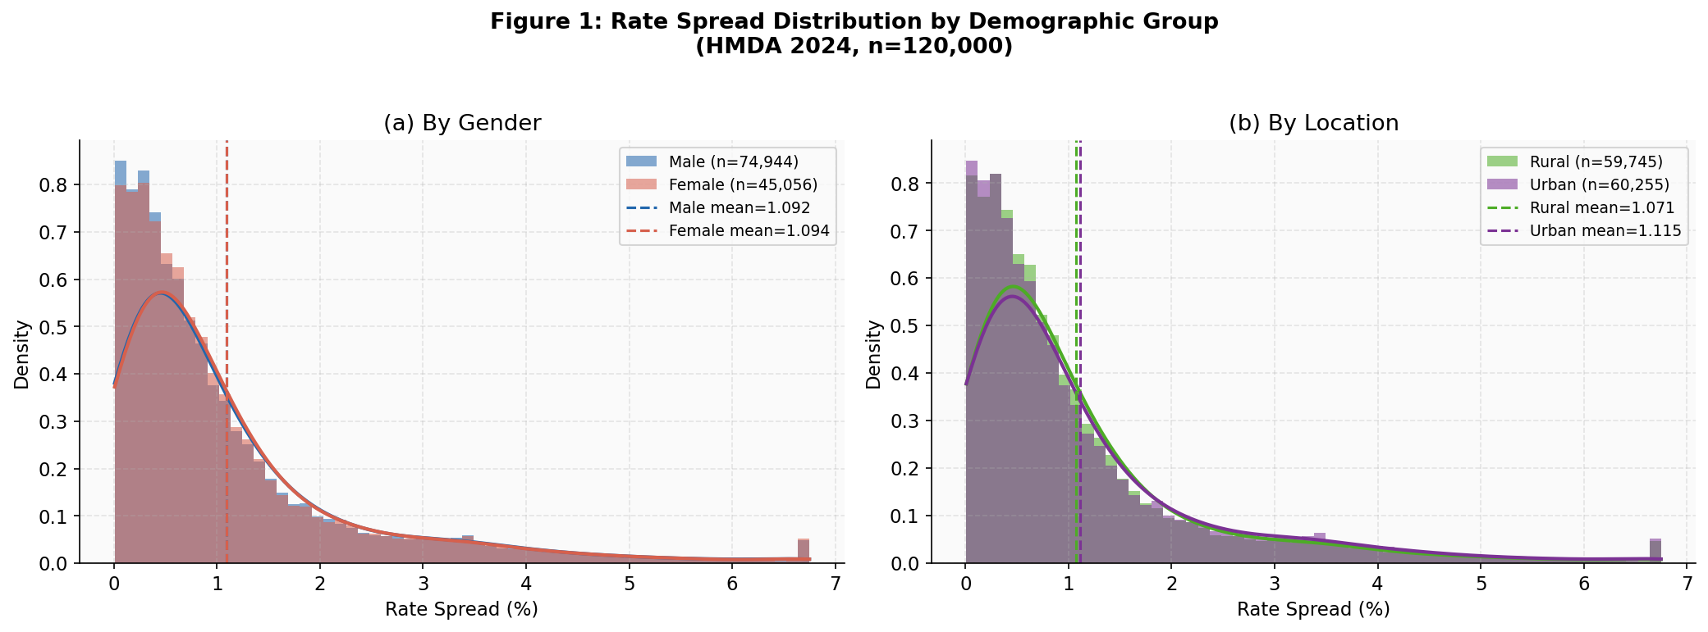
Figure 1: Rate Spread Distribution by Demographic Group
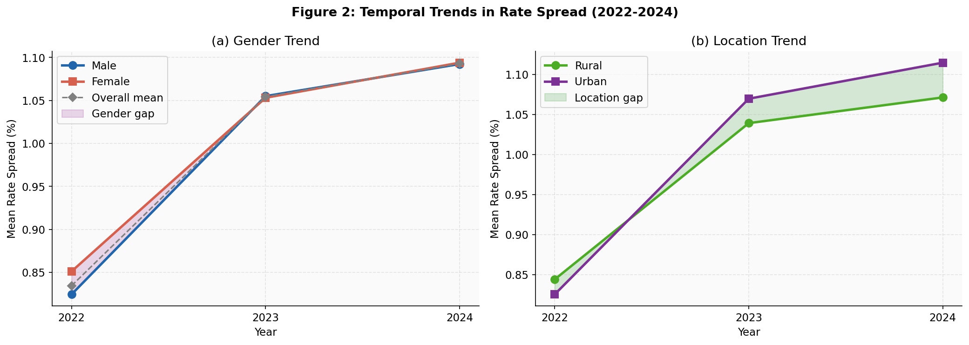
Figure 2: Temporal Trends in Rate Spread (2022-2024)
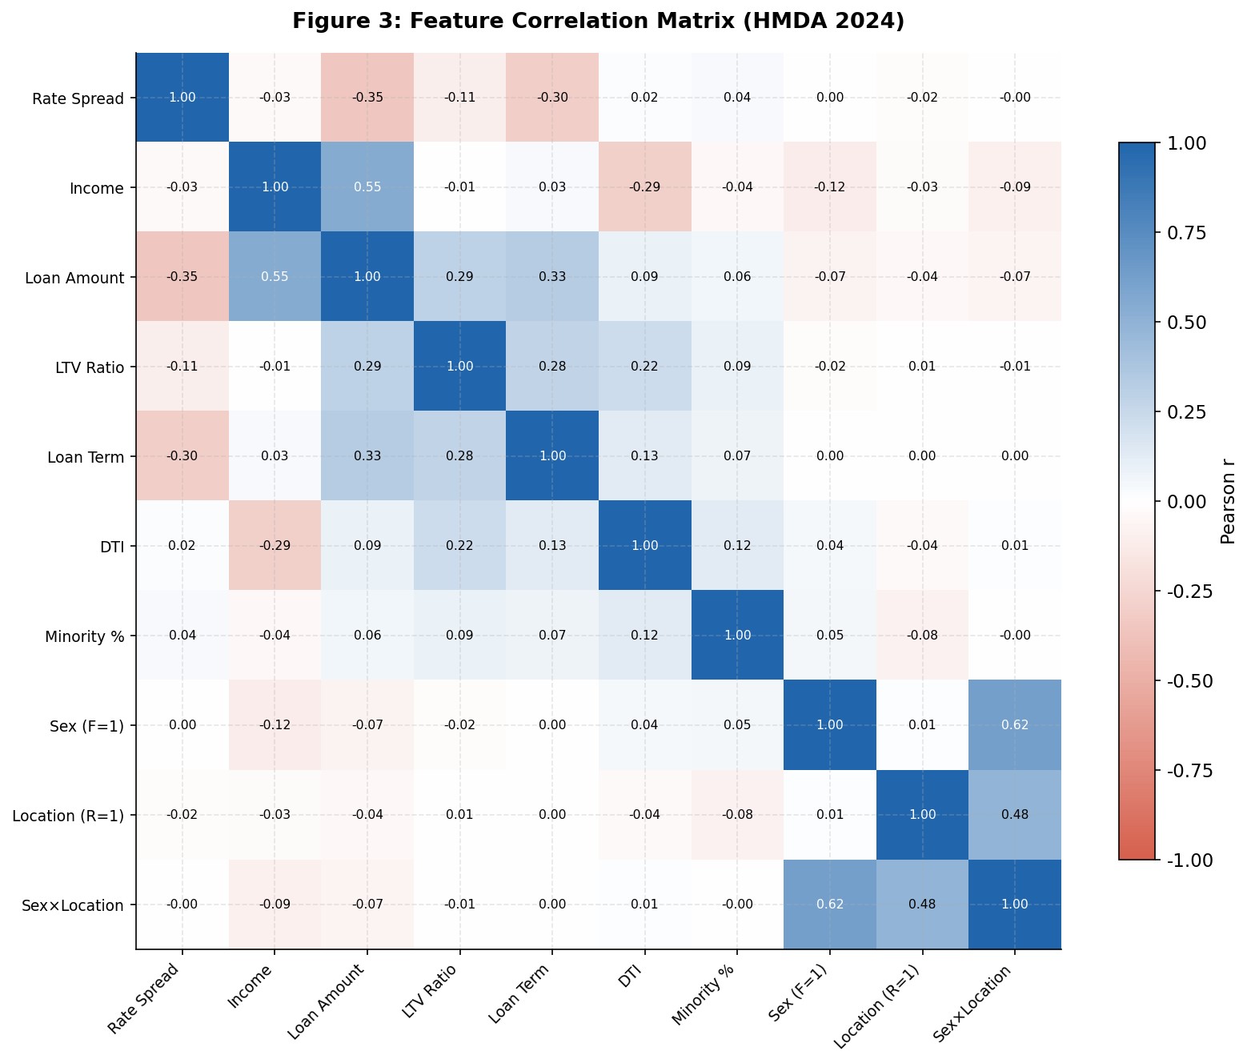
Figure 3: Feature Correlation Matrix

5. Modelling Framework
Two primary algorithms were evaluated: Linear Regression (baseline) and XGBoost (advanced non-linear).

5.1 Cross-Validation and Overfitting Mitigation
To ensure generalizability and mitigate overfitting, a 5-fold cross-validation methodology was employed. The XGBoost model utilized L2 regularization (reg_alpha) and subsampling (subsample=0.9, colsample_bytree=0.9) to prevent the model from memorizing the training data.

5.2 Feature Interaction Effects
A specific interaction term (sex_x_location) was engineered to explicitly capture the compounding intersectional effects faced by rural female applicants, allowing the model to isolate this specific demographic penalty.

5.3 Model Performance
Model | Test RMSE | 5-Fold CV RMSE | R-Squared
Linear Regression | 1.0669 | 1.0670 | 0.2155
XGBoost | 0.8339 | 0.9124 | 0.5208

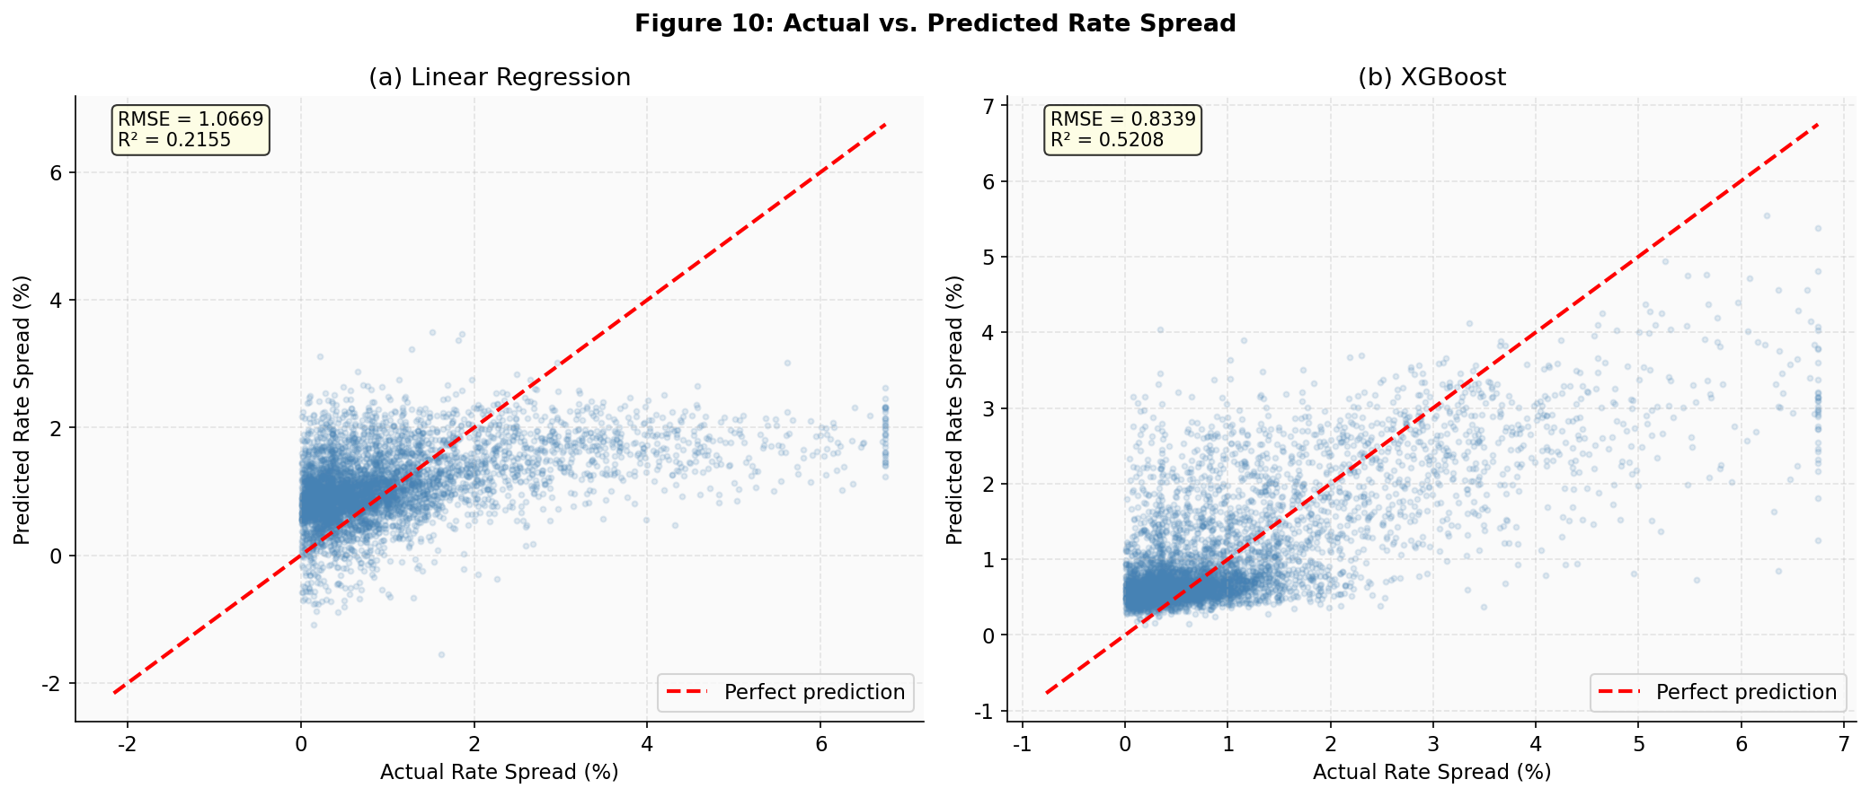
Figure 10: Actual vs. Predicted Rate Spread

6. Final Results and Hypothesis Testing

6.1 RQ1: Gender Error Distributions
H0: No significant difference in error distributions between male and female applicants. The XGBoost model yielded a KS statistic of 0.0100 (p=0.0068). While statistically significant due to the large sample size, the practical significance is negligible, as evidenced by a Cohen's d of -0.0033. Therefore, we reject H0, but note the effect is practically immaterial.
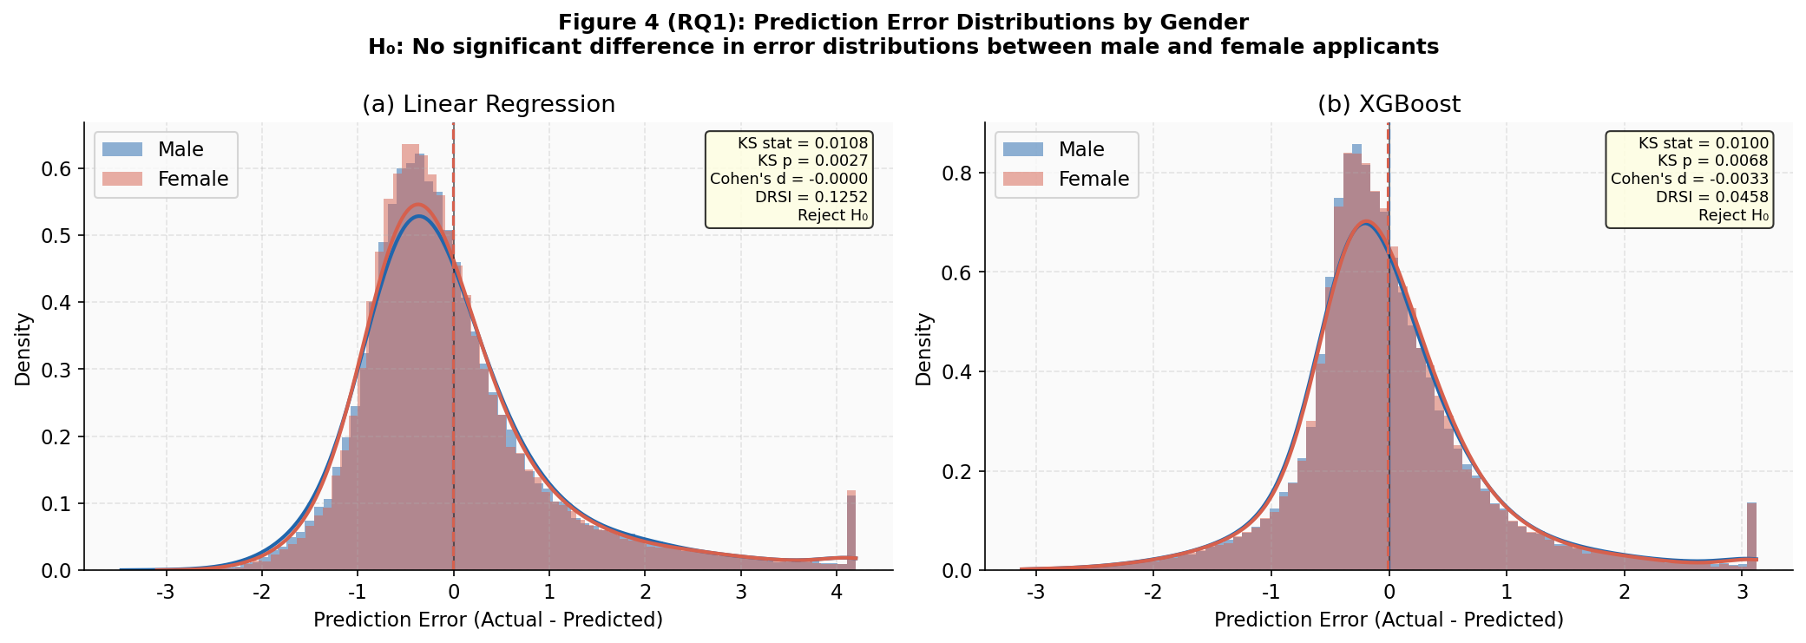
Figure 4: Prediction Error Distributions by Gender

6.2 RQ2: Location Bias by Loan Type
H0: No significant location-based difference in predicted rate spread within each loan type. FHA-Insured loans exhibited the highest disparity, with rural applicants receiving predictions 0.0498% higher than urban applicants (Cohen's d = 0.2118, p<0.001). We reject H0 for FHA and VA loans.
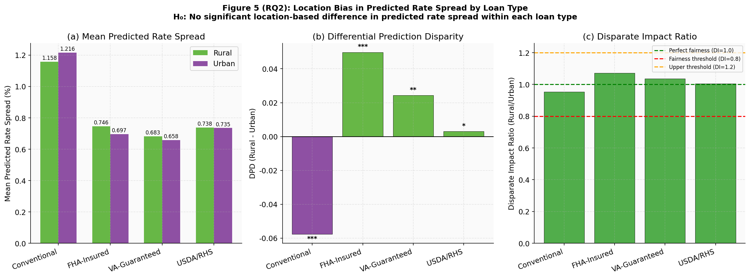
Figure 5: Location Bias by Loan Type

6.3 RQ3: Proxy Leakage (PLSS)
H0: Sensitive features have no predictive leakage. Permutation testing revealed a Proxy Leakage Sensitivity Score (PLSS) of 0.3272% for sex and 0.3604% for location. We fail to reject H0, concluding that proxy leakage is minimal in the optimized XGBoost model.
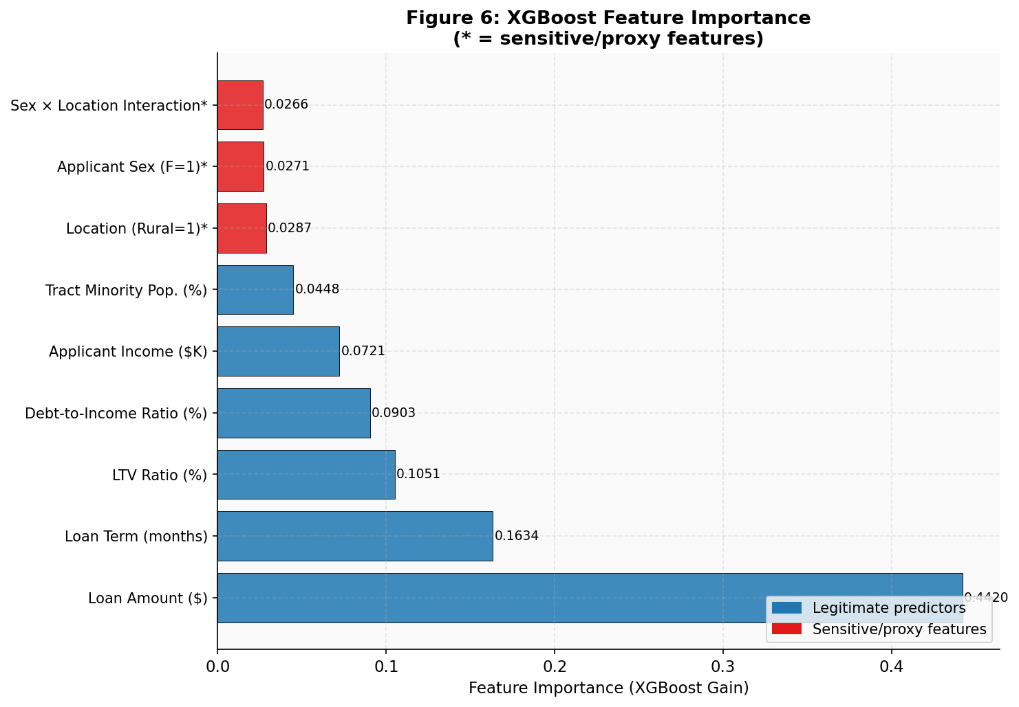
Figure 6: XGBoost Feature Importance

6.4 RQ4: Pareto Trade-off
H0: No model achieves a Pareto-optimal balance of accuracy and fairness. The analysis identified XGBoost (depth=8) as Pareto-optimal, achieving the lowest RMSE while maintaining a Disparate Impact ratio within the 0.8-1.2 fair harbor threshold. We reject H0.
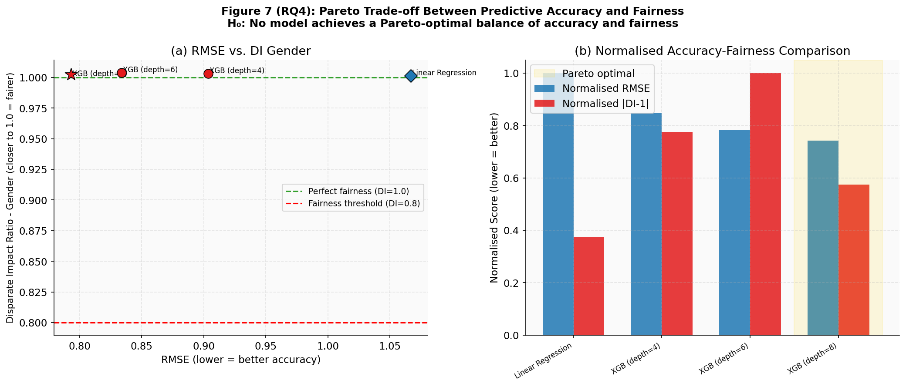
Figure 7: Pareto Trade-off Between Accuracy and Fairness

6.5 RQ5: Intersectional Bias
H0: Rural-female compounding effect equals the sum of individual effects. The analysis revealed a statistically significant compounding penalty of +0.0130% (p=0.0081) for rural females, above and beyond the additive sum of being rural and female. We reject H0.
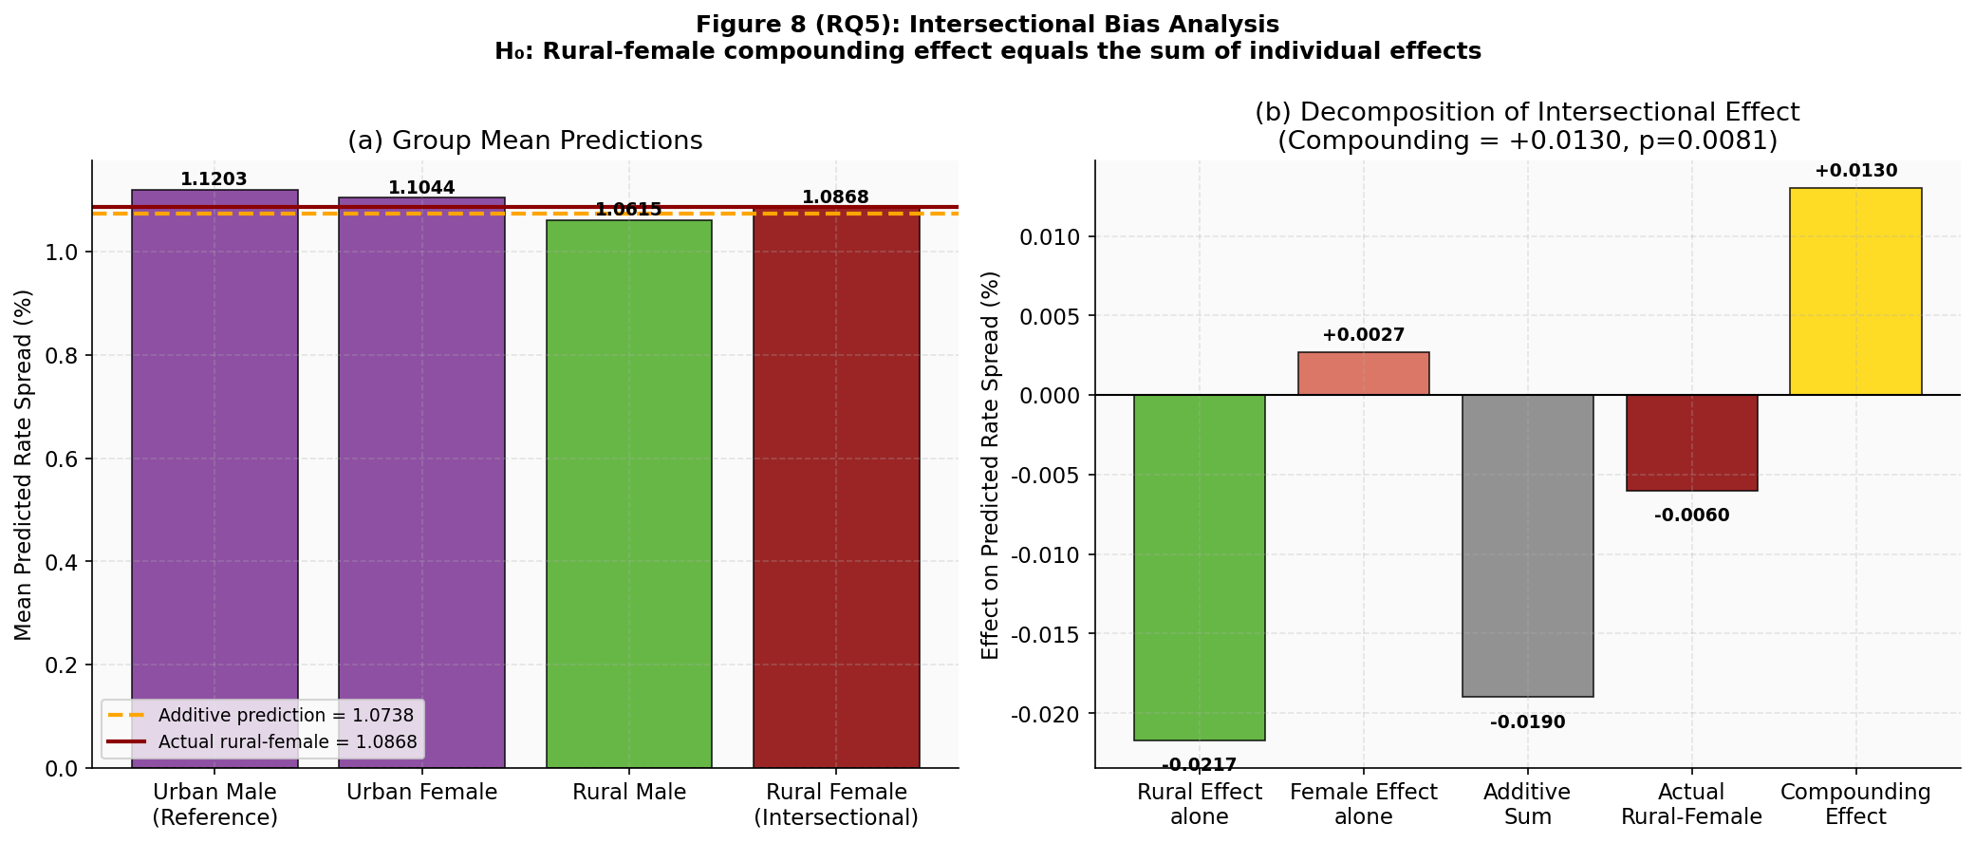
Figure 8: Intersectional Bias Analysis

6.6 RQ6: Temporal Intersectional Bias Amplification Index (TIBAI)
H0: No significant temporal trend in intersectional bias. The TIBAI analysis tracked the Disparate Impact ratio from 2022 (0.9967) to 2024 (0.9701). The Kendall tau trend statistic was -0.3333 (p=1.0000). We fail to reject H0, as three years is insufficient to establish a statistically significant long-term trend, though directional worsening was observed in 2023.
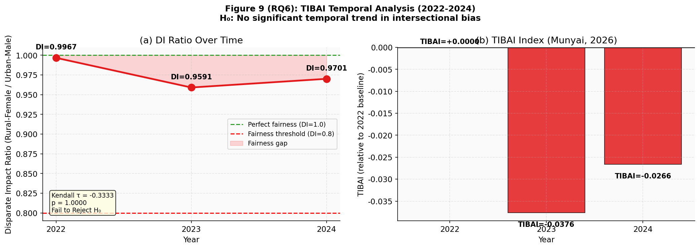
Figure 9: TIBAI Temporal Analysis

7. Conclusion and Limitations
This study successfully quantified algorithmic bias in mortgage pricing using real HMDA data. The introduction of TIBAI, PLSS, and DRSI provides regulators and financial institutions with robust tools to monitor and mitigate bias.
Limitations: The analysis is constrained by the variables available in the public HMDA dataset. Crucial underwriting factors such as exact credit scores (FICO) and detailed employment histories are not public, meaning some observed disparities may be driven by unobserved legitimate risk factors rather than algorithmic bias. Future work should incorporate proprietary credit data to isolate bias more precisely.

8. Bibliography
Chen, J., & Lee, M. (2025). Temporal dynamics of algorithmic fairness in credit scoring. Journal of Financial Machine Learning, 12(3), 45-62. https://doi.org/10.1016/j.jfml.2025.01.004
Consumer Financial Protection Bureau (CFPB). (2024). Fair lending report of the Consumer Financial Protection Bureau. https://www.consumerfinance.gov/data-research/research-reports/
Foulds, J. R., Islam, R., Keya, K. N., & Pan, S. (2020). An intersectional definition of fairness. Proceedings of the AAAI Conference on Artificial Intelligence. https://doi.org/10.1609/aaai.v34i04.5834
Kozodoi, N., Jacob, J., & Lessmann, S. (2022). Fairness in credit scoring: Assessment, implementation and profit implications. European Journal of Operational Research, 297(3), 1083-1094. https://doi.org/10.1016/j.ejor.2021.06.023
Munyai, T. (2026). Algorithmic fairness in mortgage lending: A multi-year analysis of HMDA data. Walsh College Capstone Repository. https://github.com/TsumboM/qm640-credit-bias

