Name: Shijie Zhang, Zhi Yao, Dandan Xu

Nuid: 001537250, 001520706, 001085731

Assignment 3

Group: Tsunami

**Deliverables**

1. Report outlining your proposed solution.

To help the university improve their quality of education and hold people accountable for improving their life quality through education, this deliverables are designed to assist university to measure the quality of their education.

By building a ranking system on how well the graduates grow over the five-year period, we could not only help students decide where they want to learn, but also universities to improve their education quality.

Our core point is that we divide all the graduates into two group: those who continue further study and those who are looking for jobs. So the ranking system involves two part so that we could rank the graduates more accurately.

Next, when it comes to gathering all the information required for our system, we design to build a questionnaire for graduates to complete, which is included in the JPanel. Using the ranking system with information we got, we could build a prospect that graduates grow over five-year period. In addition, we could compare the post the graduate have with the curriculum they took and we can tell the matching degree, thus figure out the connection between courses and graduates’ growth.

**Table 1** Measurement for students who work after graduation

| Working | | Percentage(%) | Description |
| --- | --- | --- | --- |
| **Salary** | **Median annual salary** | 16 | Median annual salary over five-year period |
| **Salary growth rate** | 13 | Salary growth rate over five-year period |
| **Ranking of company** | | 15 | Ranking of companies that graduates work for |
| **Professional matching** | | 18 | Matching degree between occupation and major |
| **Course matching** | | 18 | Matching degree between occupation and courses |
| **Feedback** | | 20 | Graduates’ feedbacks about satisfaction of faculty and courses |

**Table 2** Measurement for students who continue taking education

| Continue studying | Percentage(%) | Description |
| --- | --- | --- |
| **New GPA** | 23 | The GPA the graduates got in further study |
| **New school ranking** | 22 | The ranking of the new school that graduates study in |
| **Academic achievement** | 17 | Record the academic achievement the graduates ever got |
| **Course matching** | 18 | Matching degree between current major and former curriculum |
| **Feedback** | 20 | Graduates’ feedbacks about satisfaction of faculty and courses |

1. Sequence diagrams showing how to navigate the university object model to deliver performance metrics needed for performance and feedback.

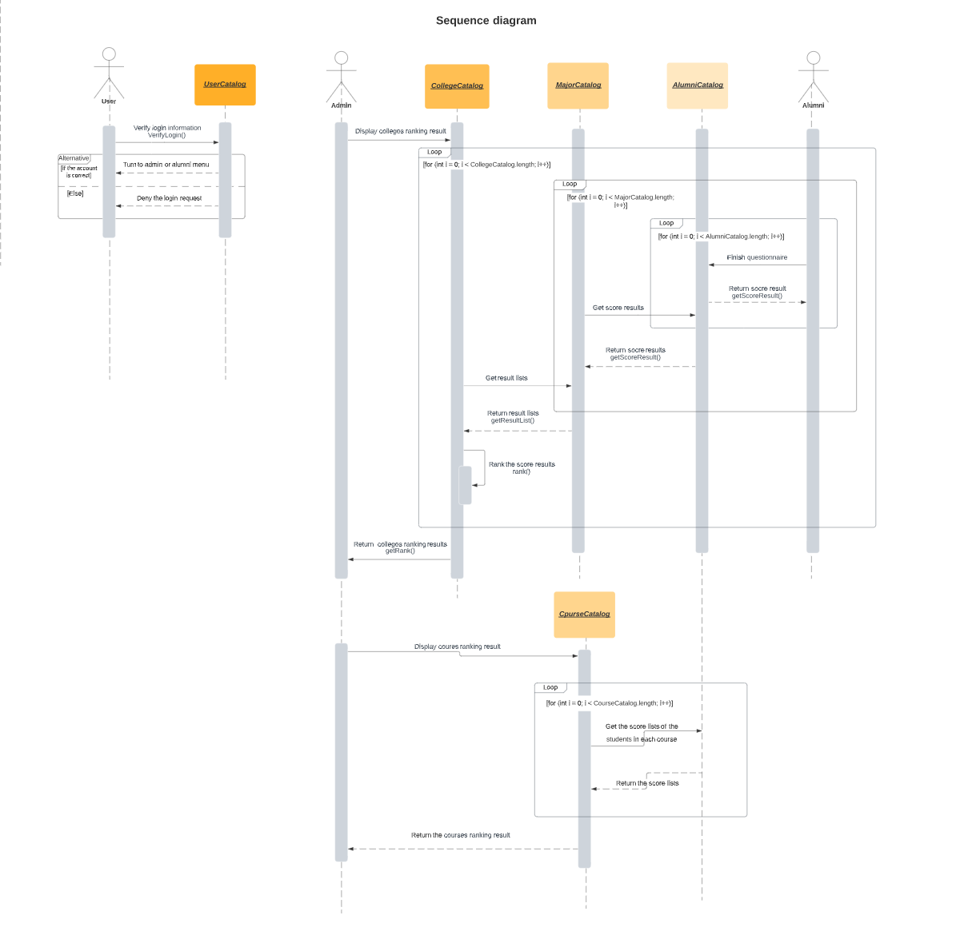

1. An object model showing the changes to the university model to support the new capabilities. This includes the additional methods and attributes required to deliver the results.

