**Travel Agency Project**

Team: Tsunami

Team Members: Dandan Xu, Shijie Zhang, Zhi Yao

1. **Project Overview:**

The system is a travel agency management system, which is used for managing the details involved in booking tickets for customers, managing airliners, flight schedule and customers’ travel schedule. Besides, for travel agency manager, special features have been added including the functionalities of booking hotels and renting cars for customers.

1. **Entities and Organizations**
2. Entities
3. Travel agency (Travel Agency Company)
4. Airline (Transportation Company)
5. Customer Directory (Travel Office)
6. Bonus point: Hotel Company
7. Bonus point: Car Rental Company
8. Organizations
9. Travel Agency Company
10. Transportation Company
11. Travel Office
12. Manager
13. Airliner
14. Bonus point: Hotel Company
15. Bonus point: Car Rental Company
16. **Work Requests:**
17. **Travel Agency Manager Role**
18. Manager can create and manage airliners.
19. Manager can book flight tickets for customers.
20. Bonus point: Manager can book hotels, and rent cars for customers.
21. **Airliner Role**
22. Airliner can create fleets, airplanes, flights.
23. Airliner can view customer’s travel schedule.
24. **UML Sequence Diagram**

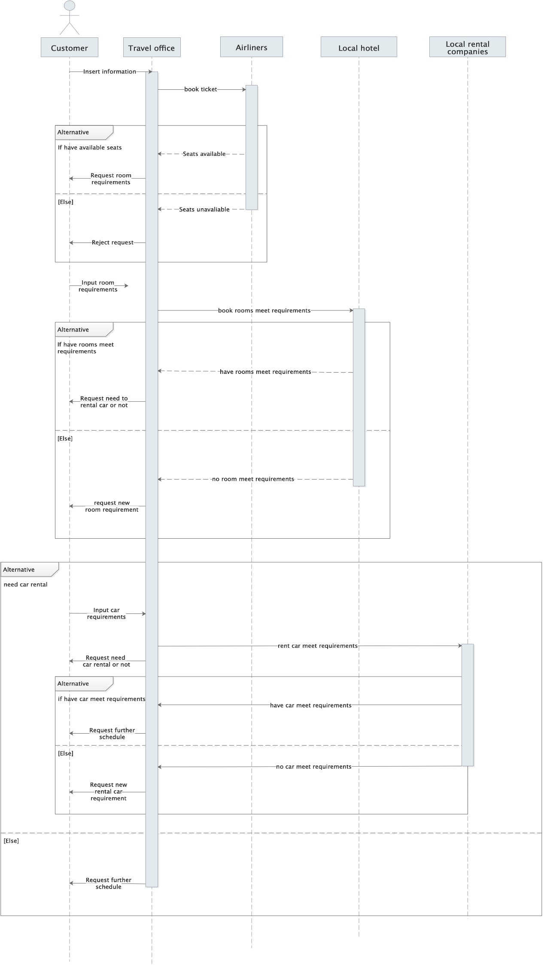

1. **User Interface**

