Zim-TTECH COP24 Q4 DATIM File Narrative
Number of facilities reporting
In COP24 Q4, a total of 823 facilities were active on the full IMPILO E-HR system. Raw data files were available from 573 sites, of which 322 were collected manually, 81 were pushed via the data pipeline and 170 were complete backups obtained via the mobile backup, with assistance from site-level staff. COP25 came with budgetary revisions that have restricted Zim-TTECH's ability to collect raw data from all active sites, resulting in low number of sites visited for manual data collection. Additionally, administrative procedures affected the timely compilation of datasets compared to previous submissions. This delay was primarily due to staff reductions and recruitments that occurred at the beginning the COP.
For the period under review, data from 449 facilities (55%) of those with the full IMPILO E-HR were successfully analysed, as illustrated in Figure 1.
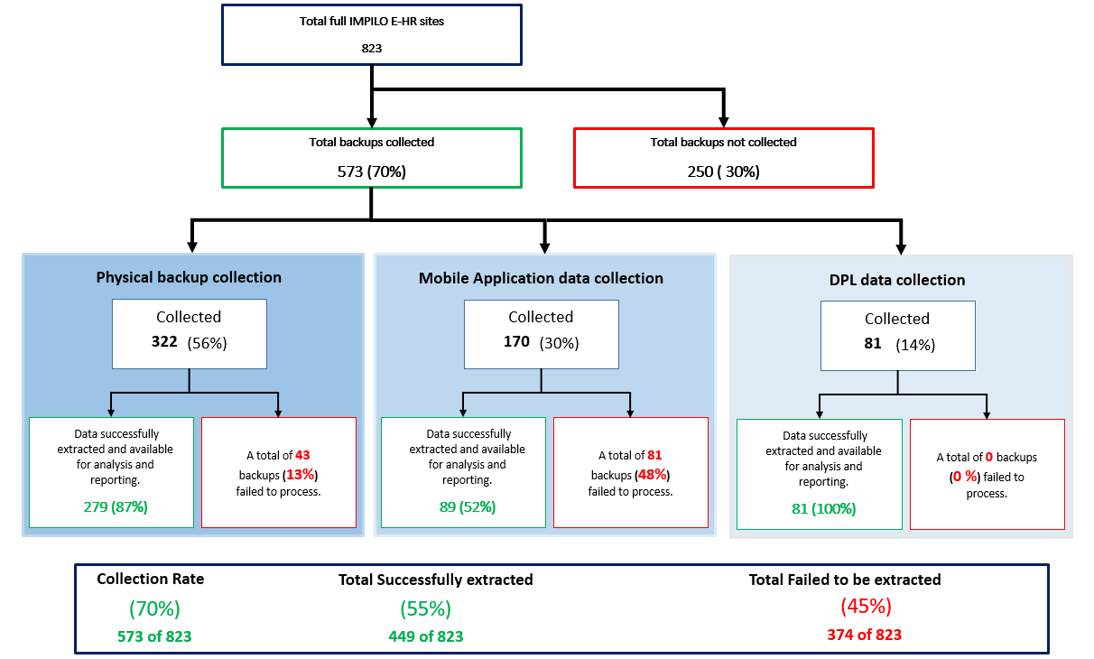
Figure 1: Summary of COP24 Q4 IMPILO E-HR data flow cascade.

Number of indicators reported.
Table 1 below shows the number of facilities reporting each indicator through IMPILO E-HR in COP 24 Q4 (excluded facilities zero reporting).
Table 1: Indicators reported through IMPILO E-HR in COP24
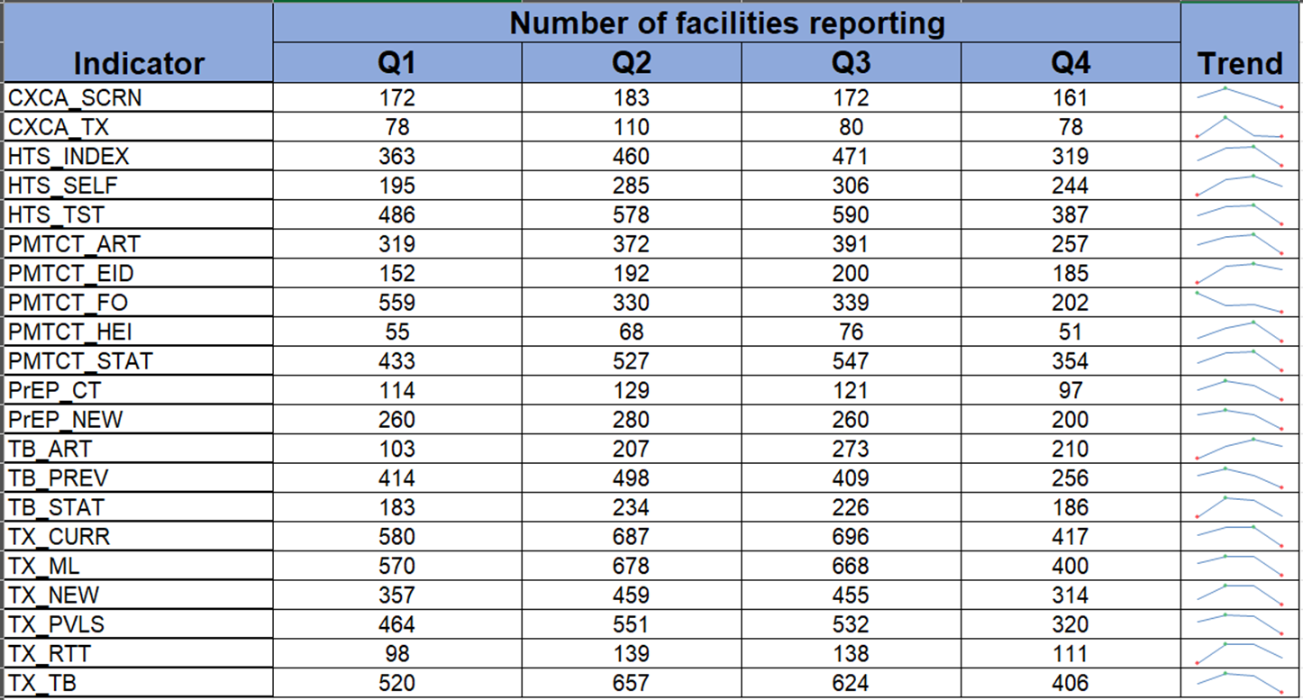
Data Quality Metrics
- Data Completeness
Data completeness in the IMPILO E-HR system is affected by user-related issues, such as suboptimal system usage and errors or omissions during data entry. Indicators that require laboratory results, such as PMTCT_EID and PMTCT_HEI, often exhibit low completeness due to healthcare workers frequently omitting to update the necessary fields or data points. In addition, usage is affected by power outages and inadequate backup power at facilities.
To improve data completeness in the IMPILO E-HR system, Zim-TTECH, in collaboration with Clinical lmplementing Partners and MoHCCC subnational teams, is actively working to address these challenges. The efforts include ongoing mentorship, providing insights into the generated data, and implementing effective data management practices including frequent data quality assessments. The facilities also require reliable power sources to enhance the reliability, accuracy, and integrity of the information stored and processed.

In COP24 Q4 TX_CURR, TX_ML, TX_TB, HTS_TST/POS and PMTCT_STAT had the highest proportion of facilities reporting (51%, 49%, 49%, 47% and 47% respectively) as shown in Figure 2 below.
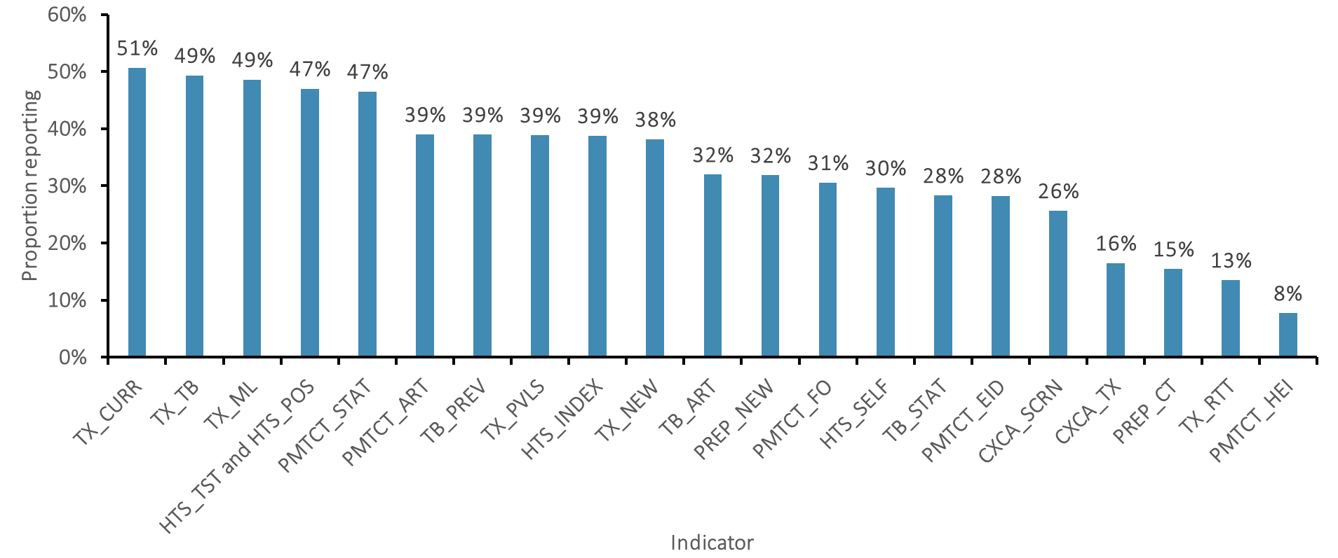
Figure 2: Proportion of sites reporting individual indicators in IMPILO E-HR COP24 Q4.
- Reporting Consistency
Zim-TTECH continued improving data reporting by addressing inconsistencies in backup submissions and developing an automated DATIM reporting process that integrates data from both mobile and manually collected databases, resulting in higher data yield. The transition to dpl and mobile application–based backup collection showed notable progress, with facilities successfully submitting complete backups increasing from 155 to 251 compared from the previous quarter, although manual collection was still required for 322 facilities. Zim-TTECH will continue to support facility teams to ensure complete backup collection and transmission through the mobile application. Trends in site reporting performance are shown in Figure 3. Travel budget limitation hindered Zim-TTECH and MoHCC from achieving 100% data collection from all active sites.
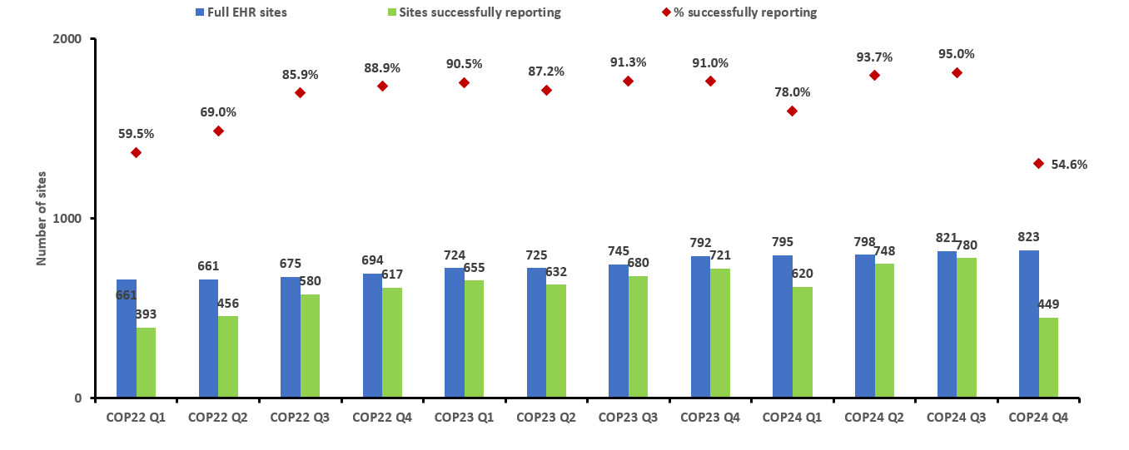Figure 3: Trends in sites successfully reporting, COP22 – COP24 Q4

Challenges
- Database collection
In the current quarter, Zim-TTECH continued to build on the mobile application and automated data pipeline developed last quarter, with focused efforts to reduce previously identified challenges such as poor network connectivity at facilities using Econet lines, the need for human intervention to change or select networks, and data incompleteness resulting from failed uploads. To address these issues, Zim-TTECH onboarded more facilities onto the automated data pipeline—an enhanced version of the mobile application that does not require manual intervention—and improved the application to ensure complete data transmission by automatically pushing missing months’ backups to the central repository. Despite these improvements, some facilities were still unable to submit backups due to new challenges, primarily the failure to transition from the SmartBiz data package to the new Econet data package on time, which affected their ability to send data to the central repository for the reporting period.
- Data extraction
In Q4, data extraction yielded higher success rates for backups collected manually (87%) and dpl (100%) compared to those transmitted via the mobile application (52%). The lower success rate for mobile application submissions was primarily due to difficulties in downloading data from the central repository, which were attributed to slow network performance at the Central Computing Services where the data is hosted. The manual backups that failed were from very large facilities, with issues arising from memory limitations encountered during data processing.
Remedial Actions Taken and Recommendations
Database collection and extraction challenges
- COP25 came with budgetary revisions that have limited Zim-TTECH's ability to collect raw data from all active sites.
- While there are only about 100 sites with internet access, this represents a small fraction of the total active sites. Moreover, many of these sites face environmental challenges, including unreliable power and inconsistent mobile coverage, which hinder their ability to transmit data via the mobile backup application.
- To address the technical challenges, the team is continuously downloading the missing data from the central repository and reprocessing it to ensure completeness. For the large facilities, Zim-TTECH is generating data in smaller batches to prevent memory-related failures during processing.

Optimized Sites Data Concordance Analysis
The table below presents a concordance analysis of key indicators based on COP24 Q4 MER data for the optimized facilities. This analysis compares E-HR data with data reported by facilities in MoHCC DHIS2. It is important to note that the concordance of HTS_TST is affected by HIV testing conducted in the community, where E-HR cannot be utilized and certain entries, particularly those for HIV-negative individuals, are not captured.
Table 2: MRF/E-HR Data Concordance Analysis for Optimized sites
District | Facility | HTS_TST COP24Q4 |  |  | HTS_POS COP24Q4 |  |  | TX_NEW COP24Q4 |  |  | TX_CURR COP24Q4
District | Facility | MRF | E-HR | Concordance | MRF | E-HR | Concordance | MRF | E-HR | Concordance | MRF | E-HR | Concordance
Bulawayo | Nketa | 627 | 675 | 108% | 21 | 25 | 119% | 24 | 25 | 104% | 4001 | 4049 | 101%
Bulawayo | Princess Magret Clinic | 976 | 825 | 85% | 30 | 31 | 103% | 36 | 34 | 94% | 2582 | 2657 | 103%
Chegutu | St Padre Pio | 938 | 969 | 103% | 23 | 21 | 91% | 18 | 20 | 111% | 1259 | 1274 | 101%
Harare | Avondale | 234 | 237 | 101% | 12 | 13 | 108% | 12 | 12 | 100% | 1314 | 1282 | 98%
Marondera | Kushinga Phikelela | 319 | 318 | 100% | 15 | 15 | 100% | 15 | 15 | 100% | 971 | 801 | 82%
Bulawayo | Mahatshula | 215 | 218 | 101% | 8 | 7 | 88% | 6 | 5 | 83% | 181 | 193 | 107%
Gweru | Somabhula | 118 | 108 | 92% | 5 | 5 | 100% | 4 | 6 | 150% | 354 | 380 | 107%
Kwekwe | Sherwood | 468 | 515 | 110% | 22 | 20 | 91% | 24 | 24 | 100% | 773 | 607 | 79%
Zaka | Bvukururu | 157 | 152 | 97% | 4 | 4 | 100% | 5 | 5 | 100% | 783 | 780 | 100%
Masvingo | Shonganiso | 74 | 73 | 99% | 3 | 3 | 100% | 3 | 3 | 100% | 386 | 389 | 101%
Harare | Mabvuku Poly | 2250 | 1995 | 89% | 73 | 75 | 103% | 84 | 19 | 23% | 4730 | 4811 | 102%
Umzingwane | Mawabeni | 264 | 248 | 94% | 17 | 17 | 100% | 16 | 14 | 88% | 1004 | 891 | 89%
Mutare | Zimunya | 439 | 408 | 93% | 14 | 16 | 114% | 14 | 16 | 114% | 999 | 969 | 97%
Chitungwiza | St Marys | 1848 | 1664 | 90% | 113 | 139 | 123% | 110 | 146 | 133% | 6925 | 6965 | 101%
Guruve | Bakasa | 267 | 248 | 93% | 3 | 3 | 100% | 4 | 4 | 100% | 479 | 500 | 104%
Chivi | Zivuku | 210 | 210 | 100% | 7 | 7 | 100% | 6 | 6 | 100% | 751 | 710 | 95%
Lupane | Lupane | 763 | 760 | 100% | 28 | 28 | 100% | 28 | 26 | 93% | 1904 | 1937 | 102%
UMP | Tsokodeka | 71 | 68 | 96% | 0 | 0 | 100% | 0 | 0 | 100% | 84 | 87 | 104%
UMP | Mashambanhaka | 167 | 154 | 92% | 2 | 2 | 100% | 1 | 1 | 100% | 597 | 618 | 104%
Murehwa | Murehwa District Hospital | 1236 | 481 | 39% | 45 | 17 | 38% | 44 | 4 | 9% | 1814 | 1682 | 93%

Key |  | 90-120%
 |  | 75-89%
 |  | 0-74%, <120%

- Facilities in Green are ready to report from E-HR with minimal mentoring and supervision.
- Facilities in Amber require additional support to ensure optimal data concordance. Mabvuku Polyclinic’s HTS_TST concordance is affected by HIV testing conducted outside of E-HR during outreach activities. Facilities such as Kushinga Phikelela, Sheerwood and Mawabeni will be supported to back capture ART visits which are causing data discrepancies.
- Facilities in Red require intensive support through collaborative efforts involving the CIP and SI teams, and the subnational leadership of MoHCC. Murewa Hospital will be closely monitored to improve system usage. Additionally, the Zim-TTECH team will visit St Mary’s Clinic to investigate why the figures reported in the MRF are way lower than those in E-HR.
Overall Data Concordance Analysis
The table below presents the concordance analysis for four indicators across the 449 E-HR sites that reported in Q4. Detailed facility-level analysis is in the attached Excel file.
Table 3: Overall MRF/E-HR Concordance analysis by indicators
Indicator | MRF/DHIS2 | E-HR | Concordance
HTS_TST | 203 622 | 76 228 | 37.4%
HTS_POS | 7 351 | 3 611 | 49.1%
TX_NEW | 7 065 | 2 819 | 39.9%
TX_CURR | 549 456 | 326 954 | 59.9%

TX_CURR Concordance Analysis for Harare and Bulawayo
Figure 4 below illustates the TX_CURR concordance for 45 sites in Harare and 23 sites in Bulawayo that had successful E-HR data extraction.
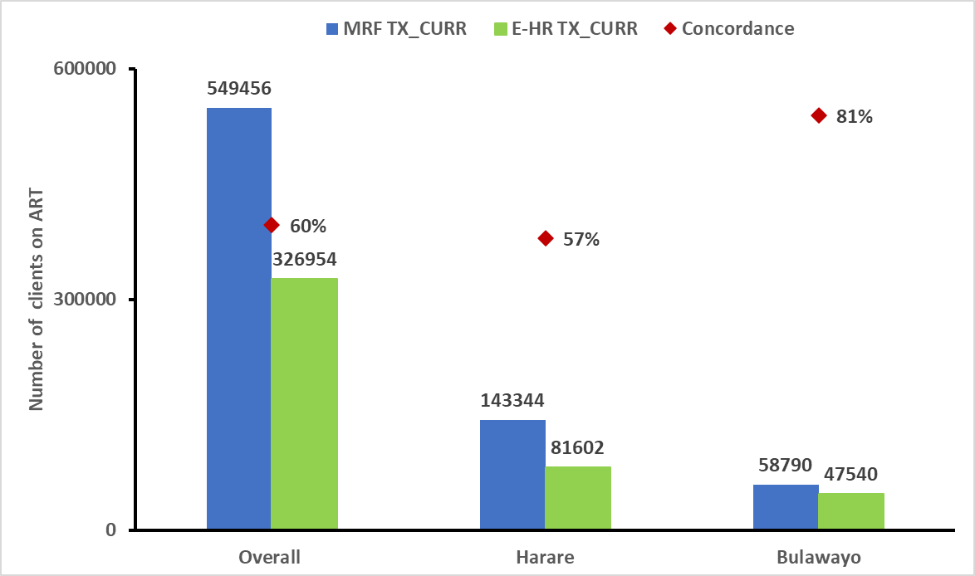
Figure 4: Concordance analysis for Harare and Bulawayo sites

