Zim-TTECH COP24 Q4 DATIM File Narrative

Number of facilities reporting
In COP24 Q4, a total of 30 facilities were active on the full IMPILO E-HR system. Raw data files were available from 573 sites, of which 322 were collected manually, 81 were pushed via the data pipeline and 170 were complete backups obtained via the mobile backup.
For the period under review, data from 30 facilities (100.0%) were successfully analysed.
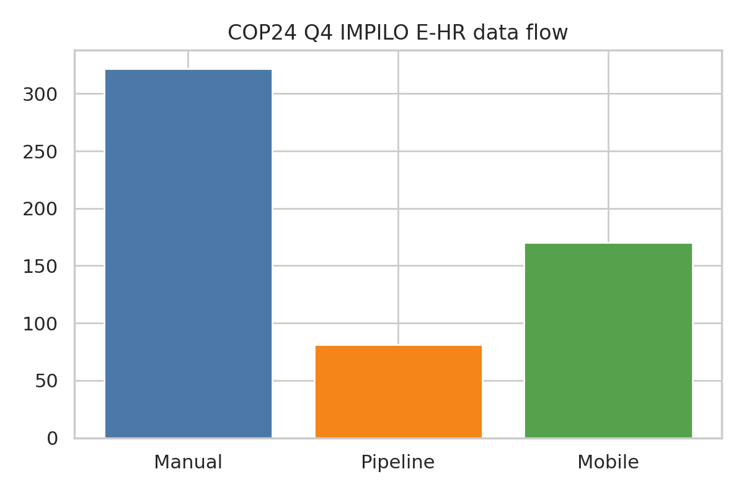
Figure 1: Summary of COP24 Q4 IMPILO E-HR data flow cascade.

Number of indicators reported
Table 1 below shows the number of facilities reporting each indicator through IMPILO E-HR in COP24 Q4.

Table 1: Indicators reported through IMPILO E-HR in COP24

Data Quality Metrics
Data Completeness
In COP24 Q4 TX_CURR, TX_ML, TX_TB, HTS_TST/POS and PMTCT_STAT had the highest proportion of facilities reporting (100.0%, 100.0%, 100.0%, 100.0%, 100.0%) as shown in Figure 2.
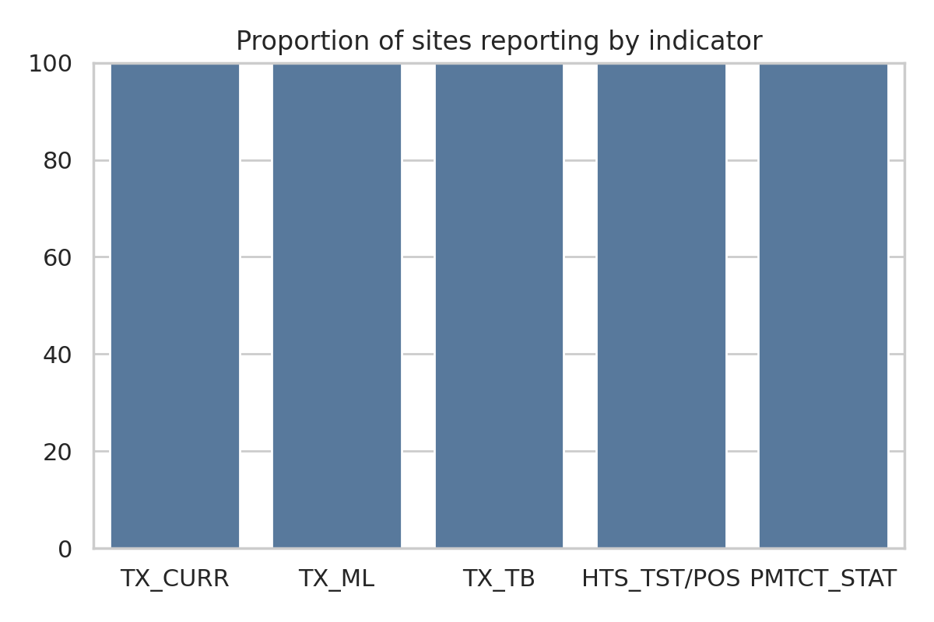
Figure 2: Proportion of sites reporting individual indicators in IMPILO E-HR COP24 Q4.
Reporting Consistency
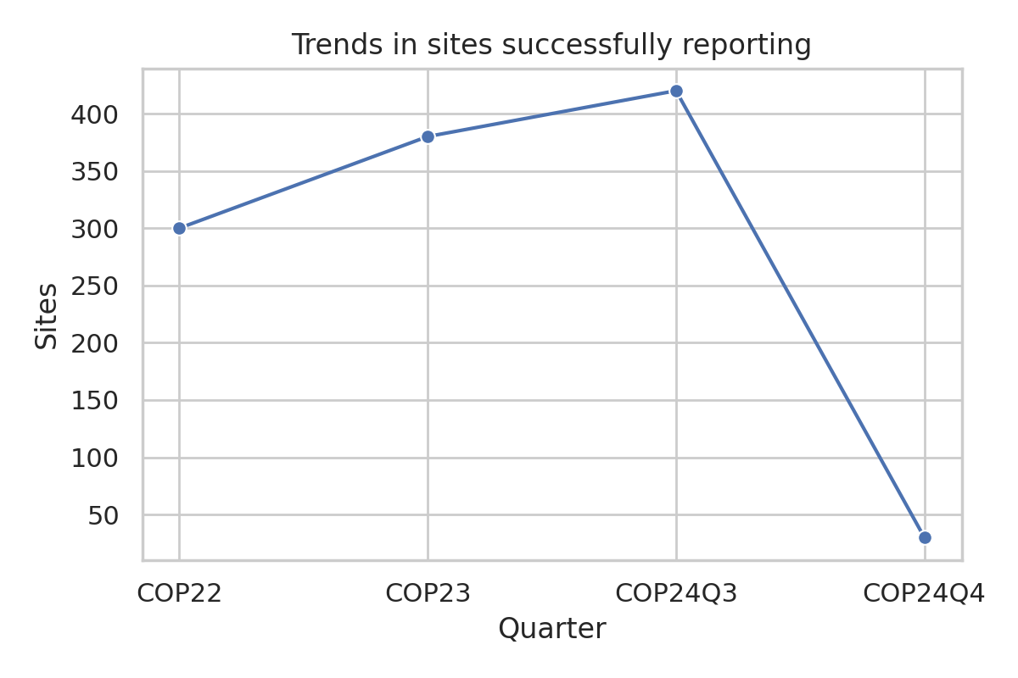
Figure 3: Trends in sites successfully reporting, COP22 – COP24 Q4

Challenges
• Database collection
Onboarding more facilities to the automated data pipeline and improving the mobile application to reduce manual intervention; addressing network selection issues and ensuring complete uploads.
• Data extraction
Higher success for manual/dpl backups compared to mobile uploads due to slow central network performance; large facilities may require batch processing to avoid memory failures.

Remedial Actions Taken and Recommendations
• Database collection and extraction challenges
• Continue downloading and reprocessing missing data from the central repository.
• Generate data in smaller batches for large facilities to avoid memory-related failures.
• Strengthen mentorship and power backup at facilities.

Optimized Sites Data Concordance Analysis

Table 2: MRF/E-HR Data Concordance Analysis for Optimized sites

Overall Data Concordance Analysis
Indicator | MRF/DHIS2 | E-HR | Concordance
HTS_TST | 5,751 | 3,195 | 55.6%
HTS_POS | 432 | 240 | 55.6%
TX_NEW | 486 | 270 | 55.6%
TX_CURR | 13,311 | 7,395 | 55.6%

TX_CURR Concordance Analysis for Harare and Bulawayo
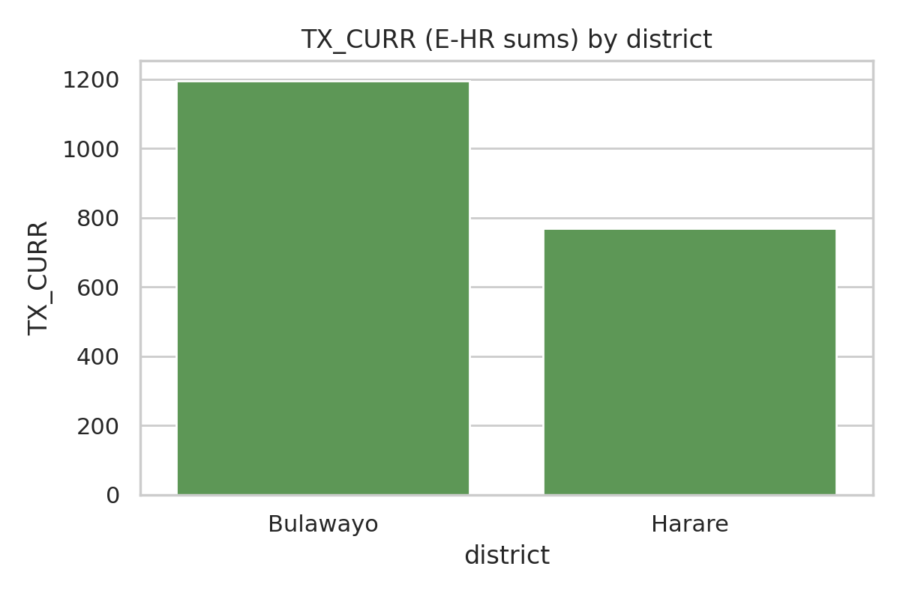
Figure 4: Concordance analysis for Harare and Bulawayo sites

