# Lab: Syntax, Functions and Statements

Submit your solutions in the SoftUni judge system at:

<https://judge.softuni.org/Contests/2749/Syntax-Functions-and-Statements-Lab>

## Echo Function

Write a JS function that takes **one string parameter** and **prints** on two lines the **length** of the parameter and then the **unchanged parameter** itself.

### Examples

| **Input** | **Output** |
| --- | --- |
| 'Hello, JavaScript!' | 18  Hello, JavaScript! |
| 'strings are easy' | 16  strings are easy |

### Hints

* Write a function that receives a single **parameter**.
* Use the console.log function to print text on the console. Each call prints a newline automatically.
* The string's **length property** is used to determine how many characters are in a given string

## String Length

Write a JS function that takes **three** **string arguments** as an input. Calculate the **sum** of the **length** of the **strings** and the **average length** of the strings **rounded** **down** to the nearest integer.

The **input** comes as **three string arguments** passed to your function.

The **output** should be printed on the console in two lines.

### Examples

| **Input** | **Output** |
| --- | --- |
| 'chocolate', 'ice cream', 'cake' | 22  7 |
| 'pasta', '5', '22.3' | 10  3 |

### Hints

* Write a function that receives three string arguments.
* Declare two variables named **sumLength** and **averageLength** that will keep the mathematical results.
* Calculate the length of the strings using the **length property**.

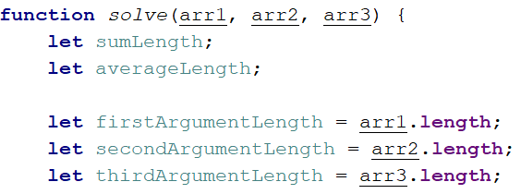

* Calculate the sum of the three lengths. 
* Calculate the **average length** of the strings **rounded** **down** to the nearest integer. Use the **Math.floor()** function.



* Print the results on the console.

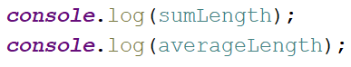

## Largest Number

Write a function that takes **three number arguments** as input and finds the **largest** of them. Print the following text on the console: **`The largest number is {number}.`**.

The **input** comes as **three number arguments** passed to your function.

The **output** should be printed to the console.

### Example

| **Input** | **Output** |
| --- | --- |
| 5, -3, 16 | The largest number is 16. |
| -3, -5, -22.5 | The largest number is -3. |

### Hints

* Write a function that receives three number arguments.
* Declare a variable named **result** that will keep the result.

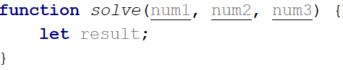

* Make several checks to find out the largest of the three numbers. Start with num1.

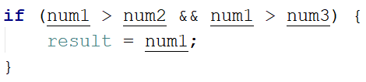

* Do the same for the others.

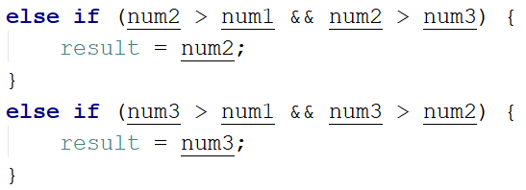

* Print the result on the console.



## Circle Area

Write a function that takes **a single argument** as an input. **Check the type** of input argument. If it is a **number**, assume it is the radius of a circle and **calculate the circle area**. Print the **area** **rounded** to **two decimal places**.

If the argument type is **NOT** a number, print the following text on the console:   
**`We can not calculate the circle area, because we receive a {type of argument}.`**

The **input** comes as a **single argument** passed to your function.

The **output** should be printed on the console.

### Example

| **Input** | **Output** |
| --- | --- |
| 5 | 78.54 |
| 'name' | We can not calculate the circle area, because we receive a string. |

### Hints

* Write a function that receives a single argument.
* Declare a variable named **result** that will keep your result.

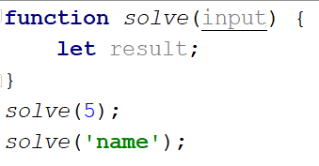

* Check the type of the input argument with the **typeof** operator.



* If the type is equal to **'number'**, calculate the circle area and print it on the console rounded to two decimal places. To do this, use the method **toFixed().**The **Math.pow()** function returns the base to the exponent power, that is, base exponent. You can find more information about the area [here](https://en.wikipedia.org/wiki/Circle):

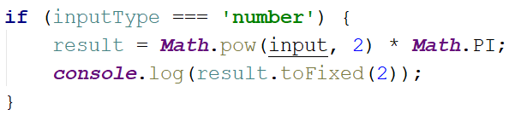

* If the type is **NOT** a **'number'**, print the following text on the console:

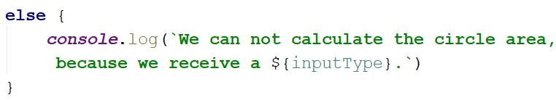

## Math Operations

Write a JS function that takes **two** **numbers** and **a string** as an input.

The string may be one of the following: '**+**', '**-**', '**\***', '**/**', '**%**', '**\*\***'.

Print on the console the result of the mathematical **operation** between **both numbers** and the **operator** you receive as a string.

The **input** comes as **two numbers** and **a string argument** passed to your function.

The **output** should be printed on the console.

### Examples

| **Input** | **Output** |
| --- | --- |
| 5, 6, '+' | 11 |
| 3, 5.5, '*' | 16.5 |

### Hints

* Write a function which receives **three** arguments:

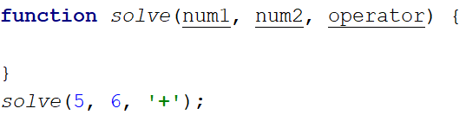

* Declare a variable named **result** that will keep your mathematical result.
* Write down the **switch** command that will take the string from your input and depending on it, perform the mathematical logic between the two numbers.

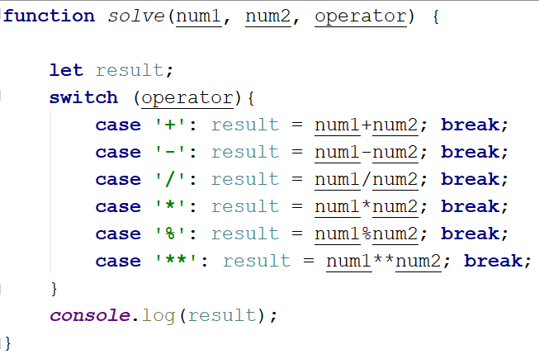

* Print the result on the console.



## Sum of Numbers N…M

Write a JS function that takes two numbers **n** and **m** as an input and **prints the sum** of all numbers from **n** to **m**.

The **input** comes as **two string elements** that need to be **parsed** as numbers.

The **output** should **return** the **sum**.

### Examples

| **Input** | **Output** |
| --- | --- |
| '1', '5' | 15 |
| '-8', '20' | 174 |

### Hints

* Write a function that receives two string arguments and parse them as numbers. Use **Number(string)** function to parse the input.

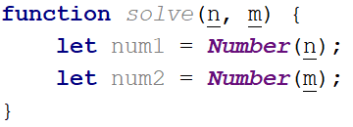

* Declare a variable named **result** that will keep the mathematical results.
* Write a **for** loop from **num1** to **num2** and every turn of the cycle, until it’s completed, add the current value.

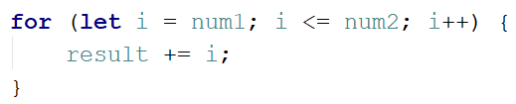

* Finally, return the result.



## Day of Week

Write a function that prints a number between 1 and 7 when a **day of the week** is passed to it as a string and an **error message** if the string is **not recognized**.

The **input** comes as a single-string argument.

The **output** should be returned as a result.

### Examples

| **Input** | **Output** |
| --- | --- |
| 'Monday' | 1 |
| 'Friday' | 5 |
| 'Invalid' | error |

## Days in a month

Write a JavaScript function to get the number of days in a month.

The input comes as two numeric parameters. The first element is the month, the second is the year.

The output must return the number of days in a month for a given year.

### Examples

| **Input** | **Output** |
| --- | --- |
| 1, 2012 | 31 |
| 2, 2021 | 28 |

### Hints

* Use **Date()**

## Square of Stars

Write a function that **prints a rectangle** made of **stars** with variable **size**, depending on an input parameter. If there is **no parameter** specified, the rectangle should **always** be of **size 5**. Look at the examples to get an idea.

The **input** comes as a single **number** argument.

The **output** is a series of lines printed on the console, forming a rectangle of variable size.

### Examples

| **Input** | **Output** |  | **Input** | **Output** |  | **Input** | **Output** |  | **Input** | **Output** |
| --- | --- | --- | --- | --- | --- | --- | --- | --- | --- | --- |
| **1** | **\*** | **2** | **\* \***  **\* \*** | **5** | **\* * * * \***  **\* * * * \***  **\* * * * \***  **\* * * * \***  **\* * * * \*** | **7** | **\* * * * * * \***  **\* * * * * * \***  **\* * * * * * \***  **\* * * * * * \***  **\* * * * * * \***  **\* * * * * * \***  **\* * * * * * \*** |

## Aggregate Elements

Write a program that performs different operations on an array of elements. Implement the following operations:

* **Sum(ai)** - calculates the sum of all elements from the input array
* **Sum(1/ai)** - calculates the sum of the inverse values (1/ai) of all elements from the array
* **Concat(ai)** - concatenates the string representations of all elements from the array

The **input** comes as an array of number elements.

The **output** should be printed on the console on a new line for each of the operations.

### Examples

| **Input** | **Output** |  | **Input** | **Output** |
| --- | --- | --- | --- | --- |
| [1, 2, 3] | 6  1.8333333333333333  123 | [2, 4, 8, 16] | 30  0.9375  24816 |