# Lab: Objects and Classes

Submit your solutions in the SoftUni judge system at: <https://judge.softuni.org/Contests/1323/Objects-and-Classes-Lab>

## Person Info

Write a function that receives **3 parameters**, sets them to an **object**, and **returns** that object.

The input comes as **3 separate strings** in the following order: **firstName**, **lastName**, **age**.

### Examples

| **Input** | **Object Properties** |
| --- | --- |
| "Peter",  "Pan", "20" | firstName: Peter  lastName: Pan  age: 20 |
| "George",  "Smith", "18" | firstName: George  lastName: Smith  age: 18 |

### Hints

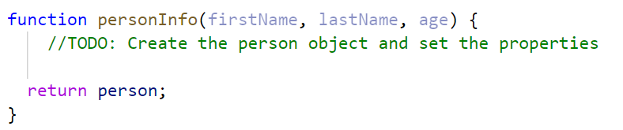

## City

Write a function that receives a **single** **parameter** – an **object**, containing **five properties**:

**{ name, area, population, country, postcode }**

Loop through all the **keys** and **print** them with their **values** in format: "**{key} -> {value}**"

See the examples below.

### Examples

| **Input** | **Output** |
| --- | --- |
| {  name: "Sofia",  area: 492,  population: 1238438,  country: "Bulgaria",  postCode: "1000"  } | name -> Sofia  area -> 492  population -> 1238438  country -> Bulgaria  postCode -> 1000 |
| {  name: "Plovdiv",  area: 389,  population: 1162358,  country: "Bulgaria",  postCode: "4000"  } | name -> Plovdiv  area -> 389  population -> 1162358  country -> Bulgaria  postCode -> 4000 |

## Convert to Object

Write a function that receives a **string** in **JSON format** and converts it to an **object**.

Loop through all the keys and print them with their values in format: "**{key}: {value}**"

### Examples

| **Input** | **Output** |
| --- | --- |
| '{"name": "George", "age": 40, "town": "Sofia"}' | name: George  age: 40  town: Sofia |
| '{"name": "Peter", "age": 35, "town": "Plovdiv"}' | name: Peter  age: 35  town: Plovdiv |

### Hints

* Use **JSON.parse()** method to parse JSON string to an object

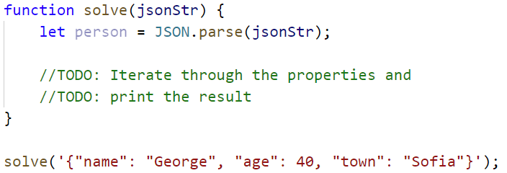

## Convert to JSON

Write a function that receives a **first name**, **last name**, **hair color** and sets them to an **object**.

Convert the **object** to **JSON string** and print it.

Input is provided as **3 single strings** in the order stated above.

### Examples

| **Input** | **Output** |
| --- | --- |
| 'George', 'Jones', 'Brown' | {"name":"George","lastName":"Jones","hairColor":"Brown"} |
| 'Peter', 'Smith', 'Blond' | {"name":"Peter","lastName":"Smith","hairColor":"Blond"} |

### Hints

* Use **JSON.stringify()** to parse the object to JSON string

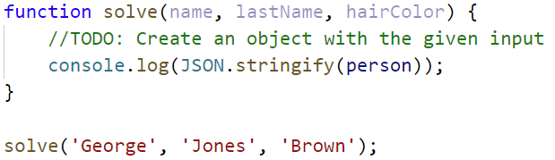

## Cats

Write a function that receives **array** of strings in the following format **'{cat name} {age}'**.

Create a **Cat** **class** that receives in the **constructor** the **name** and the **age** parsed from the input.

It should also have a method named **"meow"** that will print **"{cat name}, age {age} says Meow"** on the console.

For each of the strings provided, you must **create a cat object** and invoke the **.meow ()** method**.**

### Examples

| **Input** | **Output** |
| --- | --- |
| ['Mellow 2', 'Tom 5'] | Mellow, age 2 says Meow  Tom, age 5 says Meow |
| ['Candy 1', 'Poppy 3', 'Nyx 2'] | Candy, age 1 says Meow  Poppy, age 3 says Meow  Nyx, age 2 says Meow |

### Hints

* Create a **Cat class** with properties and methods described above
* Parse the input data
* Create all objects using the class constructor and the parsed input data, store them in an array
* Loop through the array using **for…of** a cycle and **invoke .meow()** method

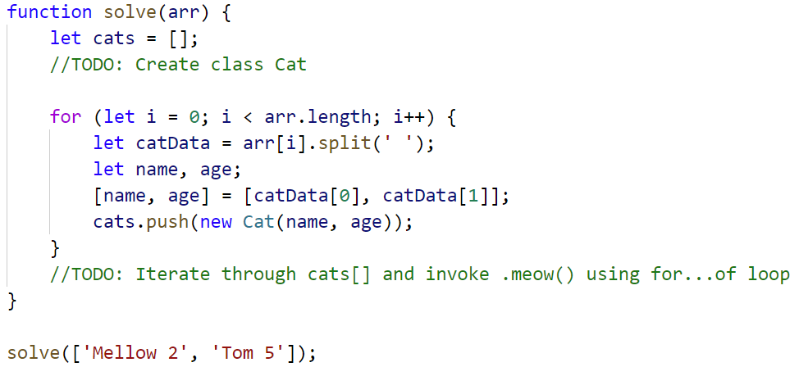

## Songs

Define a **class** **Song**, which holds the following information about songs: **typeList**, **name,** and **time**.

You will receive the input as an **array**.

The first element **n** will be the number of songs. Next **n** elements will be the songs data in the following format: **"{typeList}_{name}_{time}"**, and the last element will be **typeList** / **"all".**

Print only the **names of the songs**, which have the same **typeList (**obtained as the last parameter**)**. If the value ofthe last element is **"all",** print the names of all the songs.

**Examples**

| **Input** | **Output** |
| --- | --- |
| [3,  'favourite_DownTown_3:14',  'favourite_Kiss_4:16',  'favourite_Smooth Criminal_4:01',  'favourite'] | DownTown  Kiss  Smooth Criminal |
| [4,  'favourite_DownTown_3:14',  'listenLater_Andalouse_3:24',  'favourite_In To The Night_3:58',  'favourite_Live It Up_3:48',  'listenLater'] | Andalouse |
| [2,  'like_Replay_3:15',  'ban_Photoshop_3:48',  'all'] | Replay  Photoshop |

### Solution:

Create a **Song class** with properties described above

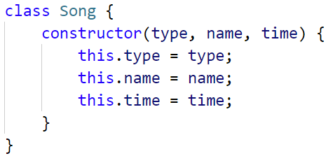

Create a new array, where you will store songs

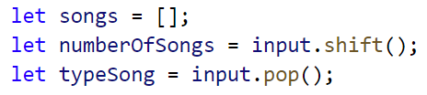

Iterate over the songs:

