# Lab: Associative Arrays

Submit your solutions in the SoftUni judge system at: <https://judge.softuni.org/Contests/1231/Associative-Arrays-Lab>

## Phone Book

Write a function that stores information about a **person’s name** and **phone number**. The input is an **array of strings** with space-separated name and number. **Replace duplicate names**. Print the result as shown.

### Example

| **Input** | **Output** |
| --- | --- |
| ['Tim 0834212554',  'Peter 0877547887',  'Bill 0896543112',  'Tim 0876566344'] | Tim -> 0876566344  Peter -> 0877547887  Bill -> 0896543112 |
| ['George 0552554',  'Peter 087587',  'George 0453112',  'Bill 0845344'] | George -> 0453112  Peter -> 087587  Bill -> 0845344 |

## Meetings

Write a function that manages meeting appointments. The input comes as an **array of strings**. Each string contains a **weekday** and person’s **name**. For each **successful** meeting, **print a message**. If you receive the **same weekday** twice, the meeting cannot be scheduled so print a **conflicting message**. In the end, print a list of all **successful** meetings.

### Example

| **Input** | **Output** |
| --- | --- |
| ['Monday Peter',  'Wednesday Bill',  'Monday Tim',  'Friday Tim'] | Scheduled for Monday  Scheduled for Wednesday  Conflict on Monday!  Scheduled for Friday  Monday -> Peter  Wednesday -> Bill  Friday -> Tim |
| ['Friday Bob',  'Saturday Ted',  'Monday Bill',  'Monday John',  'Wednesday George'] | Scheduled for Friday  Scheduled for Saturday  Scheduled for Monday  Conflict on Monday!  Scheduled for Wednesday  Friday -> Bob  Saturday -> Ted  Monday -> Bill  Wednesday -> George |

## Address Book

Write a function that stores information about a person’s **name** and his **address**. The input comes as an **array of strings**. Each string contains the **name** and the **address** separated by a **colon**. If you receive the same name **twice** just **replace** the address. In the end, print the full list, **sorted alphabetically** by the person’s name.

### Example

| **Input** | **Output** |
| --- | --- |
| ['Tim:Doe Crossing',  'Bill:Nelson Place',  'Peter:Carlyle Ave',  'Bill:Ornery Rd'] | Bill -> Ornery Rd  Peter -> Carlyle Ave  Tim -> Doe Crossing |
| ['Bob:Huxley Rd',  'John:Milwaukee Crossing',  'Peter:Fordem Ave',  'Bob:Redwing Ave',  'George:Mesta Crossing',  'Ted:Gateway Way',  'Bill:Gateway Way',  'John:Grover Rd',  'Peter:Huxley Rd',  'Jeff:Gateway Way',  'Jeff:Huxley Rd'] | Bill -> Gateway Way  Bob -> Redwing Ave  George -> Mesta Crossing  Jeff -> Huxley Rd  John -> Grover Rd  Peter -> Huxley Rd  Ted -> Gateway Way |

## Storage

Write a function that takes a certain number of **items** and their **quantity**. If the same item appears **more than once**, **add the new amount** to the **existing one**. In the end, print all the items and their amount without sorting them. The input comes as an **array of strings**. Try using a **Map()**.

### Example

| **Input** | **Output** |
| --- | --- |
| ['tomatoes 10',  'coffee 5',  'olives 100',  'coffee 40'] | tomatoes -> 10  coffee -> 45  olives -> 100 |
| ['apple 50',  'apple 61',  'coffee 115',  'coffee 40'] | apple -> 111  coffee -> 155 |

### Hints

Create the **solve()** function and create a new **Map()**:

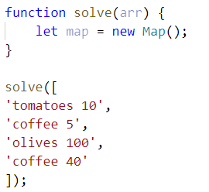

Loop through the array, split into tokens, and create variables for each one:

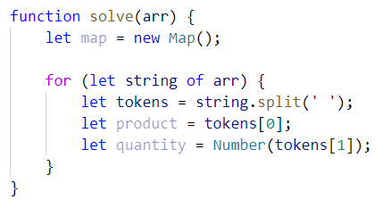

* This time for the quantity we need a number because if we see the same product again, we must add the new quantity

Now let us make the checks for the keys on the map:

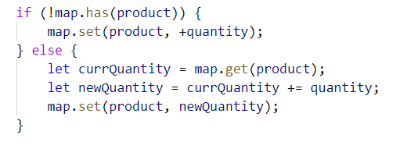

* First, we check if the map does ***NOT*** have the product we are currently at and **if so**, we **set it to the given quantity**
* Otherwise, we get the **existing quantity**, we **add the new quantity,** and **set** the product’s quantity **to the new** one

Now we just have to print the result:

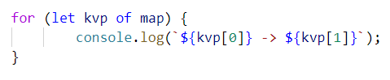

* Each key-value pair is and an **array of 2 elements** (the **key** and the **value**), so we use a **for-of** loop and print the key and the value

## School Grades

Write a function that stores **students** and their **grades** throughout the year. If a student appears more than once, **add** the new **grades** to **existing ones**. Finally, **print** the students and their **average grades**, sorted **alphabetically** by **student name.** The input comes as an **array of strings**.

**Note:** The **average grades** must be fixed to the second decimal place.

### Example

| **Input** | **Output** |
| --- | --- |
| ['Lilly 4 6 6 5',  'Tim 5 6',  'Tammy 2 4 3',  'Tim 6 6'] | Lilly: 5.25  Tammy: 3.00  Tim: 5.75 |
| ['Steven 3 5 6 4',  'George 4 6',  'Tammy 2 5 3',  'Steven 6 3'] | George: 5.00  Steven: 4.50  Tammy: 3.33 |

## Word Occurrences

Write a function that **counts** the times each **word occurs** in a text. Print the words **sorted by count** in **descending** order. The input comes as an **array of strings**.

### Example

| **Input** | **Output** |
| --- | --- |
| ["Here", "is", "the", "first", "sentence", "Here", "is", "another", "sentence", "And", "finally", "the", "third", "sentence"] | sentence -> 3 times  Here -> 2 times  is -> 2 times  the -> 2 times  first -> 1 times  another -> 1 times  And -> 1 times  finally -> 1 times  third -> 1 times |
| ["dog", "bye", "city", "dog", "dad", "boys", "ginger"] | dog -> 2 times  bye -> 1 times  city -> 1 times  dad -> 1 times  boys -> 1 times  ginger -> 1 times |

### Hint

* Create a map
* Loop through the elements of the array of words
* Update the map
* Sort the map by value in descending:



* Finally, print the result in the format as the example above